THE FAMILIAR - AND NOT SO FAMILIAR - W.A. FIRTH: HIS LIFE AND TIMES IN BELFAST
Peter B. Paisley
Sydney, Australia

W.A. Firth’s diatoms are renowned but his wider work attracts little comment: his palette has colours which belie prevailing monochrome impressions conveyed by the literature. Furthermore I find no consideration of his place and time, which were pregnant with historical significance.
Irish research at a distance is frustrating. Records are fragmentary: many perished in the Civil War following declaration of the Irish Free State (as with English civil wars – or Irish famines - one should specify which one.) Irish interest in old mounts is scanty - slides get jettisoned, so evidence is lost. Relevant archives, and repositories like that in Belfast’s Linenhall Library, are not on line. Obstacles notwithstanding, my small collection invited a wider perspective than is often offered.
The standard view – an incomplete picture
My collection is probably typical of most, consisting largely of diatoms like those below.
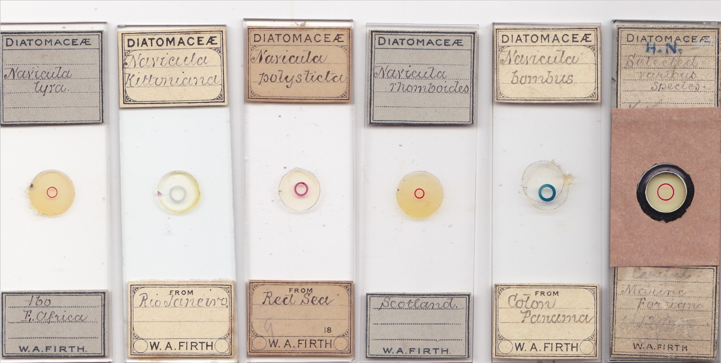
The slide on the extreme right may appear papered, but it is in fact a repair job.
Plate 17 in Microscopical Mounts and Mounters however hints at a wider range, and includes a mount of echinus spines.
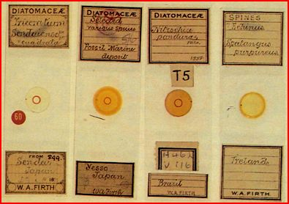
This made me re-examine my Firth slides and various archives, to conclude that “diatomist” is necessary, but not sufficient.
Beginnings
The first record of Firth as diatomist seems to be in late 1877 (an exact date was not recorded), when his entries of arranged mounts won a prize at the Belfast Naturalists’ Field Club. The judges, praising his “consummate skill”, had this to say:
“They might be taken as models of careful manipulation, and would compare favourably with any microscopic work which we have hitherto seen by the most eminent mounters in Britain”.
That expertise did not spring from nowhere: he must have been mounting for some time. His first advertisement in Science Gossip (June 1877) does not mention diatoms, and shows he mounted other material: he sought merely “interesting” slides in exchange, presumably to study various techniques.
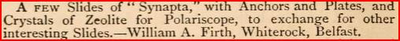
The zeolite was almost certainly obtained from the Giant’s Causeway: it is not clear whether he made zeolite mounts or just offered the material. He advertised again in August 1877 offering slides of synapta, with no mention of diatoms. His next entry, in November, for the first time mentions diatoms – he was seeking them from “New Nottingham and other good foreign diatomaceous deposits”. In exchange, he offered “two Co. Antrim earths” and “well mounted slides” (whose material was not specified). Meantime, another Science Gossip entry perhaps whetted his appetite: in January 1877 Eugene Mauler of Travero, Switzerland, sought diatoms from many locations – including south Mourne. This cannot have failed to attract Firth’s attention – and Mauler was among those offering cash.
Firth did not advertise again until March 1878, when he now sought diatoms from “Irish and foreign” locations. In exchange, he offered “well mounted slides” – of unspecified material: by now, presumably, the well mounted slides included diatoms, but probably not exclusively.
The Firth name appears next in Science Gossip in April 1879, somewhat enigmatically. An “Albert Firth of Ballymurphy” wanted specimens of glass rope sponge, offering “good micro slides” in exchange.
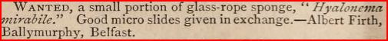
Ballymurphy lies between Whiterock and Springfield Road (a known Firth address): this must be our Firth, who mounted glass rope sponge, as in the example below. His communication with Science Gossip may have been signed “W. Allott Firth” or “William Allott Firth”, causing editorial confusion and corruption of the journal entry to “Albert”.
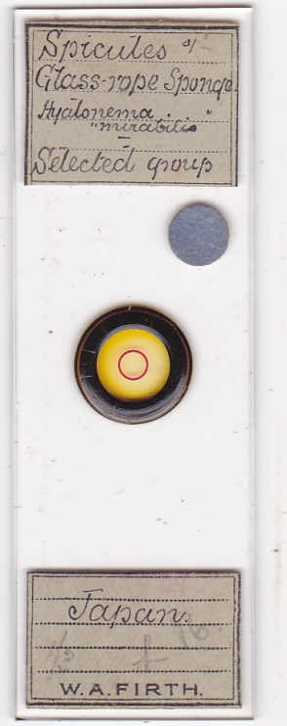
His early work clearly featured a variety of material. The slide below echoes his first two advertisements and is probably early, but unfortunately it is undated.
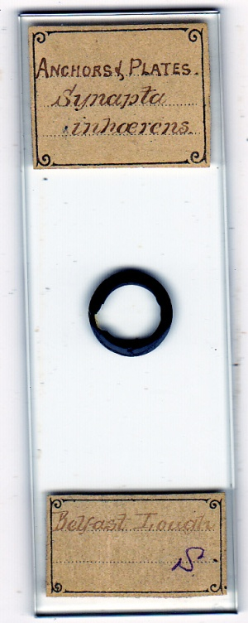
Material gathered in Belfast Lough by Firth
Encouraged by the Field Club prize, and doubtless with an increasingly high reputation, Firth was gathering diatoms from far and wide in the years after 1877, building up a stock of diatom mounts for sale or exchange. He was still winning prizes in 1893, by now with arranged diatom mounts, acclaimed as below.
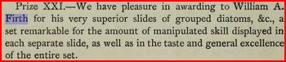
They were by no means his only interest, but by January 1882 he had already established himself as the Belfast diatom expert, reading a paper to the Club on their morphology, distribution and mounting.
From Yorkshire to Ulster
Whiterock, Firth’s first known Ulster address, was on Belfast’s fringe, near the inner northern shore of Belfast Lough. There were bleachfields nearby, and Firth’s father Joseph went to Ulster as a bleachfield manager, having previously held that post at the Swithen works near Kexbrough in west Yorkshire. There was a concentration of the linen industry around the Falls Road/Springfield Road areas – both being addresses associated with W.A. Firth: Joseph, as a bleachfield manager, may well have had connections with several firms.
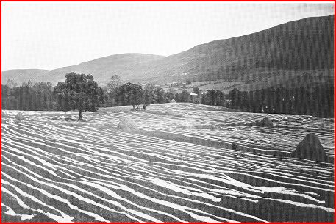
Late nineteenth century photograph of a bleach green in the Belfast area
The lough is a tidal estuary: Whiterock is not very far from sand/mud flats and rock pools with plenty of low tide collecting opportunities.
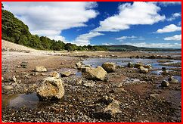
Foreshore at low tide near Whiterock
There was much to interest naturalists. Substantial Belfast Lough areas are now sanctuaries for birds such as the black tailed godwit, and nearby Strangford Lough has even richer ecosystems; but tiny things captivated Firth. He married in Belfast in October 1882: he seems to have left the Whiterock family home some time before that (his movements in Belfast seem protean!) Wherever he was, shores were still nearby – Belfast was not huge, much of it coastal.
Both Firth and his father Joseph were long time members of the Belfast Naturalists’ Field Club, and it is likely that Joseph encouraged boyhood mounting at their Whiterock home. The Club’s most famous member was Wyville Thomson, President of the sister society, the Belfast Natural History and Philosophical Society. He excited meetings with reports on his Lightning and Porcupine voyages, before embarking on the Challenger: but he emphasised that equally interesting material could be found close to home, urging research on the abundant foraminifera around Ulster shores. Firth, for one, responded with mounts.
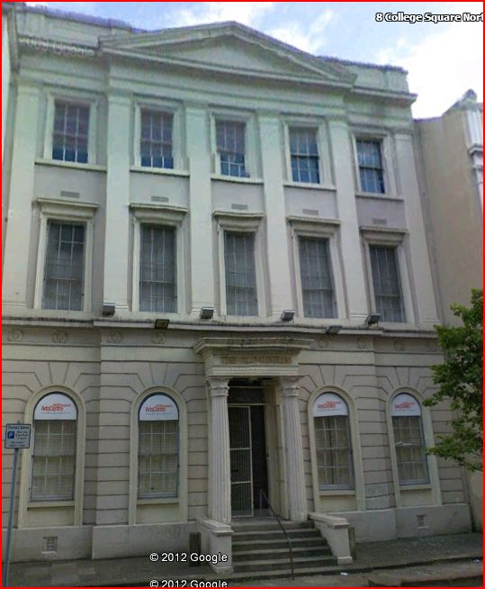
Rooms of the Belfast Natural History and Philosophical Society at 7 College Square North, now a museum: the Field Club often held meetings in this handsome building. The portico is an exact copy of an original in Athens.
Charles Elcock mounted Pacific Ocean Challenger foraminifera, exhibiting them at a Club conversazione in November 1879: both Elcock and Firth joined the Club in 1876, and both mounted foraminifera from local waters. I suspect such Firth mounts were made prior to, or in the early stages of his precocious emergence as a diatomist.
Dating and identifying Firth slides
Dating is difficult - Firth seldom included the information. When he began mounting is unclear, as is when he achieved significant commercial success, or whether he ever derived most of his income from mounting (I doubt it). In the 1901 and 1911 Irish censuses he is listed as a linen bleacher, like his father before and his son after him: there is no reason to think he gave up working in the linen industry. The rare papered mount below is probably early.
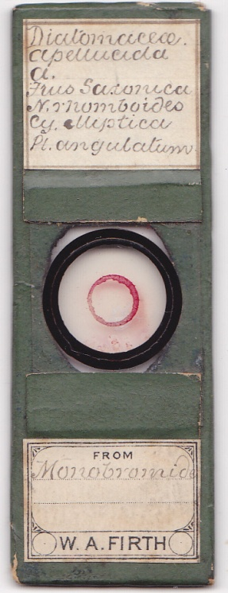
Like so many others, it is undated. His printer sometimes made labels with partial information, as on the examples below.
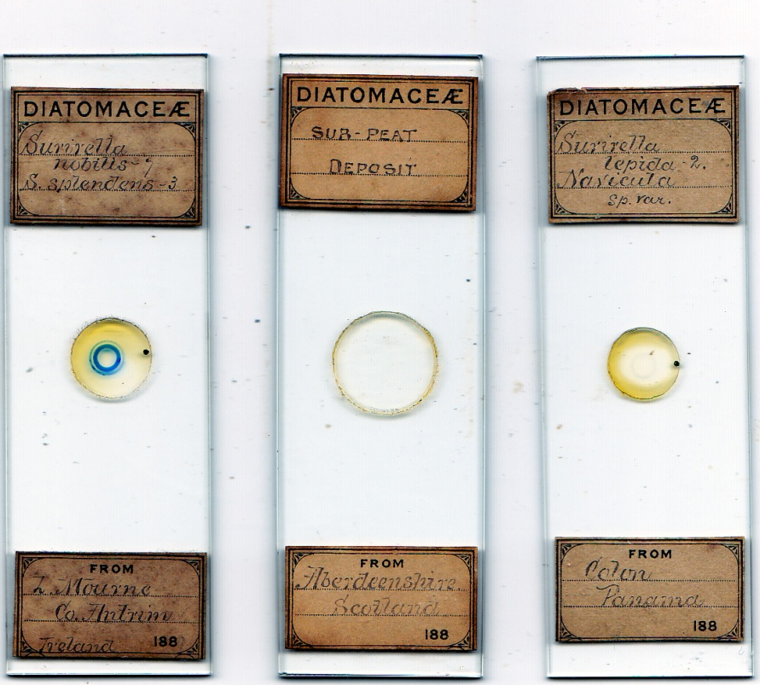
Diatoms mounted in the 1880s
Perhaps his printer thought the labels should be more precise than Firth himself – that below was printed in 1881.
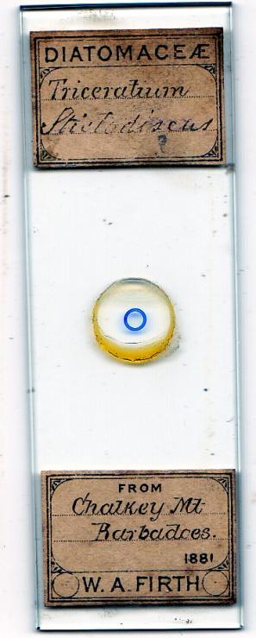
The lower label format varied, sometimes adding small circles inviting dating (and anticipating a new century to come). Again however, Firth rarely bothered, but occasionally did so, as on the examples below.
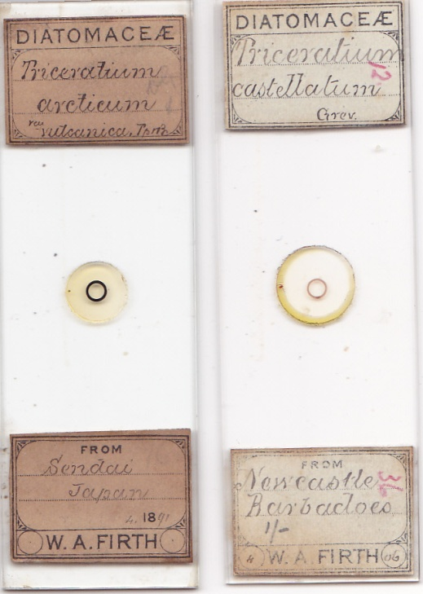
These slides are dated 1891 (left) and April 1906 (right)
Identification, like dating, can be difficult, but handwriting comparison is useful. The slides below languished on my “miscellaneous” trays, until I began making single letter and whole word comparisons.
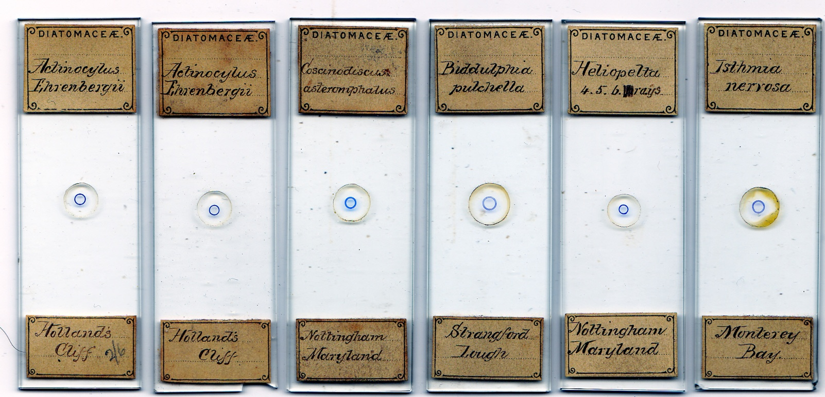
I cannot tell when these were made, but they were evidently in demand at the time, witness the duplicates. A strong clue is the Ulster location of the Strangford Lough example. Extrapolation of upper label examples from two of the above for comparison is pretty suggestive. If, as I believe, they are Firth’s, they may be early, before he had labels bearing his name.
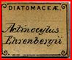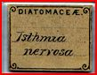
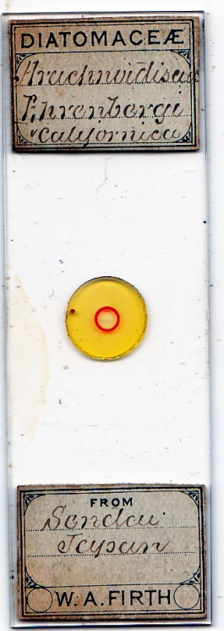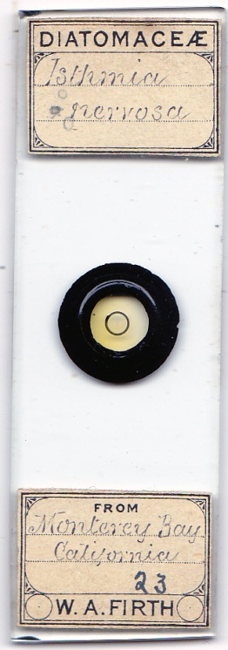
Compare also the inscription “Monterey Bay” on the lower labels of two slides above – it is closely similar. There may be many Firth mounts lacking overt ascription which go currently unrecognised. Sometimes he signed his mounts, as in the examples below: again, these may date from before he had labels with his name.
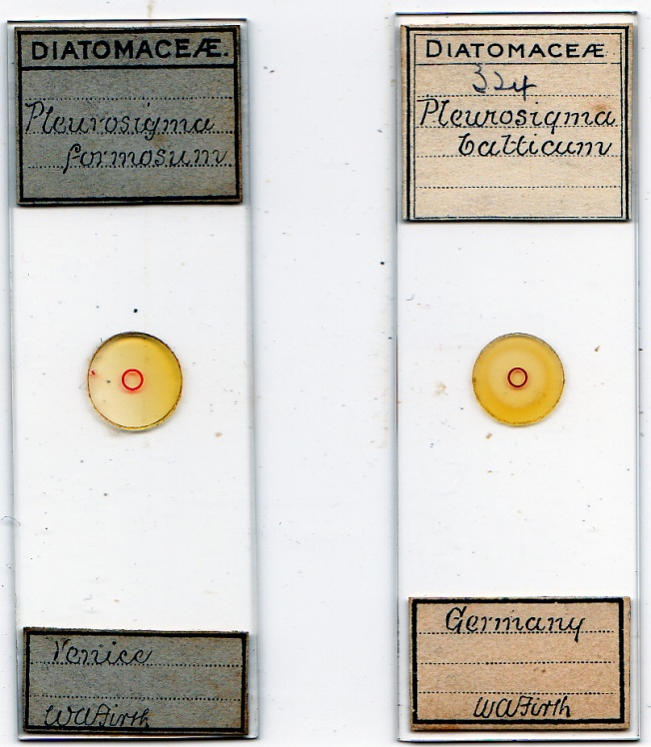
The paucity of dates hinders any conclusion about Firth’s overall period of mounting activity: I think it diminished significantly after about 1910, but readers with large collections may have contrary evidence.
Mavericks?
Firth is a Quaker name well established, and prestigious, in Yorkshire. Quakers dominated the Irish linen industry, so Quaker connections may have facilitated Joseph Firth’s move to Ulster. English censuses list no religious affiliation: Ireland being Ireland, censuses there did, and in 1901 the W.A. Firth family was noted as Church of Ireland (in the Anglican communion, but disestablished since 1871). The same is true of the 1911 census, by when they were in Ravenhill Road.
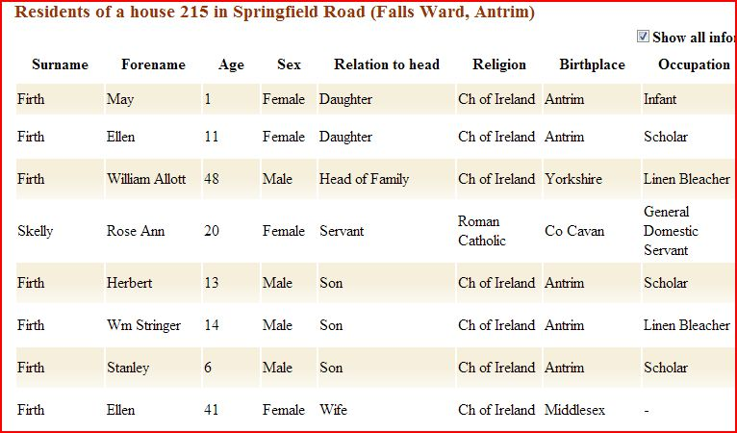
W.A. Firth and his family in 1901
From addresses in various journals, only Tempère seems comparably nomadic. Multiple Belfast addresses are recorded after Whiterock. Reconstruction from the ages of Firth’s children could suggest moves to increasingly larger premises, to accommodate a growing family. But the Firth family was not poor, so why not acquire larger accommodation earlier?
Many moves could signify real estate speculation, of course: or locations quoted in Microscopical Mounts and Mounters (which do not exhaust the list) might be premises rented for laboratories, photographic rooms, or art studios. Some addresses in MM&M, and the Field Club’s membership records, are near his known whereabouts in the two censuses.
Even so, the number of addresses seems exceptional. Photographic chemicals, splashes from water colouring, accumulation of specimens and mounting materials – the combination evokes a bohemian scenario which may not have pleased landlords. If Firth was renting, he could have been as unpopular a tenant as was Beethoven in Vienna.
Intriguing information came from Quaker headquarters in Dublin: Quaker Firths were notorious for impropriety, including “marrying out” and “more serious misdemeanours”. My source did not elaborate, but the Firths were often regarded as renegades. Three generations of Firths worked in Belfast as linen bleachers, and Quakers dominated the Irish industry. If there was a network of premises available via Firths’ employers, there may have been a series of disapproving landlords. My inquiries to date all led nowhere regarding our Firth family’s Quaker allegiance (or not), so all I can say is that by 1901 W.A. Firth was firmly Church of Ireland. Be that as it may, I cannot ignore the circumspect hints from Dublin.
An expanding market
For Joseph Firth, the move to Ulster in the 1860s was opportune. Mechanised linen manufacture was booming in Belfast, the major export outlet for linen goods. Yorkshire also had a mechanised linen industry, centred round Leeds, but the bleachworks managed in Yorkshire by Joseph handled both linen and cotton.
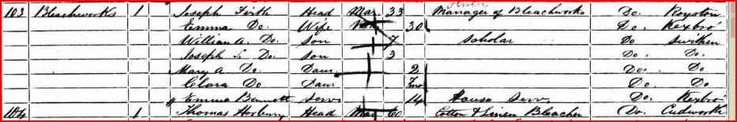
From the 1861 English census: Joseph Firth’s neighbour was both cotton and linen bleacher.
The Confederate rebellion in America, and resulting Union naval blockades, brought a “cotton famine” to British mills: linen sheets and tablecloths, for example, usually for the “higher end” market, were now more widely sought products.
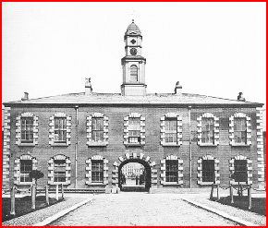
The White Linen Hall, Donegall Square, Belfast, the mercantile centre for the trade. The Firths would have been familiar with it, until its demolition in 1898.
Belfast shipbuilding was rapidly expanding, creating big demand for linen ropes: by the late 1870s the Belfast rope works was on its way to becoming the largest in the world, and by 1914 Belfast was the world’s biggest producer of linen goods.
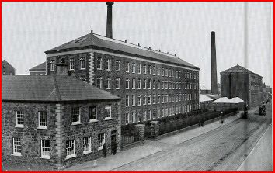
Brookfield linen spinning mill, Crumlin Road, Belfast: the mill began operations in the 1860s as a direct response to the rise in demand for linen yarn due to the American Civil War.
A manager in the linen trade like Joseph Firth would have found steady employment in a rapidly expanding Ulster industry, as would his son William and grandson William, also qualified linen bleachers.
Violent times
Wars erupted globally in Firth’s lifetime. The Franco-Prussian war saw the first aerial bombardment of civilians, during the siege of Paris. The American Civil War involved territorial extent and army sizes comparable to Napoleonic campaigns: both sides of that conflict had multiple family ties to Ulster. In 1879, President “Unconditional Surrender” Grant visited his ancestral Ulster homeland: there were cheers in Belfast streets – though doubtless not from those whose sympathies lay with the Stars and Bars: nor, as a Protestant often suspected of atheism, was he welcomed by most Catholic citizens. As the Washington Times observed, his Irish visit was “not all clover”. Many generals on both sides of the American Civil War had Ulster lineage, and one Confederate general – Joseph Finegan – was born there.
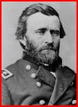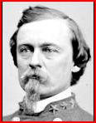
Ulysses S. Grant and (R) Joseph Finegan
The later, Edwardian, period was one of relative calm in England: not so in Ireland, where English political machinations did nothing to quell conflict over Home Rule. Randolph Churchill, gambling on “playing the orange card”, had declared “Ulster will fight, and Ulster will be right”. Possibly some of Firth’s moves – from Springfield Road, for instance - were to escape threatened sectarian violence: the British political crisis over Home Rule in 1912-14 stimulated massive demonstrations and paramilitary activity throughout Ulster. Fearing “Home Rule means Rome Rule”, Unionists plotted armed rebellion.
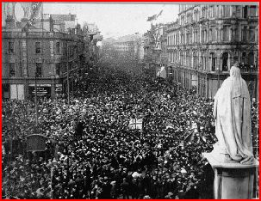
Ulster Covenant day, central Belfast, September 1912. Firth must have witnessed scenes like this.
The paramilitary UVF went on to form the bulk of the British army’s Ulster Division: this, with most of its officers, was well nigh wiped out at the Somme in July 1916. In Ireland, nothing was peaceful: the year of the Battle of the Somme also brought forth the Dublin Easter Rising. A major section of the Irish population had threatened armed rebellion - to stay within the British Empire. Not long after that, another section rose in actual armed rebellion – in an attempt to leave it.
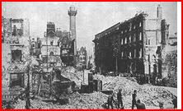
Dublin, Easter 1916: Sackville Street after the assault by British troops, tanks and artillery
The last straw no doubt was the 1916 attempt to include Ireland in conscription for war in Europe. Trotsky modelled some of his successful Bolshevik strategy on the abortive 1916 Easter rising in Dublin, and in Ireland, the failed Easter Rising soon inspired a sequel causing the first British imperial domino to fall in the twentieth century. Firth may have learned no Irish history as a Yorkshire child: as a Belfast adult, he lived through the middle of it.
Quakers – renegades or not – must have deplored all the strife: so must a family like the Firths (whatever their religion) with loyalties on both sides of the Irish Sea.
Contests of belief
Intellectual matters may not usually involve rifles and howitzers, but verbal warfare can be bitter. In 1874 the British Association held its meeting in Belfast, and its Presidential Address, appropriately, was delivered by the Irishman John Tyndall, Darwin’s bull mastiff. His defence of rational progress – in particular Darwin’s ideas - pulled no punches. He relished confrontation with natural theology: in his preface to the seventh thousand publication of his Address, he declares,
“I have raised up against myself a host of enemies......I derive some comfort, nevertheless, from the reflection of Diogenes, transmitted to us by Plutarch, that ‘he who would be saved must have good friends or violent enemies; and that he is best off who possesses both’. This ‘best’, I have reason to believe, is mine”.
He denounces,
“.....what I must regard as the extravagances of the religious world.....the very inadequate and foolish notions concerning this universe which are entertained by the majority of our authorised religious teachers; at the waste of energy on the part of good men over things unworthy.....of the attention of enlightened heathens.”
On natural selection, he concludes,
“We cannot, without shutting our eyes through fear or prejudice, fail to see that Darwin is here dealing, not with imaginary, but with true causes.”
With non-biological science, he flatly declares matters beyond dispute:
“We claim, and we shall wrest, from theology the entire domain of cosmological theory.”
Tyndall goes much further, ridiculing the then recent doctrine of papal infallibility, and accusing the Catholic hierarchy of falsifying history. Ireland, Belfast least of all, is not the place for such views to promote harmony: as George Bernard Shaw remarked, “those who have not lived in Ireland do not know what protestantism is” (he should have included catholicism.)
Where young Firth stood on these thoughts I do not know: but they must have left lasting impressions. Perhaps he felt remote from controversy in concentrating on the study of microscopic life.
The Field Club: science, religion, history and art
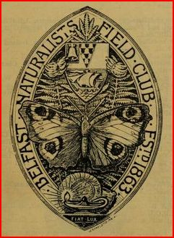
The Belfast Naturalists’ Field Club emblem: the motto “let there be light” had more layers of meaning in the Belfast Club than in most places.
Firth joined the Club in 1876 and from 1879 sat on its committee for many years. The Club did important research in many fields, and religion/science friction created lively debate at meetings. Long after Tyndall’s Belfast address, the waves it created still broke on the shores of research. One member, the Rev. John Andrew, in Belfast as a missionary “Angel” (read “bishop”) of the Catholic Apostolic Church, a breakaway protestant sect, delivered an evening address in 1887: the minutes record (with approval) his “Some thoughts on the Development Theory of Creation”, in which he rejected evolutionary explanation, emphasising that no convincing “missing links” had been found. Many Club office bearers over the years were clergy, among them Rev. H.W. Lett of Lurgan, whose prolific microscopical research and skilled drawings regularly appeared in the Journal of the Postal Microscopical Society: his paper for the Club in 1888 echoed the Rev. Andrew’s sentiments with
“an able reply to the attacks of Professor Tyndall on Christianity” (the minute recorder’s evaluation).
From outside, all this may appear backward looking: but it shows the Club’s tolerance of diverse beliefs – it functioned amicably on the common ground of research. Many papers, implicitly or otherwise, had evolutionary perspectives, and I found no evidence they excited censorship or opprobrium. In March 1873 for instance the Club published Robert Smith’s lengthy paper defending “Darwinism”, in which he vigorously denied that evolution was incompatible with religion: members could agree to disagree, without rancour.
Keen historical interest characterised Club excursions, many of which were joined by Firth. The railway to Larne gave quick access to Belfast Lough’s north coast, often Firth’s collecting ground. The stop at Kilroot was at Swift’s first parish, probably where he wrote A Tale of a Tub. The “great master of disgust” may or may not have lived in the unique oval cottage there.
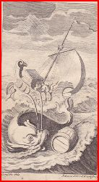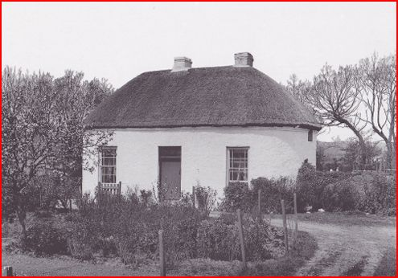
Frontispiece to my 1743 edition of “A Tale of a Tub”, and the cottage. That Swift once lived in Kilroot is indisputable: that he inhabited this cottage is probably apocryphal, but it was always known as “Dean Swift’s Cottage”.
In Firth’s lifetime a few survivors of the nineteenth century famine were still around: “Swift’s Cottage” was a reminder that such disasters had occurred before. The most savage polemic against criminal government inaction ever penned – Swift’s “modest proposal” to alleviate Irish starvation with recipes for cooking babies – was not forgotten. One Club excursion stopped at Kilroot to inspect the cottage, and also took great trouble to procure a vehicle to collect samples of the local gravel for geological and microscopical examination.
A little further down the coast the train stopped at Carrickfergus, where the twelfth century castle still had inhabitants. On the sea wall nearby, William of Orange landed troops in pursuit of King James. That was long ago, to the English: to the locals, as Firth would discover, it was yesterday.
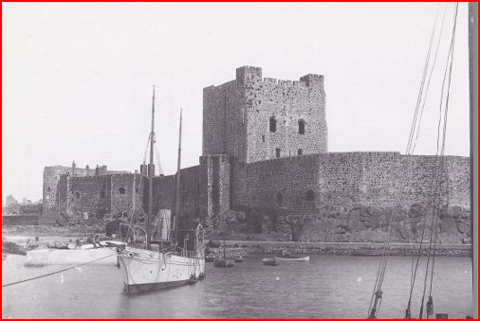
Carrickfergus castle
All this may seem remote from diatoms or foraminifera. For Club members, though, microscopy and history were part of an integrated whole: Elcock presented foraminifera mounts and brass rubbings from historic tombs with equal enthusiasm. History, ever a factor in Ulster and often contentious, might offer triumphal hope, and generated huge public pride in 1912: the hope soon turned to despair. Foraminifera were not the only things Firth could observe in Belfast Lough.
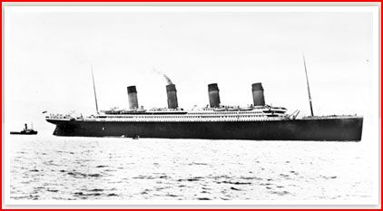
The “Titanic” on its maiden voyage down Belfast Lough
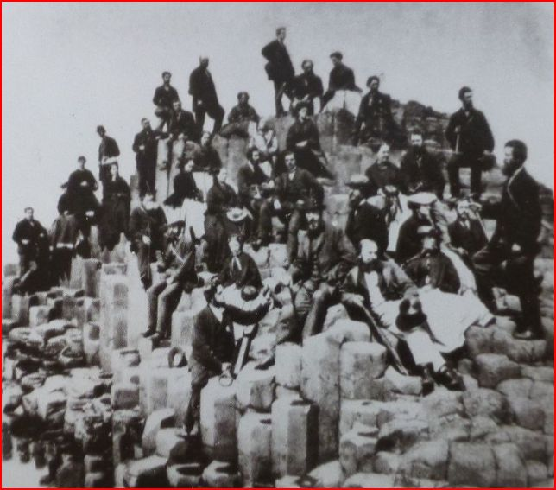
From a microphotograph retailed by Wheeler: members on a trip to the Giant’s Causeway in 1863, the year of the Club’s inauguration. The standing figure on the extreme right may be Wyville Thomson. Image coutesy of Peter Hodds.
The Club often included art in its exhibits. Andrew Nicholl, uncle of a club member and known for local paintings, and some from the Pacific islands, lent canvases of Ulster scenes. Ireland is rich in stone inscriptions and prehistoric decoration, and the Club published research on them. I found no images of Firth’s paintings, but he is mentioned more than once as exhibiting water colours of Ulster scenes at the Club. At a meeting in 1887, Firth and William Swanston reported on the diatoms of Lough Mourne and the Mourne mountains: the following year, Firth, Swanston and Joseph Wright “lent a number of oil and water-colour drawings and engravings”. Unfortunately Firth’s art contributions then were not specified. He also studied timber, and in October 1882 exhibited “a series of wood sections”. Whether these sprang primarily from artistic or scientific motives (or both) I cannot say. If any still exist, they seem undocumented, but further wood sections were exhibited more than once at Club meetings.
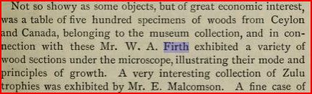
Wood growth and Zulu trophies: Club members had pretty eclectic interests! From Field Club reports, October 1882
In 1890, the Club President William Gray introduced an exhibition of photographic and other publishing work, and
“drew special attention to the art of chromo-lithography, an art in which our city excels, and has a world-wide reputation for beauty of design and excellence of workmanship.”
Archaeology, microscopy, geology, chemistry, ecology, art, photography, architecture, musical theory: the list does not exhaust disciplines explored by Club activities. Etymology of the Irish language was the focus of one symposium: I leave English readers to ponder the leading contributors.
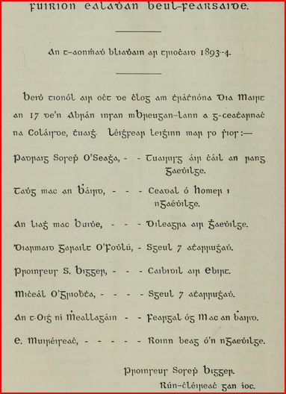
The Club was anything but narrow in its outlook; but breath did not hamper the depth of its investigations.
Some contemporaries
The Yorkshire Quaker emigrant Charles Elcock arrived in Belfast around 1874, and, as noted previously, both he and Firth joined the Field Club in 1876. Structural similarities between Elcock’s mounts and what I take to be early Firth preparations are striking, as illustrated below.
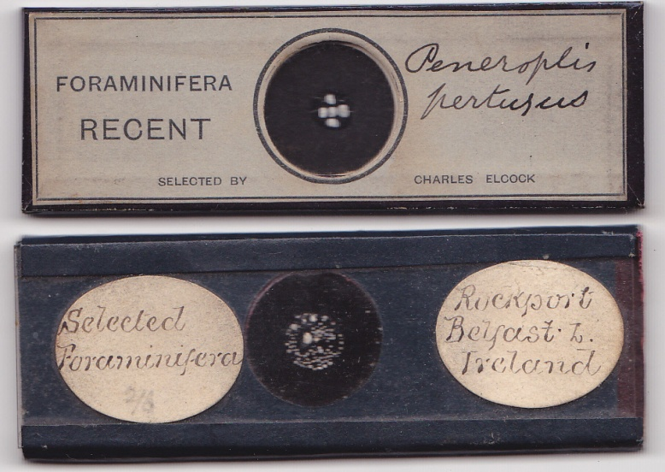
Mounts of foraminifera by Elcock and Firth: the Firth material is from the southern shore of Belfast Lough
Elcock achieved high renown as a mounter of foraminifera, and if the two collaborated, Firth was learning from a master. Equally bulky, Firth mounts differed from Elcock’s, in that his slides were removable, allowing direct inspection of material.
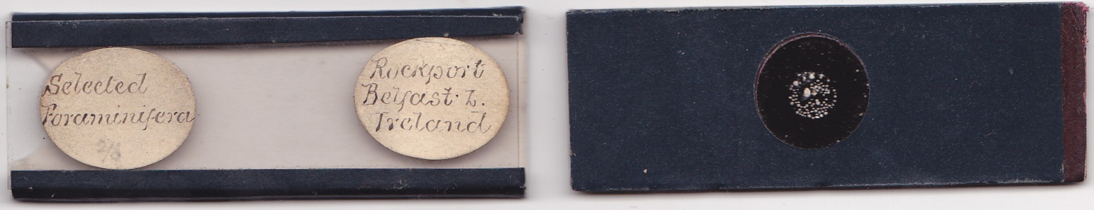
Just about everyone mounting foraminifera in the nineteenth century seems to have used material from Dog’s Bay, in Connemara, so it is no surprise that Firth did so too.
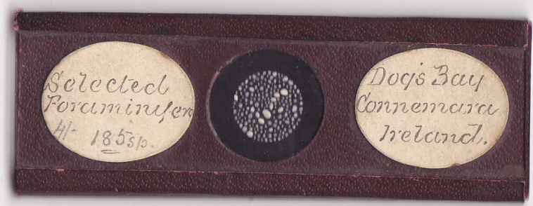
The four shilling price on the slide above seems to be the original: if so, Firth was not selling such wares cheaply. This example is clearly designed as an “exhibition” mount.
Association with Elcock may have brought Firth commercial contacts: Elcock was well established with London retailers by the 1880s, as his advertisements show.
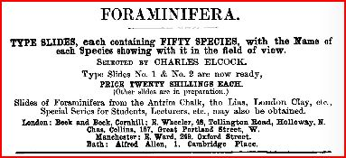
Elcock’s advertisements were run often by the Journal of the Postal Microscopical Society: the above is from April 1884.
Whatever the case, Firth made many foraminifera mounts, with sales through big retailers like Baker, and others in London.
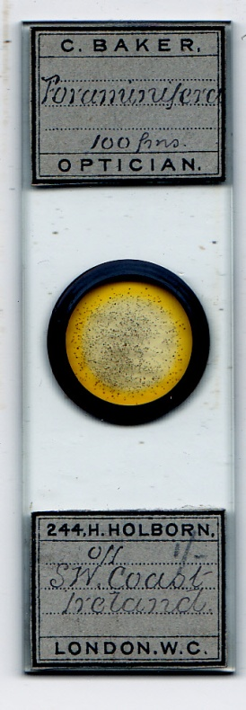
Firth foraminifera retailed by Baker, almost certainly showing material from one of the “Lord Bandon” scientific voyages.
In the 1890s, the surgeon James Barbour was retailing slides in London and the USA. Comparison of handwriting on labels leaves no doubt that Firth was mounting for him.
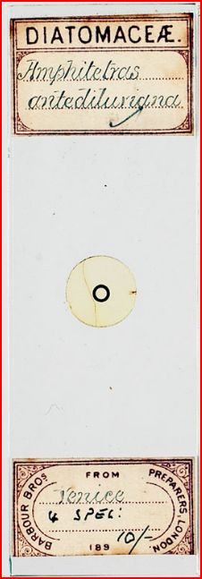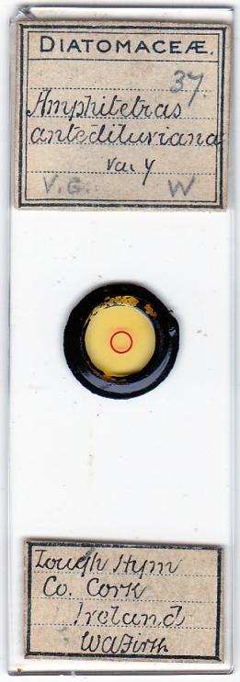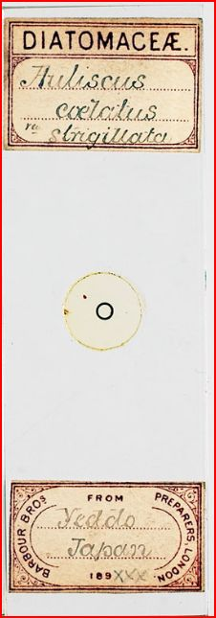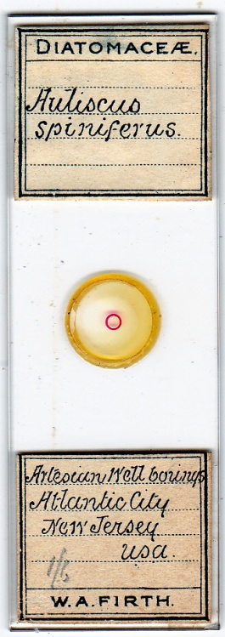
Some label comparisons: images of Barbour Bros. slides courtesy of Brian Davidson
John H. Barbour joined the Club in October 1894: Firth was no longer on its committee, but still active in the Club. John Barbour subsequently presented it with a rock slicing machine built by Combe, Barbour and Combe. Their normal output was heavy textile manufacturing machinery, which Firth would have known well from his involvement in the flax trade.
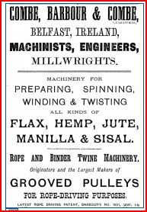
The Combes and the Barbours were entrepreneurs of Scottish origin: some family connection between John and James Barbour seems the likely explanation for Firth’s retail sales under the “Barbour brothers” label.
Firth joined the Quekett Microscopical Club in 1881, bringing him more contacts in Britain and overseas. Joseph Wright – another Field Club office bearer – researched material from the Lord Bandon voyages sponsored by the Royal Academy of Ireland. Wright’s contacts with museums and learned societies in England and Ireland may have opened further doors for Firth. Handwriting on cardboard slides of Lord Bandon material, below, has been identified as that of Arthur Earland.
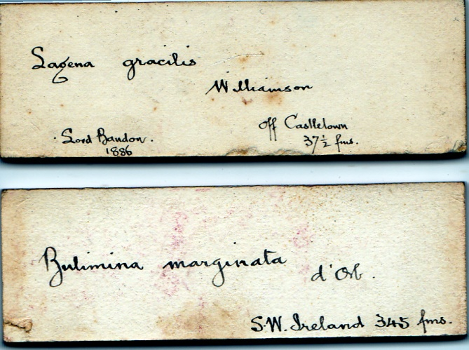
Before the Club was founded, Alfred McCoy held a chair in Belfast until leaving in 1854 for Melbourne, and seems to have created something of a local fashion for cardboard mounts. The typical format of McCoy slides is shown below.
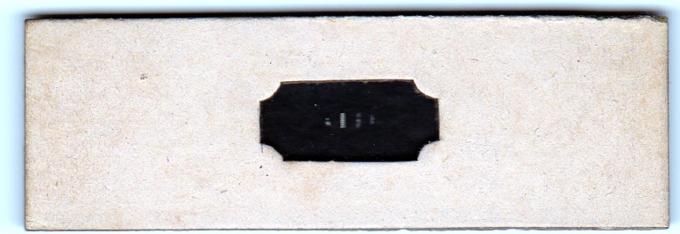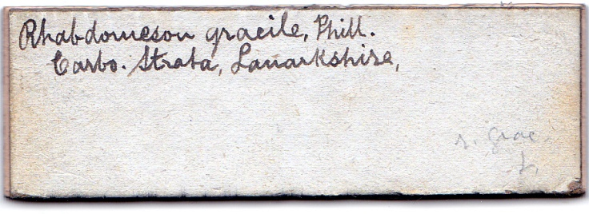
Front and rear of a cardboard slide with typical McCoy format. I have not identified the handwriting.
I found no evidence that Firth mounted on cardboard: it is vulnerable to application of liquids, and those I have seen all feature dry preparations. The fashion never caught on much generally, but persisted in Ulster, witness the slide below.
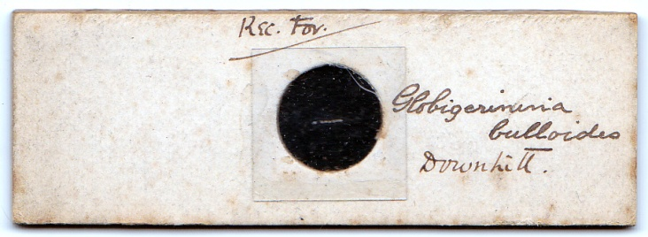
Foraminifera from Downhill, mounted in 1880
The railway led to Derry, stopping at coastal Club destinations like Downhill, with its pristine beach: a favourite among the Club’s classicists was the cliff top folly, modelled on temples of Vesta in Italy and built by the eccentric Earl Bishop of Derry.
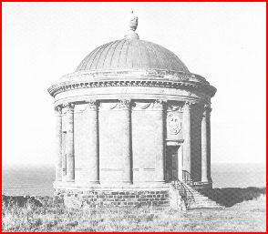
The temple at Downhill, on the cliff top, and specimens for the microscope on the shore below – a typical combination for Club members on excursion.
Further round the coast another tidal estuary, Lough Foyle, offered much for research round its shores. Famous in recent decades for the Derry Sub-aqua Club’s discovery of a ship from the Spanish Armada, Lough Foyle yielded smaller treasures a century previously. The slide below bears what may be the same handwriting as that on the Downhill mount.
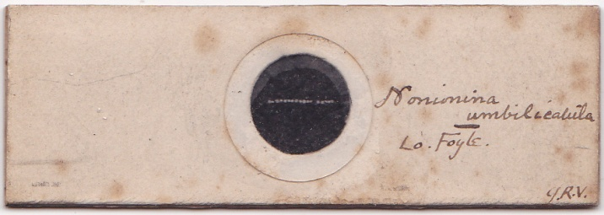
Initials on this (undated) slide may be those of John Vinycomb, who became the Belfast club’s President
The most notable ship joined by a Club member was the Challenger: its scientific chief Wyville Thomson held a university chair in Belfast before moving to Scotland. Challenger material generated an even larger volume of literature than the Indian plague commissions of the 1890s: a vast amount was documented by taxonomists like the Englishman G.S. Brady, some of whose slides, like that below, still trickle through today’s market.
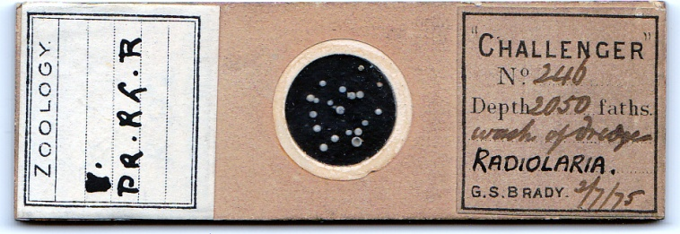
Brady’s name was attached to nomenclature of many new species, as on the slide below, with Earland’s handwriting.
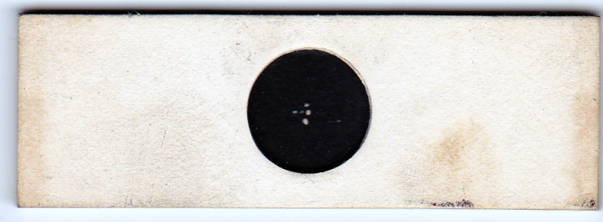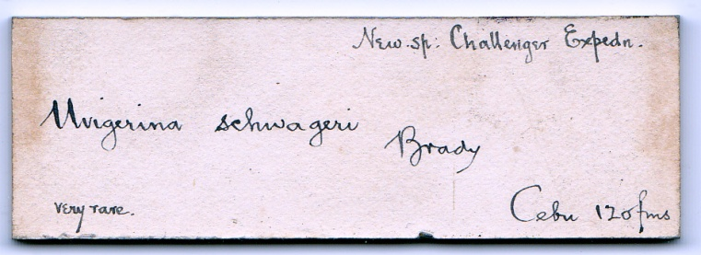
Long before Wyville Thomson’s findings were written up in official government publications however, club members received data “from the horse’s mouth”. For instance, in Club meetings in 1870-71 Thomson exhibited new species found during his Lightning and Porcupine voyages, well before the public could read about them in Thomson’s The Depths of the Sea, which was not published until 1873. The Challenger voyage finished in 1876, the year Firth joined the Field Club, and he may well have examined slides made by Wyville Thomson like those below.
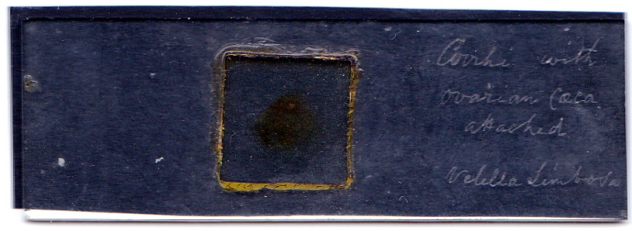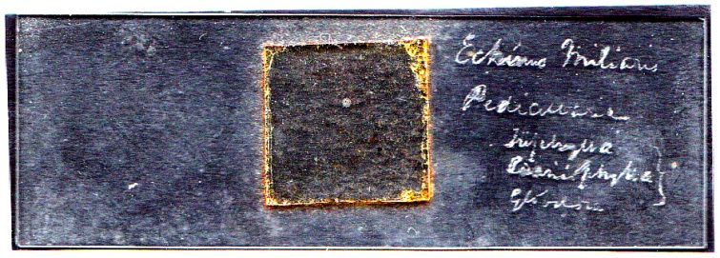
He may have obtained the Challenger material below from Thomson himself.
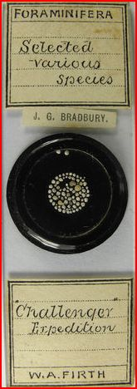
This slide recently sold at auction: unlike his bulky foraminifera mounts, which were earlier, it is on conventionally sized glass. (Image from eBay)
Predictably perhaps, Firth also mounted a diatom species named in honour of the ship.
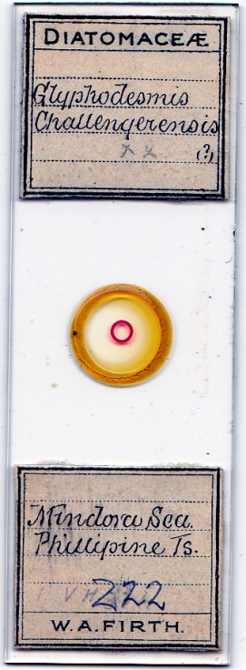
Glyphodesmis Challengerensis, mounted by Firth
Another Quaker, Samuel Malcomson, mounted much material, including some for Royal Irish Academy research with Wright, on Irish ostracoda. He was prominent in the Club from 1880, soon joining its committee. Malcomson slides like those below were used for teaching at the Queen’s University Anatomy Department.
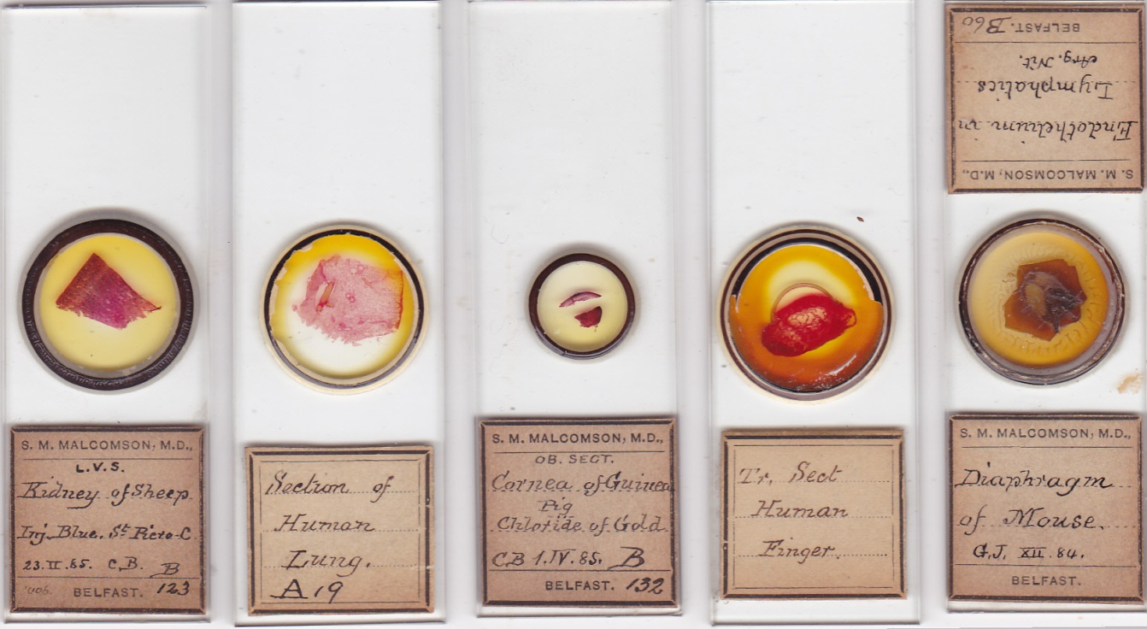
Some slides by Samuel Malcomson
Malcomson and J.J. Andrew often collaborated in making university teaching slides, as for instance on the mount below, where the label is Malcomson’s but the handwriting is Andrew’s (see also my article on Andrew in Micscape, May 2010).
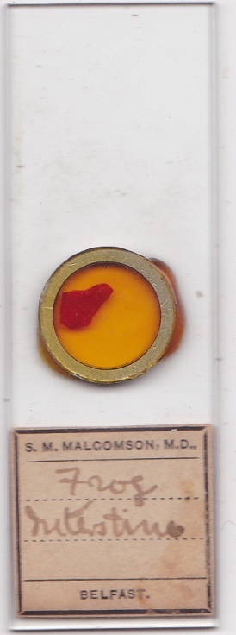
Andrew, Malcomson and Firth knew each other well – all were contemporary leading members of the Belfast Field Club: I found no evidence that Firth collaborated with either in mounting, but it is possible, particularly when Andrew was mounting and photographing microorganisms in his home at University Square.
Some of Malcomson’s ostracoda mounts survive and are now in the National Museum of Ireland in Dublin.
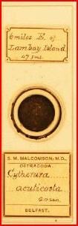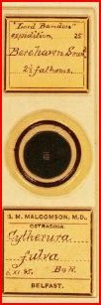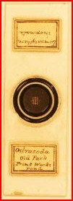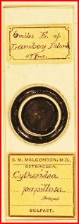
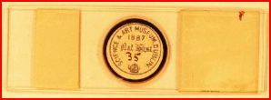
Malcomson ostracoda mounts: images courtesy of the National Museum of Ireland, Dublin. The reverse of one is shown, with the date 1887, when they were received by the museum.
I found no evidence that Firth supplied the Belfast Anatomy Department: if mounts were acquired by the university, they were likely to have been for botany or zoology students, but inquiries turned up no evidence for or against this. Nor have I located any Firth ostracoda mounts, but Elcock made them, as below, and I would be surprised if Firth did not.
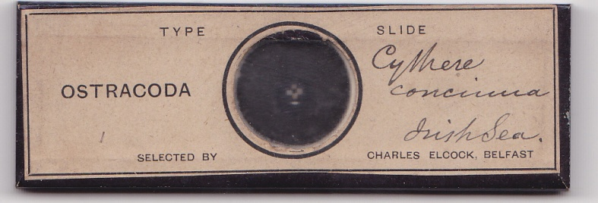
Another mounter, W.S. McKee, joined the Field Club in 1879, and was subsequently on its committee: his attractive butterfly wing and other insect slides, some of which are illustrated below, must have appealed to Firth the water colourist.
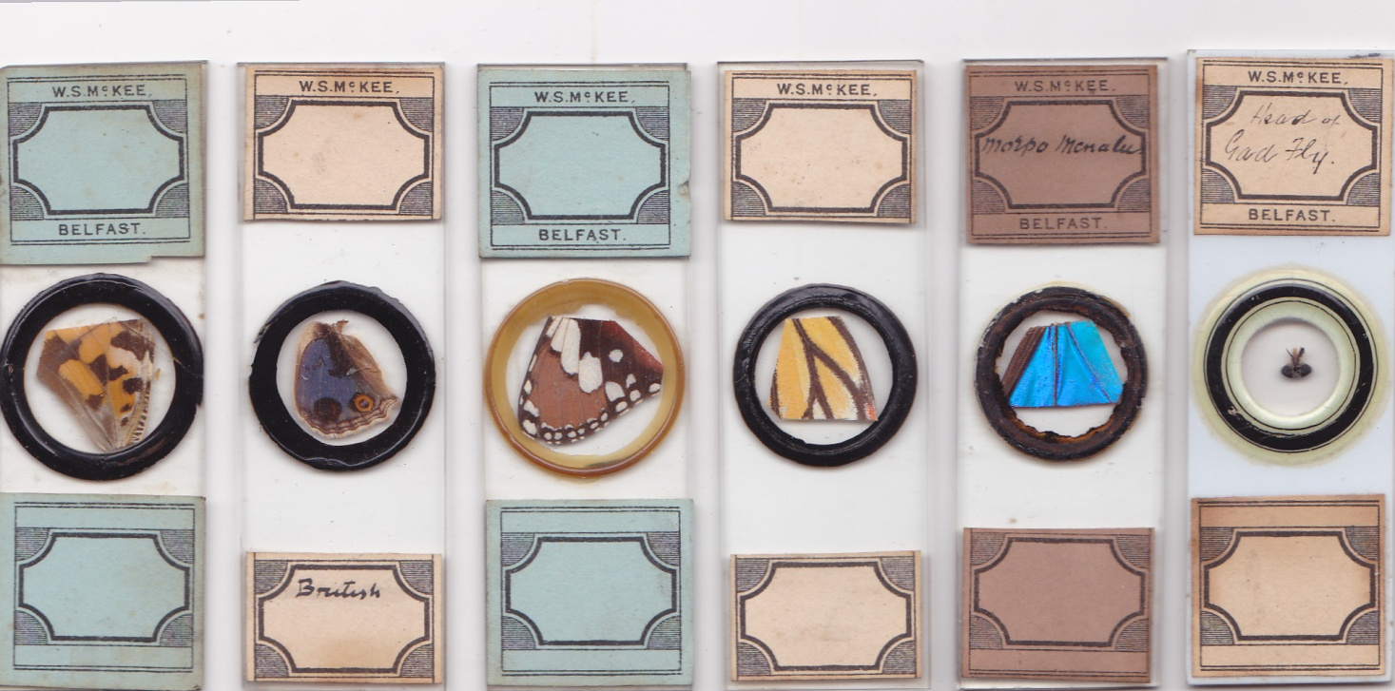
Firth certainly mounted insect material, including butterfly scales and insect eggs, as in the examples below.
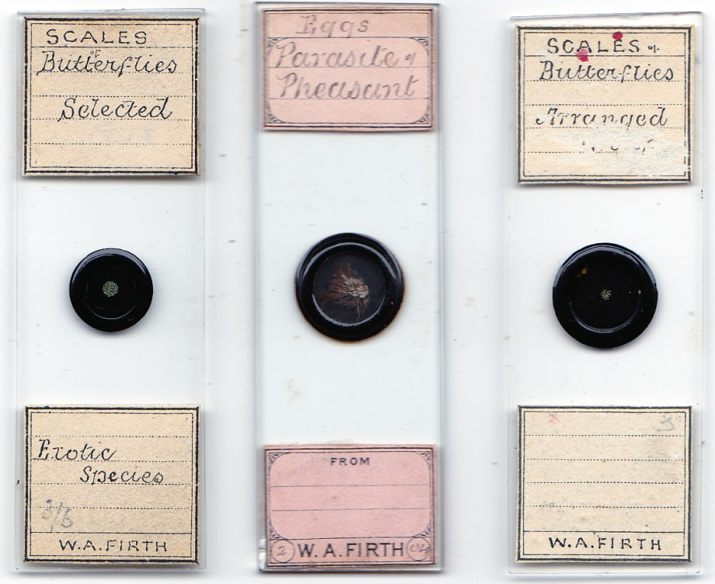
Not what one usually associates with Firth: the labels on the scales slides suggest that a series was done, and the same may be true of insect eggs; the slide above, centre, is dated February 1904.
Three generations of microscopists in the Andrew family joined the Club – the “Angel”, the Rev. John Andrew, his son John J. Andrew who became President of the British Dental Association, and his son in turn, John Andrew junior, who developed a talent for geological mounting. J.J. Andrew and W.A. Firth were both members of the Ulster Amateur Photographic Society: both were keen photomicrographers, and very probably collaborated on this from time to time.
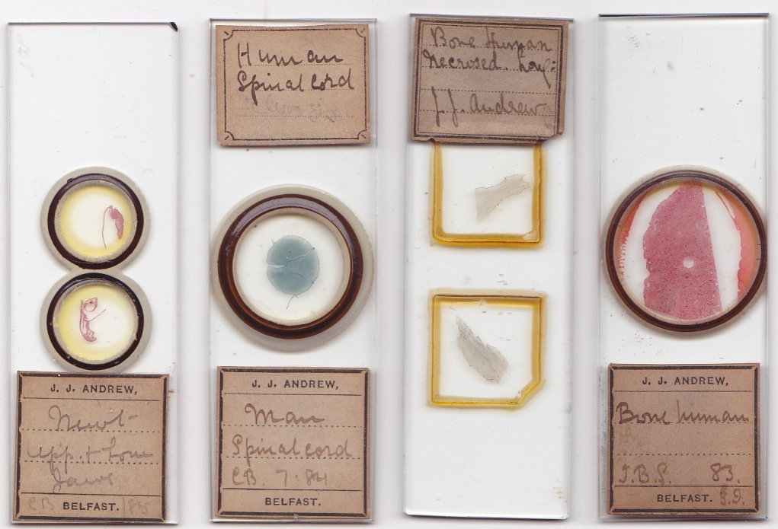
Various tissues mounted by J.J. Andrew
Firth as artist
Since Firth appears to have produced many water colour paintings, some almost certainly survive, at least in family descendants’ collections; but I have been unable to locate records or images of any.
Compared to other mounters, Firth indulged in little superficial elaboration. I found only one papered example, in plain monochrome (already illustrated above). He often ringed his mounts, but I found few multicoloured rings like those below.
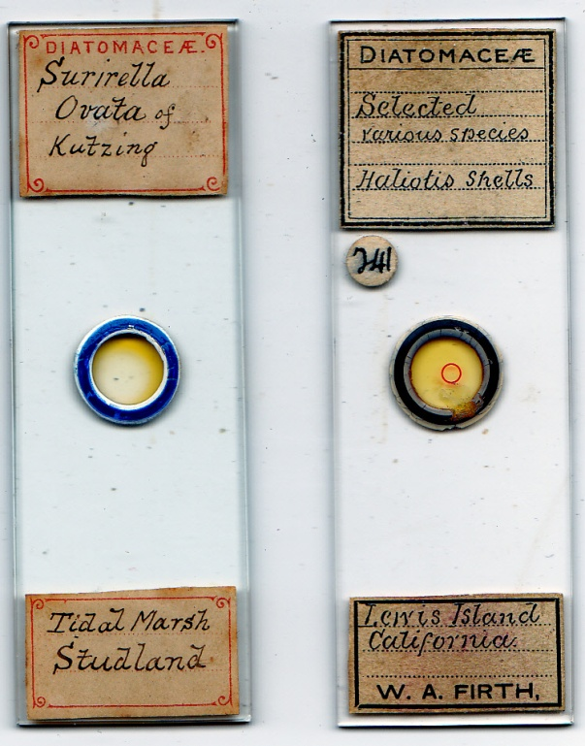
He favoured gloss black, with, it seems, few examples of more than its minimal application: the slide below is an exception.
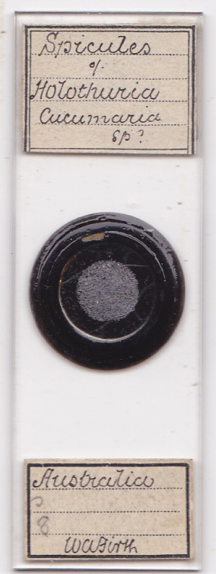
Minimalist presentation, shared by other late nineteenth and early twentieth century mounters, mirrors the modernist trends of art nouveau: as a water colourist, Firth, more than most, was presumably alive to such general influence. His uncluttered style has its own appeal, as in the attractively presented mounts below.
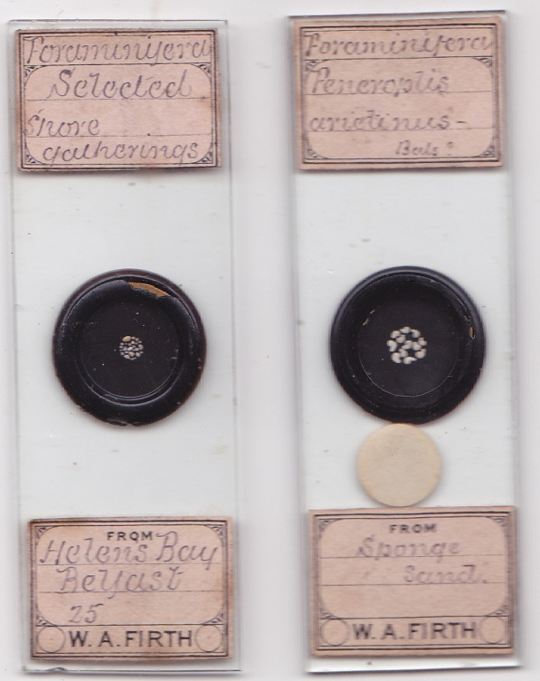
It was under the microscope though, rather than to the naked eye, that Firth’s work came into its own artistically.
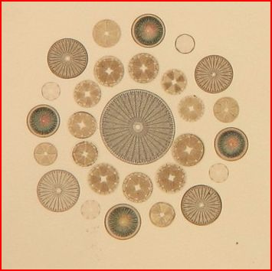
The familiar Firth
Diatom arrangements like that above won Firth prizes at the Belfast Field Club, and international renown. While skilled at such work, he attracted most praise for single species mounts. Here he had few rivals: as Spitta said, it was absolute flatness which distinguished his work, making it valuable for diatom identification. Flatness made Firth’s forte, if not his fortune. Commercially, arranged mounts probably brought him income from collectors: the same is true today for his surviving work. It is not surprising therefore that he made mounts, and arrangements, of other material.
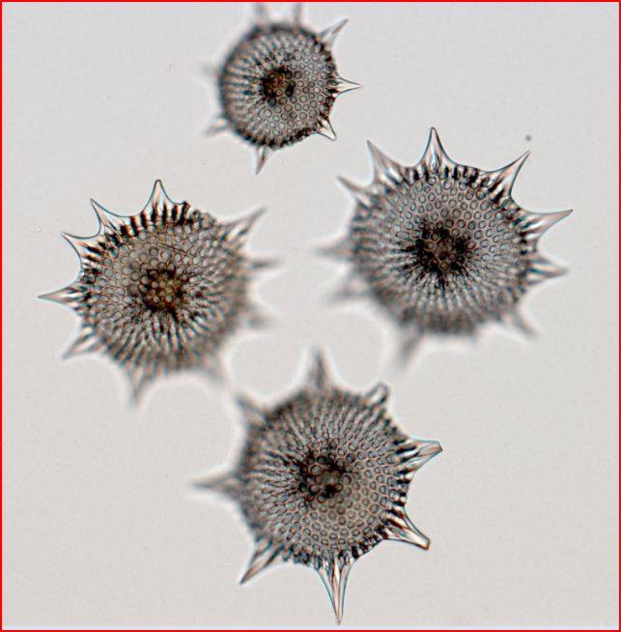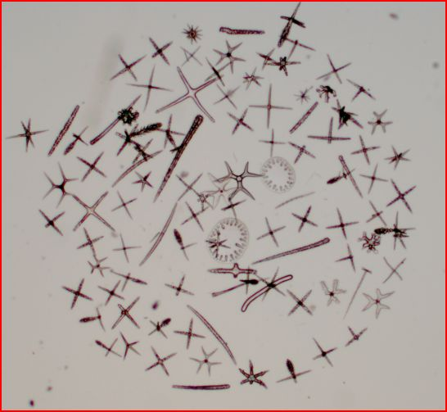
Some less familiar Firth: grouped polycystina, and a spicule arrangement. The spicule arrangement has suffered displacement over the years, but it still conveys Firth’s manipulative skill.
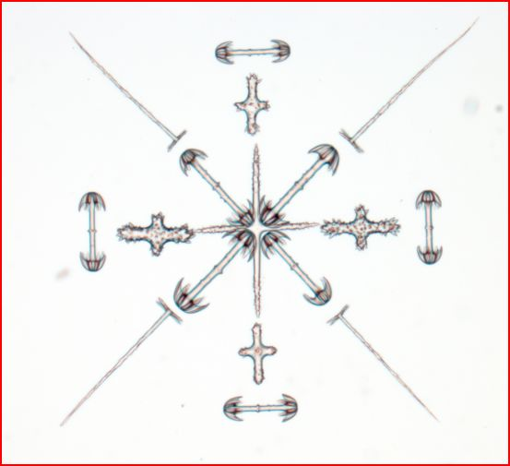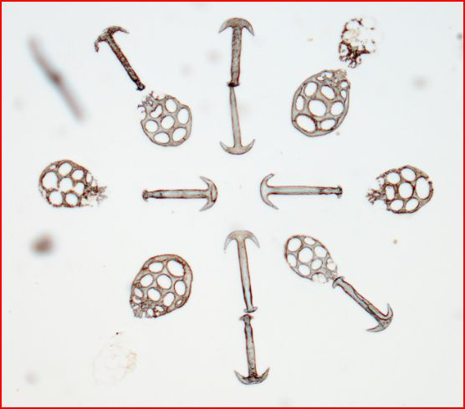
More non-diatom arrangements by Firth: the synapta slide (R) is probably one of his earliest.
I apologise to readers for non-inclusion of illustrations of more Firth arrangements: these require direct illumination photography, which as yet I am unable to access. Hopefully an updated version of this article will include them.
Ancillary activity
Firth was a keen photomicrographer. His diatom work found its way to Spitta’s 1899 Handbook of Photomicrography. Widely renowned by then, he was the only diatom mounter specially commissioned for Spitta’s book. As Spitta comments,
“Before purchasing.....let us say an arachnodiscus Ehrenberghii – the photographer must assure himself it is mounted perfectly flat on the cover-glass and in a highly refractive medium. We know of no mounter of diatoms in the United Kingdom that can surpass Mr. Firth”
In plate 3, figure 5, Spitta shows the photograph below, explaining
“This specimen was expressly prepared by Mr. Firth of Belfast, and is mounted especially flat.”
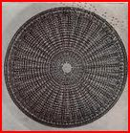
Spitta took his own photographs, like this one: Firth’s keenness as a photomicrographer makes it sure that he took others like it, and Field Club reports mention his correspondence with publications such as the Photographic News and the British Journal of Photography, as well as prominence in the Ulster Amateur Photographic Association.
A deep niche
Despite wider interests, Firth concentrated on diatoms. Sales faced competition from others like Cottam, and major commercial firms like Clarke & Page: compared to big population centres like London or Birmingham, Belfast was hardly at the epicentre of microscopical commerce. This was offset by demand resting on Firth’s high reputation, witness Spitta seeking him out: moreover he had a network of acquaintances Like Thomson and Wright, well placed in the establishment, to recommend him. The sale via Baker has been noted: slides were also retailed in Glasgow, as in the example below.
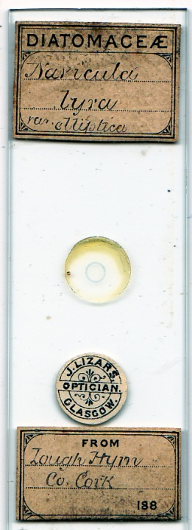
The Lizars family had major optical shops in Glasgow and Belfast, and there were centuries of connections between Ulster and Scotland, from the time when one kingdom spanned the sea between them, and before: sales in Glasgow are not surprising. Firth’s situation had its advantages too: Dog’s Bay and Toome Bridge were favourite sources of foraminifera and diatoms, respectively. For many, personal gathering involved a sea voyage: for Firth, it was locally accessible.
The diatom market was specialised, but extensive. Diatoms were more keenly sought by collectors than most other material. Their study could border on obsession: examples below illustrate the zeal of diatomania.
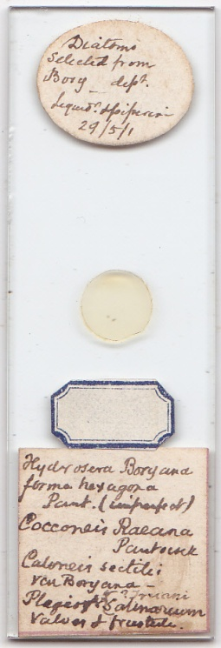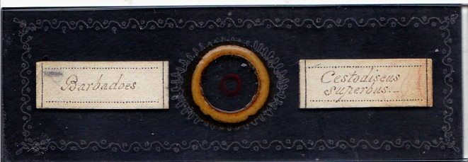
On the left, labels with meticulous details of a strew: on the right, exuberant inscribed decoration embellishing a prized specimen of Cestodiscus superbus from Barbados (neither mounter has been identified)
With potential clients like these, and a huge number of diatom forms available, Firth, with a reputation for excellence, a repertoire of rare forms and the ability to make attractive arrangements, would have had no difficulty in selling. He may have chosen a niche market, but it was a pretty deep niche. At home, Firth was long recognised as an authority on diatoms, witness his definitive paper to the Field Club on their morphology, and mounting methods.
Specimens from far and wide
Diatoms from all over the world made it on to Firth’s mounts.
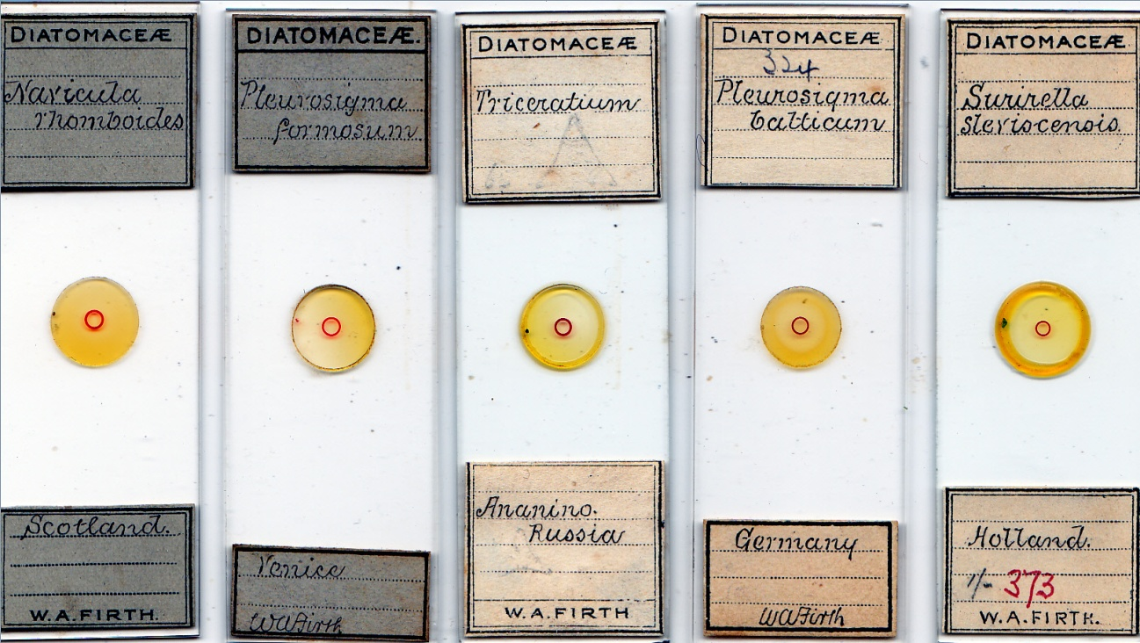
Scotland, Italy, Russia, Germany and Holland feature on the slides above: with the exception of Scotland, which he may well have visited, these European countries are unlikely to have contained material obtained by Firth in person. Even less likely in this respect are locations in North, Central and South America, or the Caribbean, as on the mounts below.
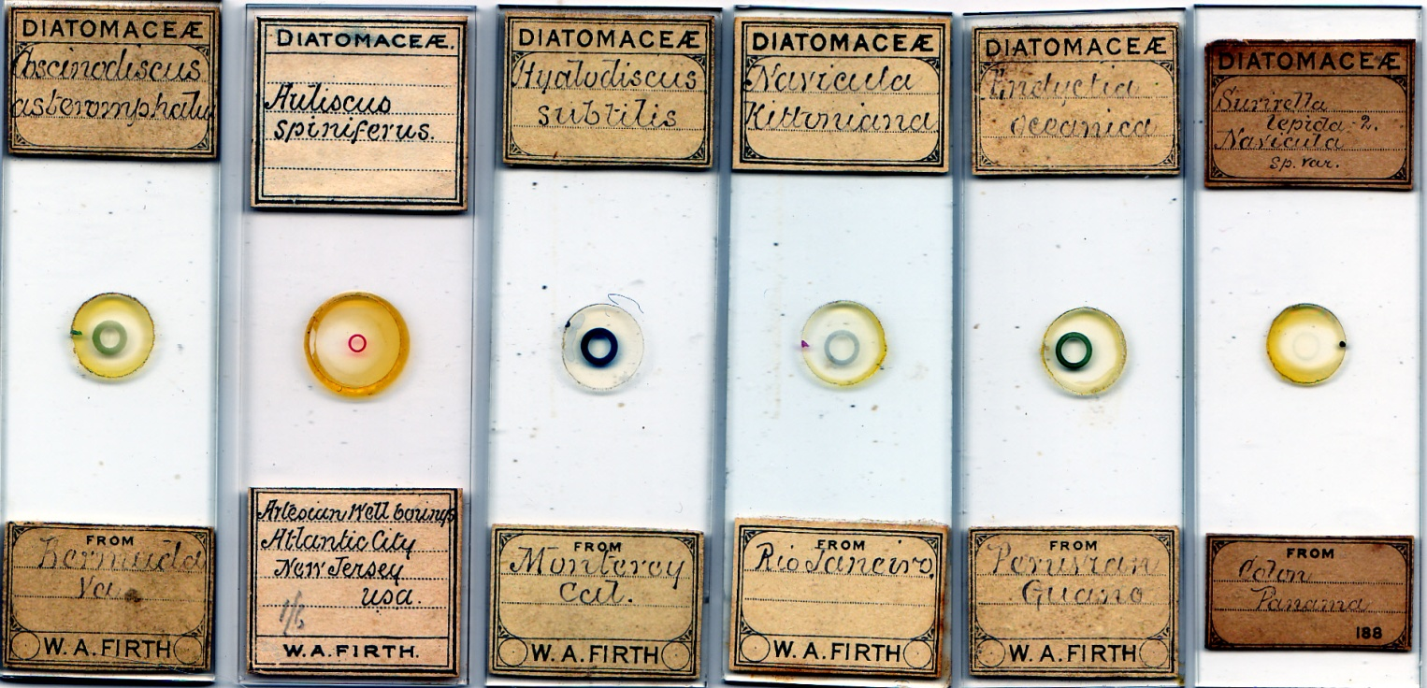
Africa, Australasia, the Indian sub-continent and the Pacific can probably be ruled out.
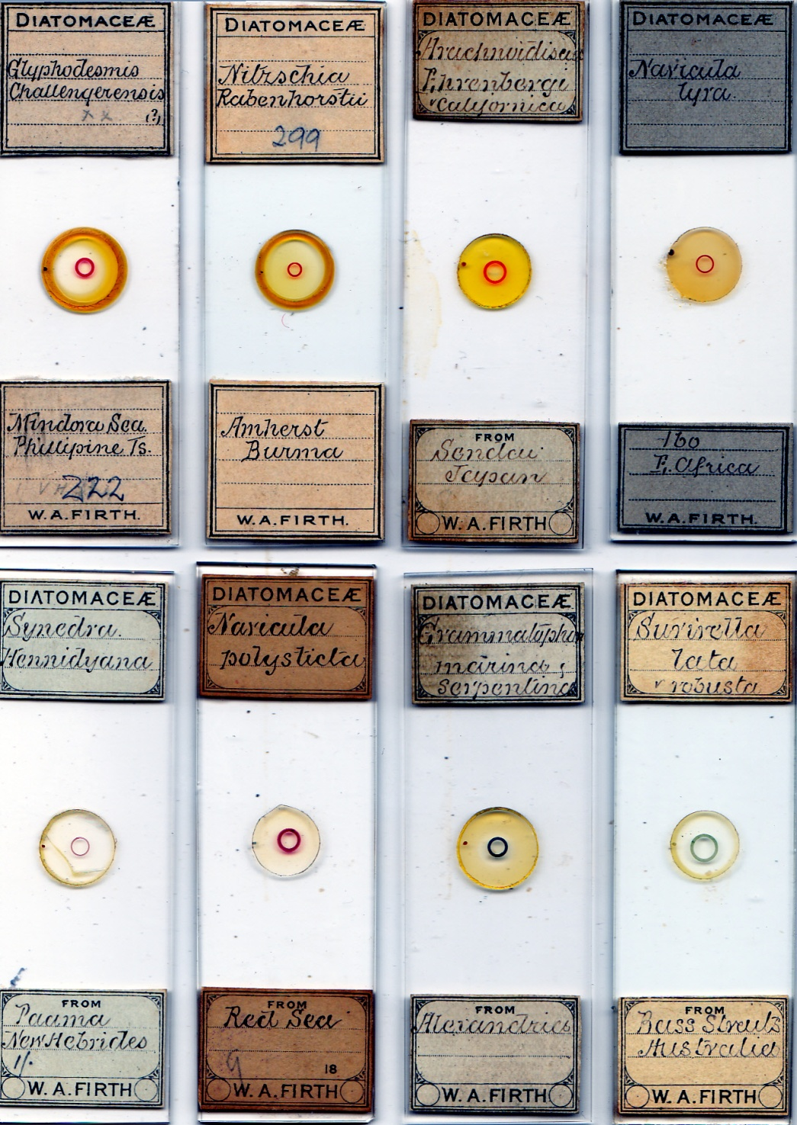
All locations above are implausible as locations visited by Firth.
The Field Club exchanged information with half a dozen sister societies in Liverpool: supplies of exotic material were brought back by the many sea captains who belonged to some of these as associate members, notably James Perry, known as a supplier of Brazilian insects: Firth may have obtained some of his Brazilian material in this way, and there was a fast weeknight steamer service between Belfast and Liverpool. There was no need however to go further than his own city for supplies – shipping from Belfast reached all parts of the globe, and seafaring was a strong Ulster tradition. Islandmagee, the peninsula at the northern end of Belfast Lough, was a favoured area for Club excursions, and it was the inhabitants’ boast that every household there included a master mariner – hence the nickname “the gold braid island”. An islet offshore was home to many seabird species, and a plentiful source of guano, with its diatoms.
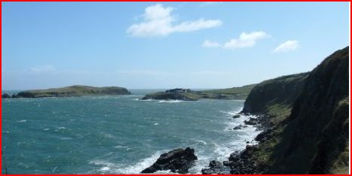
Muck Island, off Portmuck, in Islandmagee: aptly named, given the guano
Twenty or so kindred societies in the USA were also regular Club correspondents, so it is no surprise that Firth mounted many American diatoms, nor that these were mostly from coastal sites.
Irish material
With local material, Firth had few if any rivals as a diatomist.
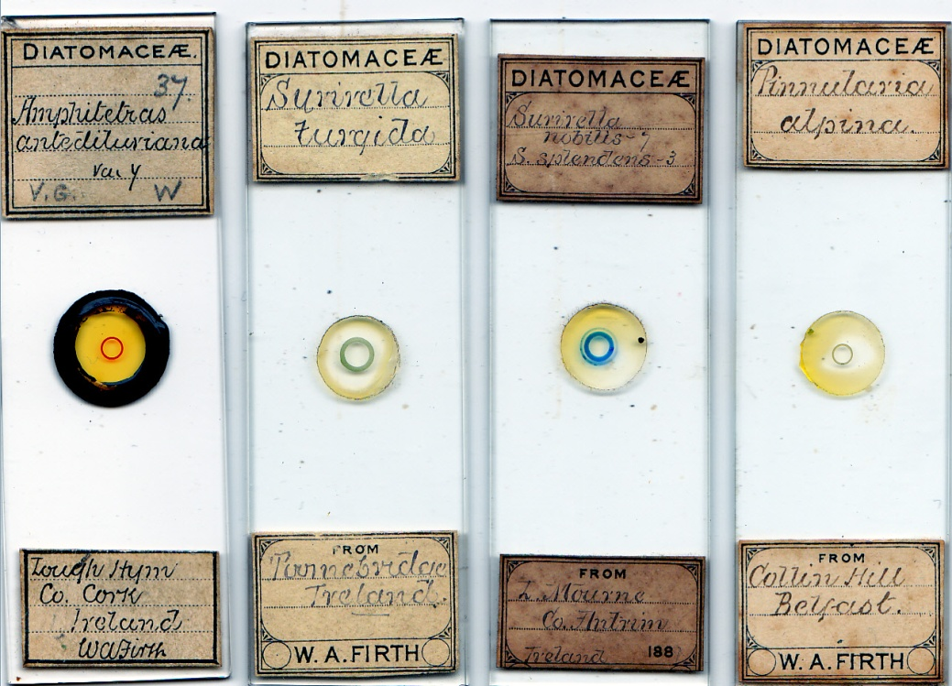
Of locations on the slide labels above, Lough Mourne deserves special mention. I have referred to extensive research done there by Firth and William Swanston, presented to the Club in April 1887.
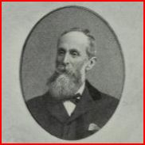
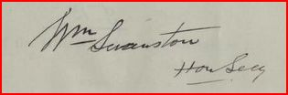
Portrait and signature of William Swanston, Club President 1892-4 and Firth’s collaborator
Firth referred en passant to “a Liverpool gentleman” (unnamed, but probably from one of the Liverpool societies) who commented on the dearth of species previously found in Lough Mourne. Firth and Swanston documented abundant flora there: this and other investigations marked Firth as the mounter of choice for those seeking Irish diatom mounts, be they academic professionals or amateur enthusiasts.
Many prehistoric artefacts were uncovered at Lough Mourne, inland from Carrickfergus, and were researched by Club members, during excavation by the Belfast Water Commissioners: inter alia a large body of diatomaceous deposits was exposed, yielding rich material for Firth and Swanston. The hills around Belfast, like Collin Hill, and nearby sites like Lough Mourne, provided pleasant environmental contrasts to work, for a linen bleacher pursuing other interests.
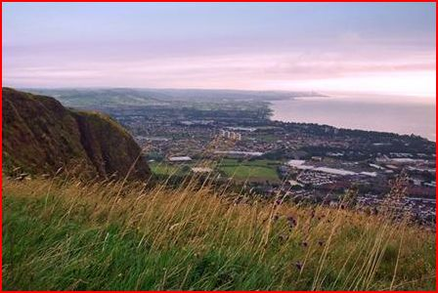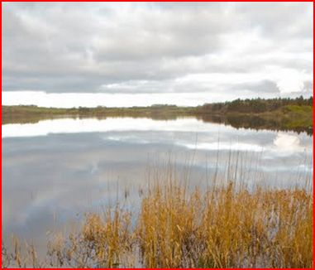
Some of Firth’s local collecting areas: left, the view north over Belfast Lough from Cavehill, Belfast (Collin Hill was nearby) and right, Lough Mourne, distantly visible from just around the corner of the rock outcrop.
Other series
I have illustrated a Firth spicule mount, and another is shown below.
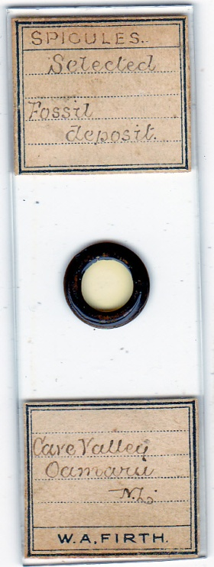
Nor, as above, did he ignore fossils, as again in the examples below.
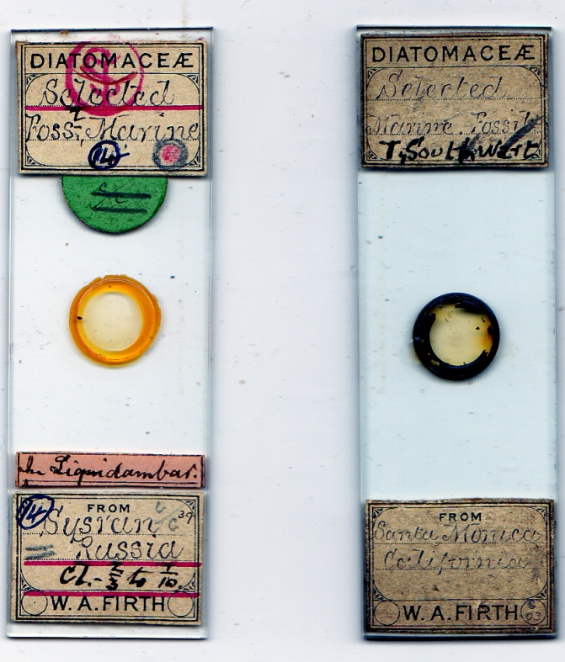
Microscopical marine life interested him in all its forms, and probably a great deal of mounting was done of foraminifera and sponges, for instance: and as evidenced by Field Club records, he made a series of wood mounts. Further research may reveal yet more talents.
Sombre last days
Firth’s name vanishes from the Belfast Club’s committee after the 1891-2 season, and along with his father’s, even from its membership list from 1899 onwards. Joseph Firth died in 1900 and was buried in Belfast City Cemetery on 2 July of that year: William was buried there on 28 July 1923. Records after the 1911 census have yielded some further relevant evidence: his last place of residence was at 87 University Street, attaching yet another address to the peripatetic mounter. He probably moved there after his eldest son’s death, in 1919, at their Ravenhill Road address.
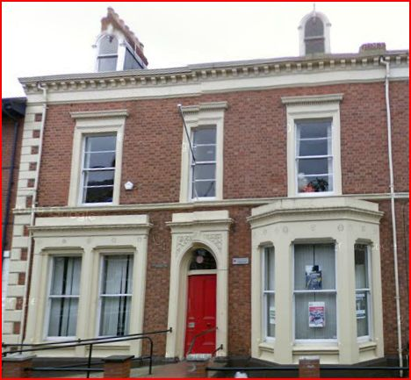
The substantial house at 87 University Street, now a backpackers’ hostel, still exists today.
Probably his job in the linen industry occupied an increasing amount of his time, in a more senior position, after and possibly before his father’s death, leaving less opportunity for mounting. I do not know whether, like Suter, his eyesight deteriorated with advancing years, and if it did, that would have hampered the exacting task of manipulating tiny specimens under the microscope. His grave, and his son’s, lie untended and overgrown in Belfast City Cemetery.
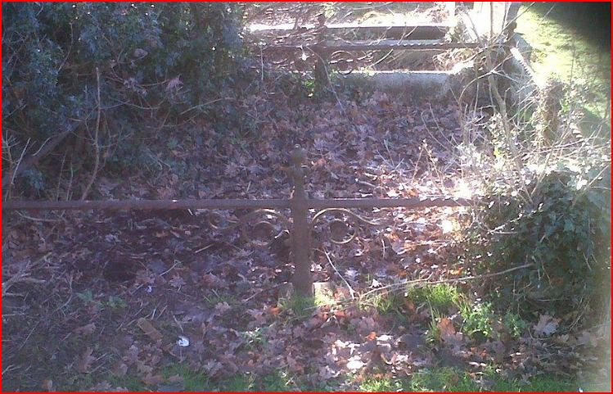
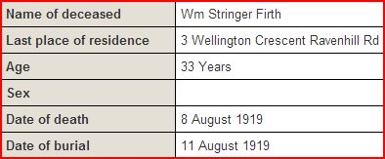
Sadness in old age: death record of W.A. Firth’s eldest son
His eldest son, William Stringer Firth, lies buried in the same plot: he predeceased his father, in August 1919. I have found no trace of William junior in military casualty records: the 1919 influenza epidemic may have killed him, although by August the “Spanish ‘flu” was past its peak in Ireland. Ceteris paribus, the likeliest alternative cause of death was tuberculosis – but that is speculation. If William junior was exposed to flax dust through his work, byssinosis is another possibility, and would render a sufferer more susceptible to tuberculosis (or, for that matter, influenza.)
Remarkably (many might say shamefully) the Field Club published no W.A. Firth obituary, nor even a listing among deceased members. But there was at least one lasting memorial: for the generation which followed him, he mentored a leading diatomist - J.A. Long.
Communicating his local diatom findings to the Spen Valley literary and Scientific Society in December 1909, Long concluded his letter thus:
“The naming of the various species, especially considering that many are extremely small, has been a very difficult matter...........A mounted specimen of every diatom.....has therefore been submitted for examination to Mr. W.A. Firth, of Belfast, and to him my best thanks are due for his cordial and invaluable advice.’
If he visited family connections in Yorkshire, or made business trips there, Firth may have met Long, who had strong family links with the textile trades. (For extensive information on Long, see David Walker’s article in Micscape, December 2011.)
Envoi
Much of this article breaks unfamiliar ground, particularly for English readers - but leaves gaps in the story. I hesitated to write, assuming such a well known mounter was already extensively documented, and was surprised to find this was not the case. There must be evidence in Belfast to enlarge on what I have done, and perhaps Firth treasures can be found, long ignored, in dusty cupboards there. I hope I stimulate someone to follow up the story, refuting conjectures where they prove to be wrong, and filling the gaps where they are widest.
If one compares Firth to a previous renowned diatomist from Ireland, one obvious choice is William Smith, who died within four years of Firth’s birth. Ironic then that Smith did much of his work outside Ireland, and that Firth was an English immigrant. Irish history is rich in such paradox; another is that Firth is forgotten by Belfast, and is relatively unrecognised today by microscopists for anything other than diatom mounts. Painter, photographer, mounter of many things: his versatility deserves more.
Acknowledgements
Thanks to Nigel Monaghan for locating Malcomson slides in the National Museum of Ireland, Dublin. (It took a while – preliminary investigation revealed no trace of them in museum records.)
Thanks to Dublin Quaker headquarters for information on the Firths
Thanks to Brian Davidson for identification of Earland’s handwriting, and images of Barbour slides
Thanks to Peter Hodds for the microphotograph image of the Field Club members
Thanks to David Walker for information on J.A. Long
Thanks to John Prineas for microphotography of arranged mounts
Sources
Unless otherwise indicated, all slide illustrations are from my collection.
Records from the Belfast Naturalists’ Field Club and the Belfast Natural History and Philosophical Society are now on line at www.archive.org
www.ancestry.com
www.quakers-in-ireland.ie
www.census.nationalarchives.ie
www.washingtontimes.com
Information on James Barbour can be found at www.microscopist.net As yet, I have been unable to trace a relationship between James and John Barbour: they may have been cousins.
Brian Bracegirdle: Microscopical Mounts and Mounters, Quekett Microscopical Club, 1998
John Tyndall: Address delivered before the British Association assembled at Belfast (8th thousand) Longmans, Green & Co., London, 1874
E.J. Spitta: Photo-micrography, Scientific Press, 1899

Email author: lois737@bigpond.com
Published in the December 2012 issue of Micscape Magazine.
URL http://www.microscopy-uk.org.uk/mag/artdec12/pp-Firth.docx

