TUFFEN’S ARTISTIC BROTHER, WILLIAM WEST
Peter B. Paisley
Sydney, Australia

For most of his adult life, William West collaborated with his brother Tuffen in illustrating a wide variety of books and journals. He shouldered the burden of printing, but could also make lithographs, probably jointly producing some work ascribed (then and now) solely to Tuffen. He maintained lithography and printing apparatus at 54 Hatton Garden for several years (living there with his family for a time), and was probably more than just the printer of many of Tuffen’s illustrations. Since Tuffen likely used the equipment at Hatton Garden, it is reasonable to think William helped with artistry, for instance in converting some of Tuffen’s wood engravings to lithography. Whatever the case, Tuffen could not have sustained his prolific output without parallel activity by William, who may have started as the junior partner but whose role probably became more than that of a mere “second fiddle”. As time went on, a formal business relationship may have existed, as indicated on illustrations by “West & Co.” – a question raised in my previous Micscape article on the Hatton Garden business, to which I have yet to find the answer. Whatever the case, the partnership soon approached equality, since each depended on the other for results.
Yorkshire beginnings
William was born in Leeds (Yorkshire) on 30th March 1828: the birth was probably at home, although it may have been in the Leeds lying-in hospital (established 1824), where Richard Charlesworth Battye was a surgeon: as seen below, he witnessed William’s birth. (A home birth seems more likely, since the lying-in hospital catered – although not exclusively -for the indigent.)
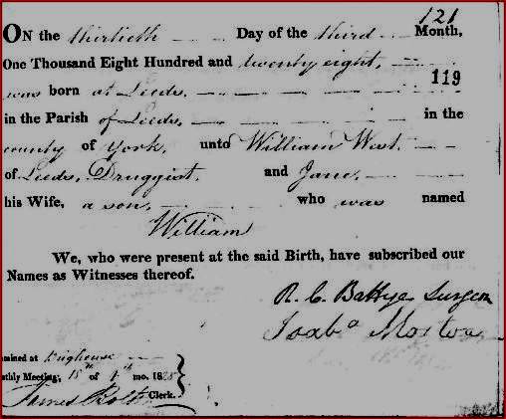
I found nothing further of William’s young life until, like his brother Tuffen before him, he was sent to Bootham School, the Quaker school in York.
William’s early work: art and artistic tuition at Bootham School
Tuffen West’s lithography expertise almost certainly originated with school training: that – so far- lacks evidence, but can be substantiated in William’s case by school records. Bootham School archives show William there from January 1841 until June 1843. During this time, William learned lithography (both in theory and in practice).
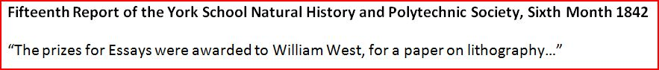
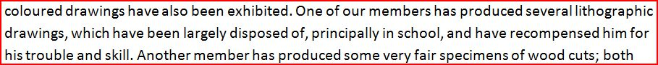
Artistic techniques of all kinds were fostered by highly able masters. For example from 1835 until 1891, Edwin Moore taught there: his Quaker family included several artists, known, like Edwin, for their watercolours.
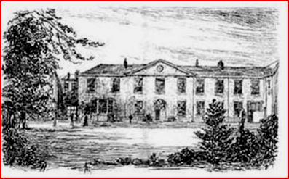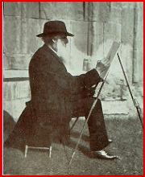
(L) sketch of Bootham School by Edwin Moore (R) the artist at work
Arguably, another art teacher was of greater importance, in view of William’s later work with Tuffen and other artists like G.H. Ford. Till Adam Smith joined the staff as a specialist art master in 1841, and oversaw production of the Natural History and Polytechnic Society Observer, whose first issue’s introduction refers to William West’s essay on lithography. The Polytechnic Society dealt in every kind of scientific and artistic activity, including microscopy.
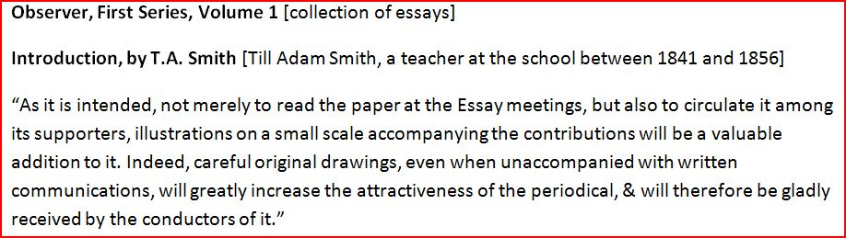
More importantly, Smith introduced illustration to Observer notes on Natural History topics – reinforcing what William West doubtless already knew from his brother Tuffen’s activities.
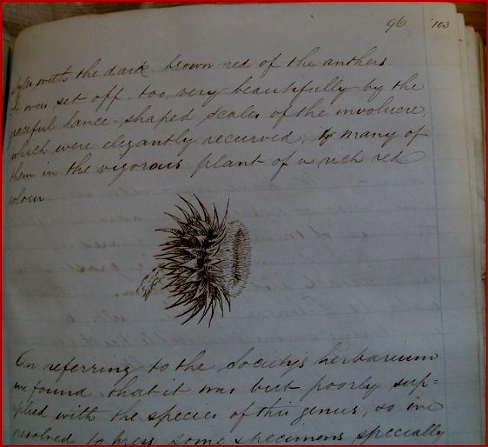
Smith’s hand colouring of the flower has faded; the extract shows a school herbarium was maintained.
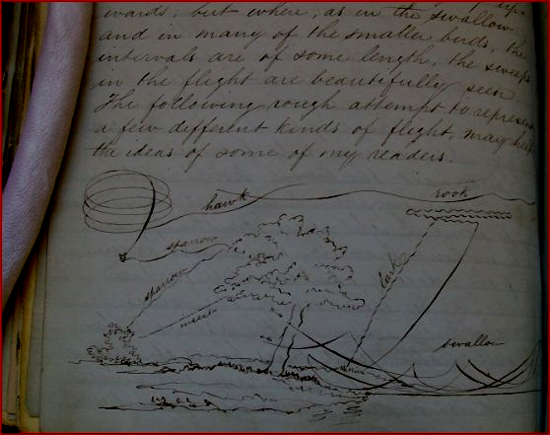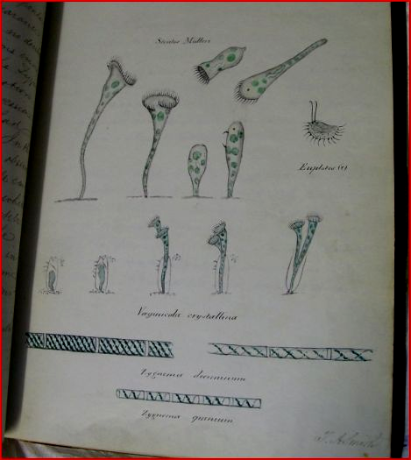
Two more Smith sketches for Observer notes: (L) flight paths of various bird species, (R) botanical illustrations, including microscopical drawing
(All the above Bootham School records have been kindly supplied by Jenny Orwin.)
William’s career choice
The school Natural History and Polytechnic Society, as already mentioned, catered for a wide range of scientific studies from astronomy to wood engraving. As in most schools of the time, microscopes would have been available there for pupils’ use. William doubtless saw the records there of Tuffen’s many schoolboy natural history activities: these do not mention microscopy, but as early as 1845 Tuffen was working on illustrations for Hassall’s The Microscopical Anatomy of the Human Body, the first section of which appeared in 1846, and William probably arrived in London around then. While at school, he must have decided to become a full time lithographer: I found no evidence he had any other adult occupation. The 1851 census (below) shows him as a lodger in Charlotte Rea’s boarding house at 4 Lewis Crescent, Middlesex.
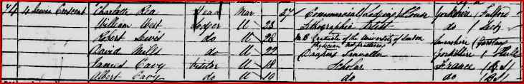
He described himself as a “lithographic artist” rather than simply “lithographer” – perhaps to emphasise that he was not a “mere” artisan, but something more creative. Some time in the 1860s, William visited Yorkshire again, possibly to meet his brother Theodore, who returned from New South Wales in 1862 to work as an engineering draughtsman in Darlington. He probably also visited other family members in Leeds - the platinograph below was made by William Hanson, who was working in Leeds in the 1860s.
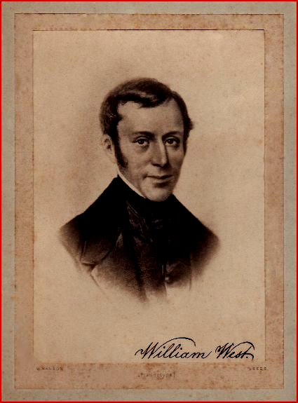
William West’s platinograph, courtesy of Elizabeth Taylor
Hanson’s studio portrait (possibly intended as the basis of a carte de visite) is that of a man of William’s age in the mid 1860s. (This was previously thought to be of William’s father, but he died in 1851, before Hanson was working in Leeds.) William’s London commitments were extensive, and there may have been a more ominous reason for this Leeds visit: we know he spent time in the Fulford Retreat, as, later, did his brother Tuffen in 1871: both brothers’ admissions were probably for depression, and there was a family history of what now would be called bipolar disorder. As I shall show later in this article, this precipitated a tragic end for William.
Iconic illustrations
Translations of Darwin’s Origin could be well illustrated, witness the Danish first edition, as in the example below.
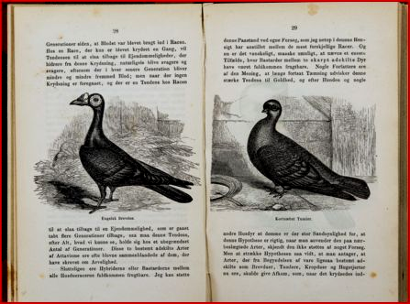
Darwin dealt at some length with variations in domestic and wild pigeons, but the English Murray editions contained no pictures of them.
Darwin’s Animals and Plants under Domestication (1868) appeared in two volumes, the first of which contains many illustrations: two are shown below, and engravings were borrowed from many sources (compare the Danish Origin above).
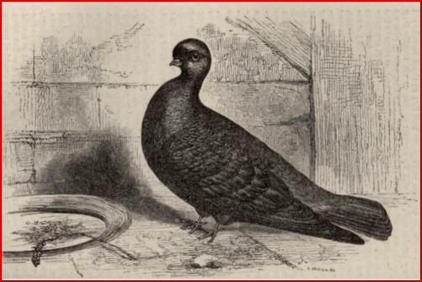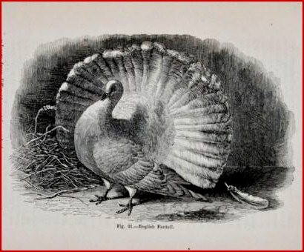
The Origin had been written in some haste due to Darwin’s learning of Wallace’s work – readers will know the “gentlemen’s agreement” resulting in the famous joint presentation to the Linnean Society. Subsequent books – many were expanded versions of chapters in the Origin – contained illustrations, like those above, which amplified his arguments effectively, perhaps particularly for a general readership. Many modern versions of the Origin, perhaps predictably, are decorated throughout, sometimes extravagantly.
Austere by comparison, the first five English editions of the Origin published by Murray contained only one illustration of any kind – a lithograph (below) made by William West.
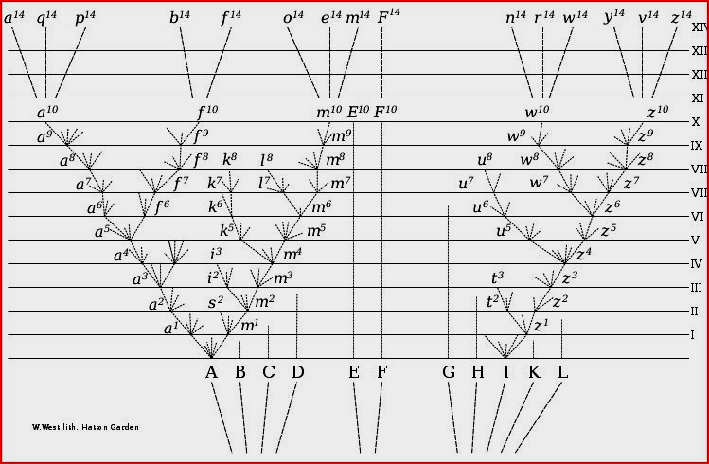
Throughout his published work, Darwin shows a preference for monochrome illustrations. Darwin considered William’s diagram vital for illustration of the concept of evolution of species from common ancestors. He originally wanted a copper engraving, but in the event, William’s lithograph was used. William’s partner, the artist George Henry Ford, provided some illustrations for Darwin’s Descent of man: first published (after William’s death) in 1871, like all Darwin’s work it was several years in the making, borrowing already published illustrations from far and wide. Since William provided the only illustration for the Origin of Species, his close association with Ford may have led to Ford’s contributions to Darwin’s later book.
Ford was a witness to William’s marriage to Barbara Chalmers in 1856 (presumably in deference to his wife’s family, the wedding took place according to Anglican rites - I have been unable to establish whether any parallel Quaker ceremony was observed.)
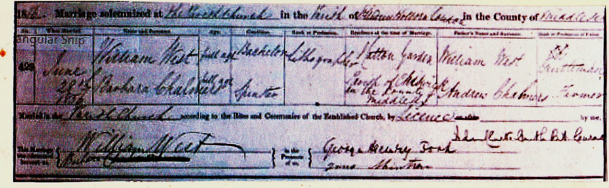
While the formal West/Ford business association lasted only a few years, they probably remained in intermittent contact thereafter.
In 1859 – the same year as the first edition of Darwin’s Origin – T. H. Huxley’s Ray Society monograph on oceanic hydrozoa was published. This work used the big – and doubtless big charging – Basire firm for lithography. Huxley and Darwin were in close communication, and the Churchill firm (like every other publisher) always looked for ways of cutting costs. Probably between the three it was determined that William’s lithography would be as good as any other, at less cost. I find no evidence of metal engraving by Tuffen or William West, although Tuffen made wood engravings, for instance for Thomas Nunneley’s On the Organs of Vision (1858), which were then lithographed and printed by both West brothers. Darwin asked Murray for a fold out plate, copper engraved: as it turned out, he got the former, but not the latter. Probably, he assumed that the Wests made metal engravings, as his letter to Murray implies that he had already nominated William as his illustrator.
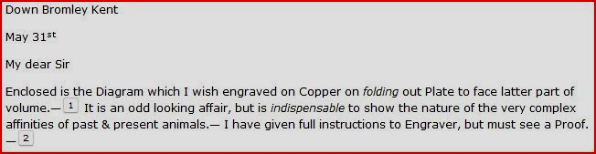
Transcription of Darwin’s letter to Murray, publisher of the “Origin of Species”
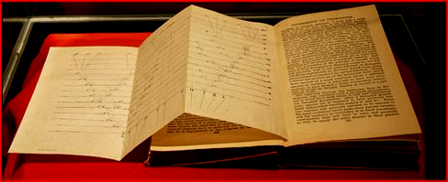
William West’s lithograph, as it finally appeared
I suspect few people nowadays (including microscopy enthusiasts) know that William West was the sole illustrator of the most important book published in the nineteenth century. Most “Google image” reproductions of William’s plate truncate it, obliterating the ascription at bottom left. Obtusely, Wikipedia uses the truncated version.
William was keenly interested in microscopy – not surprisingly, since it was one of the things encouraged at Bootham School, and Tuffen had published profuse microscopical illustration by the time William came to London. Records show that William joined the Quekett Microscopical Club within six months of its first meeting, some years before the publication of the first volume of its journal. (Surprisingly, Tuffen never became a member.)
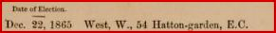
The surgeon B.T. Lowne read a short paper at the club’s meeting on November 27 1868, based to a large extent on C.M. Topping’s mounts of blow fly probosces, developed in the 1830s and long since regarded as a triumph of mounting technique. Topping’s method, followed by many other preparers, had become an icon of microscopy.
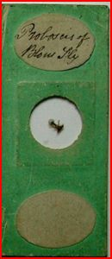
An early example of Topping’s blow fly mounts: the slide is smaller than standard size, and presumably dates from the 1830s, since Topping adopted the now standard 3x1 inch size by 1840. Image courtesy of Howard Lynk.
Lowne’s paper prompted William West’s printing of the first illustration in the first issue of the Quekett Society journal.
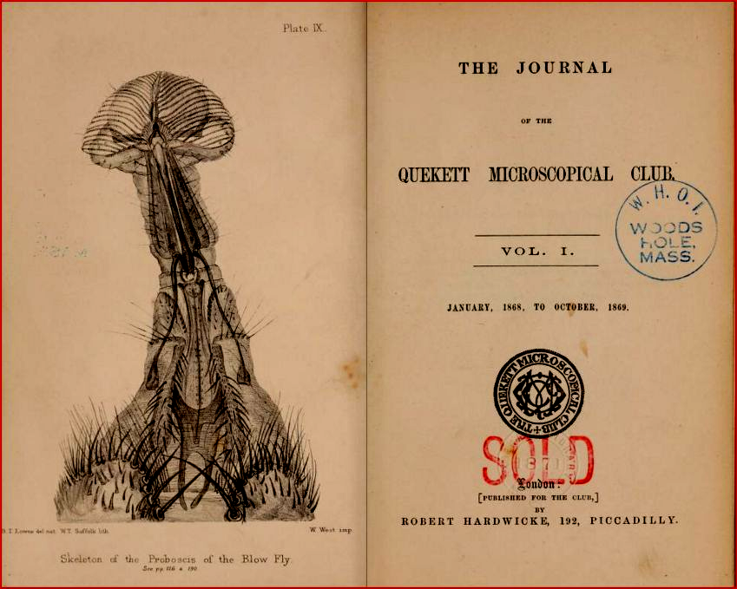
Pride of place! William West’s printing of the blow fly image could hardly have featured more prominently.
This example (like the lithograph in the fifth edition of Darwin’s Origin) is poignant, given that William died under tragic circumstances less than two years after Lowne read his paper. Stock in hand must have awaited review for publication, and as I pointed out in a previous Micscape article, illustrations crediting William West as the printer continued to appear after his death, notably in the journal Popular Science Review, which Tuffen West edited for a time.
Posthumous publication
Accumulated prints, awaiting review by authors or in a queue for publication, and some lithographic stone, presumably remained at 54 Hatton Garden after William’s sudden death in 1870. That accounts for some illustrations appearing after 1870, but not all: which poses a conundrum. Various explanations are possible, but some must remain speculative.
The sixth edition of the Origin first appeared in 1872, two years after William’s death, still featuring his lithograph. Various small corrections and additions were made, until the sixth edition, over the years: my own copy (excuse the foxing!) appeared in 1895 and has the identical illustration, but now with printing specified as “West, Newman & Co imp.” The West here was not Tuffen, but probably there was some family relationship, and Newman was a Quaker.
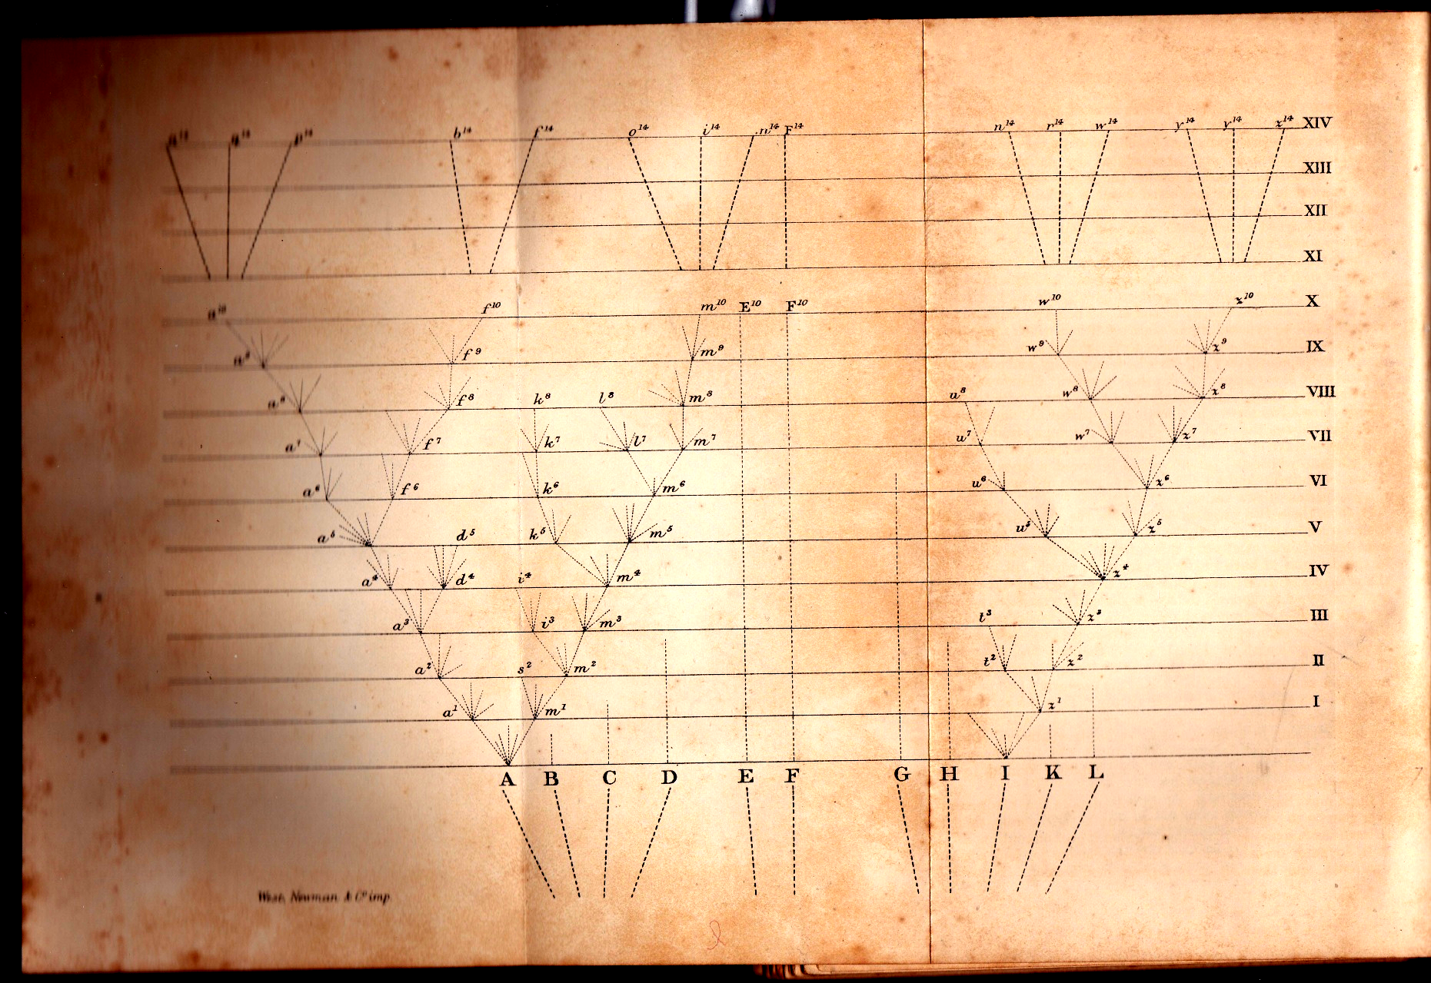
West and Newman occupied 54 Hatton Garden for several years, and a firm under that name remained based there until well into the twentieth century. (I have been unable to establish exactly when they moved in.) The publishers of Popular Science Review may have assumed that the West printer in question was William, hence accredited him with “W. West imp.” at bottom right of various plates. That might account for his name appearing on illustration of material from the Challenger expedition, which did not set sail until some four years after William’s death.
The Wests: a family beset by tragedy
As mentioned above, bipolar disorder assailed William and at least two of his relatives – Tuffen, and an as yet unidentified uncle. This did not end well for William, who tragically died in 1870 in Bethlem Hospital (“Bedlam”).
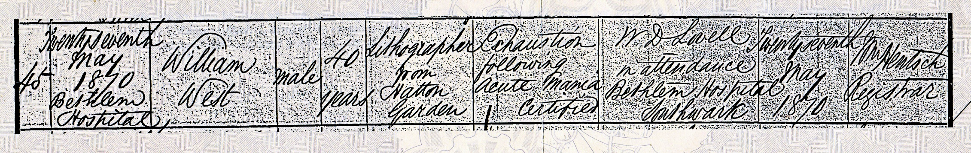
The West family was afflicted by much more than bipolar disorder, and I shall deal with the details at length in a forthcoming Micscape article. For now, suffice it to say that William’s premature death interrupted what was arguably the most productive mid nineteenth century partnership in scientific illustration, particularly in the many fields dependent on microscopy for advancement. Tuffen continued to make illustrations after William’s death, but he was never again so prolific.
Acknowledgements
As always, Jenny Orwin of the Bootham School has provided valuable material.
Thanks to Elizabeth Taylor for the image of the platinograph of William West
Thanks to Michael Pritchard of the Royal Photographic Society for information on William Walton
Thanks to Howard Lynk for the Topping blow fly mount image: for this, and other early Topping
mounts, see his www.victorianmicroscopeslides.com website.
Sources
www.ancestry.com
Quaker birth records, accessed via www.ancestry.com
Wikipedia
Google Books
Google Images
www.darwinproject.ac.uk
Note: this article is designed to be read in web page format.

Contact author at: lois737 AT bigpond DOT com
(Anti-spam format, replace capitals with appropriate character and remove spacing.)
Published in the February 2017 issue of Micscape Magazine.
www.micscape.org

