Smart Phone and a Microscope
by Bill Resch, USA

Recently I was wondering if my smart phone could take decent pictures through a microscope. I started out by just holding it against the eye piece. This was very hard to do, because it had to be perfectly centered and also had to be held an exact distance from the eye piece. Yet, my first tries looked promising, so I thought that with the help of a simple device it could be done. This was very desirable to me, because I like to take a microscope with me on my camping trips and since I always carry a phone, I would have a camera to take photomicrographs.

I started out with a flat piece of plastic and a sleeve, made of plastic, which fits snugly around the eye piece.

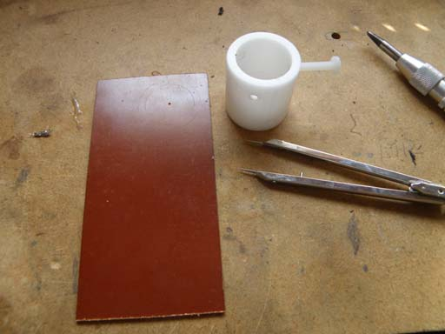
I drilled a ¼ inch hole for the phone camera lens and bolted the sleeve to the plate, centered around this hole. Then, along the left side and bottom, I bolted some plastic strips. Into these strips, I inserted plastic screws, which will allow me to get the phone precisely centered.

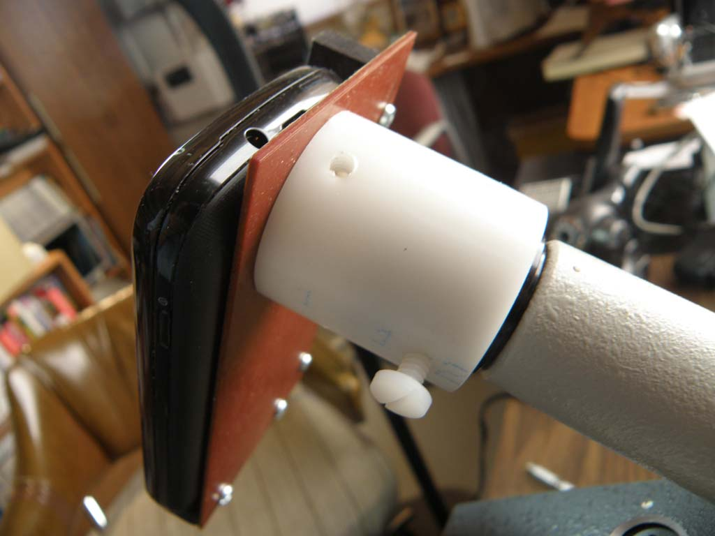
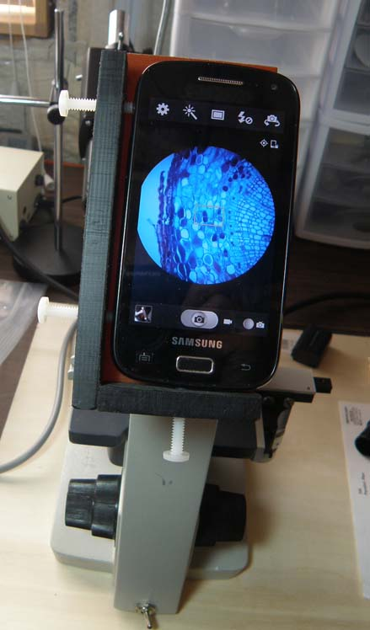

As can be seen, there is vignetting, but this can be alleviated by zooming in. So far all the smart phones I have seen, allow zooming.

The images taken with my phone do not seem to have the same level of resolution as I get by looking through the microscope myself, but it's close enough for field trips etc. Since the microscope and the phone are battery powered, this makes it very portable. Also, the large image on the phone makes focusing easy. To take a picture, it just takes a light touch on the phone's screen. There is no vibration or jarring to mess up the image.

I made an interesting observation by also posting some of this on my Facebook page. I posted many microscope related images before and never got any response, but when I posted this, I got many positive responses. I guess people can relate to smart phones more than microscopes.

On this battery powered IO microscope, I removed the binocular body to make it lighter. I also removed the oil immersion lens and replaced it with the 20X. If its not easy to use, I wont use it. All this helps....

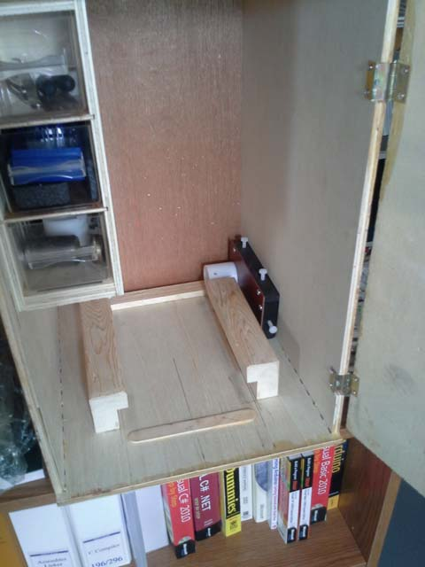
My modified microscope case with phone holder. I call it the microscope smart phone interface.

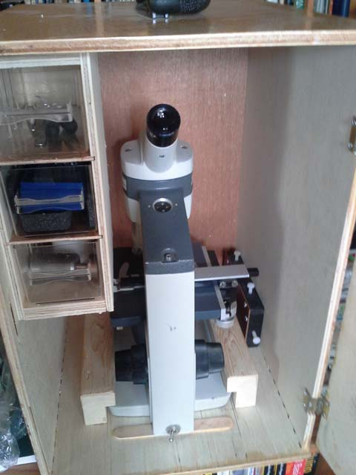
Some images taken with my not so expensive Samsung smart phone:

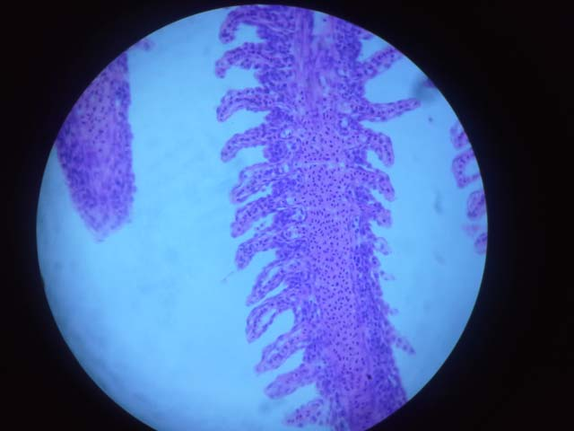
Fish Gill
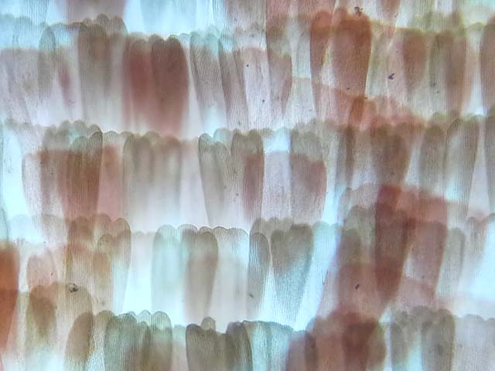
Viceroy butterfly wing

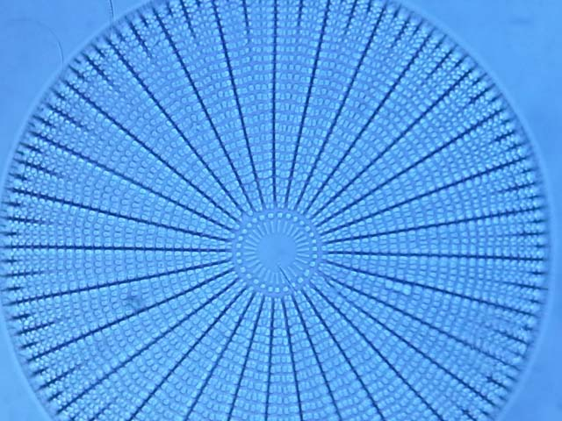
Diatom

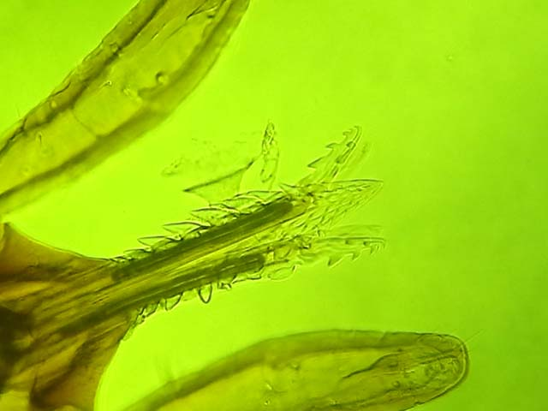
I removed this deer tick from my wife's leg

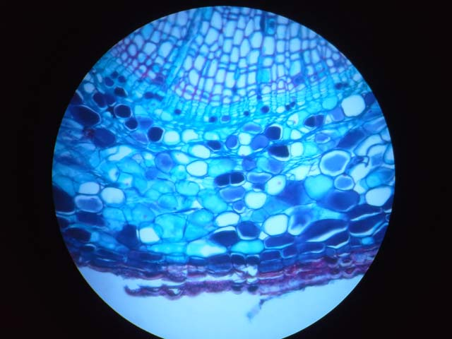
Pine root

None of these images have been photo shopped, except for resizing to fit the pages.

Bill Resch
Saint Michael MN.
USA
wresch@embarqmail.com

Published in the November 2014 issue of Micscape Magazine
www.micscape.org

