REMARKS ON HENRY WEBB’S OUTPUT
Peter B. Paisley
Sydney, Australia

Henry Webb’s surviving mounts seem much fewer than those by others. Some factors partially explain the scarcity: but, probably more survive than is generally supposed, and there seems evidence for a larger view of Webb’s output than is usually held. I also pose problems to which I offer no clear solutions: readers may find material to throw light on them.
Webb’s career
William Barwell Turner knew Webb well, and admired his work. In his book on Indian freshwater algae, he says
I have desmids and algae mounted by him, in camphor-water, still sound and perfect, although the slides
were prepared 40 years ago!
One of Webb’s algae from Turner’s cabinet appears below. The labels are Turner’s (he may have papered the original slide).
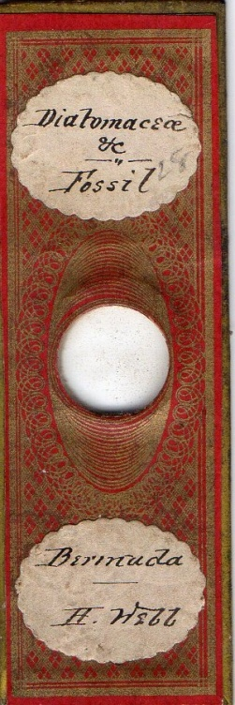
Hair from various species commonly interested 19th century microscopists, and Turner mounted several: two examples are shown below.
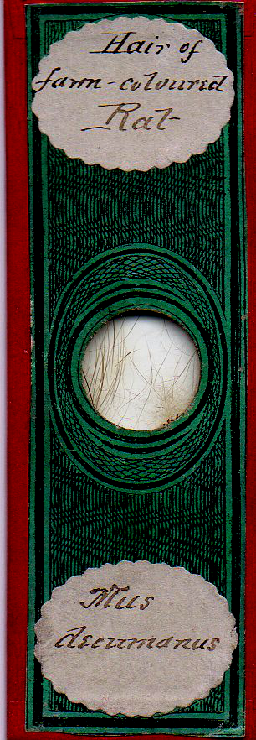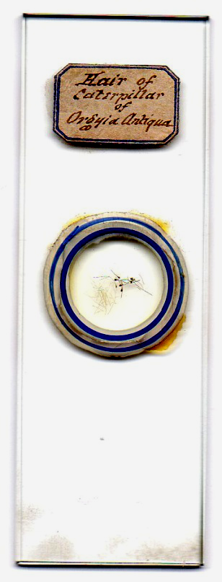
Other slides from Turner’s cabinet are also of hair, but not mounted by him. Of those shown below, one is by Webb (and labelled as such by Turner) and while I cannot prove it, I think the others are, too.
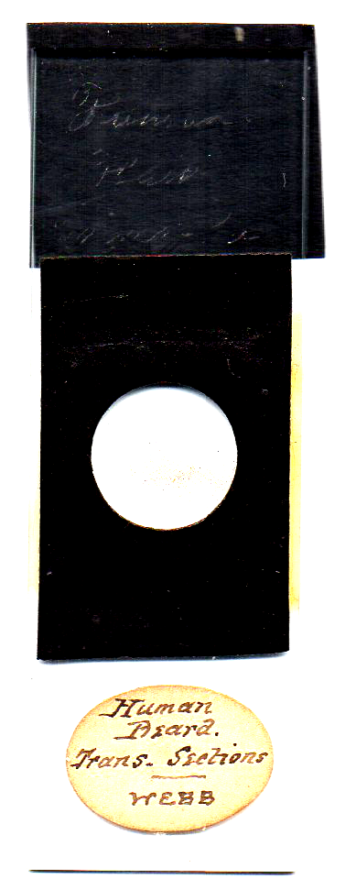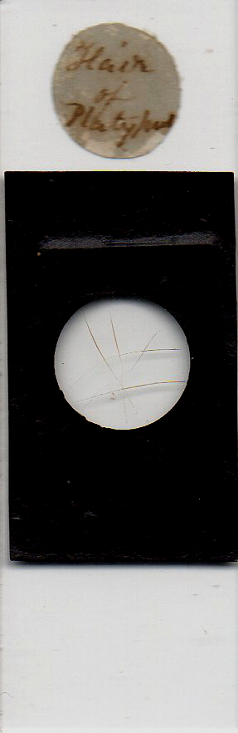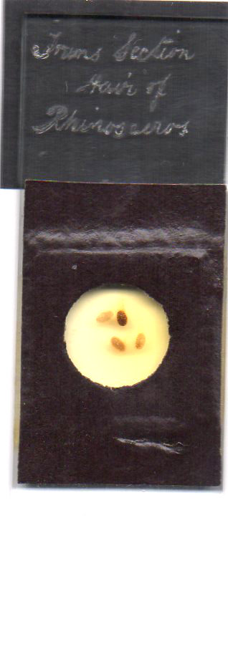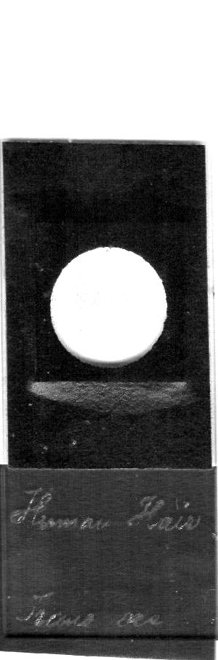
Slides with plain black paper like this were passé by the 1860s, when the style had largely fallen out of favour. Presumably therefore any such by Webb pre-date his papered slides.
Turner’s book was published in 1892: it specifies Webb mounts from 40 years previously, indicating a career under way by around 1850. The expertise did not spring from nowhere, and implies mounting by the middle 1840s. Turner adjudged Webb easily the leading mounter (facile princeps) of his day: his reputation generally stood high - in 1865, the year before Webb’s death, Lionel Beale included him in a list of recommended mounters including Norman, Topping, Hett and Barnett. (The fact that Beale recommended Webb implies not only quality, but at least a certain quantity of supply.)
As a brewer, Turner was concerned with the quality of various grains, and their diseases. It is no surprise that a Webb mount of puccinia wheat blight (below) was in his cabinet.
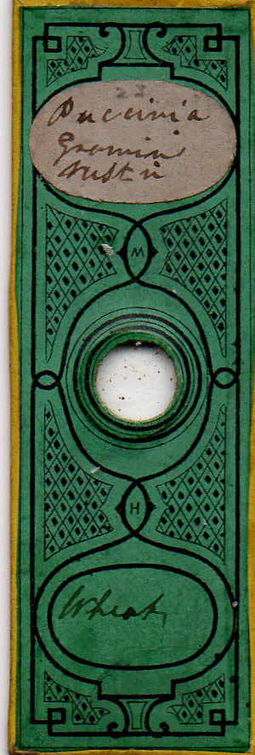
Webb’s work before he began papering probably largely escapes notice: I think his career spanned twenty years or more - although not until the decade 1851-61 did it become his principal occupation as declared in census records.
Deep-cell mounts
Webb’s deep-cell mounts are vulnerable; for instance, temperature change can part the cell from its slide. Cell fluid, depending on chemistry, may slowly mix with the cell itself, making tissues unintelligible to microscopy – something also perhaps enhanced by temperature change. The mount below came from the cabinet of William Barwell Turner, and both kinds of damage occurred. In Sydney’s summer heat the cell came adrift – happily without leaking before I re-secured it with glue. Over a century ago, judging by Turner’s incomplete upper label, it may have been problematical to identify the tissue. The deep-cell material seems quite soft. I suspect it may be a mixture of asphalt with paraffin wax or beeswax, or it may be gutta percha: all those materials were used for making cells in Webb’s day, but given the history of the mount I am disinclined to attempt sampling its material for analysis.
Careless handling of deep-cells can damage them irreparably, causing them to be discarded (far more likely than with flat mounts.) In short, the very nature of some Webb mounts promotes their current scarcity.
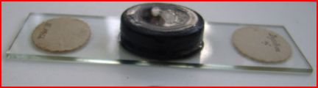
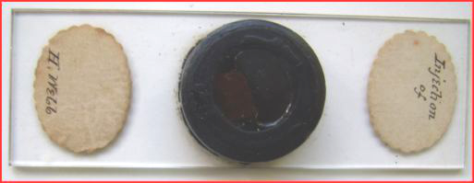

Unidentified injected tissue mounted by Henry Webb: the cell is 8mm. deep. The label handwriting is Turner’s.
More Webb deep-cell mounts are shown below: these, while comparatively shallow, are still 4mm. deep. Whether the cell of frog eggs ever contained fluid I cannot tell.
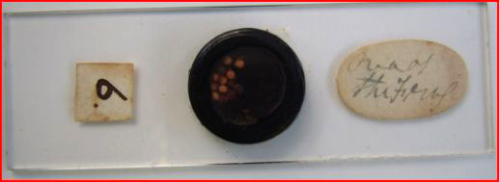
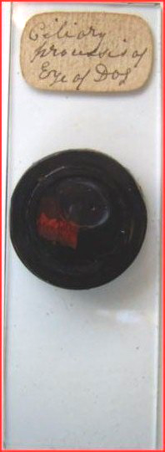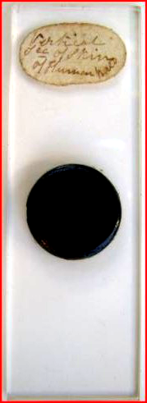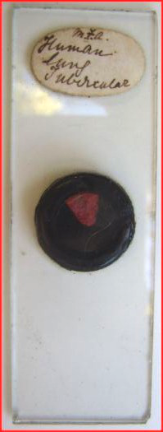
Webb deep-cell preparations. The initials “m.f.a.” on the tubercular slide may be those of the victim.
If a significant proportion of Webb’s output was deep-cell, it is not surprising that little in that category survives today. For comparison, consider the Normans’ output, which, overall, survives in profusion – but one seldom finds deep-cell examples, although presumably they once existed in appreciable numbers: the same is true of Topping.
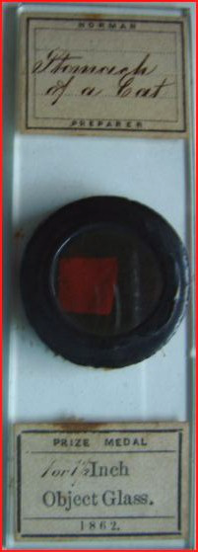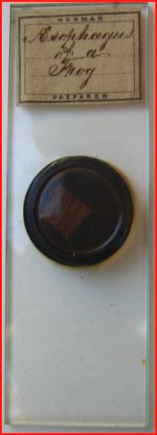
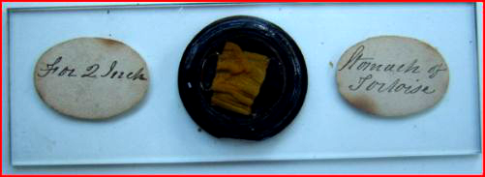
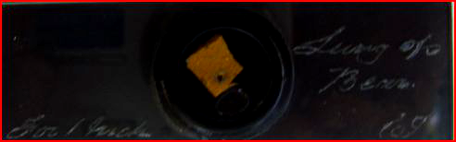
Some deep-cell mounts – two each by Norman and Topping. Like those of Webb, few survive today, compared to other mount formats.
(There is an inventory of Turner’s slides in the Leeds University library, which may reveal the original existence of much more Webb deep-cell material. The library price for scans of these monochrome pages exceeds my business class return airfare, and has doubtless increased since I first inquired. Millionaire academics and students, presumably prolific in Leeds, could check the pages out.)
Two more deep-cell mounts are shown below: while I am not completely sure, I think they are by Webb.
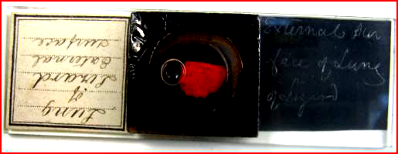
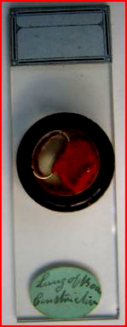
An owner has added a label to the lizard slide, but its inscribed writing may be Webb’s.
Since none of these deep-cell mounts are dated, it is impossible to guess when they were made; but I think Webb probably continued to make such mounts throughout his career.
A solo exhibitor
Meetings of societies often feature trade exhibits, usually by several rival companies. It is uncommon to find “unopposed” exhibits, including those by mounters. But in August 1856, at the Provincial Medical and Surgical Association’s meeting in Birmingham, a soirée featured three microscope exhibitors (Smith & Beck, Field and Parkes) but only one mounter – Henry Webb. Members were impressed:
Mr. Henry Webb of Birmingham, who is a most able microscopic injector, exhibited some beautiful preparations.
Deep-cell mounts and injected specimens, while not specified, were probably among the exhibits. The fact that Webb was the only exhibitor is significant: 211 members from all over Britain attended, so doubtless Webb’s mounts made a strong impression, conveyed by word of mouth to many others after the meeting ended.
Beginnings
I cannot identify Webb in the 1841 census: he was born in Bristol about 1816. Interestingly, another Henry Webb born then and still living in 1841 in Gloucestershire – in Winterbourne – was a butcher, as was his elder brother Joseph. If our Henry was a relative of this family, he may have had an early interest in things anatomical - and microscopy was rapidly becoming the new anatomy. How long Webb remained in or near Bristol I do not know: there were natural history and microscopical societies thriving there and in nearby Bath, and the Bristol medical school (one of the oldest in the country) like others was beginning to embrace the new knowledge, so Webb may have seen microscopical material in his youth, at school or via local clubs or natural history societies.
The 1851 census shows him in Edgbaston, Warwickshire, working as a gardener: while already a skilled mounter (as Turner attests), gardening seems to have been his major occupation - but by the 1861 census he was described as a “microscopist”. How far back can we see him as such?
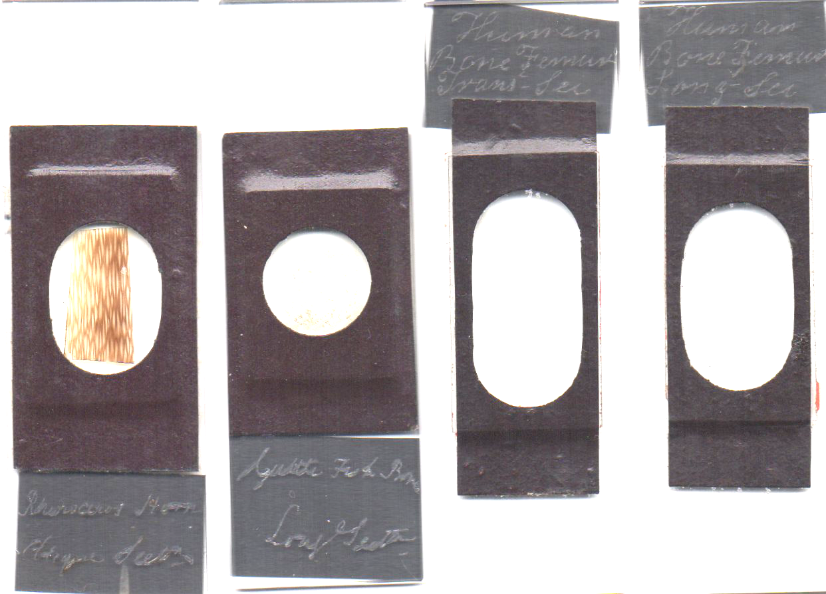
These four slides may well be by Webb: all came from Turner’s cabinet. The two human femur bone sections (R) have “Pritchard type” red sealing wax surrounding the specimens.
Assuming the mounts with sealing wax are the earlier – as seems reasonable – it’s interesting that the two on the left, above, have less neat handwriting than the two on the right, suggesting that Webb suffered intermittent problems with his vision from early in his career.
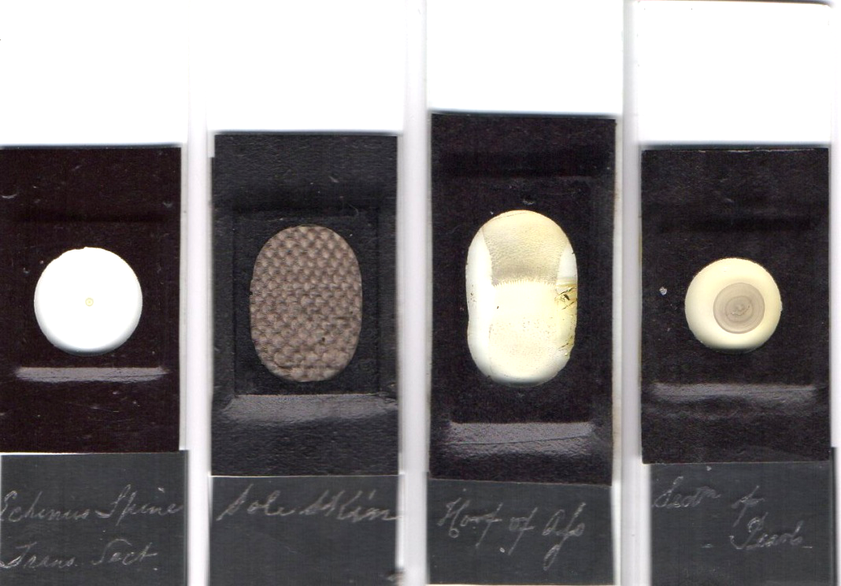
More mounts like the four above (not, this time, from Turner’s cabinet): again, the inscribed writing may well be Webb’s.
The eight slides above include sections of pearl, rhinoceros horn, human femur and cuttlefish bone: all fairly difficult materials to mount. Many yet unidentified mounters made such black papered slides: one hair example from Turner’s cabinet – already illustrated – is Webb’s work, and he probably mounted more like it. By 1860, papers of every conceivable pattern were becoming available: plain black was passé, and besides, full papering saved time – and money – on glass edge finishing.
Webb’s late papered mounts show skill with hard material, and it is logical to assume that he developed the necessary expertise much earlier, reinforcing the possibility that the black papered slides above are by him.
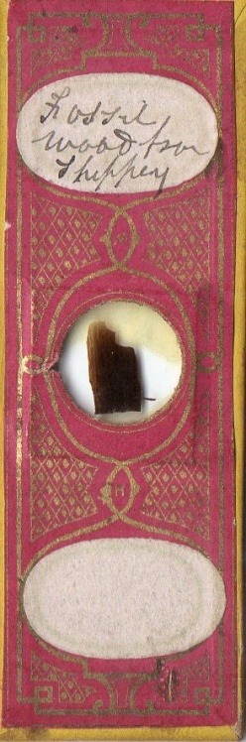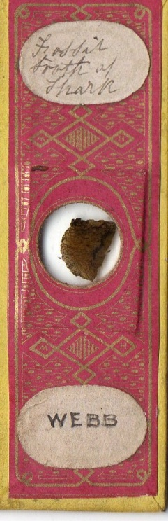
Fossil wood from the Isle of Sheppey, and a fossil shark tooth (the latter, yet again, from Turner’s cabinet)
The slides below have Pritchard style red sealing wax, largely concealed by black paper, but visible at the edges. Their inscribed handwriting is very similar to that on slides already shown. All three have owner’s labels, and I have removed one to show the diamond inscription: the other two bear the same inscribed handwriting beneath their paper labels.
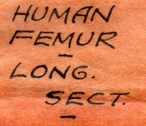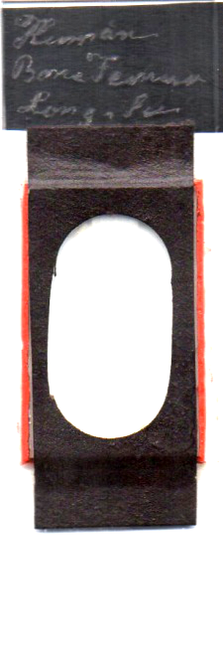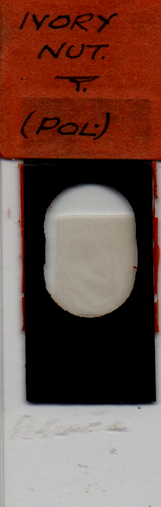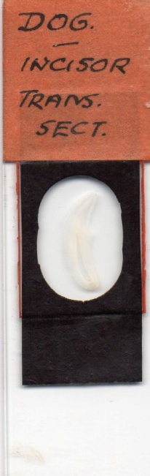
Webb’s handwriting may be suspected by its very irregularity. The examples above have variably neatly inscribed writing, while some mounts bear a more haphazard scrawl. Only very rarely does a “smoking gun” appear – a signature, as in the example below.
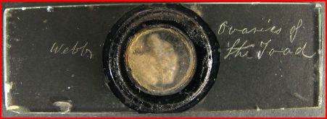
A signed Webb slide: image courtesy of Richard Courtier
Webb’s irregular writing is consistent with vision difficulty. Common pathology, like cataract or glaucoma, causes insidious impairment which may gradually make microscopy problematical, or even, finally, incapable of providing a living.
Experiments with appearance
Lack of dates on Webb mounts make it impossible to determine when he began trying out various coloured designs for his papers. It seems likely that the Field firm of Birmingham supplied him with papers, in a variety of formats. The somewhat complex wavy lined patterns on the well known “F” slides used by several mounters are echoed on some (presumably early) trial papers, before Webb finally settled on his two designs bearing the small “H” and “W” initials. These last were possibly designed for him, rather than by him: they were not perhaps the wisest formats for someone with vision difficulty. Presbyopia or/and astigmatism may well account for the frequency with which the initials were transposed on application of papers to glass. Whether Field supplied Webb’s final designs is perhaps doubtful, given their lack of wavy lines, but that is a matter for speculation.
“F” slides, with a horizontal wavy line pattern, were used by Webb, who stuck his labels over the “F”, or wrote on the blank panel: two examples are illustrated by Brian Stevenson in his section on Webb at www.microscopist.net , and two of the three below may add to this.
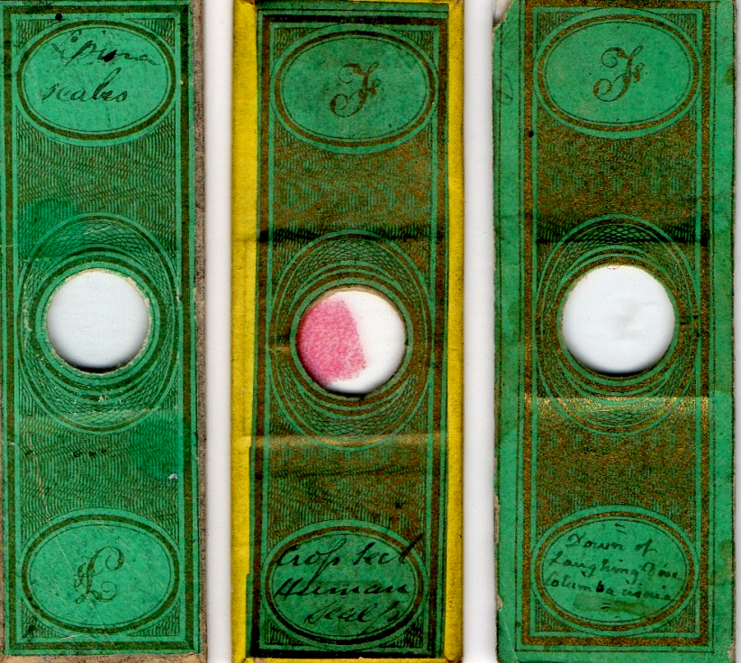
The “F” slide on the extreme right above does not bear Webb’s handwriting, but the other two well may: the fact that the “F” is upside down on the lepisma scales slide reinforces that opinion (see my remarks on visual problems).
During these experimental times Webb also used wood rather than glass at least once, as in the example below.
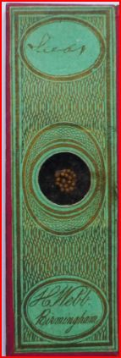
This wooden slide has a group of seeds: Webb has not named the species.
The horizontal wavy line pattern of “F” slides has been replaced by a vertical one, in various colours (these may also have been supplied by Field, since the oval panels top and bottom are identical in size and shape to those on “F” papers.) Two more examples are shown below.
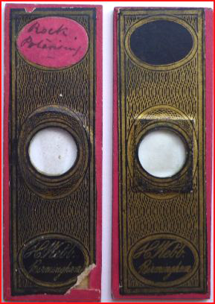
Webb’s late papered mounts
Webb, at latest by 1861, had finally settled on two paper patterns very different from those shown above, and seem to have been his preference until his death. A selection is shown below.
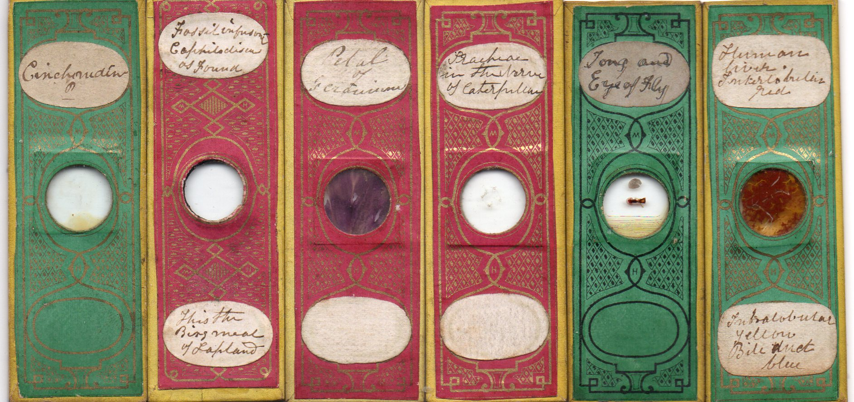
Something all six mounts above have in common is that the “HW” initials are presented upside down, or in the case of horizontal initialling, back to front. This is consistent with visual problems: the lesser panels on the papers are very small indeed, and the “H” and “W” initials therein are even smaller. So: did Webb sometimes employ someone to label his slides? The three shown below pre-date Webb’s death by some years and share the same handwriting – not Webb’s - and all have the “H” and “W” in the correct alignment.
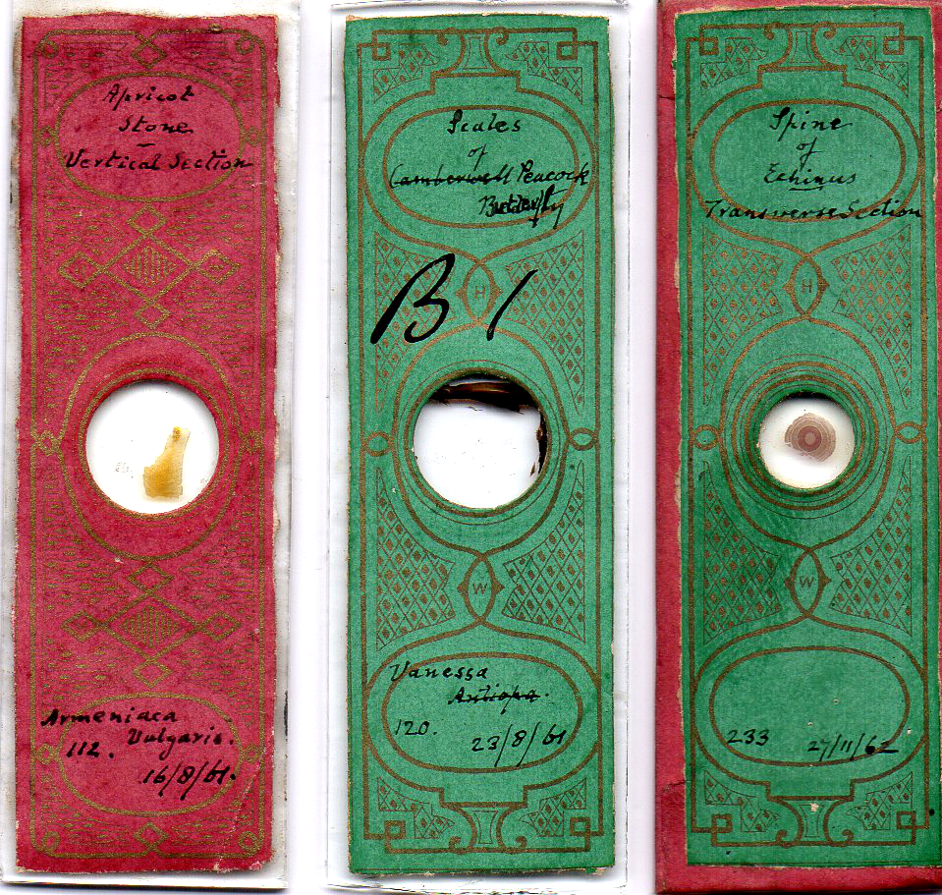
I have not seen dated slides like these bearing Webb’s known writing. Numbers on the three above suggest that they came from a large series: was this all by Webb, commissioned and labelled by the owner? Or did the series contain slides by many mounters, including Webb? I have no evidence to support either idea. Again, Webb may have sometimes employed an amanuensis (perhaps a family member, or a friend): in that context, as noted, the three slides above all have the correct orientation of “H” and “W”. Of course, Webb did not always “get it wrong” with papered slides, but one gets the impression this was a “hit or miss” affair due to impaired vision. The flea mount below has the initials the right way up on the front paper: but one notes that the rear paper has a lower panel with “H. Webb Birmingham”, making it much easier to know which way up the labelling – and initials - should read (on both sides).
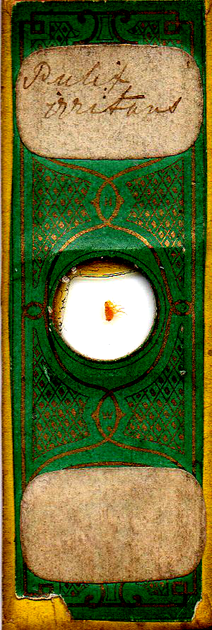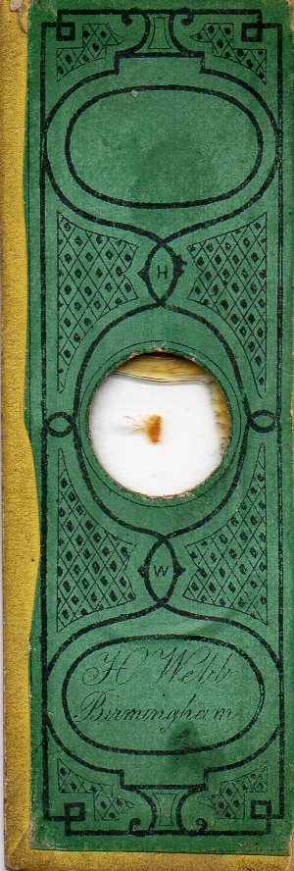
Irish connections
The slide below is intriguing. The mount was made by the Rev. Lewis George Mills, headmaster of the Armagh Cathedral School, a leading light of the Armagh Natural History and Philosophical Society and an FRMS. Webb was the only exhibitor of mounts at the Dublin International Exhibition in 1865, and may have been invited to exhibit by Mills: they obviously knew each other before that, since the Mills mount was prepared in 1863, using Webb’s paper on the front.
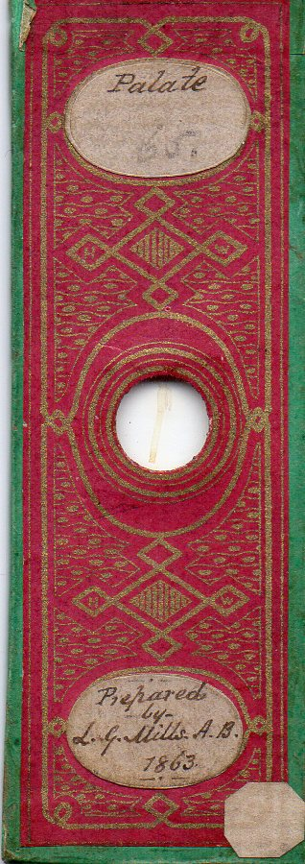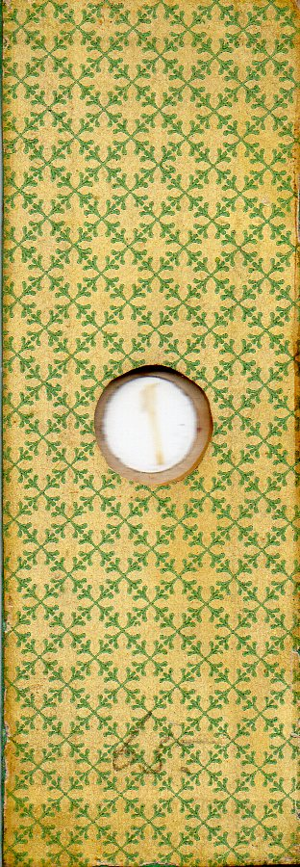
The Mills palate mount with its rear paper (the latter being most un-Webb like)
Mills used many papers for his mounts – indeed, in some four dozen examples I’ve seen in my own collection and in images sent by museums, I have not seen him use any paper more than once. I therefore think he persuaded Webb to give him the paper for the palate slide above, to acquire further variety. Whatever the case, Webb – just as at the 1856 Birmingham soireé – was unopposed as an exhibitor of mounts at the 1865 Dublin exhibition. That suggests that Webb had significant sales in Ireland: there is now little Irish interest in old slides, another possible reason for today’s apparent scarcity of Webb mounts. Mounts in Ireland may languish in obscure corners of museums, attracting no interest and undocumented (Malcomson’s ostracoda mounts are a recent such example).
Commerce via networking?
Secondary labels are conspicuous by their absence from Webb’s fully papered, or unpapered and inscribed slides, either in my collection or in the literature. This suggests that Webb developed a network of “word of mouth” clients to sustain his business, and the fact that he was the sole exhibitor in at least two well attended exhibitions reinforces that concept. There may be one exception, though: Smith & Beck retailed slides by many mounters at their first premises at 6, Coleman Street, in the decade to 1856. A few examples are shown below.
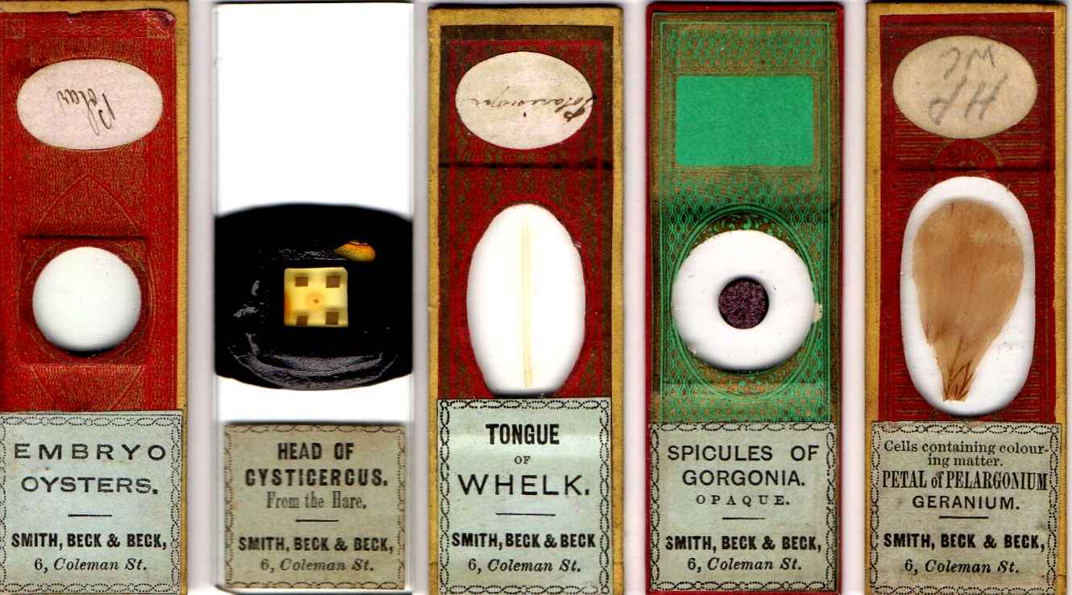
From left, mounts by Sharpus, “acari/palate man”, Barnett, “Greenpapers” and Topping.
Many other such examples from 6 Coleman Street survive, but without evidence (such as Barnett’s handwriting on the whelk tongue above) it is difficult or impossible to identify the original mounters, as with the 5 mounts below.
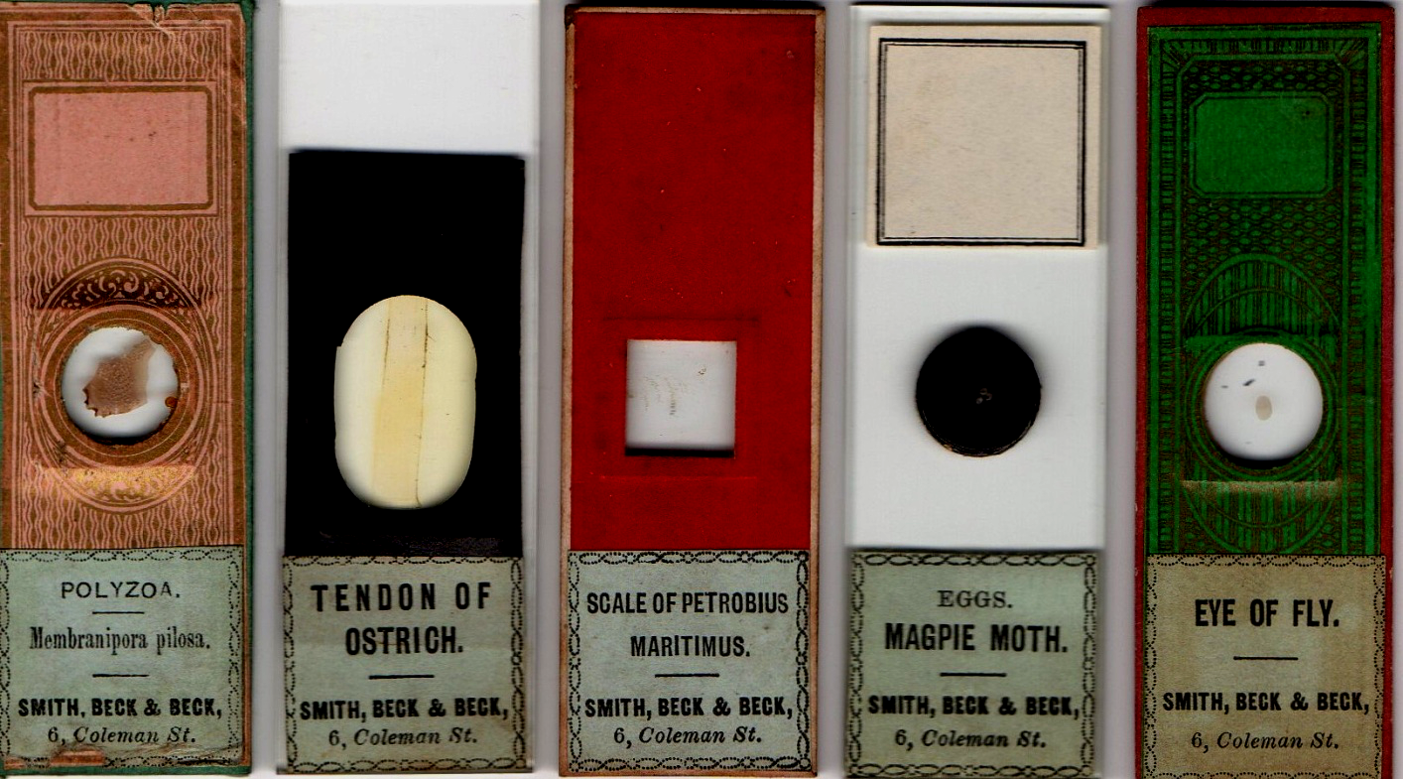
Given the number of mounters retailed by S&B from the start, it would be surprising if Webb was not among them. They certainly knew of him in 1858 – they could hardly have missed him as the sole exhibitor of mounts at the same Birmingham soirée where they exhibited microscopes – but an association probably existed well before that. The slide below, I think, was made by Webb: both the deep-cell style and the subject matter strongly suggest his work, as does the fact that it is an injected specimen, for which Webb was renowned.
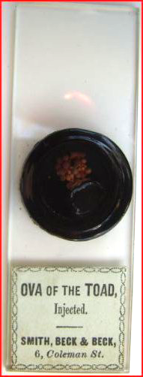
Like Amadio, Smith & Beck sold slides not only by prolific mounters like Topping or “Greenpapers” but also by those with a smaller output of quality work. One example is “Halfpapers”, whose mounts, like Webb’s, turns up fairly rarely today – and, like Webb, secondary retail labels are hardly ever seen. An exception is Smith & Beck, as in the example below.
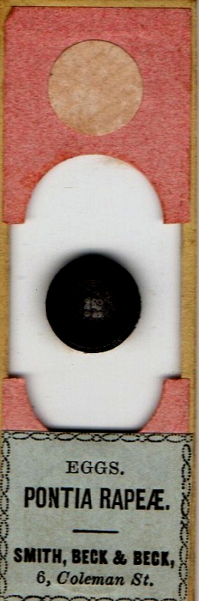
“Halfpapers”, too, may have relied on a network of “word of mouth” clients – as I think is the case for Webb – and it’s possible that inscribed and wholly unpapered examples of his/her work are “out there” awaiting discovery.
Individual commissions?
The mounts below seem likely to have been specific requests by Webb’s clients.
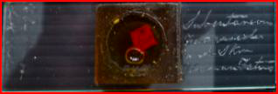
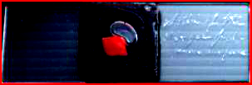
Two deep-cell mounts of skin and subcutaneous tissue: foetal skin (upper example) also features on another mount (R) below.
The mounts came from sales of different collections: lack of labels suggests that those who originally obtained them from Webb specified exactly what was wanted, and had no need to add anything.
Two more mounts, below, may be by Webb, made to order for different clients who attached their own labels.
.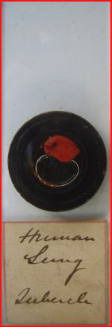 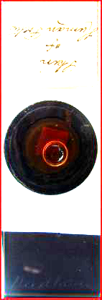
These two mounts turned up in the UK, after long languishing in different homes: inquiry failed to yield any other provenance.
The tubercle deep-cell is very similar to Webb mounts already shown. The other, a deep-cell specimen of human foetal skin, with a different owner’s handwriting, echoes the foetal skin deep-cell mount already shown above. (It bears a diamond inscription “Needham”, which I take to indicate that it belonged to, or was destined for, Joseph Needham, who is known to have collected pre-1870 mounts.)
Black papered mounts – for the open market?
Judging by my collection, there are a good many extant Webb plain black papered mounts of the kind already illustrated. Of my fifty-odd such slides, at least a dozen seem highly suggestive of Webb’s early work: I illustrate four below.
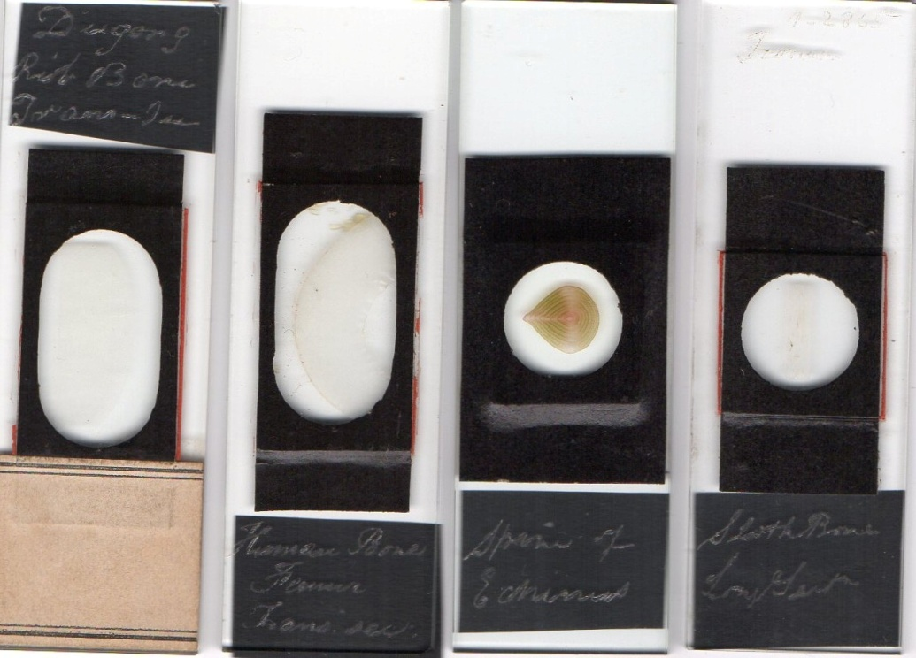
I have not discovered any record of commercial premises owned or rented by Webb: as was the case later, for instance, for Suter, he may have prepared and sold his work entirely from home. Early in his career, assuming Smith & Beck retailed Webb’s work, many Webb slides with plain black paper may have been aimed at the London market. Such slides continue to emerge as old collections come up for sale. So far, no S&B slides in my collection – bar one possibility - yield unequivocally Webb inscribed writing: but illustrated below are four I consider to be likely candidates. (The femur and ivory nut mounts have red sealing wax.)
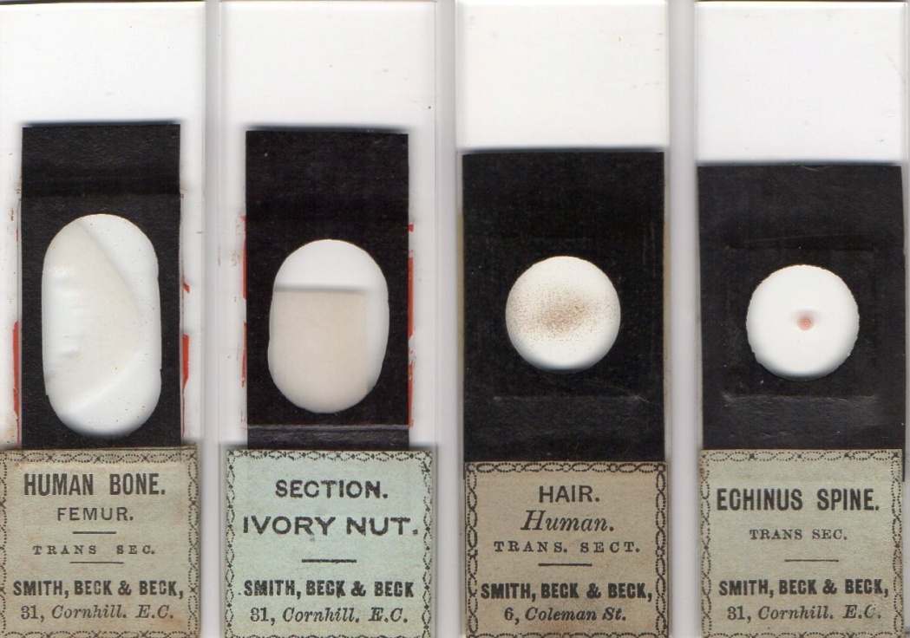
These are from Smith & Beck’s second address, after the move from 6 Coleman Street, where they were 1865-1880. Most of that period was after Webb’s death – but firms continued to retail old stock as long as demand existed. Consider, for instance, a slide retailed by the Ross firm in 1879 at 164 New Bond Street, illustrated in Bracegirdle’s Microscopical Mounts and Mounters, plate 31 L.
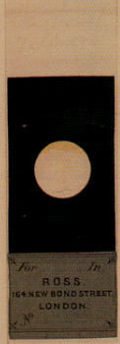
The style above had long gone out of fashion by 1879, so this is presumably old stock which Ross probably wanted to shift, since they were in the process of moving premises (twice) around that time.
Below, I have placed two slides I think are by Webb alongside the same subjects and style with S&B labels: the similarities are obvious.
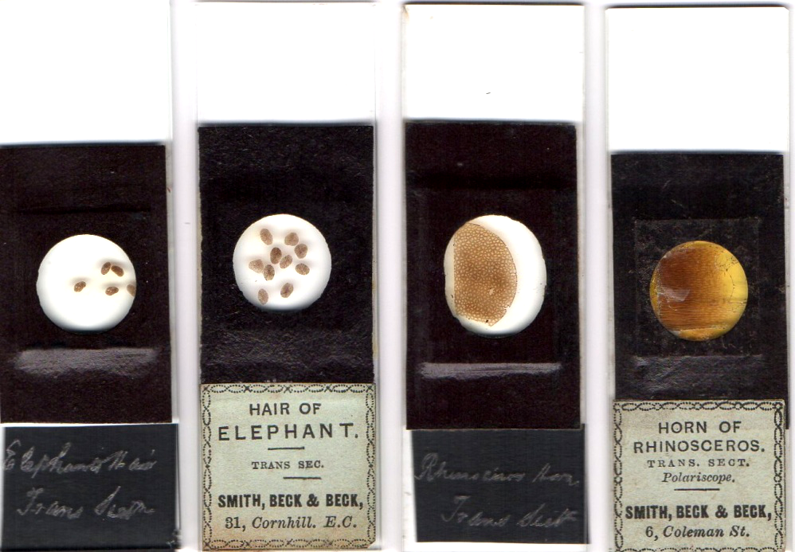
Only one slide in my collection from Smith & Beck’s first London premises reveals diamond inscription beneath the S&B label.
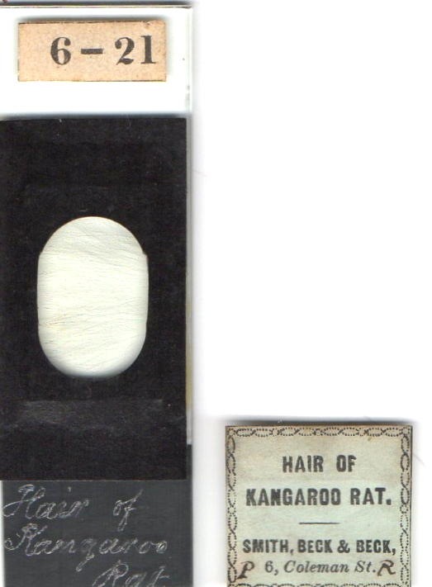
The kangaroo rat hair slide above is shown, with its removed S&B label. It has diamond inscription which might just be Webb’s, from an early stage in his mounting career when his vision was still relatively normal.
Insane?
Webb’s death certificate specifies carbolic acid poisoning “while insane”. “Insane” is vague by nineteenth century criteria, let alone today’s. I include few biographical details in this article: those interested can find Brian Stevenson’s account at his web site www.microscopist.net . However, much remains to be discussed regarding Webb’s death.
Carbolic acid poisoning is by ingestion or significant skin contact. Swallowing implies suicide, but might be accidental in someone with significant visual impairment – as is true of spilling the acid on the skin (a cause of death featured in some bygone murder fiction). If Webb’s death was suicidal, depression is the obvious underlying diagnosis. If readers doubt that death might be accidental – either by ingestion or skin contact – I refer them to the internet, which documents several such 19th century deaths.
19th century psychiatry offered sparse differential diagnosis - quite disparate conditions were lumped together. Would Micscape readers describe Tuffen West as a “lunatic”? He spent time in the Fulford Lunatic Asylum – suffering from depression – but nobody today would term him a “lunatic”, either before or after his time at Fulford.
What then of Webb’s “insanity”? His erratic handwriting suggests visual impairment. Exactly what cannot be specified, unless family records like diaries turn up. The aphorism “common things occur commonly” applies to both depression and a variety of visual defects. Presbyopia is a likely reason for the “H” and “W” being so often mis-positioned on Webb’s papered mounts: further impairment like cataract might predispose towards depression. He died aged 50, a likely age for macular degeneration. This last would severely impair central vision – so necessary for work with the microscope – and could, as the “last straw”, precipitate severe depression. I have found no coronial details to clarify the circumstances of Webb’s death, and all the above is conjectural: but “insane” is neither specific nor useful.
Chemical mounts
Webb’s last work confirms opportunity (but not motive) for carbolic acid poisoning – he was working on chemical mounts in his last days. A near neighbour, William Porter, was a chemist/pharmacist, and probably supplied Webb with chemicals. After Webb’s death Porter took over his mounting business, selling Webb’s residual stock under his own label. Three examples are shown below. Porter inked out the “H” and “W” initials on slides already made by Webb: his label designation “preparer” seems less than honest, unless he and Webb collaborated in making chemical mounts shortly before Webb’s death. The inking out was not always completely successful, for those looking closely, as can be seen in my enlargement of part of the cane sugar mount below.
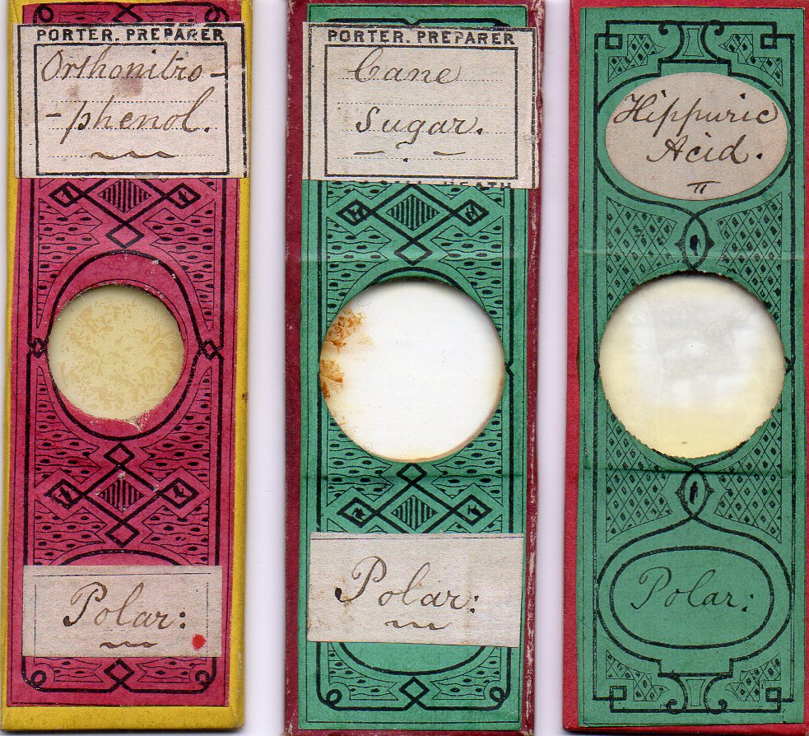
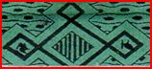
Chemical mounts sold after Webb’s death by Porter: all have the “H” and “W” the wrong way round, which suggests they were made by Webb, and that Porter removed and/or covered any Webb labels, substituting his own.
Almost all examples I’ve seen of the “Porter” slides with Webb’s papers are chemical mounts, confirming them as a late development in Webb’s mounting career. If Webb’s death was suicide, the phenol compound above is a little chilling (phenol is an alternative name for carbolic acid). However, unfamiliarity with new materials, combined with visual impairment, also supplied opportunity for accidental death. Of course if Webb was already depressed due to vision impairment, the new materials gave him a ready means for suicide. We may never know the truth – but “insane” can be discarded as hopelessly vague.
Swan song
Webb is the only mounter known for posthumous exhibits – at the Paris international exposition of 1866-7. In the British section, there were many microscope makers, but only two exhibitors of mounts – Norman and Webb. Unfortunately Webb’s exhibits were described only as “microscopic objects”, without any details such as whether they were injected and so on.
The exhibition opened some months after Webb’s death, so the question arises, who took the mounts to Paris? I think the likeliest answer is Smith & Beck, who were one of the microscope exhibitors.
Concluding remarks
My essay poses several problems. If readers re-examine their collections, evidence may emerge to clarify and further document Webb’s work. Who knows what is still in Birmingham, where Webb probably had a significant clientele? Mid 19th century Birmingham underwent an explosion of population and industrial productivity. Directories of the time show hundreds of surgeons there, doubtless reflecting the prevalence of industrial accidents. Surgeons are a likely group to show interest in things microscopical, and if even 10% of them were Webb clients, they would have contributed significantly to his business. That is only one example: there were several thriving scientific societies whose membership also probably ordered Webb mounts. Again, Turner’s statement that he had several Webb slides with mounts of desmids and diatoms suggests that some may yet come to light in Leeds. It is sure much more of the tale remains to be told.
Acknowledgements
Thanks to Richard Courtier for the image of the signed Webb mount.
Thanks to Peter Hodds for locating some Webb mounts.
Sources
All slides illustrated come from my collection except for the signed Webb slide and the Ross labelled mount.
www.ancestry.com has census details
www.archive.org contains a detailed account of the British section of the 1867 Paris exposition.
www.microscopist.net has a biographical essay on Webb.
Bracegirdle’s Microscopical Mounts and Mounters
W.B. Turner Algae Aquae Dulcis Indiae Orientalis (Stockholm, 1893) (my copy is a modern reprint)
Journal of the Provincial Medical and Surgical Association 4, p.684 (1856)
Lionel Beale How to work with the Microscope (1865) p.263 (both British and American editions mention Webb)
Full details of the Dublin International Exhibition (1865 -6) can be accessed via Google Books

Comments to the author are welcomed. Email - lois737 AT bigpond DOT com
Published in the September 2014 issue of Micscape magazine.
www.micscape.org

