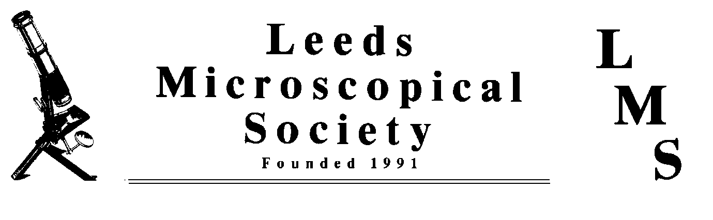

Annual Meeting at Morley. Saturday 4th June 2011
Once again our annual meeting will be at St. Mary’s Church Hall, Morley on 4th June 2011, from 9.30am onwards.
To cover the charge for room hire the cost will be £5 per person. Lunch will again be available from the kitchen. (Remember the bacon butties). The theme of the meeting will be ‘Aquatic Life’, and people are asked to bring displays and specimens from their local area.
Speaking at 2.00pm will be Mike Smith and Barry Nattress on Tardigrades. We would welcome other short talks. If you can help please contact Mike.
This year’s raffle prize will be some Little Imp microscopy CDs kindly donated by Steve Gill.
It is essential to let us know beforehand if you need a sales/display table.
I look forward to meeting you all again.
Mike Smith

