WILLIAM JOSEPH NORMAN REVEALED

Peter B. Paisley

Sydney, Australia

Scrutiny of some unusual slides stimulated my curiosity as to who wrote their labels and who made the mounts. Many members of the Norman family were involved in slide making, evidenced by numerous handwritings on labels, and five of J.T. Norman’s sons are known to have made mounts. I know of no concrete evidence, but it is not unlikely that wives and daughters also were involved - the number of handwritings on Norman slides exceeds that of documented mounters in the family. (It has been said that Wheeler’s mounting firm probably involved all his children, including the daughters.) Female skills in predominantly male preserves often went unacknowledged in Victorian times. There were exceptions with slide preparation: Mary Ward, Louise Clarke and Mary Somerville all wrote comprehensive books on the subject, and the Clarke book seems to have been a best seller. Others may have sold slides, like perhaps Mrs. M. Wright (illustrated below), about whom little or nothing seems to be documented.

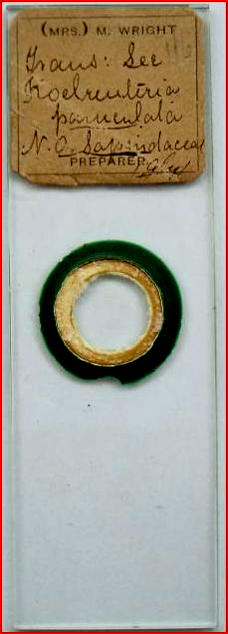

The mysterious Mrs. Wright – image courtesy of Peter Hodds

Be that as it may, one of J.T. Norman’s sons was both label writer and preparer, namely the second Norman son. I have seen only one example where his slide is signed, but handwriting comparison allows ascription of many other slides from the Norman firm to William Joseph Norman.

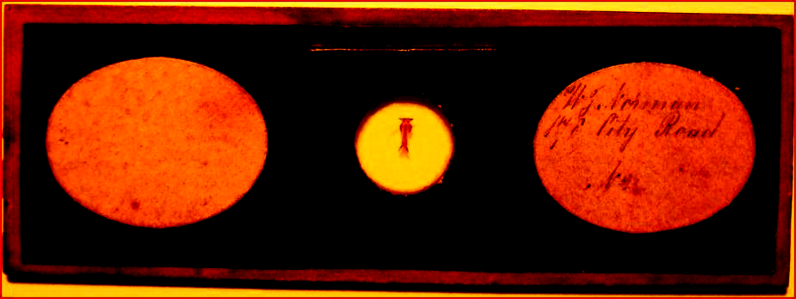

A mount of a Tabanus fly tongue by W.J. Norman – image courtesy of Trevor Gillingwater

One slide may not seem much to go on, however letter by letter comparisons (more of which presently) – and other considerations – leave little doubt as to the provenance of many Norman slides displaying much more familiar presentations.

Handwriting has components which are relatively involuntary, notably slope and any tendency (or not) to write cursively. In the example above by W.J. Norman, the slope, and semi-cursive style, look identical to that seen on known Norman slides: examples are illustrated below.

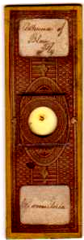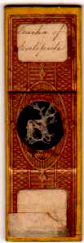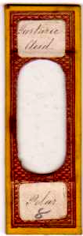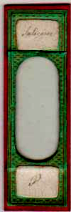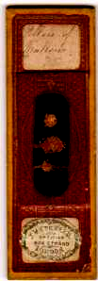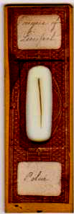

More than usual information, for Norman slides, is given on the blow fly slide (far left). Duplicates are also labelled thus. The Linnean name, M. vomitoria, is written on the lower label, and appears on duplicates – significant, in the context of William’s interest in insects.

Involuntary traits like slope and cursiveness are generally more prominent when actions are oft repeated – for instance, when a large number of slide labels is written, as was the case when 178 City Road was the site of Norman family production. The 1861 census shows J.T. Norman and his two sons (J.T. and W.J.) all involved there in mounting, as shown below: the output is known to have been substantial.

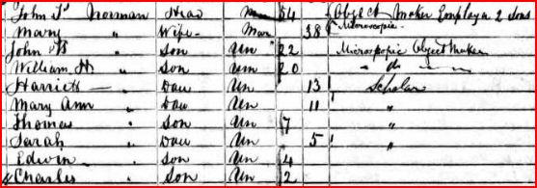

The Norman family at 178 City Road, in the 1861 census

The census taker displays idiosyncrasy: both John junior and William (above) can seem to have “H” as the middle initial, because of abbreviation to ideograms – stylised “Ts” and “Jh” for Thomas and Joseph, as in the illustration above: hence arise multiple transcription errors in databases like ancestry.com. (modern transcribers are unlikely to recognise the abbreviations). The census, and the signed W.J. Norman slide already illustrated, confirm William as not merely a label writer but as an “object maker”. Dates of his mounts are problematical, but some can be narrowed down by collateral evidence. Smith & Beck were at their 6 Coleman St. premises between 1847 and 1856: two slides with the familiar Norman brown paper pattern bear secondary S&B labels, and have stickers inscribed with “Polar” which seems to be in William’s handwriting, in particular the capital P.

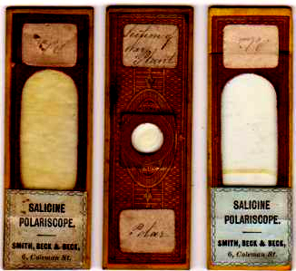

The two S&B slides from their first address are shown, with a third in the middle for comparison which bears “Norman London” panels added to the generic brown paper. The slides are of interest in several ways. Smith and Beck seem to have been assiduous in disguising overt identities of preparers who supplied them with mounts, but in this case the job was incompletely done. The two secondarily labelled slides above were re-issued upside down vis à vis their original state. I successfully steamed off the secondary labels, which revealed traces of the - not quite total - removal of original descriptive labels, and the results (original way up) are shown below.

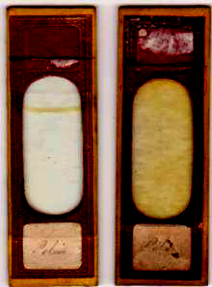

The S&B salicine slides unmasked. Traces of the original descriptive labels remain: that on the right still has (illegible) vestiges of its original writing.

A puzzle
Perhaps S&B considered the “Polar” labels unidentifiably generic, but they betray their writer, and S&B probaly realised this. Prolific mounters, like Norman, or “Greenpapers”, for instance, sold in their own right but also were retailed incognito with added S&B stickers. Doubtless some observant buyers detected, or at least suspected, the original mounters: but many more probably bought from S&B’s big optical shop uncritically. Profits for all parties were assured, but buyers who identified original mounters’ handwriting might bypass S&B and go direct to mounters themselves, cutting out the middle man. If this became widespread, S&B’s sales would take a dive, and the mounters themselves might lose a reliable source of income. No-one wanted that: illustrated below (image courtesy of Peter Hodds) is a very interesting slide.

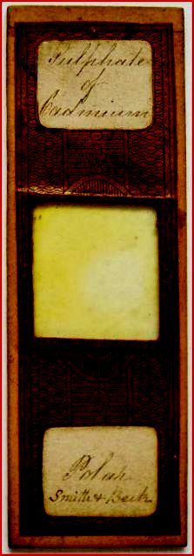

William Joseph Norman made the slide. It was unlikely to sell at S&B’s shop in the condition seen above, since the upper label would have revealed even further evidence of whence S&B sourced their on-sold Norman mounts. Perhaps it was sent to S&B by William, or he intended it to be sent, as a reminder to make their customary disguise complete, safeguarding the commercial relationship. The Norman firm frequently supplied S&B, as attested in surviving ledger books: this slide may have been assigned for retail there, but never reached its destination. Whoever owned the slide at some time may have added “Smith + Beck” beneath “Polar” on the lower label (the writer may be different), misinterpreting a Norman slide as an S&B “original”, on the basis of slides already retailed with their lower Norman “Polar” labels intact. Whatever the explanation, it’s an intriguing survival.

Norman variety
Most slides in my collection which use those brown papers, and bear William’s handwriting, lack the “Norman London” panels, so are, presumably, earlier productions. Since William was already described as a mounter by 1861, those slides may well have been made in the mid or late 1850s. No firm exhibits more prolific variation in design than early Norman examples: slide materials, and paper designs flourished with tropical exuberance. Metal and wooden slides are shown below.

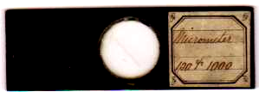
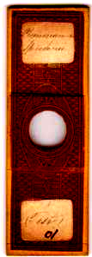

The micrometer slide is brass, painted black: the wooden slide is probably mahogany.

Of greater interest, perhaps, is that the wooden slide above has been labelled in apparently identical handwriting to a horizontally presented slide with a paper not hitherto documented as used by the Norman firm.

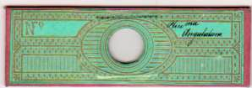

There seems no room for doubt the Pleurosigma mounts had their labels inscribed by the same writer. Even less doubt surrounds the whole word comparison shown below: a Norman mount is compared here to another horizontally presented slide with the same paper pattern as that of the Pleurosigma slide above. The handwriting and the spelling variant are identical. If readers doubt their Norman provenance, I invite comparison with the known Norman slide also shown (although the other variant –salacin – is used).

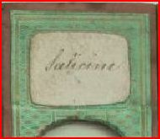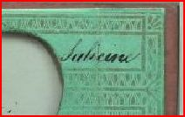
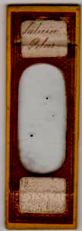

Rarely, cardboard was also used, as in the example below: the handwriting here is quite different (image courtesy of Peter Hodds).

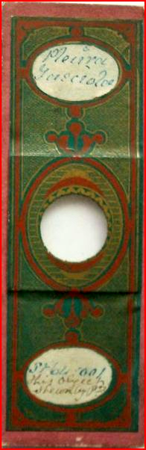

As in the cardboard example, vertical presentation is standard for Norman slides, and horizontal alignment is rare. Judging by the signed W.J. Norman slide and the micrometer slide, already shown in this article, their maker had a liking for that mode, as well as displaying individuality in choice of paper colour. More horizontal mounts are shown below: the Pleurosigma slide already shown is included for comparison. Possibly a Dytiscus slide like that below appeared at the London exhibition of 1862, although it cannot be dated with confidence.

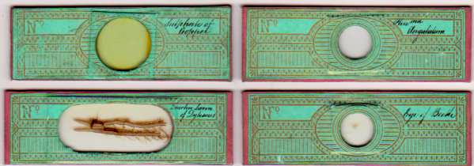

Two known Norman slides are shown below: compare the handwriting of “sulphate” and “beetle” to that on the papers above.

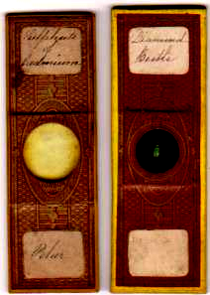

Single letter comparisons
First, a close-up of the W.J. Norman signed slide, to show letter formations. “No. 3” presumably indicates that several Tabanus mounts were made: how many were decorated with this highly distinctive colour and horizontal orientation I cannot say. (Regarding horizontal slide orientation, William seems unique amongst the Norman family.)

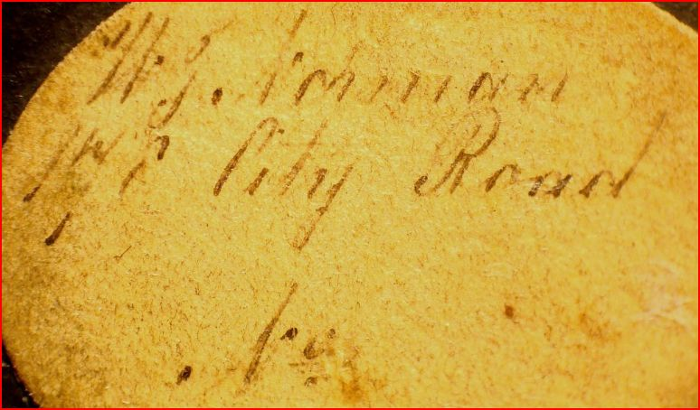

I have extrapolated several individual letters from the slide label above, and these are shown below.
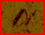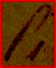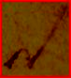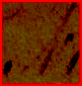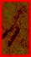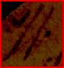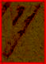

a c d n r w y

Here for comparison are letters extrapolated from labels on known Norman slides.

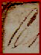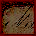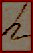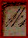

No individual’s handwriting is ever totally consistent, but as comparisons go this is about as good as it gets. Below are the Norman slides from which the second set of clips above were taken, in the same alphabetical order.

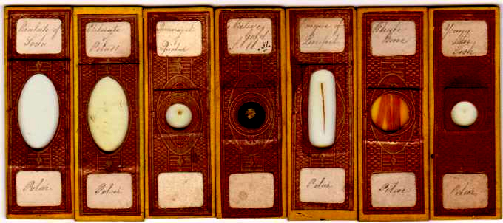

If William Joseph Norman made and labelled the first slide illustrated in this article – and there seems little reason to doubt it - the same is true of these.

A different label writer
As already shown by the cardboard slide, other early Norman slides carry a very different handwriting on their labels. Some examples are shown below.

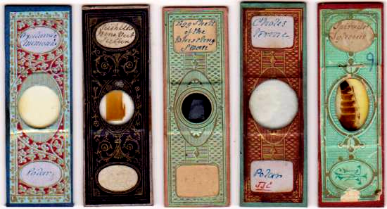

Early Norman slides, papered in a variety of patterns and colours

Many such slides have a somewhat florid “JTN” monogram on the back, as in the illustration below. The monogram shows strong stylistic affinities with Norman’s business card from 178 City Road, and probably emanated from the same design /printing firm.

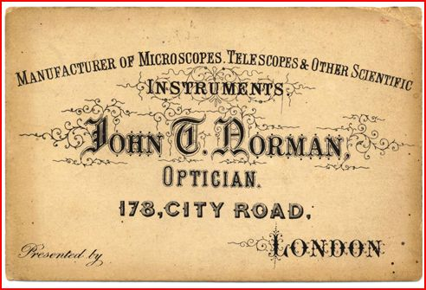
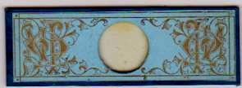

Norman’s monograph and business card, probably from the early 1860s

The handwriting on the slides just shown occurs on many early Norman slides, and is pretty consistent, as is true of William Norman’s slides. The two handwritings are quite distinct. So: whose is this other handwriting? The prevailing opinion is that it is that of John T. Norman senior. It seldom seems to occur on unpapered slides made after 1862, datable terminus post quem from the “Prize Medal” inscription on their labels. This raises interesting questions. Norman senior did not hand over his business to his sons Alfred and Edwin until 1892. But the fact that he continued as business proprietor until then does not mean that he continued to make many slides, at any rate after 1862. One might therefore conclude (if the handwriting above is Norman senior’s) that he made few slides post 1862, comparatively early in the firm’s long history, or that, at any rate, he stopped writing their labels. Either or both are possible, but more likely he did indeed hand over the bulk of activities to his offspring, remaining as overall eminence grise (at least five of his children – and possibly more – had mounting skills.) That alternative, of course, rests on the acceptance (generally held) of Norman senior’s handwriting. But on what is this opinion based?

Looking through the literature, there seem to be but two surviving documents definitely written by Norman senior, both of which have been reproduced in articles in the Quekett journal. They are reproduced below.

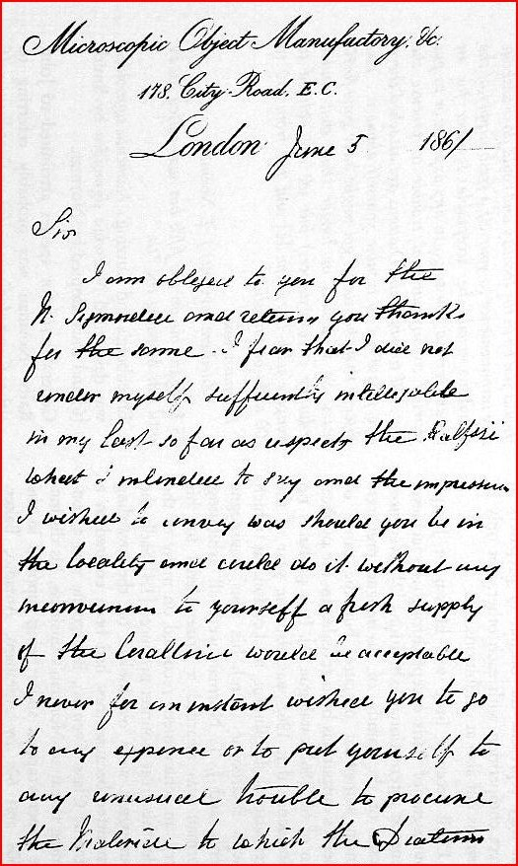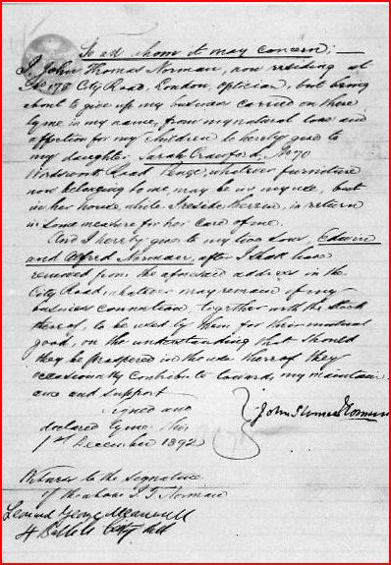

Left: part of a letter written By J.T. Norman senior in 1861, and right: a deed of agreement by J. T. Norman senior in 1892, handing over control of his business to his sons Edwin and Alfred.

The handwriting (particularly in the document at right, above) has a different style, in slope and degree of cursiveness, to that seen on many early Norman slide labels: on the latter under consideration here, the letters are always separated. Some caveats are necessary. There are some differences between the handwriting on the two documents; the agreement was written several decades after the slides were labelled; and the purposes of label writing differ from those of the documents. Handwriting may well undergo modification through time. Intentionality is also a factor: the separated letters on the slide labels may have been deliberately done thus, for clarity. Different situations often produce different styles (I write my notes cursively, and use abbreviations, but I print my prescriptions).
On that basis, the evidence is not strong enough to satisfy a forensic handwriting expert who has examined the details that it is J.T. Norman’s handwriting on the slide labels. That examination however is based on photographs in journals – scrutiny of the documents themselves would be more satisfactory, and it may be that this would confirm or deny the handwriting on slides as JTN’s. The general acceptance (by those with more expertise on Norman than I, and more extensive collections) rests therefore to no small extent on “what I tell you three times is true”, rather than on substantive forensic analysis. I tend to accept the handwriting on the labels as perhaps JTN’s (until proved otherwise): but there are other possibilities – a wife, for instance, might write the labels for slides made by her husband. Collateral evidence, at any rate in print to date, seems lacking: I offer some thoughts on this in what follows.

Of blue ink, and other things
The slides just illustrated above have one thing in common, namely the label writer’s penchant for the use of blue ink. This was not shared by other label writers in the Norman firm, and it only seems to occur on early slides. On slides which have survived well, with their colours unaffected by sunlight and wear and tear, there is little doubt that the colour in question is cobalt blue. The three slides below are relevant here.

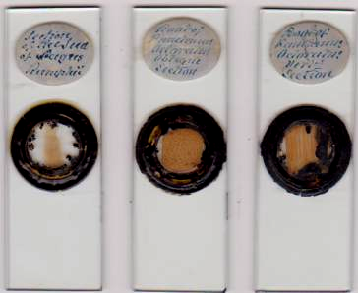

These slides were labelled using cobalt blue ink, and share the handwriting style of papered slides already illustrated.

Can one date these slides? They were obviously ringed freehand, so they probably pre-date the advent of turntables and were produced in the late 1840s. If that is so, it would narrow the label writer down to J.T. Norman senior, or his second wife (née Mary Boroff). Diamond inscribed slides (probably from the same period) bear the same handwriting, as illustrated below.

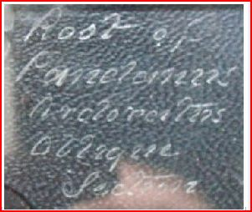

From a diamond inscribed slide of the same vintage as the previous three – image courtesy of Peter Hodds

There are good reasons why Norman senior would have taken an interest in cobalt blue ink. Many early Norman slides were chemical mounts, so JTN certainly had expertise there. As declared in various records, brush making overlapped with slide and scientific instrument making for around two decades as a source of Norman senior’s income. I consider it highly likely that the brushes in question were artists’ brushes. Manufacture of yard brushes and the like in Victorian times was subject to labour division: the most soul destroying repetitive part of this was bristle drawing, an occupation generally relegated to children, females, workhouse inmates, “idiots”, and even the blind. As an industrial enterprise it involved different individuals doing bristle drawing, body and shaft manufacture, assemblage, and so on. Census records customarily record the number of employees for a proprietor: no census until 1861 shows this for J.T. Norman senior, and there were only two employees then – the elder sons, both specified as mounters. No member of the Norman family other than JTN was described as a brush maker: the sons took up slide mounting and daughters went into millinery. If JTN ever ran a brush factory, it was not at home. A London trades listing from 1852 shows many brushmakers, but the name Norman does not appear among them (Mrs. Mary Norman does appear though, as a milliner at 24 King St., Holborn). Brush making, therefore, seems to have been confined to JTN senior, and the most likely types of brushes were those used by artists – a more skilled and satisfying activity which could be performed by one person.

Contact with artists in mid Victorian times automatically involved familiarity with cobalt blue. Since the sixteenth century, Chinese porcelain with its cobalt blue and fine white glazes had fascinated Europeans, at times stimulating crazes. Later production in Delft, and elsewhere in the Netherlands, brought production closer to home for importation to England, and lower prices put pieces within reach for almost all levels of society. At the dawn of the nineteenth century re-discovery of formulae for cobalt blue pigments in France, and its commercial production there, and in Norway and Germany, soon led to large scale commercial production. By mid century, when Norman began slide making, it had gained popularity among English artists, notably through John Varley’s influence. Norman, given his chemical expertise and possible contacts in the art community, more than likely made his own ink – hence those early slide labels.

All this seems to render it very possible that the handwriting on the labels is that of JTN senior, in a deliberately stylised form. However: this is not proof, and his second wife cannot be excluded as an early label inscriber.

William Joseph Norman and his career
Like others, I have been unable to trace William in any 1891 census. He is variously described in other censuses from 1861 onwards as “microscopic object maker”, “optician”, “histologist” and “entymologist”. His lifelong trajectory through microscopical pursuits displays a prominent interest in insects, although he made slides with many other subjects. This is hardly surprising for someone who grew up beside the British Entymological Society’s rooms, with a father who was a prominent member. He may have brought considerable kudos to the Norman brand at the 1862 exhibition, when the judges made special mention of the tracheal system of a large insect when awarding their prize medal. The horizontally presented mount of the trachael system of dytiscus, shown already in this article, answers just this description.

While he contributed to the family slide output from City Road for many decades, he had moved to Walthamstow in Essex by 1881, where he remained until his death in 1917, apart from a possible overseas stay accounting for absence from the 1891 census. Did he produce slides independently of the Norman aegis? Several in my collection aroused suspicion, on the grounds of handwriting, so I subjected them to whole word and multiple single letter comparison (as described previously) with known Norman papered slides. On that basis, the slides below are examples of William Joseph Norman’s work.

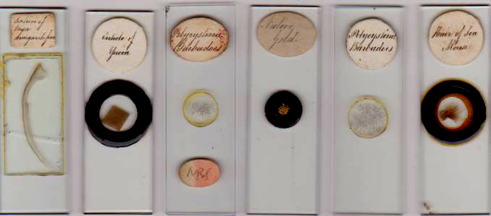

Many other such slides in my collection have the same handwriting, and readers will probably find some among their own. In some cases, word comparison with known Norman slides can be satisfyingly complete – as for instance in the case of native gold slides, as in the slides shown above and below.

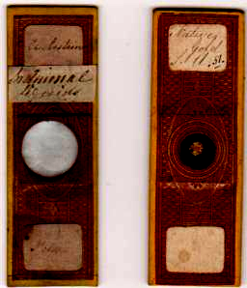

Unusual slides, in more ways than one – the papered native gold mount is on cardboard.

These, and the previous six, mark William as very much the individual. Duplicates, as with ever popular Barbadoes polycystina mounts, were being produced – presumably commercially – outside the Norman firm: and additional explanatory notes were added to mounts done within the firm. Thus “in animal liquids” is an addition to one slide, in a way I have seen on no other Norman slide, and “S.A.” is added as a qualification to native gold. (This may be South Australia, where in the decade from 1846 there were several abortive gold rushes). The extra information echoes his specification of M. vomitoria on blow fly slides.

William apparently branched out successfully on his own: in such attempts by other sons, one ended in bankruptcy, and another stimulated a guarantee not to use the Norman name, in the cases of John T. Norman junior and Charles Norman, respectively. William, adhering to the latter condition, not only contributed substantially to the family business, but remained very much his own man. Probably the patriarch gave his blessing to “moonlighting” as long as the Norman name or logo was not used. And he may have respected William’s business abilities since the Smith & Beck faux pas, if it was indeed William who first noticed it. Or perhaps most of these unpapered and unascribed mounts post-date the handing over of the Norman business to Alfred and Edwin, with William still contributing but also going his own way commercially.

How early did William start mounting? The slide below seems to bear his writing, and is very atypical of Norman papered slides (as is true of the first slide illustrated in this article, and the horizontal mounts.) Perhaps it is from William’s youth, and represents one of his “trial runs”: the larger writing might indicate a more juvenile hand, albeit a recognisable one.

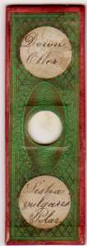

Given a father and elder brother mounting for the family firm, William may have begun in his early teens. Judging by census records, he continued successfully for many decades. Early Norman slides with his writing range widely in subject matter, featuring not only insects and chemical preparations but many botanical and zoological mounts, interests which long continued, and also extended to geological preparations. Examples of his scope are shown below, both from family and independent mounting, the latter evidently commercial.

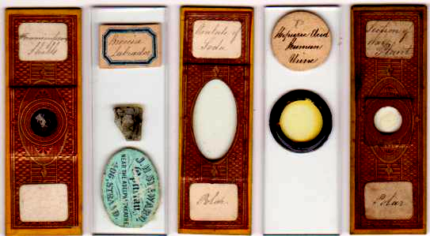

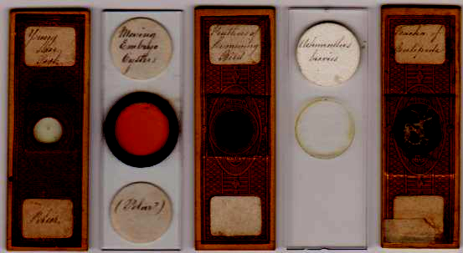

Some more comparisons and examples

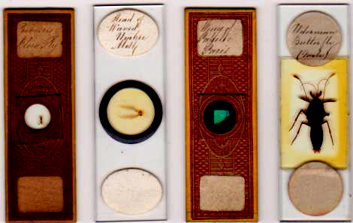

An independent spirit within the Norman family

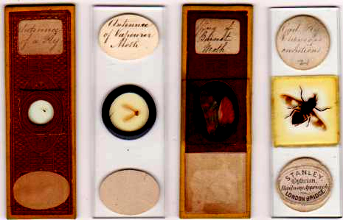

And, apparently, selling independently

As remarked previously, no individual’s handwriting is ever completely consistent. In the slides immediately above, the word “antennae” is almost exactly the same, but the capital M is written in two different ways: the same is true of William’s capital S. The same M or S variations occur on many slides – both papered and unpapered – which bear specific Norman labels of various kinds. The two further slides below emphasise commerciality, both under and beyond the Norman firm’s aegis.

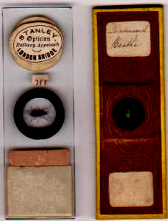

I have shown the reverse of the left slide above to emphasise its commercial nature. Its diamond beetle mount is too deep for front focus via my scanner: but the word “diamond” on both labels is so exactly replicated, short of forgery it would probably stand up as evidence of identical handwriting in any court.

Given that Norman senior’s very early microscopical interests involved diatoms, it would be odd indeed if William’s activities did not involve these. A few slides shown below confirm that he made such mounts.

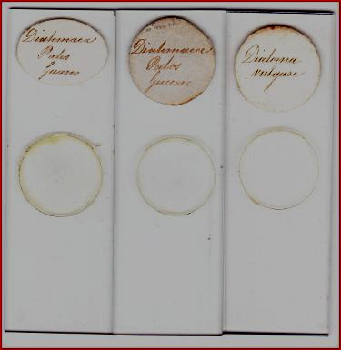

As can be seen, duplicates of the Pylos guano diatoms occur (there are more in my collection). This may be pure coincidence: more likely, it reflects wide scientific and commercial interest in guano as a fertilizer since the 1840s. (Spain went to war against Peru and Chile (1864-6) over control of guano.) England, at the mid century height of its hunger for world trade domination, haggled with Portugal over the Ichabo Islands, and ended by annexing them (1861-6) to its South African Cape Colony, to monopolise their commercial guano supplies. Long before that, the trade was flourishing, as for example attested by the advertisement (below) in the Glasgow herald of March 1855.

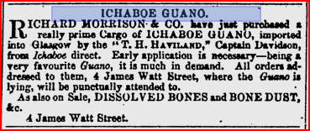

Even earlier, microscopy had joined in the general interest: Topping slide labels are not often dated, but the one shown below is.

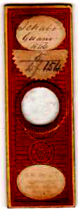

Ichabo guano (1846) by Topping

Sir William Gell’s archaeology in the Pylos region early in the nineteenth century had already re-kindled interest in the bat guano there, and its place in Greek mythology. All in all, diverse attention to this guano seems to conspire to make interest in its microscopy inevitable, and William presumably saw the commercial opportunities. (As far as I can discover, he never used cobalt blue on his labels: it is something of a curiosity that its advocate John Varley painted Sir William Gell’s portrait.)

Concluding remarks
As far as I know, no signed slide akin to the first one shown in this article, by any other member of the Norman family, has so far been documented. If any turn up, that would facilitate isolating the work of other brothers from the generality of Norman firm productions (and, who knows, might show that the ladies also played a part). If the slide from one of J.T. Norman junior’s shops, illustrated in Brian Stevenson’s article (see sources below) does indeed bear his handwriting on the label, then his work could also be isolated from the general Norman output. As far as William Joseph Norman is concerned, I feel convinced that many collections contain numerous examples of his work languishing unascribed among miscellanea. His “non-Norman” output, as defined by lack of specific Norman labels, may have been vast. Much remains to be discovered about individual activity within the Norman business. Until now, “Norman slides” have generally been considered en masse. If papered Norman slides bearing William’s handwriting were prepared by him – and there seems little reason to doubt it – he was a major force within the family firm. And given his other mounts, William Joseph Norman deserves stand alone consideration.

Email author: lois737 AT bigpond DOT com.

Acknowledgements
Thanks to Peter Hodds for locating several slides, and supplying images.
Thanks to Cliff Hobden (Director, Forensic Document Investigation) for expert opinion.
Thanks to Trevor Gillingwater for the illustration of the W.J. Norman signed slide.

Sources
Except where indicated, slides illustrated are from my own collection.
www.ancestry.com
www.historicaldirectories.org
For a comprehensive account of the Norman family, see Brian Stevenson’s article at www.microscopist.net : for those wishing to pursue particular aspects, it includes a comprehensive list of references.
For reproductions of documents written by John T. Norman senior, see:
Brian Bracegirdle: J.T. Norman, Microscopical Mounter, Quekett Journal of Microscopy (1996) 37, 514 -535
Stanley Warren: Comments on a letter from J.T. Norman, Quekett Journal of Microscopy (2001) 39, 189 - 191
On JT Norman junior’s shops, see Brian Stevenson: JT Norman’s retail shops on Queen Victoria Street and Whitecross Street, Quekett Journal of Microscopy (2009) 41, 155- 159
On cobalt blue, John Varley and Sir William Gell, Wikipedia contains handy summaries, and there is much more besides available on the internet.
Accounts by social and industrial historians of (non artists’) brush making in the nineteenth century reveal it as, frankly, a bloody awful job, particularly bristle drawing. Typically it involved division of labour between several workers. By contrast, artists’ brushes need skilled artisans: Windsor and Newton, for instance, still employ master artists’ brush makers who train for several years.

Published in the April 2012 issue of Micscape Magazine www.micscape.org

