UNUSUAL NORMAN MOUNTS
Peter B. Paisley
Sydney, Australia

Some years ago I acquired a slide shown below: its label had Norman monograms at all four corners – or so I thought. The mounting style and methodology was typical of many late mounts by William Norman, illustrated by the comparison below.
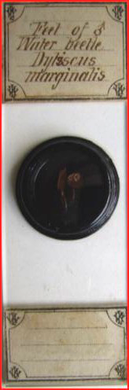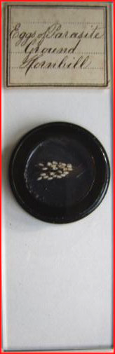
Feet of Dytiscus (L), with (R) eggs of ground hornbill parasite by William Norman (one of his favourite subjects)
Close inspection however revealed anomalies - the “J” and “N” were the “wrong way round”: also, colleagues convinced me that such mounts were not from the Norman firm. The “reversed N” made me wonder about some variant of Cyrillic, but I thought no further about it at the time.
A few years later, in a Micscape article (July 2012) on John Thomas Norman junior, I mentioned the unusual mounts again, raising the possibility that they might be “fakes” - attempts to mislead buyers into accepting them as by the Norman firm.
Ironically, the true state of affairs should have been staring me in the face from another Micscape article (June 2012), on William Norman, which I had written the previous month. When finally the “penny dropped” I wondered why the obvious had eluded me so long. The monogram on the unusual labels is indeed “WJN” – but back to front, and is a printer’s error, of a kind which is well known.
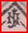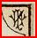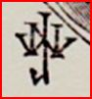
Above: left, initials from a common Norman label design (the monograms are deployed diagonally at label corners); centre, the botched monogram (deployed upright) from the corner of an atypical label; right, William Norman’s monogram from a book illustration. The label printer’s botched WJN “mirror image” seems clear.
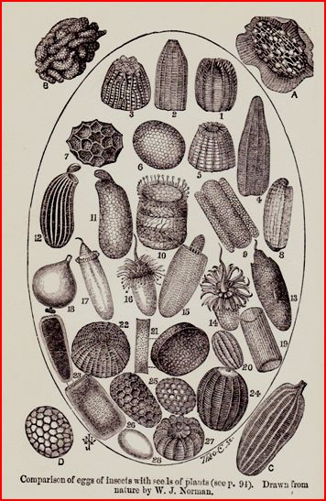
An illustration from James Crowther’s “The Microscope and its Lessons” (1891). William Norman’s monogram appears at lower left.
Colleagues have suggested that the mirror image “WJN” might have been for stylistic reasons, as on florid rear papers on some early Norman slides, where a set of “JTN” initials is echoed in mirror image, creating bilateral design symmetry, as in the example below.
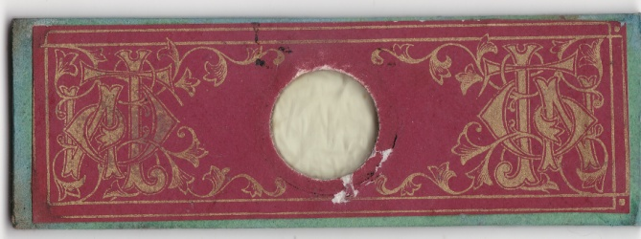
The back paper on a Norman slide: the “correct” JTN (John Thomas Norman) monogram is on the right of this illustration, with its mirror image on the left. The same block (or photograph) was presumably used for both images, which are identical apart from the reversal, and without which the design would have lacked symmetry.
However, all the aberrant “WJN” initials are the “wrong way round”, hence have no such stylistic symmetry. The florid design above is intentional, but mirror image errors are well known printers’ mistakes: among the vast number of mounts produced by the Norman family, only a few with the aberrant “WJN” monograms seem known. William probably soon noticed the error, ceasing to use the labels as a result - see the group of three slides illustrated below, one of which has the same handwriting but no botched monograms.
One problem begets others
If the labels are unusual, so is the handwriting thereon. Who wrote on these labels? The writing is not William’s normal cursive script, nor is it that in his notebook (which I think was written by his wife). There are at least as many scripts on Norman labels as there are known mounters in the family. The handwriting on the unusual “WJN” labels does appear on more conventional Norman labels, but fairly rarely.
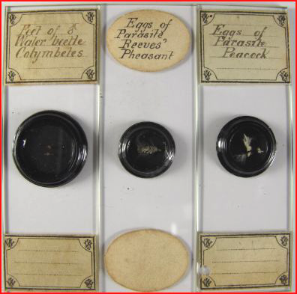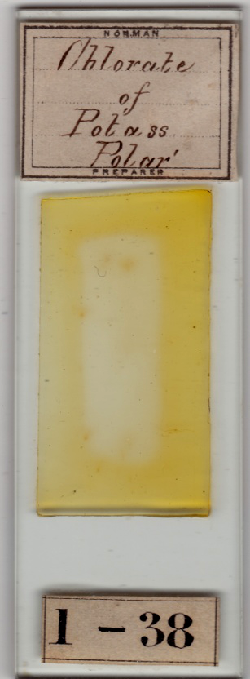
A group of three slides, including two with the reversed “WJN” monograph (image courtesy of Richard Courtiour): the handwriting seems identical to that on my “Chlorate of Postass” mount, with its conventional Norman label.
I do not know whose handwriting this is: certainly not that of John Norman junior, nor William Norman’s cursive, nor most of the many handwritings seen on Norman labels.
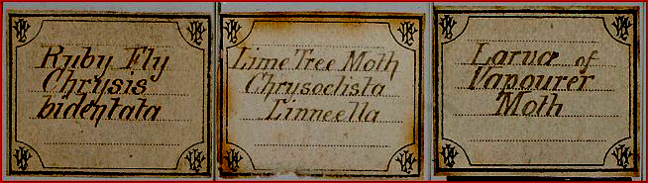
Three more labels with the same handwriting: image courtesy of Brian Davidson
Sorting through my Norman slides (some two thousand) I can find only a few with that handwriting on conventionally printed Norman labels, as on the “Chlorate of Potass” shown above. Two more mounts below from my collection, seem to share the same script.
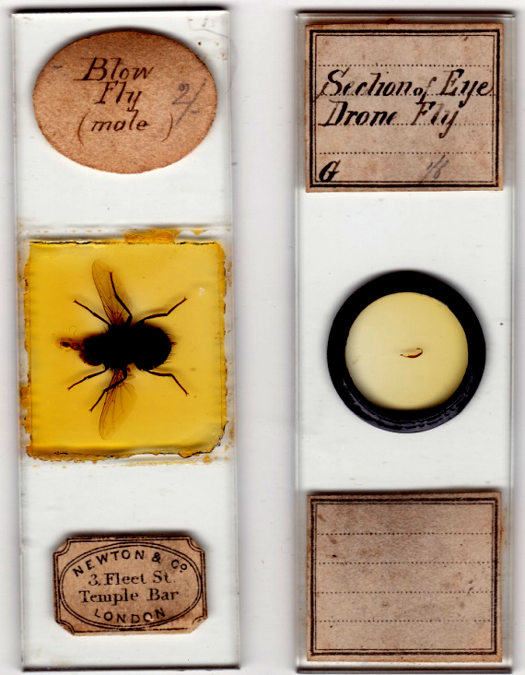
All the aberrant slides, with or without reversed “WJN” monograms, feature insect material, the focus of William Norman’s mounting activities later in his career, particularly after his move to Walthamstow.
So much for the subject matter – but who wrote on the labels? I have long suspected that females in the Norman family, and perhaps even some in-laws, contributed to the business. It seems reasonable to assume that they helped from time to time, if only to assist with labelling. Two of the Norman daughters – Mary Ann and Sarah – married printers, and quite a lot of Norman slides are found with wholly or partly printed labels. One wonders if sometimes the females joined in actual mounting – if only out of familiarity with the intense industry surrounding them, and curiosity about the details. In that context, perhaps the likeliest candidate seems J.T. Norman senior’s second wife, nee Mary Boroff.
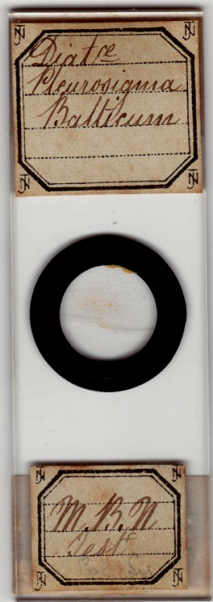
The initials “MBN” on the lower label of the test mount above may represent M(ary) B(oroff) Norman.
The girls grew up amidst intense mounting activity by many family members. Their childhood must have been a bit like that of Charles Darwin’s youngsters: Charles spent many years working on barnacles, and when visiting friends or relatives the children used to ask, “where does your father keep his barnacles?”
This, of course, is speculation, and readers may have alternative explanations and/or evidence about the handwriting on some Norman labels, or participation in the mounting process. For label production, the extended Norman family did not lack printers, or ready access to them: as already mentioned, two of the girls – Mary Ann and Sarah – married printers, and three of Alfred’s children worked for printers while William was still alive and mounting. I have no evidence to support these various possibilities as the source of the misprinted “WJN” monogram, and it may not have been any of them, but another printer altogether, who was soon discarded.
Envoi
Whatever the detailed explanation of the aberrant labels, they seem to be few and far between in the general context of Norman work, with its truly vast output. Realising the cause of the “mirrored” monograms recalled a memory from many decades ago. Back in the cretaceous era, when compositing layout with moveable blocks still prevailed, I was the editor of my medical school student magazine, and responsible for page design. One such was an entire half page in very large bold type, featuring the word “POETRY”. Unfortunately I failed to spot a compositor’s error until it was too late, and the print run was over. The result was “YRTEOP”. When the magazine was distributed for sale I strove to avoid eye contact – but within a day I learned that the misprint was being hailed as a stroke of design genius. Neither I nor the designer of those misprinted “WJN” labels deserved such an accolade.

Contact author at: lois737 AT bigpond DOT com
(Anti-spam format, replace capitals with appropriate character and remove spacing.)
Published in the April 2015 issue of Micscape Magazine.
www.micscape.org

