THOSE OTHER MOUNTS BY ADOLF SCHULZE: NEW EVIDENCE
Peter B. Paisley
Sydney, Australia

Recently acquired slides throw light on the activities of Adolf Schulze – providing fresh evidence, but posing difficult questions.
A Starting point
Sorting my slides revealed two Baker labels whose handwriting seemed familiar. Microscopical Mounts and Mounters plates seem to yield two handwriting possibilities – Earland, or an undesignated mounter on plate 42D in MM&M.
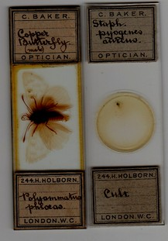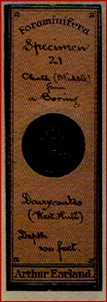
(L) Two Baker mounts from my collection, (R) illustrations 44D & 42D in MM&M
Earland can be ruled out - the mount on the extreme right above is dated 1878, when he was only 12 years old. Another of my mounts (below) has label handwriting somewhat reminiscent of that on the MM&M 42D example above.
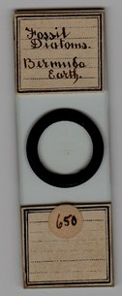
This and the MM&M 42D illustration above hint at gothic script, suggesting possible Germanic influence. With nothing more to go on, I thought no more about this until now.
German influence
My thoughts on Germanic influence on handwriting proved relevant: a recent article by Brian Stevenson, thanks to information from Peter Hodds, unmasked Adolf Schulze (born and educated, and qualifying as an engineer, in Saxony) as the mounter shown by the MM&M 42D example. Accordingly, I now know he made the mount (below) in my own collection.
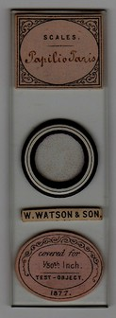
A Papilio scales mount made by Adolf Schulze in 1877
Handwriting here is less “gothic” than on other Schulze labels, but the mount is recognizably his from its distinctive label patterns. Butterfly scales were favoured Schulze choices, not least since they could be sold or exchanged. Schulze mounted diatoms, offering to exchange scales mounts for specimens of Amphipleura pellucida, in Science Gossip in July 1876: that he mounted many species is attested by an article on Surirella gemma in the same issue, and supported by substantial evidence later in this article.
My scales slide above was sold by Watson & Son, probably via W.W. Scott’s opticians premises at 182 Sauchiehall St, Glasgow, which claimed to be Watson’s sole agent. Stocks of Watson instruments, and presumably also mounts, were held at repositories in Glasgow and Edinburgh, and Schulze belonged to societies in both cities. Brian Stevenson suggests that cut down Watson labels indicate intended sales in Glasgow (as opposed to London). I think the explanation is simpler: full sized Watson stickers would have spoiled the look of Schulze mounts - obscuring their lower labels thus hiding technical information, something he would not want.
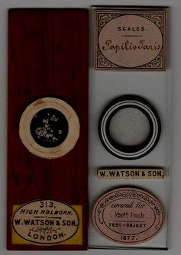
The mount (L) has a Watson retail sticker – who knows what information the label beneath may have revealed?
Schulze mounts of the sort shown above(R) turn up very rarely on auction sites such as eBay: two more are shown below, including an example of the even rarer lower label bearing Schulze’s name.
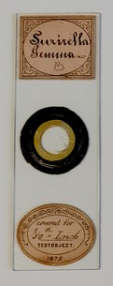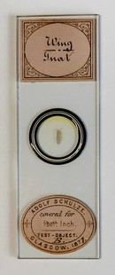
Images courtesy of Peter Hodds
The fact that the Surirella gemma mount is dated twelve years after Schulze’s Science Gossip article about it, plus Watson stickers on his slides, suggest commercial success for his mounts – borne out by evidence shown presently. The papilio scales mount is clearly by Schulze: handwriting less “gothic” than the MM&M 42D example emphasises need for more examples proving common origins (or not). Handwriting of anyone is never totally consistent, but sufficient examples and collateral evidence may promote confidence.
An exact match
Examples illustrated at the outset of this article could have been red herrings, but prompted thoughts about handwriting. Pasteur said discovery favours a prepared mind – and when I saw them offered at auction, I recognised some mounts as bearing the same handwriting as that of Schulze, or someone involved with his mounting activities. A match as precise as that below is rare.
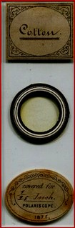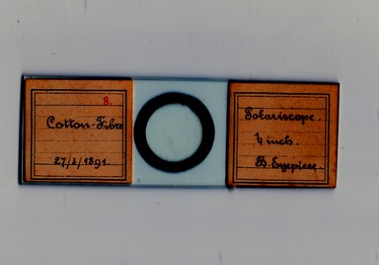
The word “Cotton” seems an exact match on these two labels. The image (L) courtesy of Brian Stevenson.
The mount (R) above is one of about 50 in my collection presented in identical horizontal style, which contrasts markedly with that of (L) above. Such mounts may have appeared at auction with frequency, unrecognised as by Schulze. In particular, the upper case C, seen also on the two Baker mounts previously, is characteristic of Schulze – significant in the light of other evidence I show presently. If my own collection, generally, is a valid benchmark, this style of upper case C is peculiar to Schulze.
Cotton and other materials
The Natural History Society of Glasgow’s obituary (January 1891) gave Schulze’s first occupation in England, in 1861, as that of draughtsman to the firm of Pratchett and Blaylock, who made steam engines: presumably Schulze was involved in their designs. He then saw better financial opportunities, so by 1866 had joined his brother in a yarn business in Manchester. Within a few years he had taken up residence in Glasgow, but maintained intermittent contact with the Manchester business.
It was a bad time for cotton, hence Manchester, due to naval embargos of the American Civil War, during which cotton was supplanted by wool and linen for yarn manufacture. By 1870, cotton spinners were back in business – probably again using American imports – near Glasgow, in Paisley, for instance at the Kerr & Co. Underwood mill. Manchester trade with the USA was well re-established by 1876:
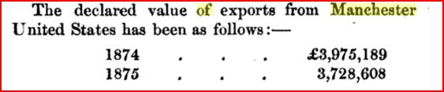
From George Sauer’s Handbook of European Commerce, 1876
Schulze probably never dealt with raw cotton, but with the value added product, yarn. Linen yarn could be obtained from close at hand in Ireland, and cotton, wool and silk from the Middle East: wool might also come from Australia, which was “riding high on the sheep’s back”, via spinners in Bradford in Yorkshire. Hence, alternatives could circumvent the “cotton famine”. The Schulze brothers established middle eastern contacts, probably during the “cotton famine”, and their trademark, below, specified Smyrna material.
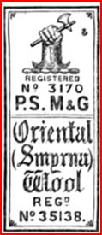
Yarn from Smyrna (modern Izmir, Turkey) included mixtures containing silk, popular for “Berlin” needlepoint patterns: pattern packages were copyrighted by the Schulze business. (Curiously, after the American civil war, resurgent cotton spinning activity sprang up in Smyrna, Georgia – now part of greater Atlanta.)
The redoubtable Mrs. Beeton’s work on needlework, much augmented by others, appeared after her death, in 1870 - so the Schulze yarn business could supply a burgeoning household industry. (I have seen no Schulze mounts featuring yarn material other than cotton, but it would be surprising if none were made.)
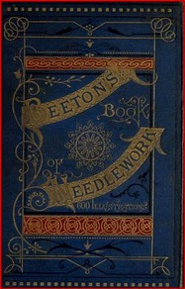
A best selling help for the Schulze yarn business?
Diatoms
Schulze’s Science Gossip entry on Surirella gemma is noted above: my own collection has no examples, but contains three mounts of other varieties – S. splendida, S. fastuosa and S. decora, shown below.
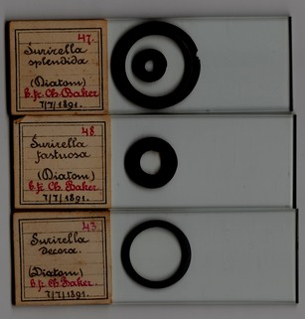
Obtained from far and wide, Schulze’s diatoms came, for instance, from Panama, Virginia, Japan and Corsica.
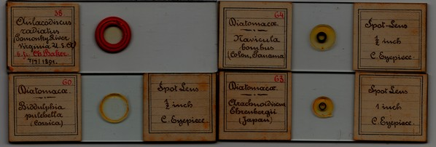
Left hand labels on these horizontally presented mounts bear numbers in red ink at the top right of their labels: I think these refer to cabinet or tray positions. More significantly, many have “6 fr Ch Baker” – again in red ink – added beneath specimen descriptions. Schulze therefore at some time negotiated to supply the Baker firm with mounts. That may have been when he attended meetings of the Royal Microscopical Society in London, or when Baker exhibited products at scientific meetings in Scotland.
The handwriting on those labels varies from upright to slightly backhand: the Baker mounts shown at the start of this article bear lower case lettering the same as that on the horizontally presented mounts, whose red ink annotations suggest that the Baker staph pyogenes and copper butterfly mounts are indeed by Schulze. As to the Bermuda fossil diatoms mount shown previously in this article, I think the label handwriting probably is that of Schulze. He certainly mounted fossil diatoms, as exemplified below.
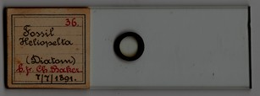
A fossil diatom mount: Schulze does not tell us whence it came
A wide range of interests
Considering his interest in scales, it is not surprising that Schulze mounted insect specimens. The Baker copper butterfly is probably by him: a whole flea mount, below, certainly is.
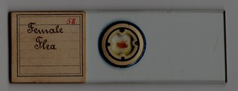
He probably “anatomised” several insects – that is certainly the case for the hive bee, below.
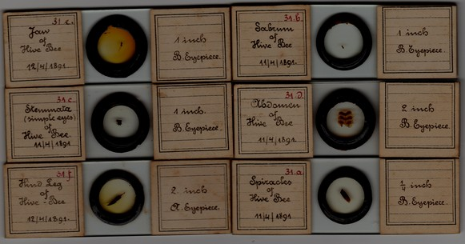
Like many other nineteenth century mounters, Schulze made proboscis preparations (below) like those pioneered by Topping.
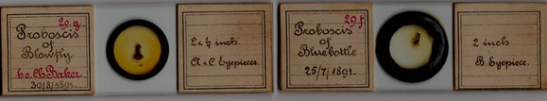
Judging by reports in a variety of publications, Schulze was fastidious in matters of microscopical technique, so it is no surprise that he liked to compare direct and transmitted illumination, for instance for the cuttlefish shell mounts below.
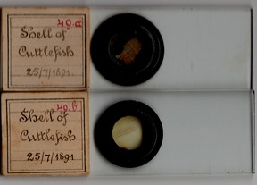
Many other materials were mounted: zoophytes, paper, sea soundings, parasites, blights and plant parts, as shown below.
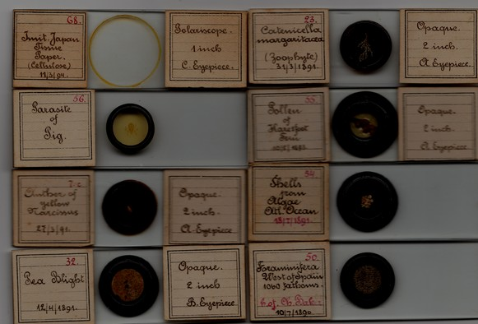
A major problem
Adolf Schulze died in early January, 1891. On the horizontally presented mounts shown in this article, some labels bear no dates. Only one (foraminifera from west of Spain, July 1890) pre-dates his death. Most have dates months after his demise, and one (Japan tissue paper) is dated March 1894 - over three years after his death. What can this mean?
Their handwriting agrees with that on known Schulze mounts from the 1870s. Possibly, one person wrote the dates and another – perhaps, previously, Schulze himself – wrote the descriptions. If so, mounts made by Schulze before his death came to light as cabinets were sorted out posthumously, dates being added by someone else as they were catalogued. Red ink additions indicating duplicates for Baker bear the same handwriting as specimen descriptions, so contracts with Baker already pre-dated Schulze’s death.
Another possibility is that Schulze had an assistant who wrote label descriptions, under direction from Schulze or in partnership with him. The likeliest candidate seems to be his wife, Joanna. His son, also named Adolph Paul Schulze, was an infant when Sculze was making mounts in the 1870s, cannot have been involved, as is even more true of the younger children.

The Schulze household, from the Scotland census, 1881
Joanna Schulze, obviously, would have been closely concerned with sorting out her late husband’s affairs and belongings. By 1891, Adolph Paul junior could have helped in cataloguing mounts, and so might have written those label dates. By then, he was working as a clerk, an occupation suited perhaps to cataloguing.
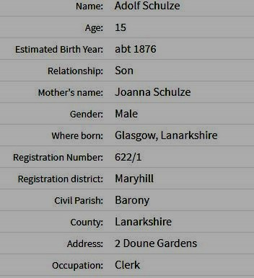
From the Scotland census, a few months after Adloph Schulze senior’s death
Joanna may have joined her husband in his microscopy activities, but short of family letters or diaries turning up, there is no way of knowing.
Lastly, someone from one or other of the scientific societies to which Sculze belonged in Scotland could have helped with sorting, dating the finds, and ensuring that duplicates reached Baker, if that had not already happened. Perhaps Micscape readers may throw light on the matter. I have not found evidence naming his executors.
Except where indicated, mounts shown in this article are from my own collection: the illustrations may stimulate readers to take a fresh look at their miscellaneous (and Baker labelled) items.
Acknowledgements
Thanks to Brian Stevenson and Peter Hodds for sharing images
Sources
Science Gossip July, 1876
Google books
www.ancestry.com
wikipedia
George Sauer: A Handbook of European Commerce, London, Marston, Searle & Rivington (1876)
www.microscopist.net contains extensive information on (and by) Schulze
www.archive.org

Comments to the author Peter Paisley are welcomed, email lois737 AT bigpond DOT com.
Published in the April 2018 issue of Micscape magazine.
www.micscape.org

