SKULDUGGERY AMONG THE MICROSCOPISTS

Peter B. Paisley

Sydney, Australia

When one thing leads to another....
A slide in my collection has an owner’s sticker (a similar one is shown in Bracegirdle’s MM&M plate 40R). The motto – in lumine luce – was common, but much less so if combined with a crest of an arm holding 5 wheat sheaves, narrowing choices to Thompson families in the USA, Ireland, and – in this case – Liverpool.

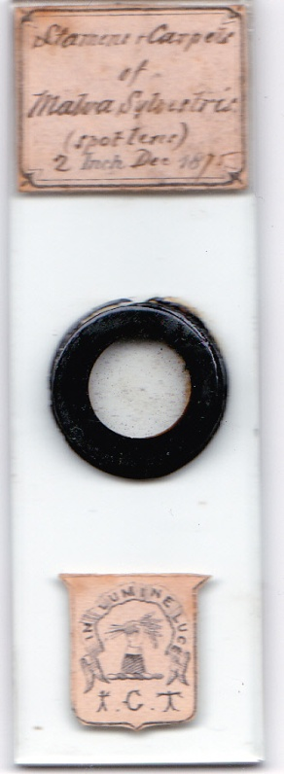

The initials are those of Isaac Crooke Thompson. I acquired it as part of a small collection which contained several slides made by Hume: the handwriting on its label has similarities to that on some bearing Hume’s initials, but there are also differences from Hume’s more usual script. Given Hume’s connection to Thompson & Capper, and the provenance of the slide, this seemed relevant. While pondering whether the slide was made by Thompson or merely acquired by him, my attention became focussed on his background.

A Liverpool homeopathic firm was founded in 1798 by Thomas Thompson. His son George was also a homeopathic chemist, as was his grandson Isaac Crooke Thompson – whose label is on my 1875 slide. Hume’s likely first connection with Thompson & Capper was via Edmund Capper of Bath, from Hume’s days in Gloucester: the provenance of the slide above, though, could indicate a possible double link with the firm.

The Thompson family prospered, not only from dispensing homeopathic remedies but also from real estate dealings.

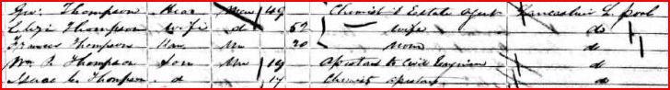

George did well: the 1861 census (above) shows his son Isaac as a chemist’s assistant, and ten years earlier there had been sufficient money to send him to boarding school in Westmoreland. In due course, Isaac had his own homeopathic dispensing business.

Isaac Thompson in the 1871 census

Systematising microscopical findings
Those of us who collect antique slides probably all have some with labels which follow a format like that on the Charles Collins junior mount below.

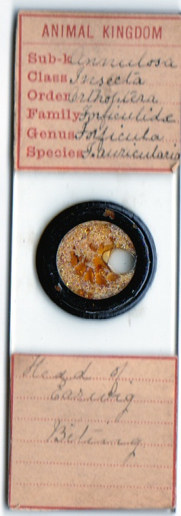

It dates from the late nineteenth or early twentieth century. Earlier, there were sporadic attempts to make labels more systematic. A Wheeler diatom mount (1868) has labels with room for annotations; whether Linnaean or not, and how detailed, was an owner’s choice. I assume this inscriber was right handed, but used backhand for Surirella nobilis, which is on the most awkward part of the labels to allow forward script.

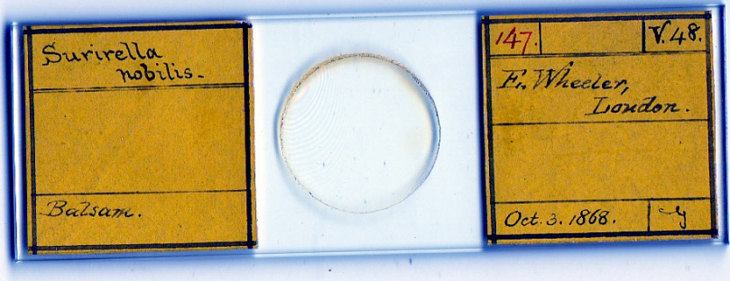

The late eighteenth century brought spectacular antipodean discoveries, and the nineteenth saw European penetration of Africa: there was constant re-sifting of classificatory detail. Lamarck, Chambers and – definitively – Darwin added evolutionary spice to debates. Fossil data added interest: icthyosaurus bone, in particular, seems to have been widely distributed among microscopists.

By and large, many microscopical findings stood remote from broader debates on classification, which focussed on macroscopical morphology, or breeding experiments. There were still plenty of creationist apologists among microscopists late in the nineteenth century, but their position did not often affect their presentation of results. In general there was no urgent need for classificatory mount labelling, in contrast to illustrations and commentaries in books featuring entire animals and plants.

With botanical and chemical material, however, two groups were much more than usually interested in precise classification, namely the apothecaries and the pharmacists. Among the latter, the homeopaths – like Isaac Thompson – and pharmacists like Hume with homeopathic leanings - were perhaps even keener to achieve precision.

Isaac Thompson the indignant microscopist
Isaac was highly active in the Liverpool Microscopical Society, for several years as secretary, subsequently becoming its president. Looking for evidence of his work in journals available on line via www.archive.org I soon stumbled on an interesting case of skulduggery. This concerned neither material he presented nor any slides he may have made, but labels he designed.

One of the early members of the Manchester Microscopical Society was E.P. Quinn. He had commercial premises which sold a variety of microscopical equipment – including labels similar to those above. In October 1883, the notice below appeared in The Microscopical News (p.294):

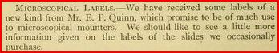

Not only were Quinn’s labels greeted as innovations, but their commercial potential seems obvious from the remarks in the journal: The Microscopical News was an “umbrella” publication covering reports from all over the north of England, and doubtless reached members of very many microscopical clubs.

This produced a spirited response from Isaac Thompson, which The Microscopical News published in November, and is worth reproducing in full:

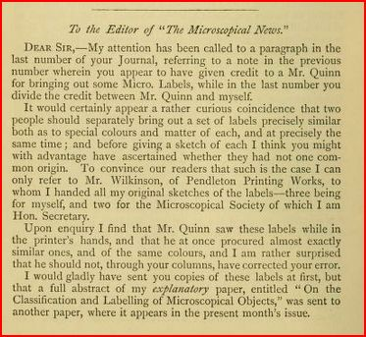

Even this however did not fully redress the situation – the last sentence of Thompson’s protest, over the page from the above, starts with a misprint.

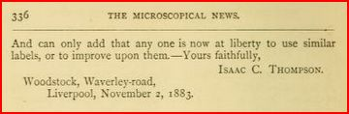

It should obviously read, “One can only add....” etc. Thus did the editor inadvertently add some small insult to injury.

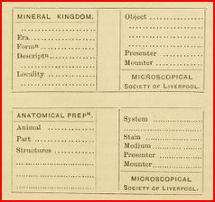

Thompson prototypes, as given to his printer

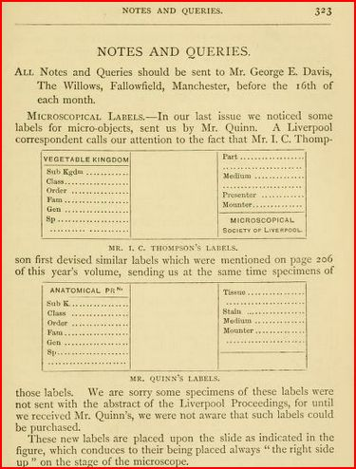

Thompson’s labels, and Quinn’s plagiarism, as recorded with embarrassment by The Microscopical News

I do not know whether Thompson took any legal action over the matter: but he had every right to feel aggrieved. Financially he was well off, of course, so he had no need for extra income from selling labels – and Mr. Quinn did not deserve to make any.

In the nineteenth century, membership of microscopical societies was enormous, and drawn from all levels of society: a huge contrast to our own time, when most of the population do not know what a microscope looks like. The label affair had correspondingly greater significance back then.

I suppose such a large cross section of society inevitably contained a few rogues, and this is a case in point. Whatever Mr. E.P. Quinn subsequently contributed to microscopical work, he was not an honest man.

In the absence of definitive evidence, like a slide with Thompson’s crest label but also signed and specifying him as the preparer, I still cannot tell whether he actually made the mount shown at the start of this article. But the affair my investigations uncovered seemed a curiosity worth recounting.

Email author: lois737 AT bigpond DOT com

Sources
www.archive.org
Brian Bracegirdle, Microscopical Mounts and Mounters, plate 40 R.

Published in the August 2012 issue of Micscape Magazine.
www.micscape.org

