Microscopy Tutorial - How to sketch the Hind Leg of a Honey Bee (Apis mellifera)

My name is Cath Hodsman and I am a Wildlife and Natural History artist. I paint and sketch all wildlife but my main specialism is entomology. I seek to get as much detail in my work as possible in order to pay homage to the hidden beauty of insects. As a result, I use microscopes to ensure I obtain as much anatomical accuracy as possible in my work. To enter the secret world of insects is fascinating and I run many arts courses on how to use microscopes to produce detailed and unique artist and scientific studies of incredible insects. I am particularly captivated by bees, especially with the well documented plight of pollinating insects. I paint and sketch them a lot in my work and as such, I am a member of the British Beekeepers Association . I think they are amongst our most fascinating and beautiful insects. To find out more about the anatomy of honey bees, I can recommend a wonderful site called "How Stuff Works". It provides lots of great facts on bee anatomy. I thought that it might be interesting to enter their secret world by doing a tutorial on how to sketch the hind leg of a honey bee (Apis mellifera) This is the process I use to produce a typical study.....
Equipment:
A microscope 20x and 40x magnification, with natural lighting
Honey Bee Hind Leg specimen (I do not kill anything for my art...I get given a lot of dead insects!)
A fine retractable .3mm propelling pencil
Selection of Graphite pencils
Selection of ordinary pencils 2b and hb
Putty Rubber
Botanical Quality watercolour Paper
Good pencil and graphite sharpener
Drawing board

Step 1: Using a 2b sharpened pencil, draw the outline of the hind leg, to ensure that each part is in proportion and in the right position. I don’t press too hard with the pencil, so I can erase anything that I am not happy with.

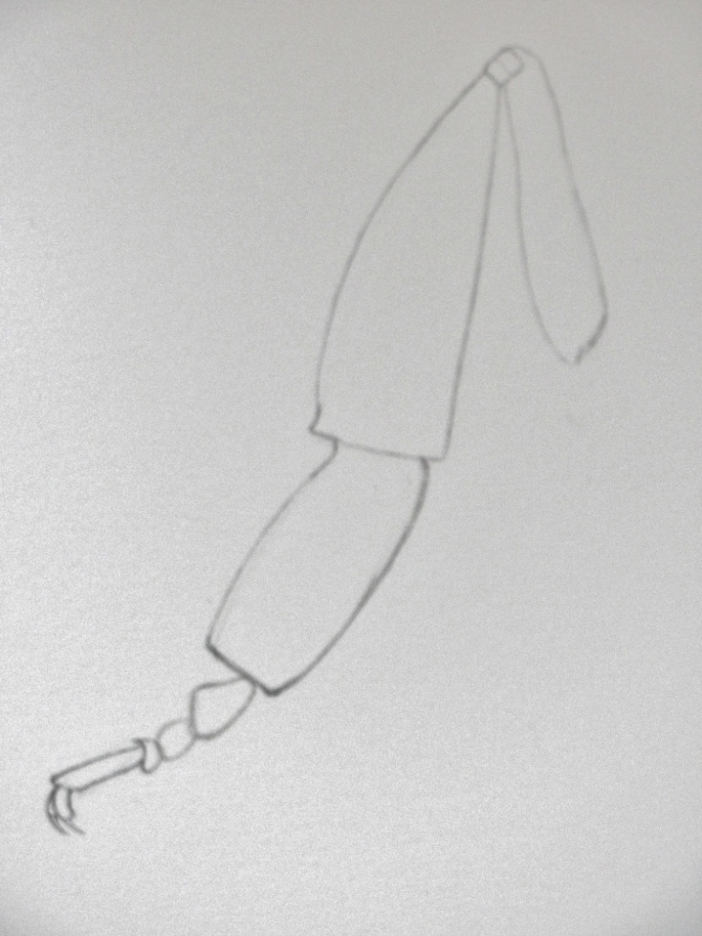

Step 2:
Once the outline is done I start to fill in the detail of each part of the bee’s leg. It is easy to get overawed by something so intricate, but by completing a small piece at a time, I don’t get overwhelmed.... I think of the bee’s leg as series of interconnected shapes that need marrying together and not that I am looking through a microscope at something so tiny that it can be barely seen with the human eye!! I start by drawing the pretarsal claw.

TIP: Sketching through a microscope can seem daunting. With a bit of practice, it will become second nature. It is simply a matter of me looking and looking again at the slide and not forgetting what I have seen...this is another good reason why it is really good to complete a tiny bit at a time. The time lapse difference between sketching an object that is in front of me and one that is on a slide under a microscope, is a matter of fractions of a second...so I don’t worry about the “gap” in between seeing the bee leg on the microscope slide and then looking at the paper and transferring the image onto it.

I use a 2b pencil, but don’t press too hard. I note where the light and dark areas are and “colour” it in accordingly. This will help to build up an initial realistic shape of the pretarsal claw. Once the first layer has been completed, I build up the depth of the shading. Look at the surface of the chitin. It isn’t totally smooth and so to get a realistic texture of this, I use tiny strokes of the pencil to build up the surface. I then draw in the hairs. As the hairs are so fine, I use the 0.3mm lead. It is important to draw them in the direction they grow in and also to get the number and thickness right too.....

TIP: To get a 3d affect, I draw the hairs furthest away from me by drawing them in very lightly and the hairs closest to me, much darker.
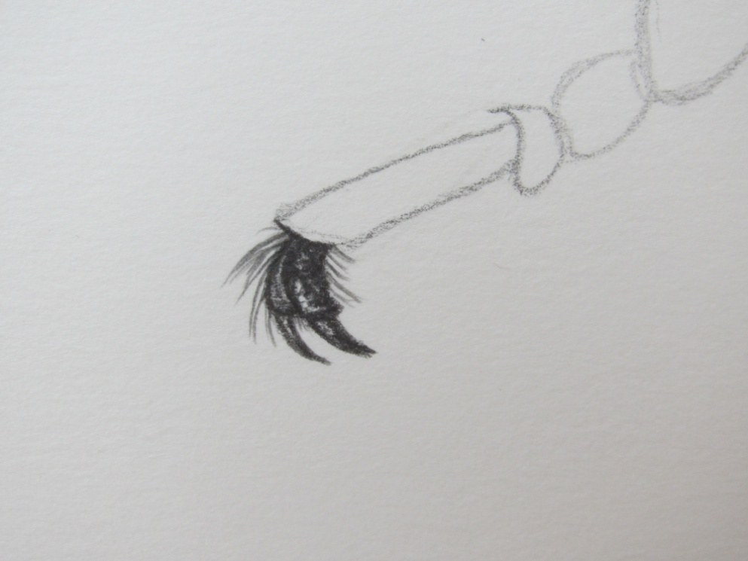

Step 3:
Using the same techniques as above, I complete each joint of the tarsus...
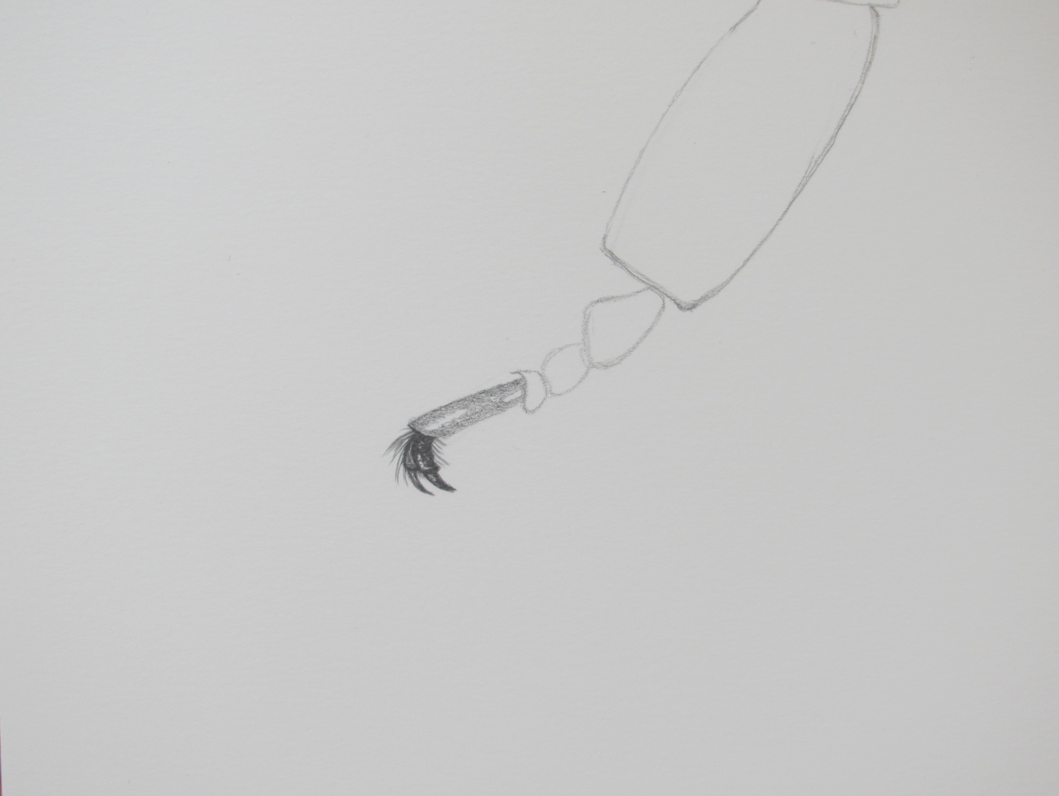

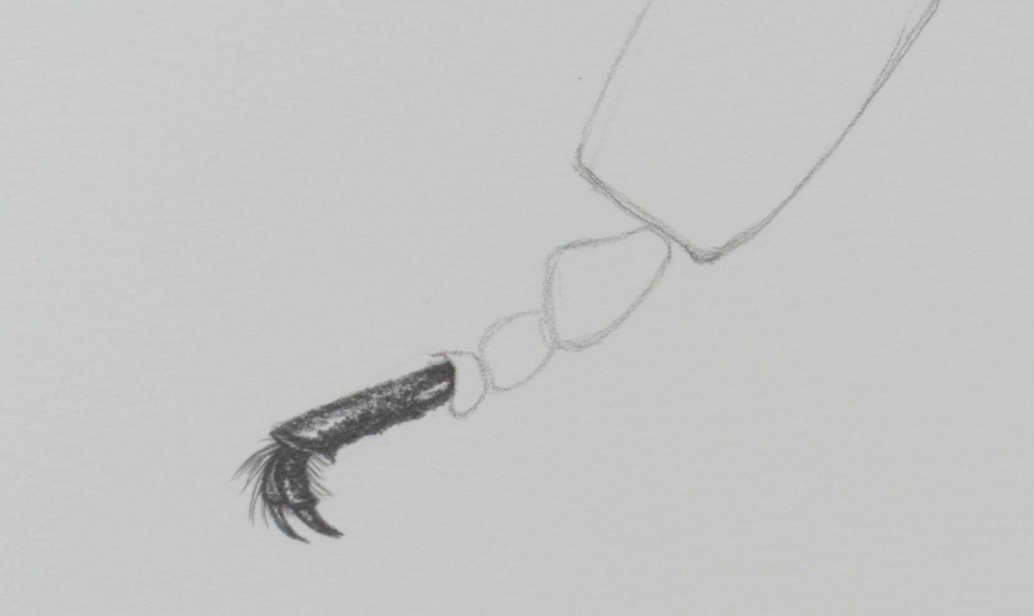

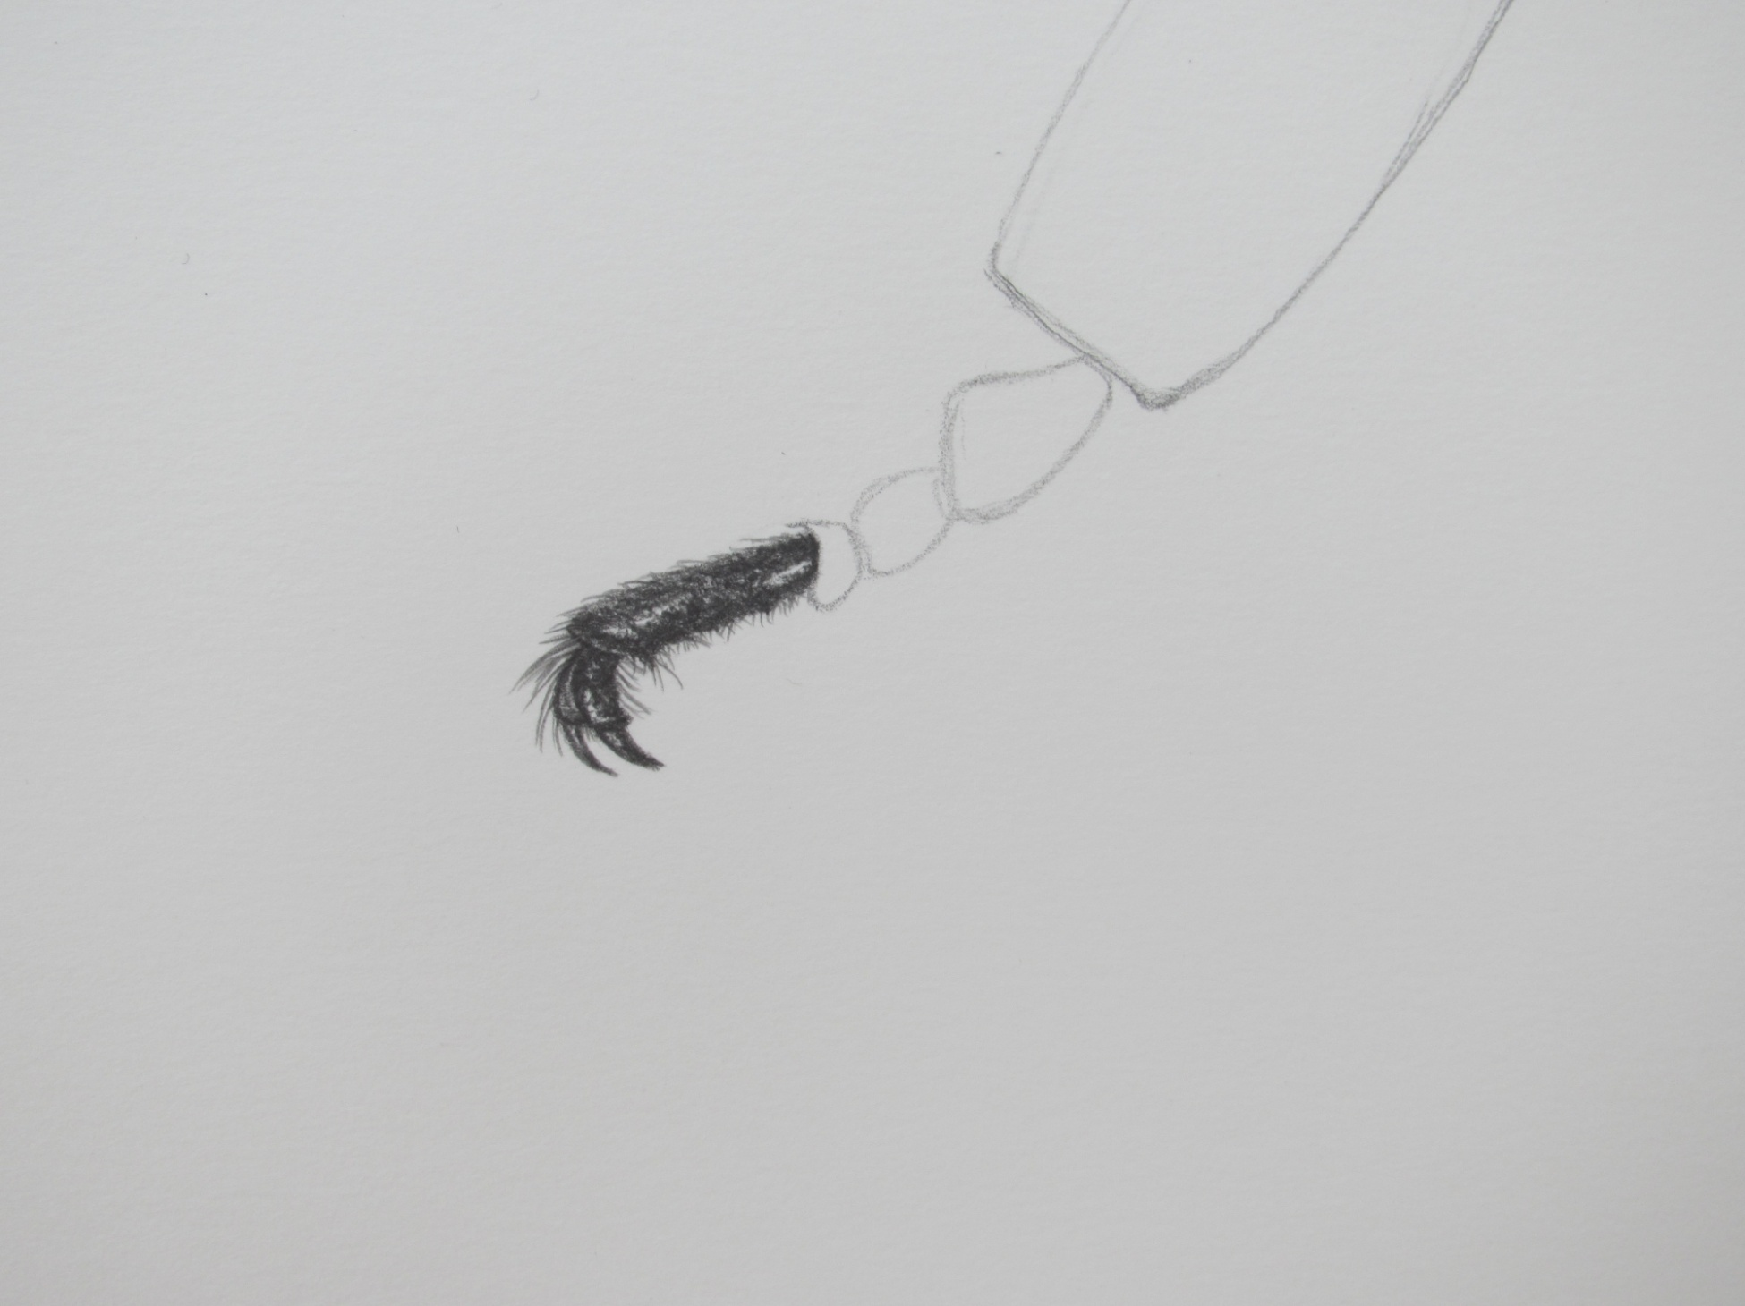
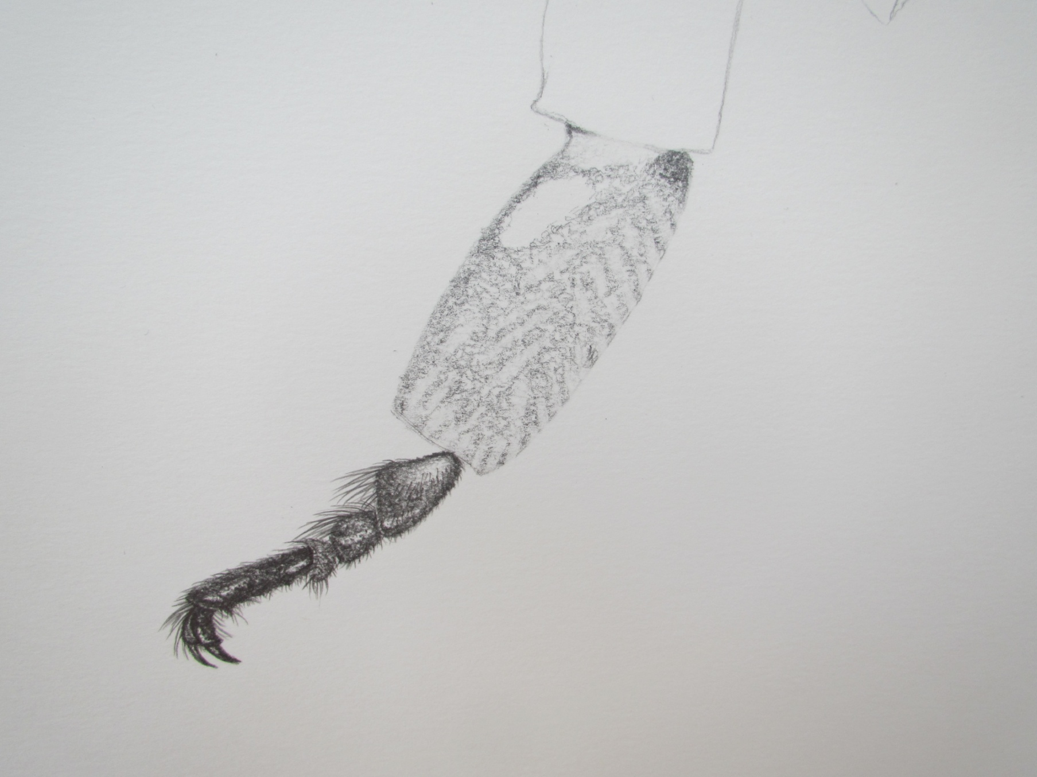

Step 4:
Once all of the individual tarsus are completed, I move onto the barsitarsus. This is the largest part of the leg that I have tackled so far, but the rules are the same. Don’t panic; build up the layers of shading,.....

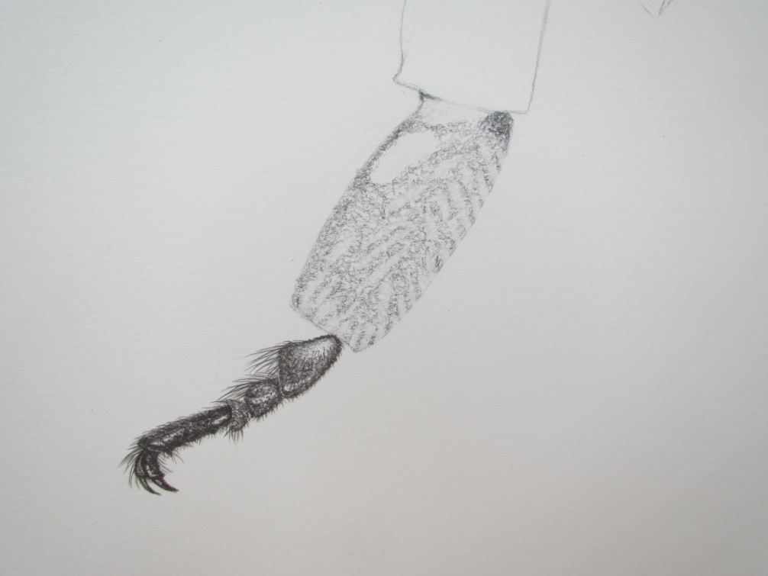

Step 5:
Add in the hairs......
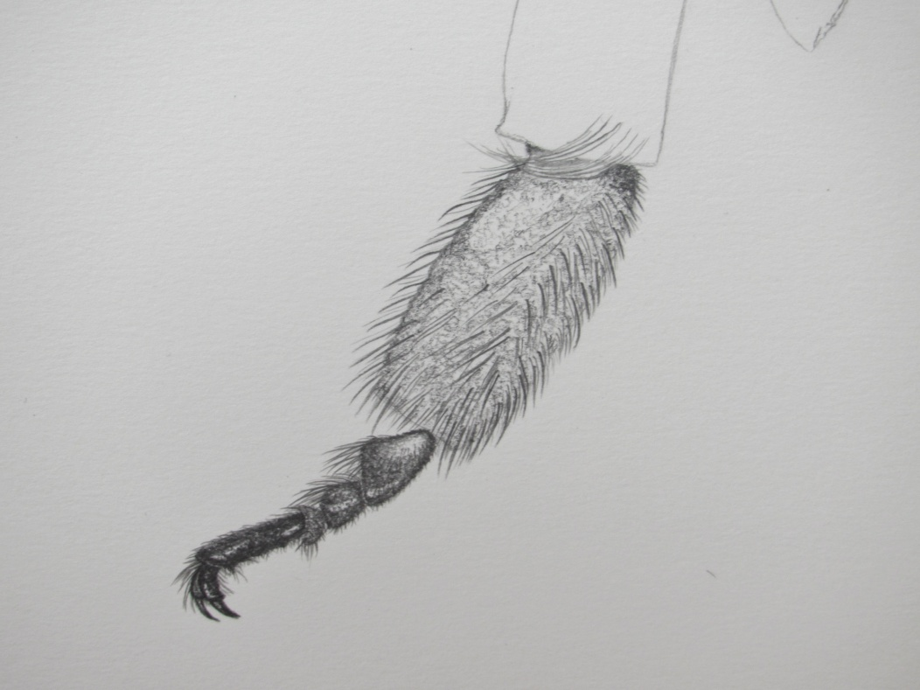

Step 6: I build up the shape of the barsitarsus using the lovely rich graphite pencils to add depth and shape.......
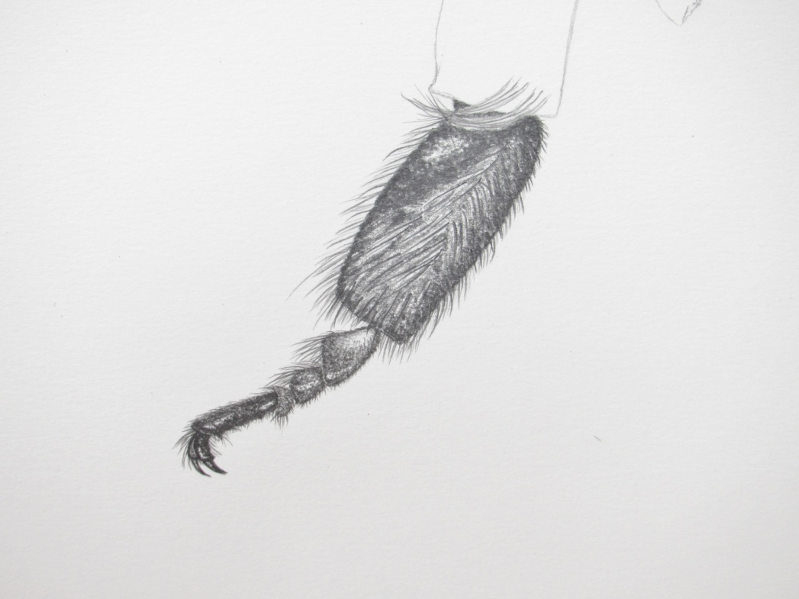

Step 7: I then start the tibia. This is a more complicated shape. It is also where the pollen basket is situated – a very significant role of this part of the bee’s leg, so it is important to get the shading just right, to emulate the form accurately.
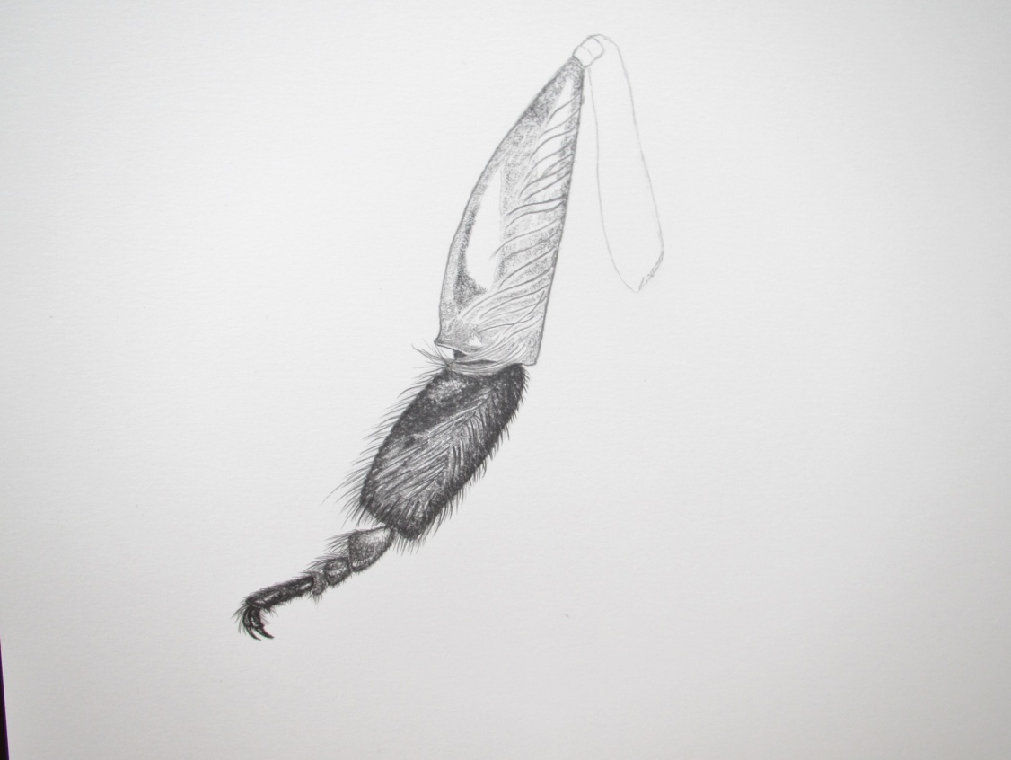

Step 8: After the shading is completed and the hairs added, I have a nice looking tibia...
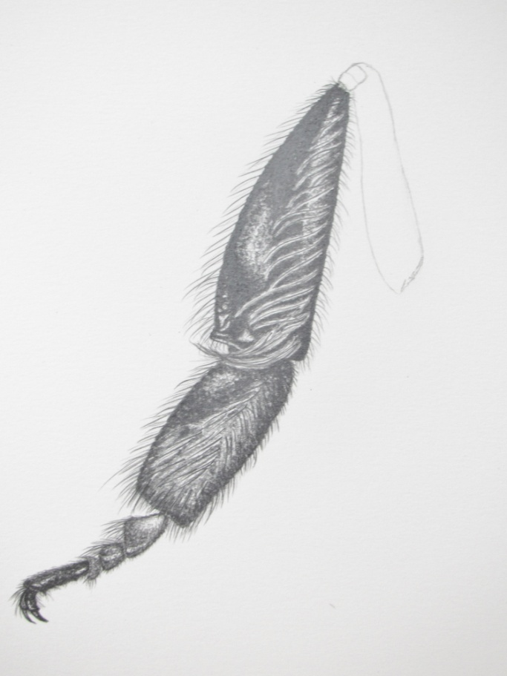

Step 9:
I then start sketching the femur – the last part of this study...
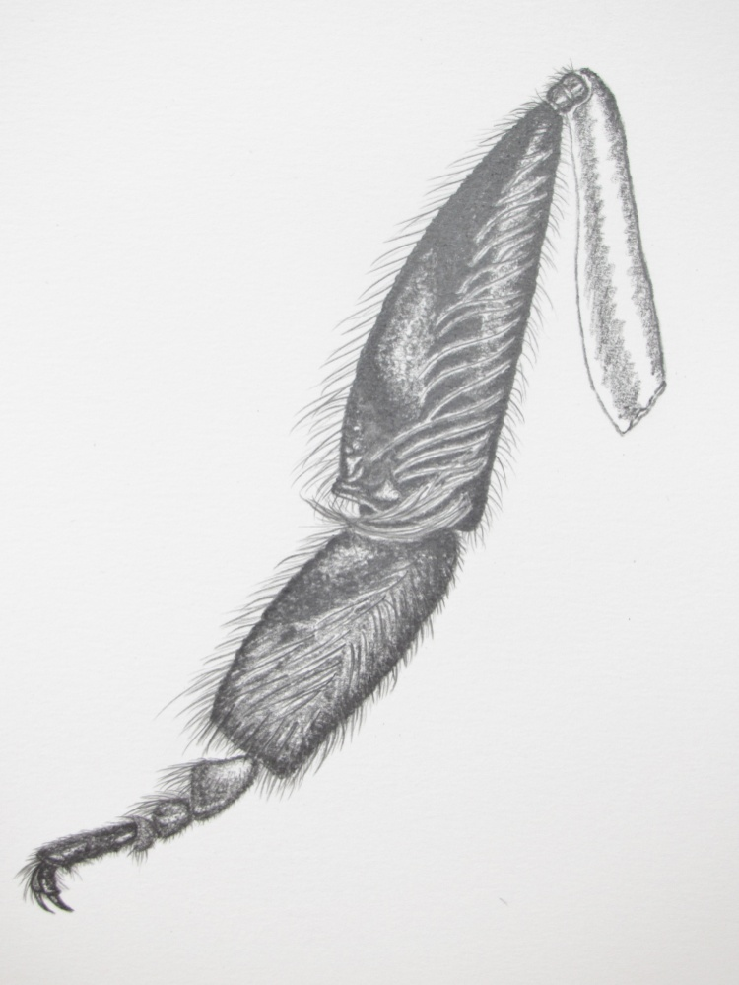

Step 10:
After careful shading and drawing in of all of the hairs, the leg is complete.....

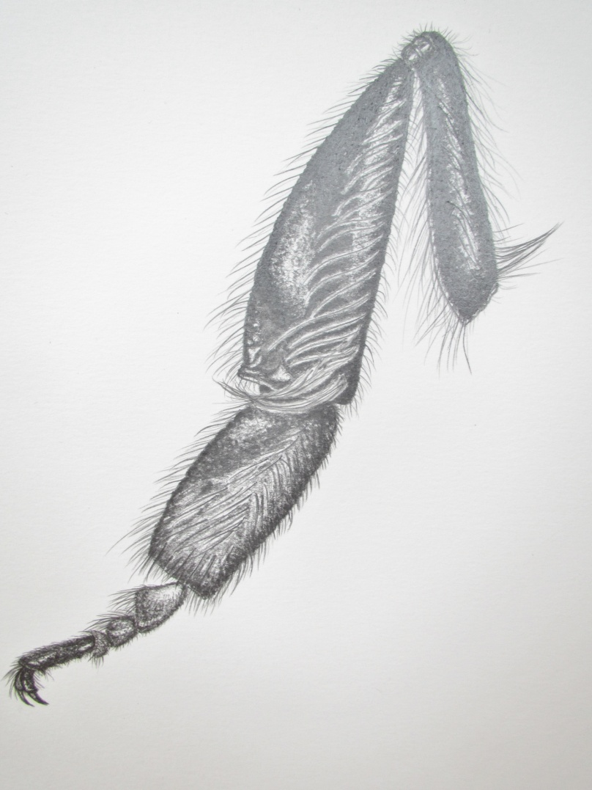

.......A unique way to learn more about the hidden detail of invertebrates and to pay homage to their wonder and beauty.

Comments to the author Cath Hodsman are welcomed.

Published in the December 2013 issue of Micscape.
www.micscape.org

