Xylotomy by Jim Schubert

This is a description of my method for preparing microscope slides of wood. These methods are not the only way of doing it, nor even necessarily the best, but they have worked for me. I have tried as much as possible, to use materials and tools readily available or easily made or purchased. By using a water based mountant for the slides, the health risks from using toxic and volatile chemicals are very much reduced.

Wood Preparation
Select, if possible, a sample from the main trunk of a tree, the outer part of the heartwood.
Ensure that the wood is properly named and labelled.
It is much easier to section fresh, unseasoned wood if this is available, and little or no soaking and other preparation is needed.
However, since it is usually not, most of these notes are assuming that the wood has been dried.
Using a tenon or dovetail saw and trimming with a sharp chisel if necessary, cut a cube of wood small enough to fit into the vice of the microtome available, and also so that the three sections will fit onto a slide, under a coverslip. (My hand microtome will hold 10mm square only – this is normally enough to show all details of the wood, except for some very fast growing ring porous woods, or woods with very large rays. Even then, careful positioning will usually reveal any necessary detail.)

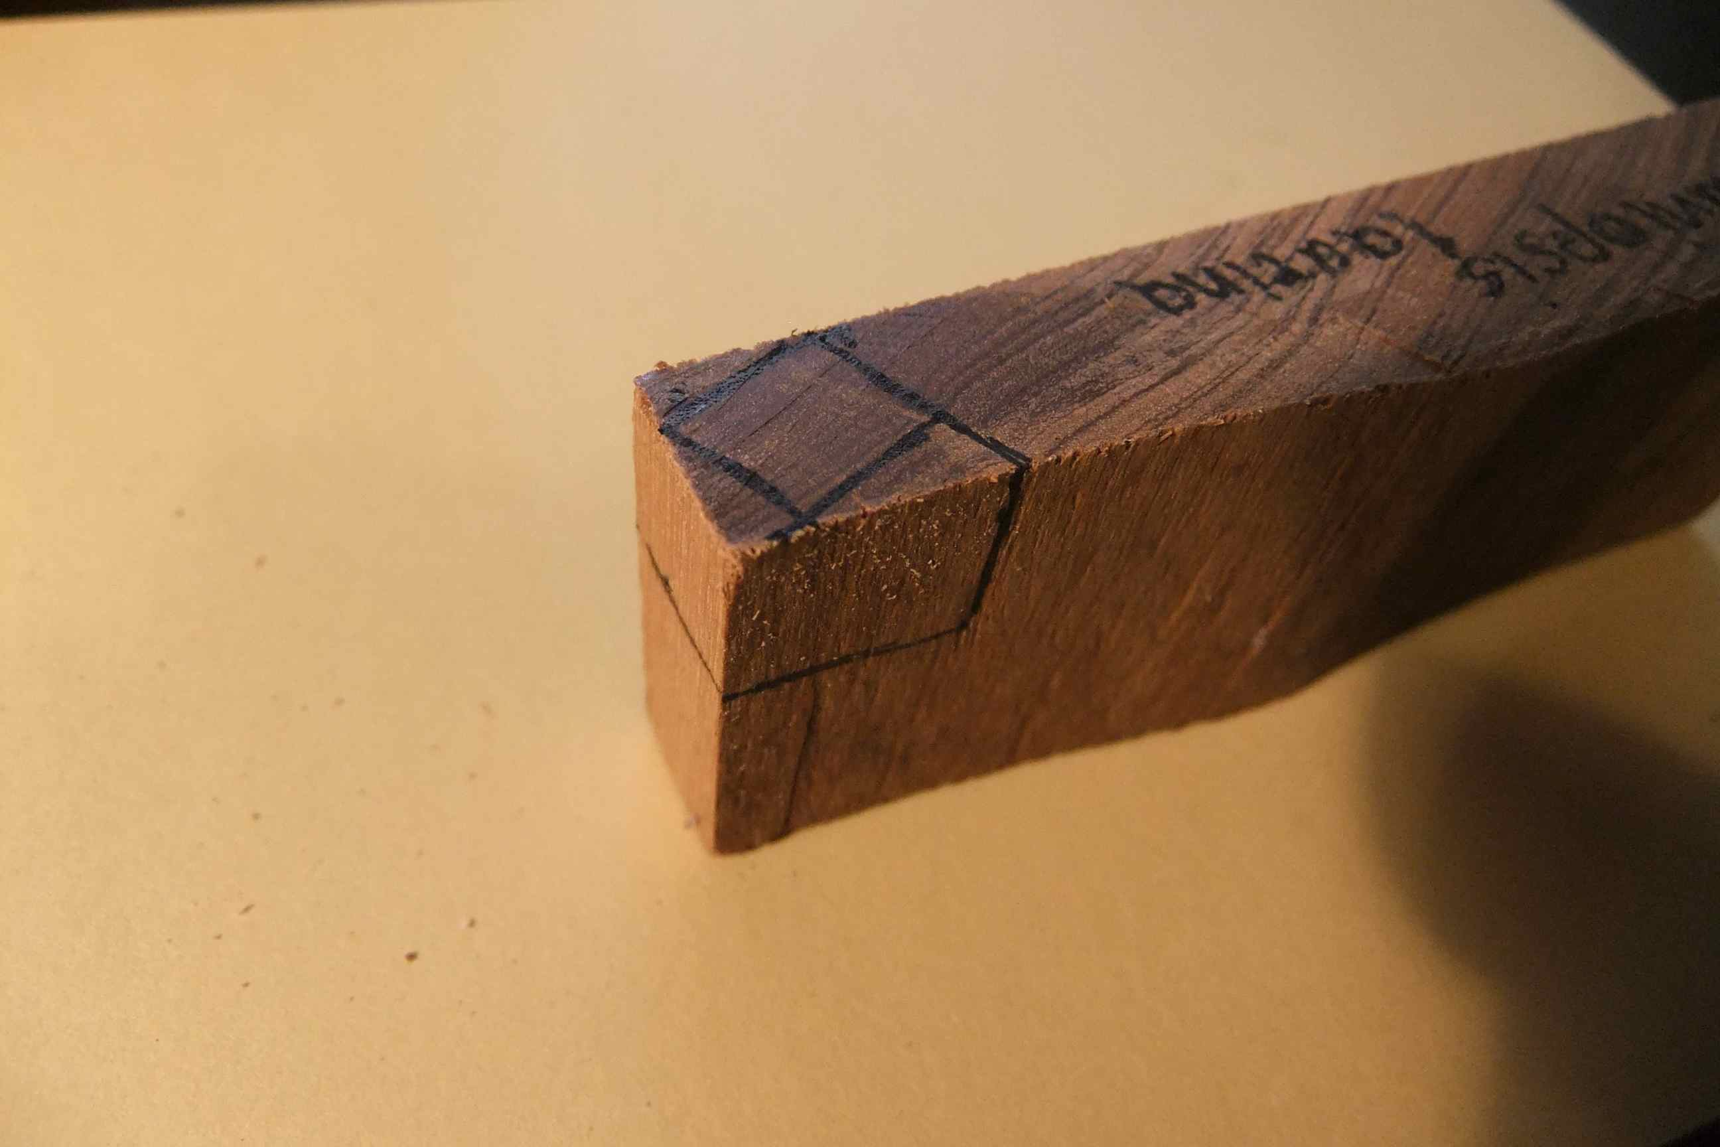
Figure 1. Marked out block aligned with grain, ready to cut.
When cutting a cube, ensure that none of the surfaces have been sanded, as the grit left behind in the wood will quickly destroy the blade’s cutting edge. If a surface has been sanded, cut away about ½ mm or so with a knife, chisel or plane.
Try to avoid wood with hairline cracks, because the thin sections will fall apart at the cracks.
The cube should be cut so that the grain aligns accurately with transverse, tangential and radial grain.

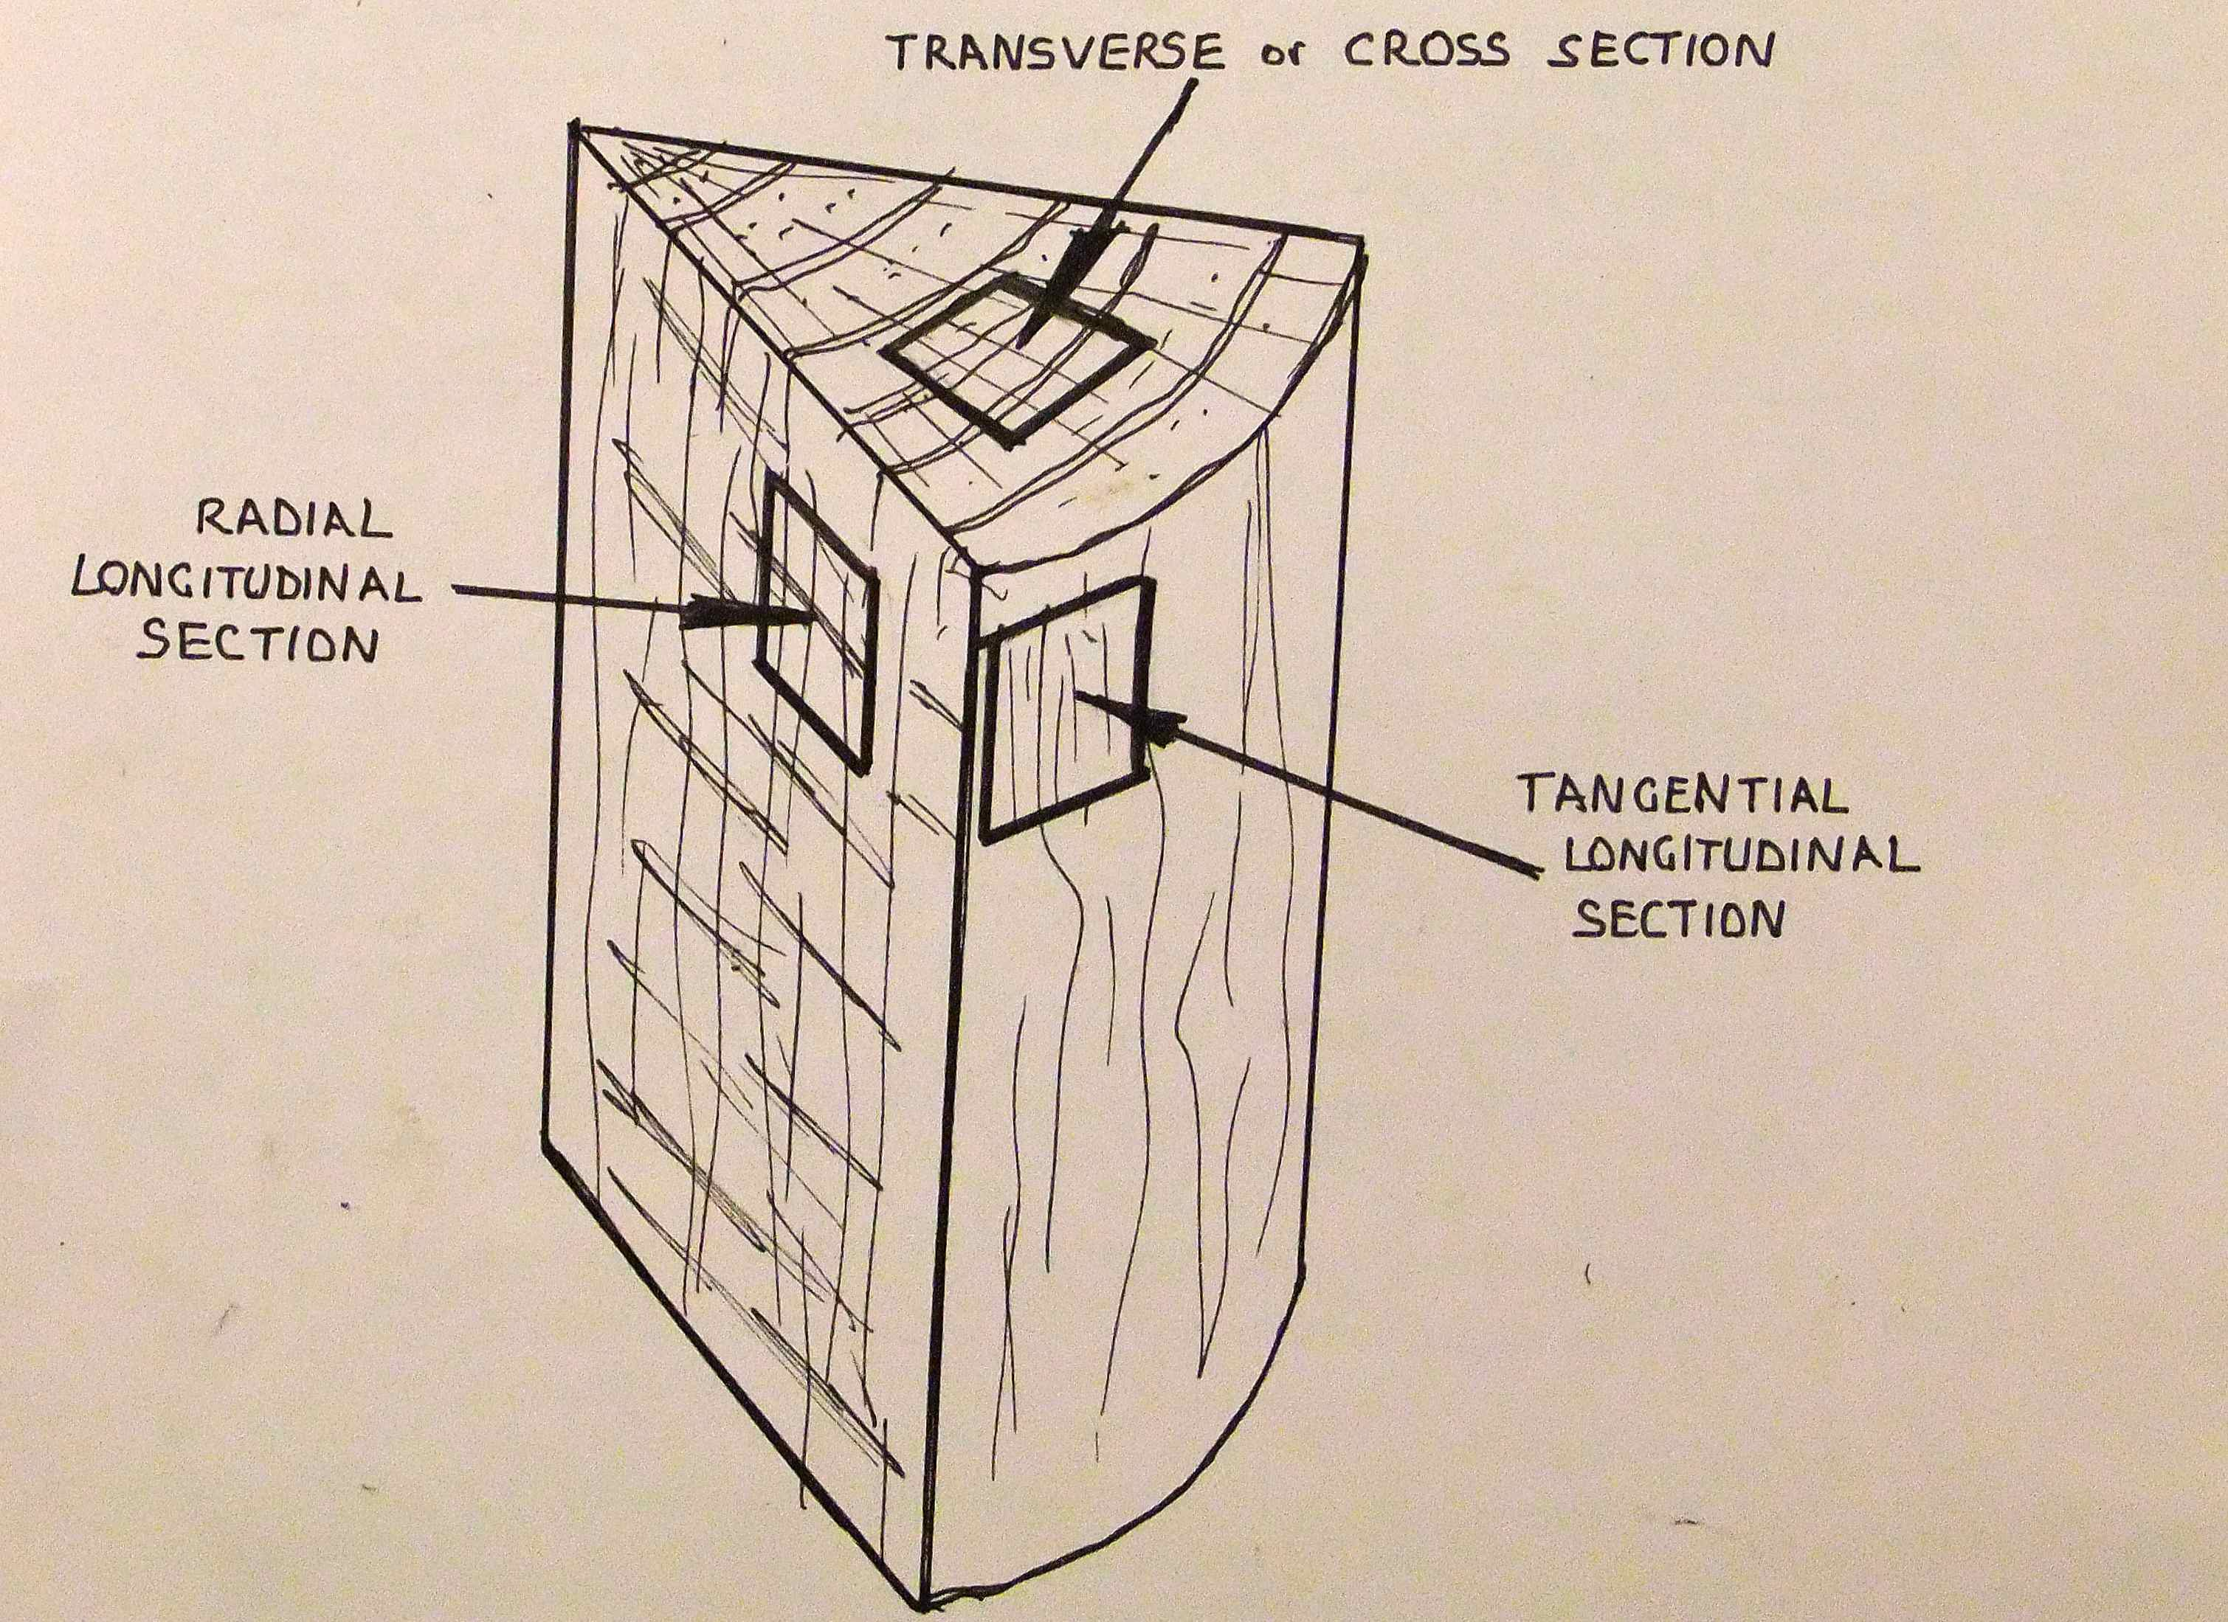
Figure 2. A segment of a log, showing the orientation of the required three sections.
If the wood is dry, determine its approximate specific gravity (SG). This can be easily done by putting a piece of the wood (eg 150x75x12 standard sample) into a large jug of water and estimate the amount that is below the water line. If ½ sinks, the SG is 0.5; if the whole piece sinks, the SG is greater than 1.0. This gives an accuracy, which is near enough because we are only using it to give an indication of hardness and what treatment may be required before cutting into the thin sections needed for microscopic examination.
SG less than0.25 wax or glycol embed, or use cornflour. (See later.)
SG 0.2 – 0.4 harden by soaking in alcohol: formalin 100:5. (meths i.e. methylated spirits is fine for the alcohol)
SG 0.3 – 0.5 harden with meths spirits.
SG 0.4 – 0.6 soak in meths/water 50:50.
SG 0.5 – 0.7 boil in water
SG greater than 0.6 boil in water with some dishwashing detergent.
SG greater than 0.9 as above plus steam onto surface of wood as it is being cut.

Notes
1/ most or all of this is unnecessary if using fresh, unseasoned wood.
2/ soaking for a day or two is usually adequate. A rough guide is that the wood should sink when sufficiently soaked.
3/ boiling for 10 – 15 mins is usually enough – more penetration can be achieved quickly by swapping the sample from boiling to cold water and back again several times.
4/ boiling in water/ detergent can be a bit tricky – the container (saucepan?) very easily froths up and overflows if the boiling is too enthusiastic.
5/ these times are suggested for 10 – 12 mm cubes. If much larger, longer times may be needed.

Wood Cutting
Some form of microtome is highly desirable if reasonable results are to be achieved. I made mine in my shed, but I do have quite a lot of equipment that many people do not have. Professional sledge type microtomes are great, but are hard to find, usually expensive, heavy and bulky and need the use of a microtome blade. A hand microtome, if of reasonable quality, can also achieve good results with a sharp chisel or plane blade. I have noticed a new one advertised on the Internet from ‘Home Science Tools’ for a reasonable price. I have only seen a photo of this and not the actual product, but it looks quite good. Others are also available, either new or occasionally second hand. Rather than hold the microtome by hand, a simple clamping arrangement should not be too difficult to arrange. I have a piece of wood with a hole fitted around the microtome body and clamped onto my bench with a small G clamp. A spare hand is very handy while cutting sections.

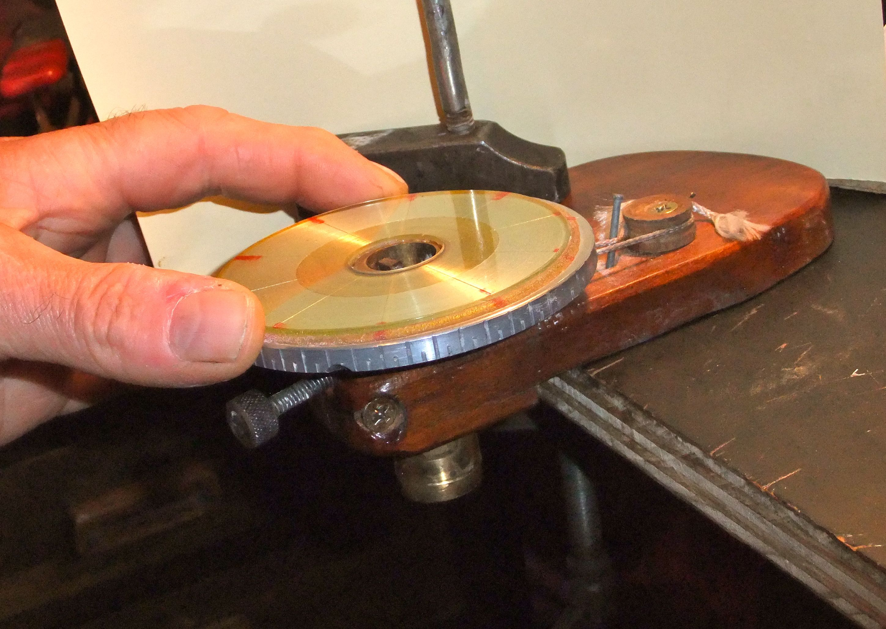
Figure 3. My homemade microtome, clamped to a bench.
Clamp the wood sample into a microtome, accurately aligning the grain for the transverse, tangential or radial section, using a 10x lens if necessary. When cutting longitudinal sections ie tangential and radial, angle the block slightly so that you are cutting ‘with the grain” rather than against it. The block should be clamped so that the side grain moves up a little toward the end of the cut. (fig. 4) This will reduce tearing of the sections and will also ensure that the vessels of hardwoods will not continue for the full length of the sections, which would then fall apart. Only a few degrees are needed, or the vessels will be too short and distorted in the sections. Aim for vessels ½ - ¾ of the length of the sections.

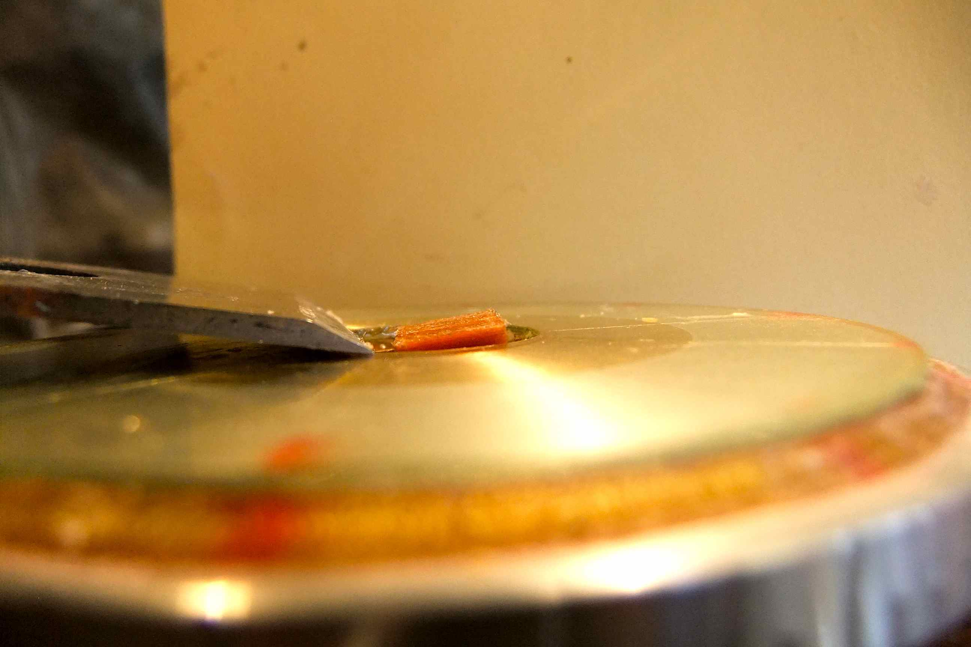
Figure 4. Wood angled slightly for initial cut so that cutting is with the grain and the pores do not travel the full length of the section.
I usually cut the cross (transverse) section first, on the assumption that the blade is sharpest at the start and that section will be as large as possible. An exception is described below for very hard woods.
Ensure that the blade is sharp. (See later section about sharpening and testing blades.)
If using a hand microtome with a plane or chisel blade, hold the blade as when chiselling a surface – bevel up and the flat back of the blade just lifted enough so that it can cut and rub on the top surface of the microtome, thus ensuring a small clearance angle. (fig. 20)
If the cutting edge has a significant microbevel or if slightly rounded on the bottom of the edge, the back of the blade may have to be raised a bit more to ensure clearance and a continual cut through the wood. On the other hand, if the back of the blade is raised more than necessary, the bottom of the edge will be rounded off quite quickly by rubbing on the surface of the microtome. Therefore use the minimum clearance angle that will allow a complete section to be cut.
If rubbing the blade across the surface (usually glass) causes too much damage to the blade, get 2 thin (0.05-0.1mm) identical brass shims 3 – 5mm wide and 25 – 30mm long, bend to a sharp angle and fit over the two corners of the cutting edge so that the edge is that height above the microtome surface. They can be held in place with a bit of sticky tape back from the cutting edge. (fig. 5)
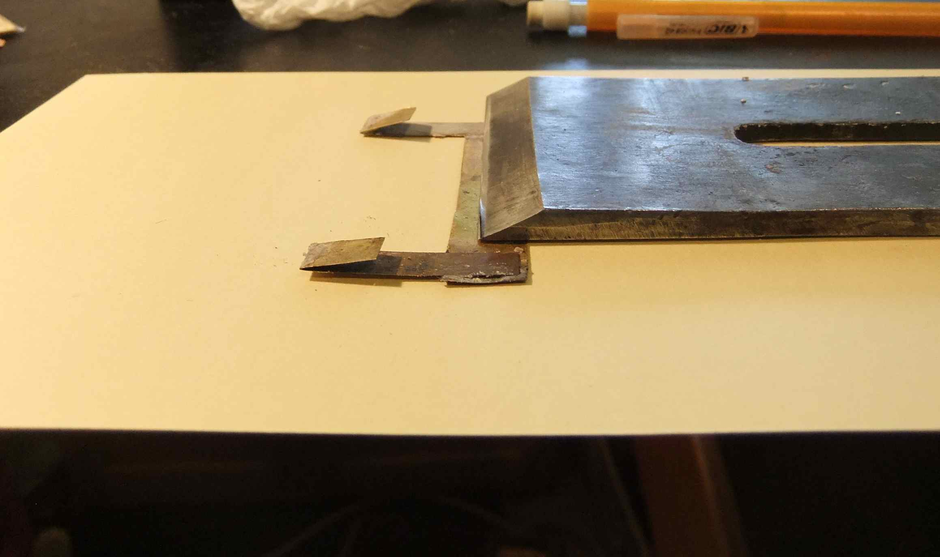
Figure 5. Brass shim used to keep blade edge above glass surface. Slide brass back so that acute angle is against the cutting edge.
Or much simpler, a lubricant such as dishwashing detergent may be put onto the microtome surface. This may help a little.
The angle of “slice” can be varied to give the best results. Usually the transverse section needs a much more slicing action – I use almost the whole width of a 60mm blade to make a 10mm section of some woods. On the other hand, tangential sections can often be best cut with very little slicing action. (fig.6)
Cutting speed can be varied – I usually cut slowly so that I can see what is happening and can reduce curling by holding the section down on the blade with a brush, while the cut progresses.
Use a lubricant on the wood and blade while cutting. This enables the section to slide up the blade more easily, with less compression and distortion.
I use a lubricant similar to that in which the section was soaked ie meths, meths/water, water, water/detergent, or straight detergent on very hard woods. (By detergent, I mean dishwashing liquid detergent of whatever brand.)
While cutting, hold a small brush (artist paint brush) on top of the section, trying to keep the section flat as it is cut and slides up the bevel of the blade. The brush should be held steady in relation to the wood block, and not the blade.

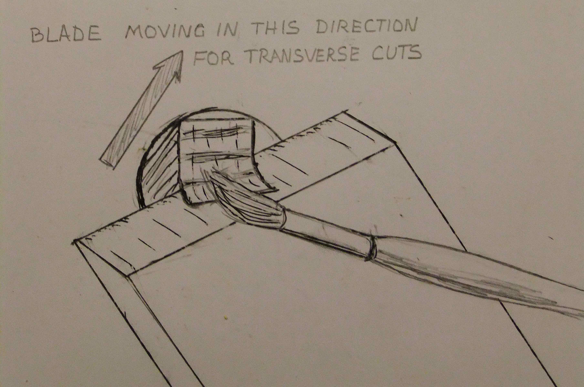
Figure 6. A brush is used to reduce curling and help section slide along blade. The arrow shows the slicing direction used for transverse sections.
Keep the block and the brush very wet with the lubricant, especially ensuring that the bevel of the blade is quite wet where the section slides up, to reduce distortion and curling of the section and friction between the section and the blade.
I leave the wet sections on the blade – slid back a bit out of the way of the cutting edge for a few minutes so that the surface tension of the lubricant holds the sections flat, reducing the tendency to curl.
Aim to cut sections of about 20μm (less than 0.001 inch) thickness. Very soft woods may turn to “mush” at this thickness and 25 – 30μm or even more may be necessary. (Check the sharpness of the blade). Very hard woods can be cut at around 15μm thickness, which may reduce the tendency to curl, or at least make them more malleable to straighten. If too thick, it becomes difficult to see fine details at high magnifications, and if too thin, the sections tend to fall apart and contents of vessels, particularly perforation plates and inter-vessel pits, tend to disappear because there is nothing to hold them in place.
When cutting very hard woods (above about 0.9 SG) I usually try to play steam over the block while the sections are being cut. This will usually soften the wood sufficiently so that the blade will cut more easily. In this case, I often cut the longitudinal sections first so that the block has time to heat up and thus become softer before attempting the transverse section, which is usually the hardest.
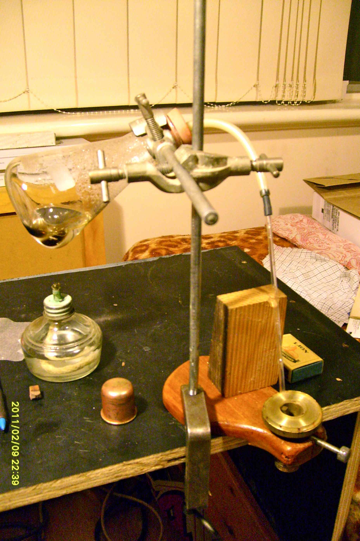
Figure 7. One way of using steam while cutting
With some woods, especially some soft woods and some ring porous woods with lots of parenchyma cells, the cutting will tear or badly distort some cells, even with a very sharp blade. The traditional way to overcome this problem is to embed the sample in wax or similar, which will hold the cells in place and eliminate most tearing of cells. However, this involves a lot of time and work, and usually the use of volatile chemicals. I recently read (Gartner & Schneider 2013) of a much simpler method, described in the next paragraph, which seems to work.
Mix a small amount of approx. equal amounts of water and glycerine (water alone will work, but will evaporate more quickly). Then add cornflour – also known as cornstarch in some countries (I used ‘White Wings’) to the liquid until a smooth paste is achieved. This should be a liquid while stationary, but it becomes solid if stirred rapidly or pressure is applied to it. While the wood is in the microtome and trimmed ready to make a section, paint a coating of this mixture onto the surface of the wood. This can be done with a clean finger or a brush. Then take the slice as normal. Then recoat the wood surface and repeat as necessary.
The cornflour can be washed out of the thin section with water before or after staining etc.
The cornflour works because it changes from a liquid to a solid when pressure is applied to it (a non-Newtonian fluid). While it sits on the wood surface, some soaks into the cells as a liquid, then, when pressure from the knife is applied, it becomes solid and supports the cells. It works very well, but will not hold together broken or cracked parts.
After cutting the sections, leave them on the blade (wet) for a few minutes, especially if they show any tendency to curl, then transfer with a brush to a Petri dish with a little water and Safranin stain.
Safranin is a traditional microscopy stain used for many years, especially for botanical work. It usually is obtained as a very concentrated red powder, which can be dissolved in water or alcohol. I use a dilute (0.1%) solution in water. If it is hard to find, it may be worth experimenting with wood stain – either water or alcohol based, or perhaps some food colouring. The colour is unimportant; the reason for staining is to make the various cells more visible.
Often a counterstain of contrasting colour and different chemical make-up is recommended to emphasise different constituents of the wood, because different stains can work on different chemicals. Slides made in this way can look spectacular and can be very useful to identify different types of cells. If using fresh sapwood, especially if bark is present, this may be worth trying, but I have found that seasoned heartwood will only stain one colour. Therefore, I do not generally use this method.
I add about 5 – 10 drops of 0.1% Safranin in water to water in the dish. If the sections show much tendency to curl, use only a small amount of water in the dish, so that the sections are held down by the surface tension of the water, and curling is reduced.
I cut all the sections I want from one piece of wood into the one Petri dish. This is usually about 6 or 7 sections of each of cross, tangential and radial. From these, I will pick out the best bits for 3 slides.
Leave for 24 hours or more for the stain to act on the sections. If you want to reduce the time, either make the stain more concentrated, or heat the sections in the stain. Swirl the dish occasionally during this time, to ensure that the stain gets to all the sections and stains evenly.
When the sections have stained evenly and enough, they are ready to mount.

Mounting
There is much information available about mounting objects on microscope slides. My method differs mainly because I use a water soluble mountant (that’s the clear substance between the slide and coverslip and surrounding the objects being mounted), while most people use a resin based mountant (Canada balsam or similar). The advantages of water based mountants are that the objects being mounted do not have to be completely dehydrated, and volatile and toxic chemicals (eg xylene) are not needed.
The substance I use is Karo, a corn syrup sugar solution available from most supermarkets. It is a clear, fairly viscous liquid, which will eventually dry without forming crystals like normal sucrose. An alternative is to use a fructose solution if Karo is unavailable. I add about 2% phenol crystals (carbolic acid) as a preservative. This is not strictly necessary, since sugar is a natural preservative (think of jam), but I am hoping that the phenol will help to discourage small insects from attacking the slides in the future. Probably other preservatives could be used, but I have not done any experimenting. Dioni suggested using Listerine mouth wash in his water based mountants at about 3% concentration.

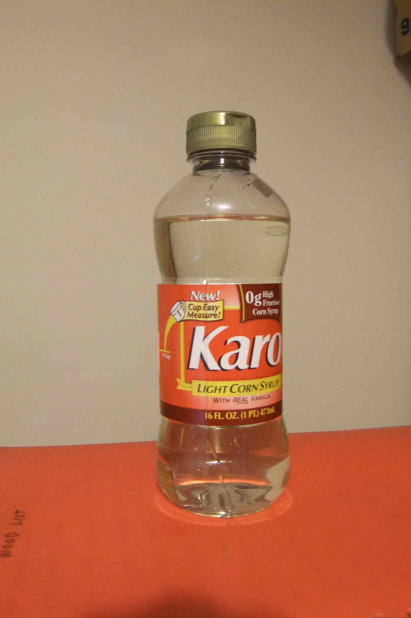
Figure 8. Bottle of 'Karo'.
Before mounting, check one section (pref. radial or tangential) by taking it from the Petri dish and putting it onto a spare slide into a drop of 80% Karo with 20% water, using forceps. Examine the section carefully at 40x magnification on a stereo microscope. If air inclusions are present in any cells (usually seen as black or with black surrounds) take all the radial and tangential sections to be used, put them in a small beaker with 10 – 20 ml. of water with 2 drops of Safranin, and boil for 5 minutes. I use a small meths. spirits burner. Transverse sections rarely suffer from this problem. If no air inclusions are seen, this boiling is not necessary.

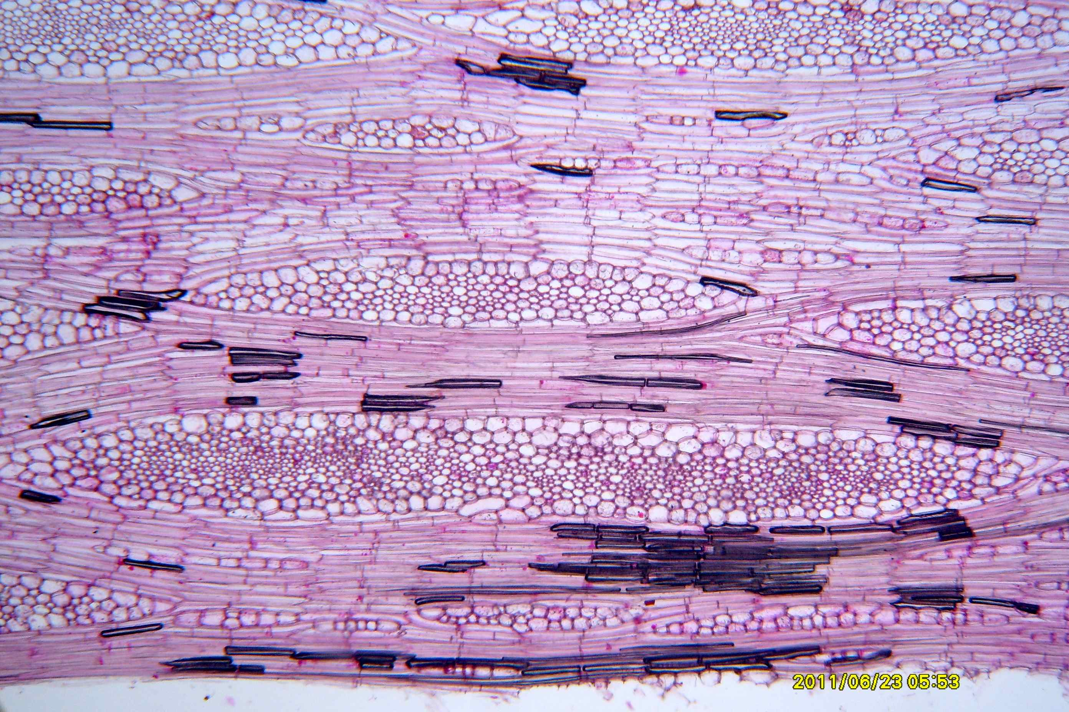
Figure 9. Showing air inclusions in fibres in a tangential section.

Then pick out the best sections to be used, and put them onto a spare slide with some 50% Karo. After about 10 minutes, remove most of the 50% Karo with a small teat pipette and replace with 80% Karo. Leave for another 10 mins and replace again with 80% Karo. After another 5 – 10 mins., they are ready to mount.
Prepare cleaned slides by rubbing a tiny amount of Mayer's albumin onto the central part of the slides, then wipe most off. I use a forefinger to rub it on and the side of my hand to wipe off the excess. Repeat for all the slides to be mounted. This acts as an adhesive to reduce the tendency of the sections to slide around when the coverslip is pressed down on the slide.
Mayer's albumin can be made by mixing equal amounts of egg white and glycerine and filtering through a tissue to remove any lumpy bits. It can only be kept a few days like this or for a month or two if a crystal of thymol is added.
Spread several drops of 90-100% Karo (actually with 2 – 2.5% phenol added as a preservative) onto the centre of a prepared slide with a thin knife or scalpel blade. Move slowly and smoothly to avoid bubbles and breathe on the slide first to moisten it a bit. Check under a stereo microscope, (lowest power; 6 – 10x) and remove any bubbles with a needle. Then, one at a time, take the 3 sections from the 80% Karo with forceps, touch them on a tissue to remove excess Karo, and place them carefully onto the slide in the 90-100% Karo.
It is worthwhile to check the concentration of the Karo occasionally because some water may evaporate over time. A simple way is to get the container next to the large bottle of Karo and tilt them both to compare the speed at which the fluid moves in the containers. If they are at the same temperature, this can be reasonably accurate. If necessary, add a few drops of water to the container.
The concentration of the Karo used as mountant is fairly important – if too dilute it is easier to make the slide, but after a few days, months or years, bubbles may appear on the slide as the water evaporates and the Karo shrinks. As I have found, this can be very disappointing! On the other hand, if the Karo is too concentrated, it is very viscous and is messy to work with and may form bubbles while manipulating it, but very unlikely to get worse as the slide ages. Some experimenting may be needed.
While looking through the stereo microscope, arrange the sections and remove any bubbles. Arrange the transverse or cross section so that the rays are square to the long edges of the slide and the radial and tangential sections so that the fibres are aligned the same way. If the weather is hot and dry, work fairly quickly and/or breathe on the slide to stop the edges drying too quickly. If really bad, try spraying the slide lightly with water. On the other hand, if the weather is very cold, try to warm the room, slides and Karo to at least 20 degrees C. or the Karo will be too viscous and hard to manipulate without introducing bubbles. The Karo can be diluted a little, but be wary of diluting it too much.

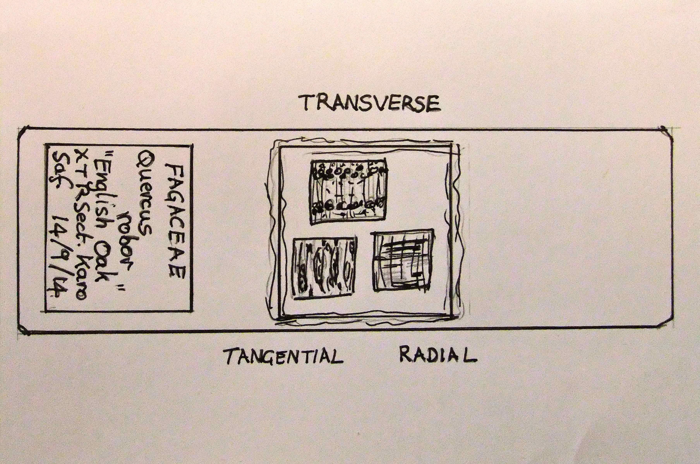
Figure 10. A finished slide, showing orientation of sections.
Get a clean coverslip, breathe on the underside (it will mist up), then put the LH edge into the Karo to the left of the sections (if right handed) and slowly lower the coverslip onto the sections, using a needle under the right edge to control it. Again watch to see that air pockets do not form while it is being lowered. If movement is not slow and careful, bubbles will form; these can be quite difficult and time consuming to remove. Also ensure that the sections do not overlap or fold over. If a curled corner will not straighten, it should be cut off with a sharp scalpel (see Ives) before mounting.

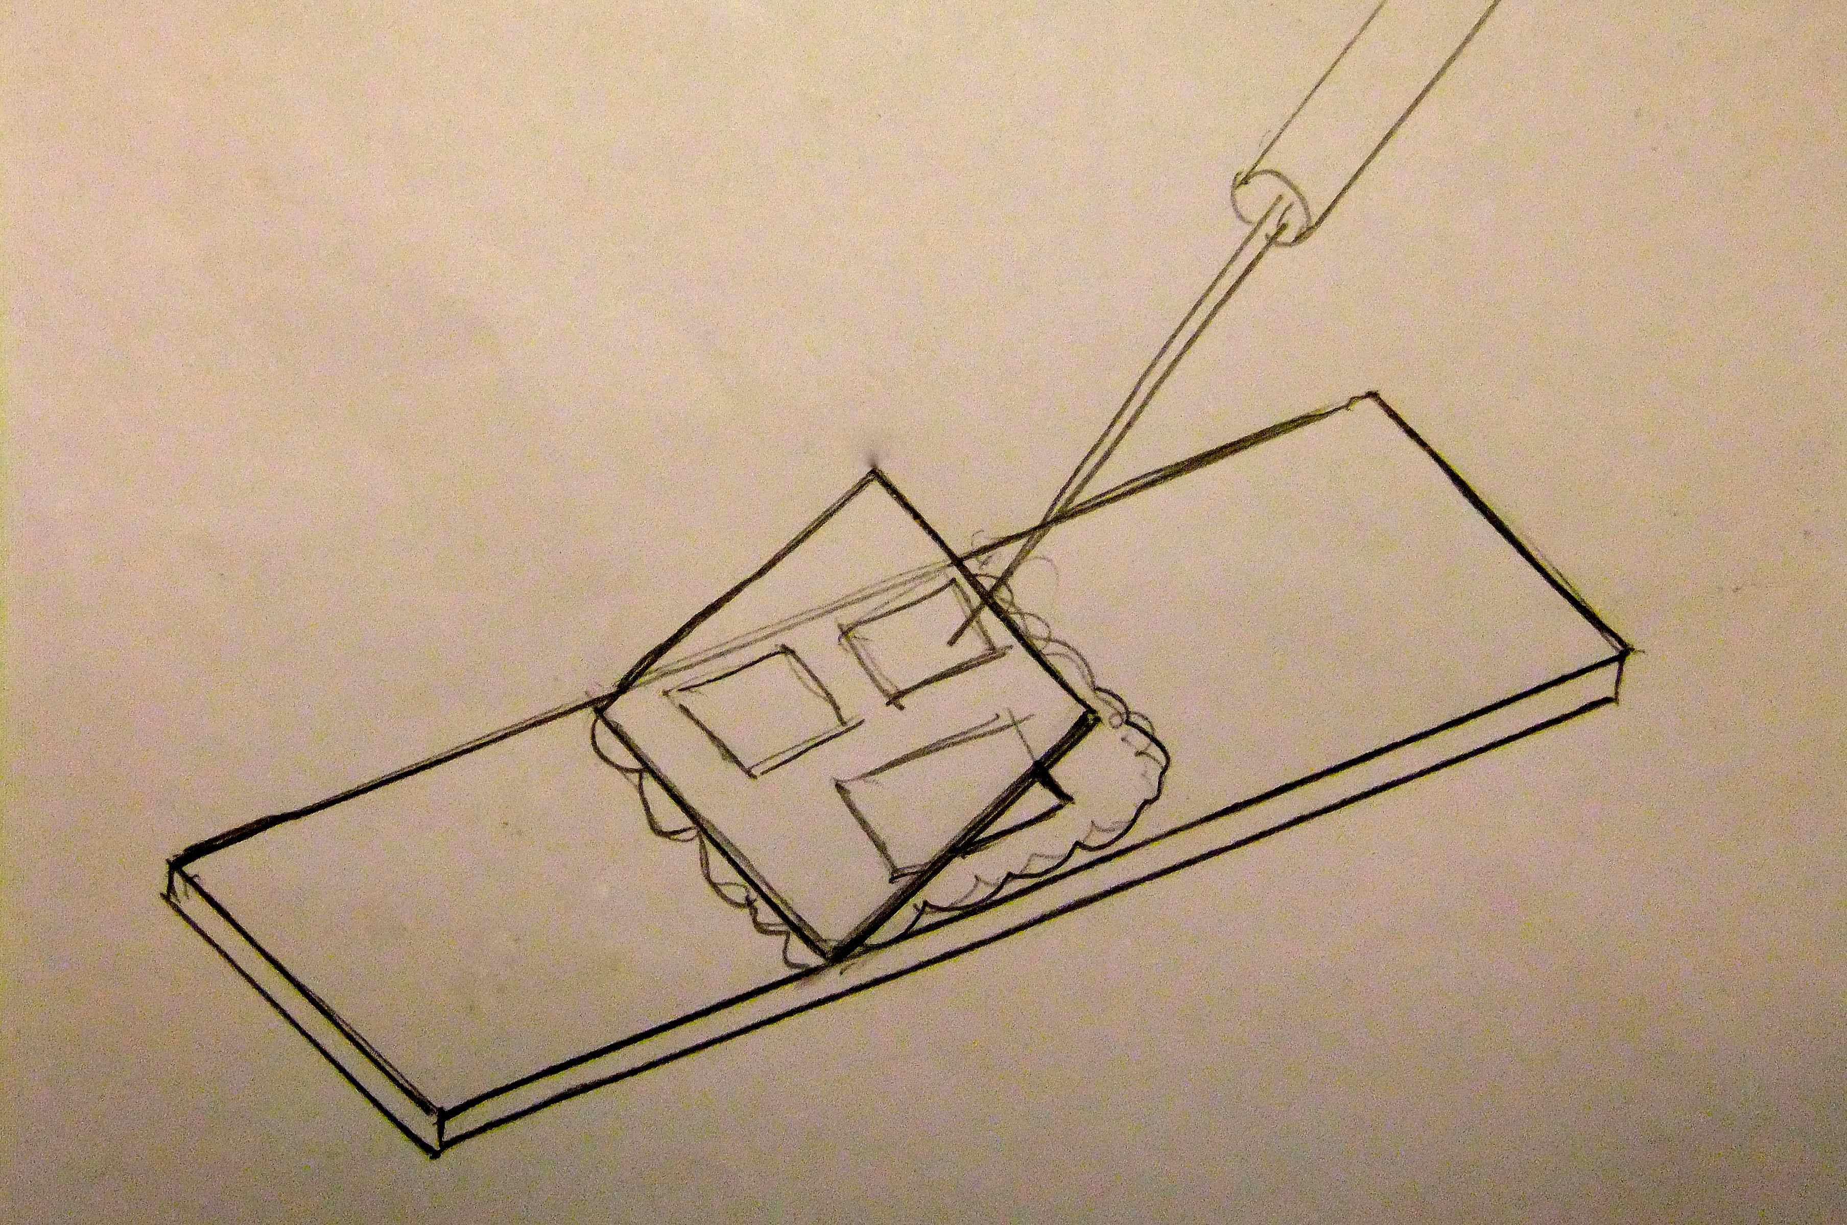
Figure 11. Lowering the coverslip with a handled needle.
When everything is in place, put the slide aside for 30 mins. or so to dry a little around the edges. Then mist spray a little water over the slide and carefully put a weight (15 – 20 gms.- I use lead weights or small bolts and nuts) on top of the coverslip to press it down. Check under the stereo microscope to make sure that everything is in place and not sliding around excessively, and that not too much mountant ends up on top of the coverslip. Then carefully put the slide aside to dry.
If too much Karo was used on the slide, the sections will squeeze out with the excess Karo to the edges of the coverslip and beyond. If too little was used, the coverslip has to be lowered very carefully to avoid large air pockets forming on the slide.
After a few hours (or overnight) check the slide again to ensure that all is well. Wet a finger in water and rub gently on the coverslip to remove excess Karo. Do not lick your fingers, but rather wash them thoroughly when finished if you have used any phenol in the Karo.
After a few more hours carefully scrape off excess Karo from around the coverslip edges with a small chisel or knife. Put aside to dry with the weight still in place. A moderately warm room should fix the coverslip in place in a few days. In cold, damp weather it may take a week or more. Do not heat excessively, leave in very dry air, or put in direct sunlight, or tiny bubbles may form near the edges of the coverslip.
When the coverslip does not move with gentle finger pressure, clean around the edges of the coverslip with a damp rag, check again for bubbles (small ones near the edges may be removed by adding a bit of 80% Karo against the edge and then gently pressing the coverslip so that the bubbles move to the edges and are replaced with fresh Karo.
Dry again for ½ hour or so, then apply 2 coats of clear nail polish around the edges of the coverslip, leaving about 1mm wide on the coverslip and 2mm wide on the slide. This is not strictly necessary, but it stops the slide becoming sticky around the coverslip in humid weather, since the Karo absorbs moisture very readily.
After another ½ hr or so, clean the slide (I use a spray of water with a little detergent, then wipe with a tissue) then apply a label, catalogue and store.
Ideally, slides should be stored flat so that if the mountant is not completely dry, the sections will not slowly slide down toward the bottom. Although the slide is firm around the edges, it may take another year or two to completely harden in the centre.

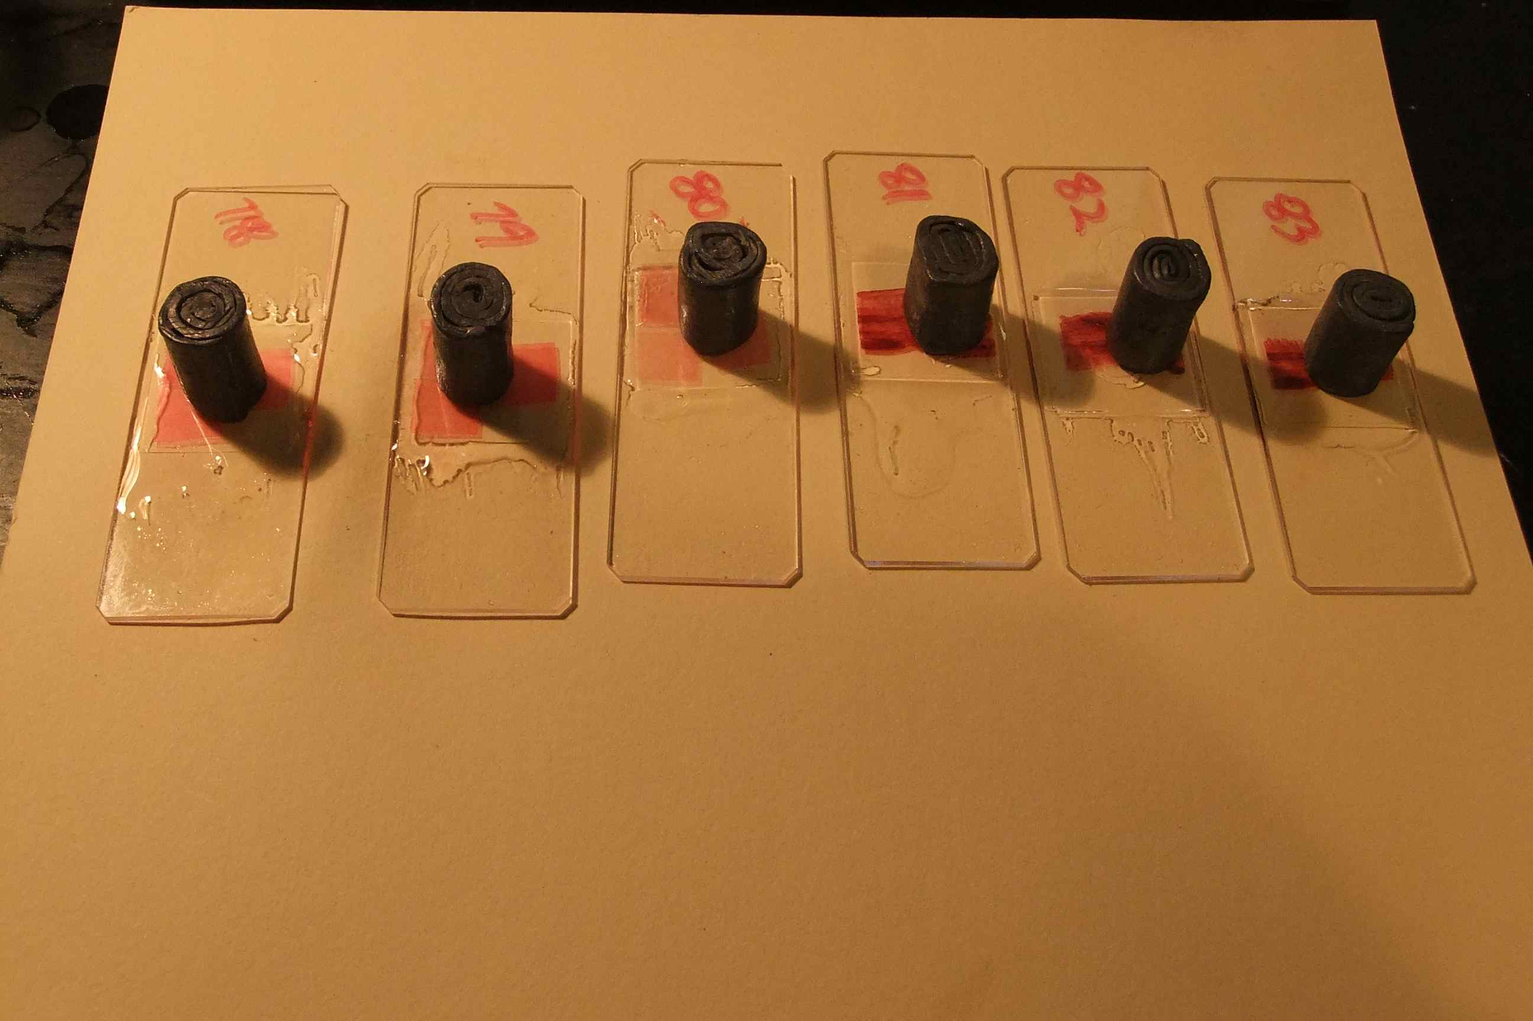
Figure 12. Slides with weights, drying.

Curling of sections of wood
1/Curling is often unpredictable, but usually worse with more dense woods.
2/ Thicker sections are usually worse and curl more than thin ones. Or at least, they are more difficult to straighten than thin ones.
3/ Curling may be reduced if the wood has been softened more, or if dense, steamed while cutting.
4/ The amount of curl may sometimes change if the direction of cut is changed. Transverse section cuts are often, but not always, best if cut in the direction of the rays and the other two sections cut in the direction of the fibres.

To Reduce curling
Use a brush to hold the section flat while it is being cut, and it slides up the bevel of the blade.
Leave the sections on the flat part of the blade, held down by the surface tension of the water, or water/ detergent.
When transferring sections to a Petri dish of water/dye keep them flat on a brush and use only a small amount of water/dye in the Petri dish so that again the surface tension keeps the sections flat.
If still difficult, transfer the sections to a spare, wet slide, with water/dye, then with 2 card spacers between them, add another slide to the top of it. Hold them together with a small rubber band. Then place into a Petri dish of water/dye and leave for a day or 2. Heating this slide combination to boiling for a few seconds may also help the sections stay flat if they are really difficult.
If all else fails, try to straighten the section by sliding, with curl down, over the edge of a slide to help straighten. A similar thing may be done by flattening the section over a finger, with the curl down. While it is held temporarily straight, put a drop of alcohol (meths spirits will do) onto it and it may stay straighter.
When mounting the sections and adding a coverslip, try to straighten it while lowering the coverslip.
If a corner or 2 have tightly curled, cut off the offending corner with a sharp curved edge scalpel, using a rocking motion to make the cut on a slide. (See Ives)

Sharpening
I use wood plane blades to cut sections of wood, but other knives can be sharpened in a similar way, but with a bevel on both faces instead of just one. In that case, the angle on each side would be ½ the angle used on a blade sharpened on only one side.
The included angle should usually end up around 30 degrees (not really critical) so with a plane blade, it would be sharpened at a 30 degree angle on one side only, while a microtome blade would be sharpened at 15 degrees on both sides.
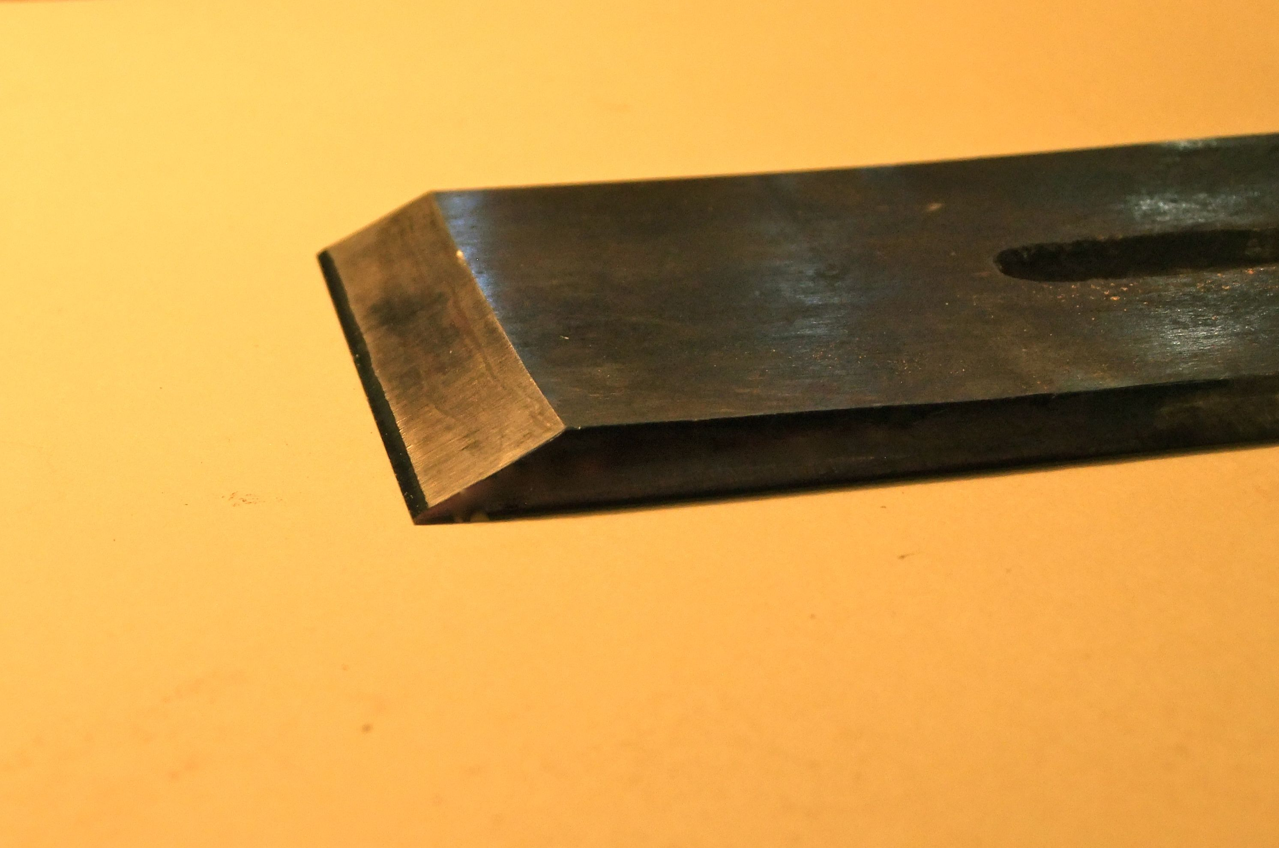
Figure 13. Side view of plane blade, showing sharpening (included) angle.
The following procedure describes sharpening a plane blade. Further information for sharpening a microtome blade can be found in Ives or just about any book on microtechnique. However, the main differences are the methods for holding the blade at a consistent angle while forming and sharpening the cutting edge. The materials used can otherwise be as I describe.
The first thing to do is to flatten and polish the back of the blade. Once this is done, very little work needs to be done to the back thereafter. The method is to rub the back of the blade on progressively finer sharpening stones until the back is polished all over, or at least 10 to 15 mm back from the cutting edge. I now use mainly diamond impregnated stones, but waterstones or oil stones will also work, or use wet & dry paper glued to a flat board. Remove all scratches with your finest stone. (I have an 8000 grit waterstone, but before I had that, I used a 1200 grit diamond stone, which was quite satisfactory, but a little slower for the next step.) Use a lubricant – a thin oil with oil stones, water or thin oil with diamond stones, but only water with waterstones. Don’t forget to clean all lubricant and abrasive off the blade before changing to a finer grit, or the remaining particles of coarser grit will scratch the surface.

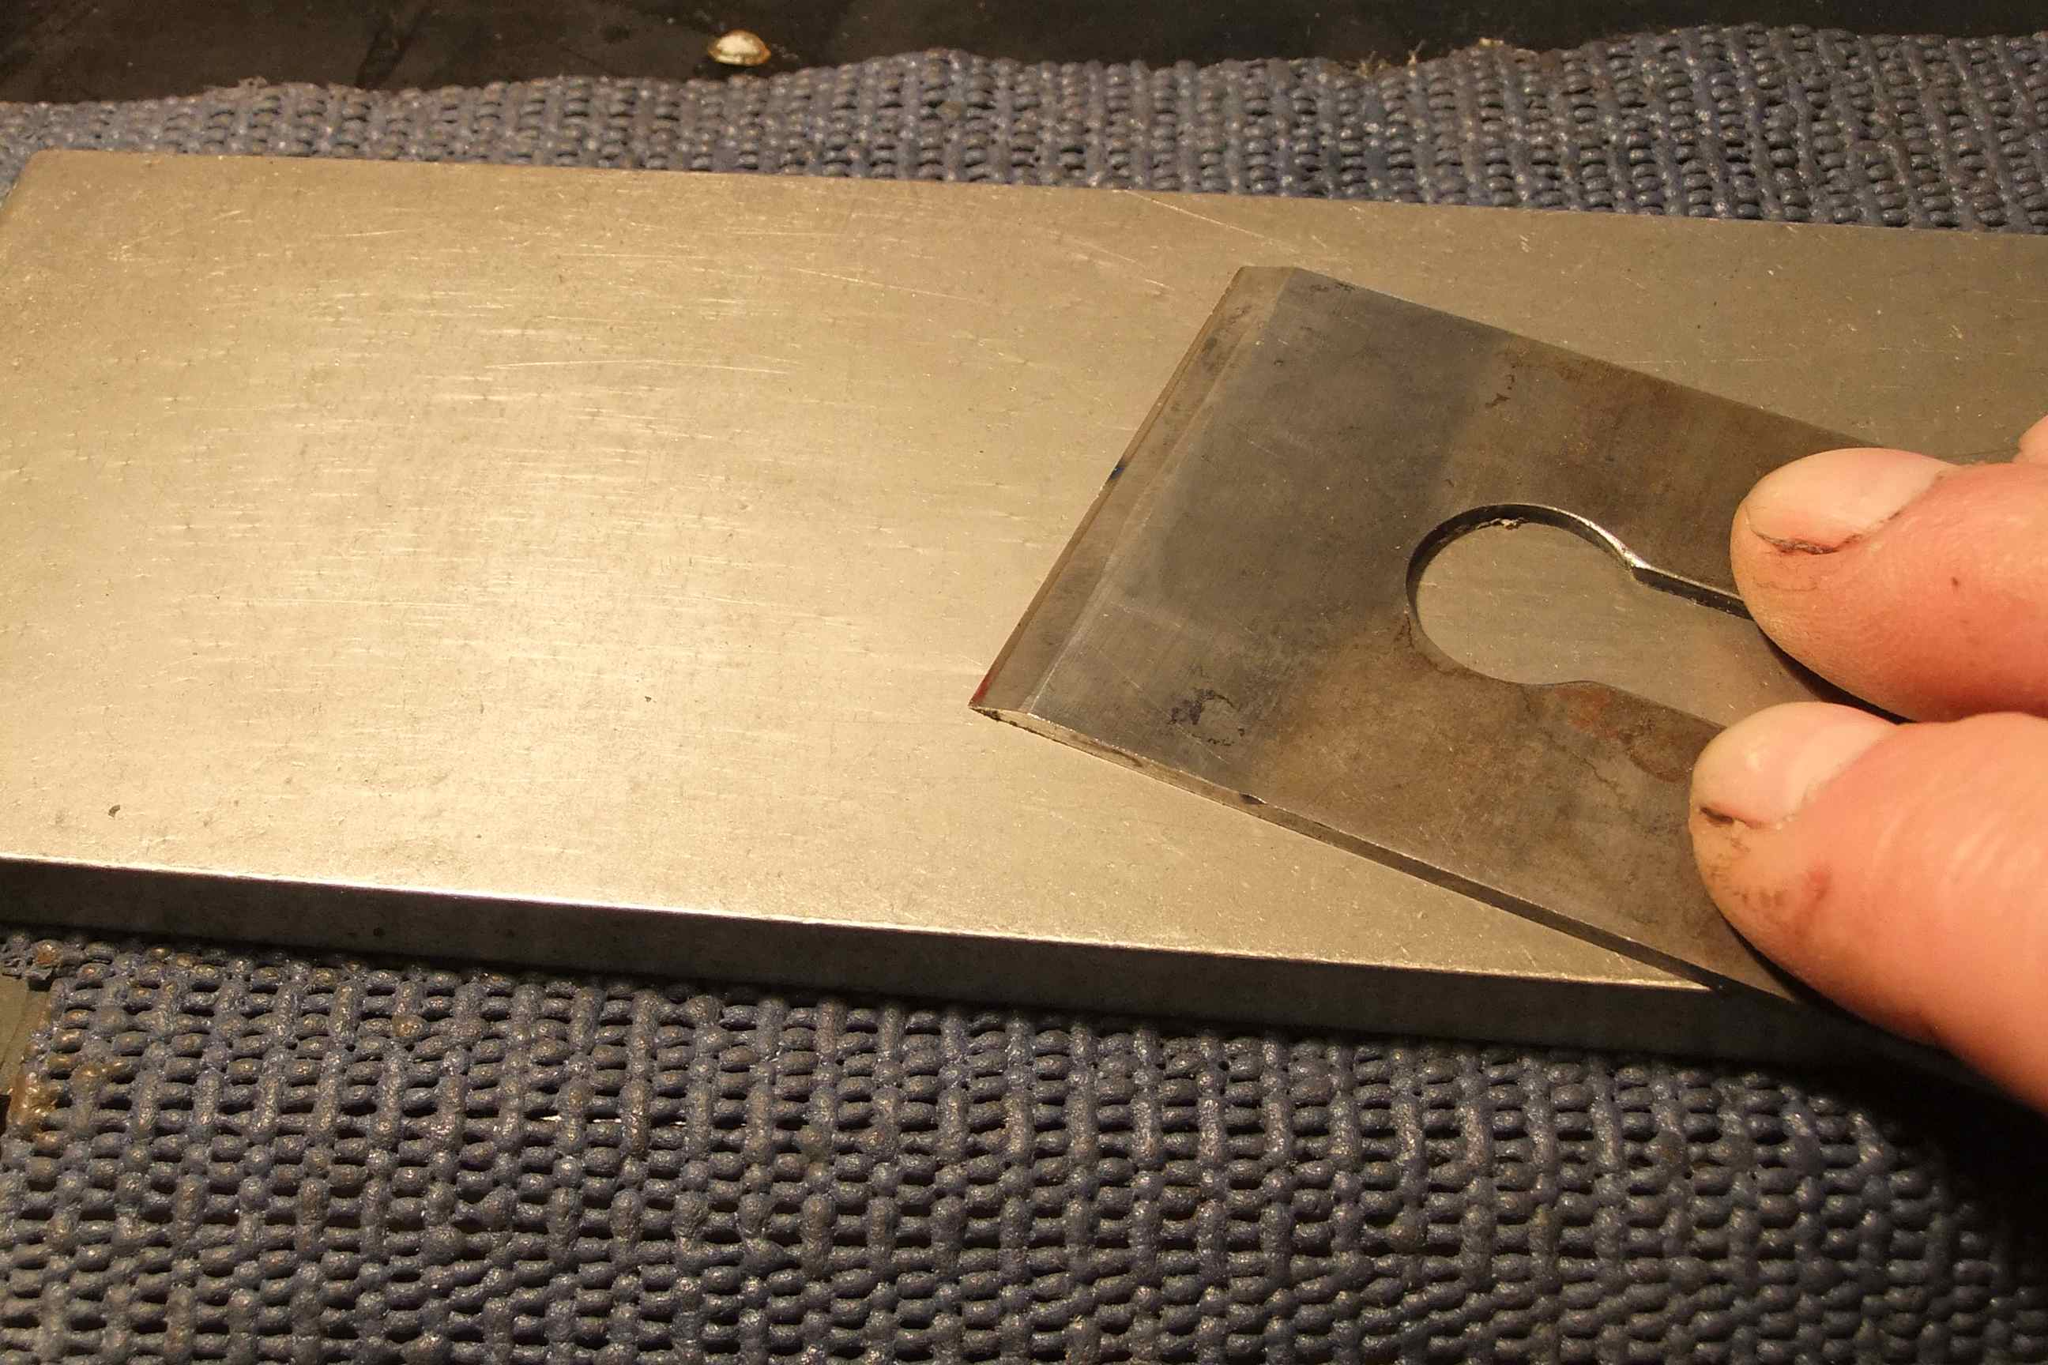
Figure 14. Flattening the back of a blade on a diamond stone.
Then get a piece of flat MDF (medium density fibreboard) or very flat fine grained wood about the size of a large sharpening stone and at least 6mm thick so that it remains flat. Make sure it is clean and that the surface has not been sanded. Get a tube of “Autosol” metal polish (available from hardware and automotive accessory stores) and spread a small amount (about the size of a pea) onto the surface of the MDF. Then rub the back of the cleaned blade on this until the back has a mirror finish. The back is now finished and should never need rubbing on anything coarser than the MDF with “Autosol”. Probably most other similar polishes will also work, but I have found the “Autosol” works better than others I have tried.
Now grind a bevel on the other side of the blade at about 25 degrees. Grind until almost to the cutting edge and be very careful that the blade does not get too hot. Never heat so that the metal changes colour, or the metal at the cutting edge will become soft and an edge will not stay sharp. If you are not brave or foolish enough to use a grinder, this step can be done with a coarse sharpening stone at an angle of about 25 degrees.
Next use a sharpening jig (I use an “Eclipse no.36” jig, but any similar jig will probably work just as well). This has a roller on the bottom to roll on the sharpening stone and a clamp on the top to hold the blade a set distance, and therefore angle, from the cutting edge. I made a simple wooden guide to enable me to always set the blade at a particular angle; in this case about 27 degrees in the jig.) Rub the bevel on a fine stone to sharpen the edge. I start with a 600 or 1200 grit stone. Keep sharpening until a small burr can be felt on the back of the blade and a secondary bevel can be seen all along the edge. Shining light onto the edge should also show this up. Clean the blade and repeat with your finest stone. I have an 8000 grit stone, but a 1200 grit stone would do, but makes the next step slightly slower.

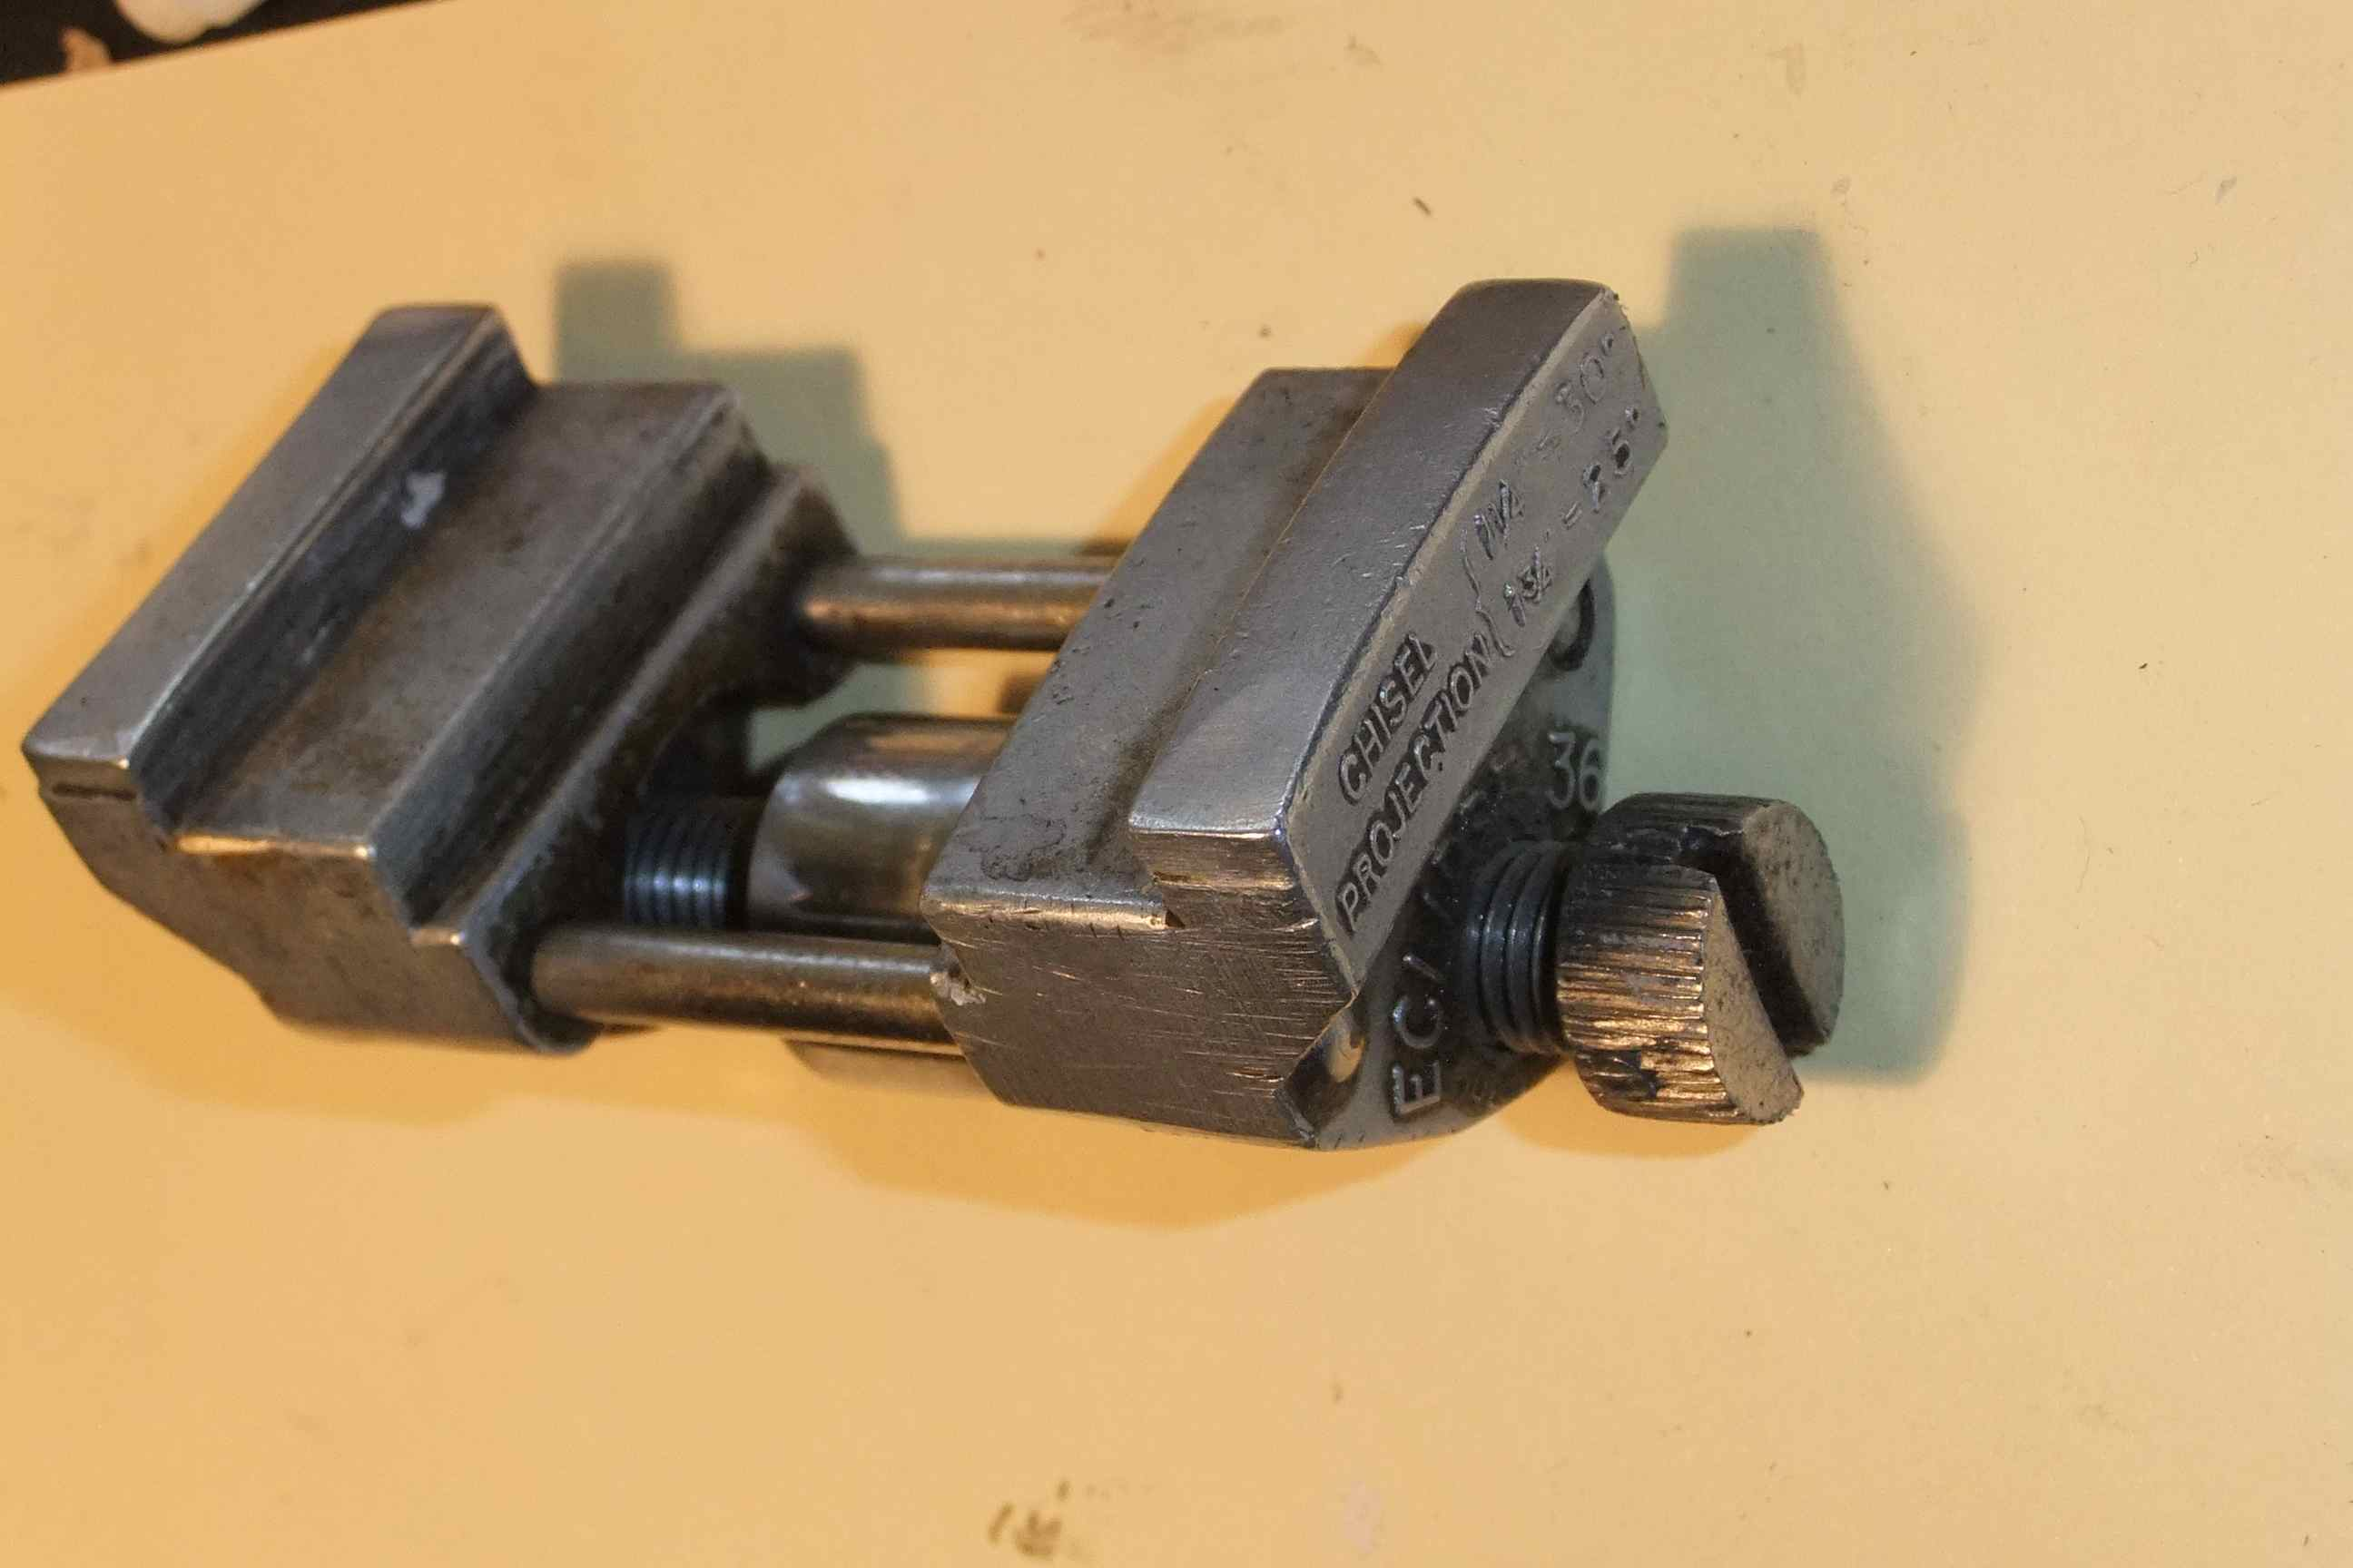
Figure 15. Eclipse no.36 sharpening jig.
Reposition the blade in the sharpening jig so that a little less is sticking out ie the blade will be sharpened at a slightly greater angle. I do this by using another homemade wooden guide or by putting a business card between the original guide and the blade. This ensures that the sharpening will take place right at the cutting edge, and make the job much quicker. Now using the MDF with the same polish as used on the back, continue the sharpening. Initially, the rubbing will have to be away from the cutting edge, but after a few rubs, can be done in any direction without the blade cutting into the MDF. Continue until light reflecting from the cutting edge will show a bright polished line right along the edge. This should only take a minute or two.

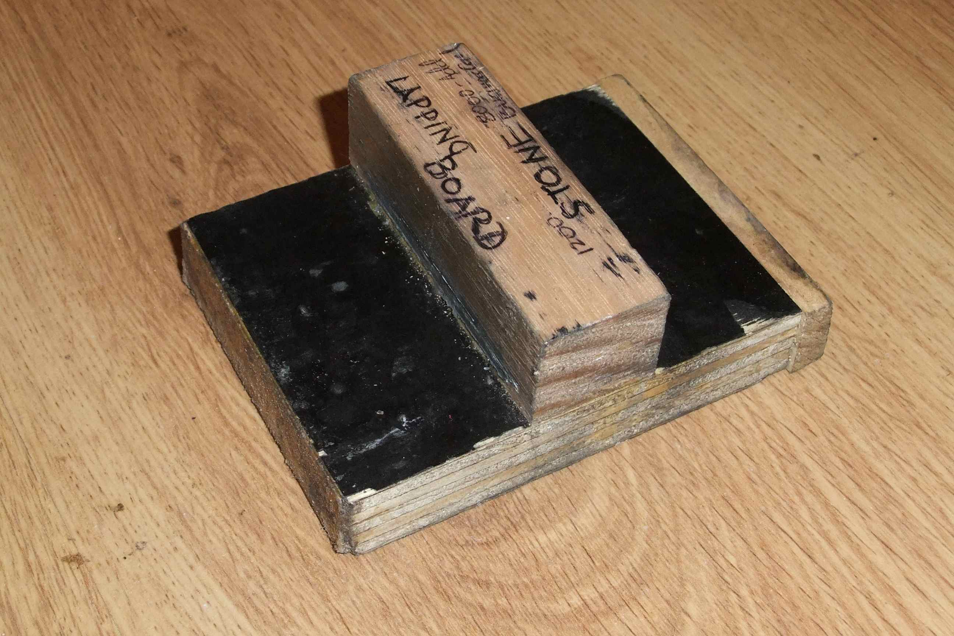
Figure 16. Home made guide for setting blade to the sharpening jig
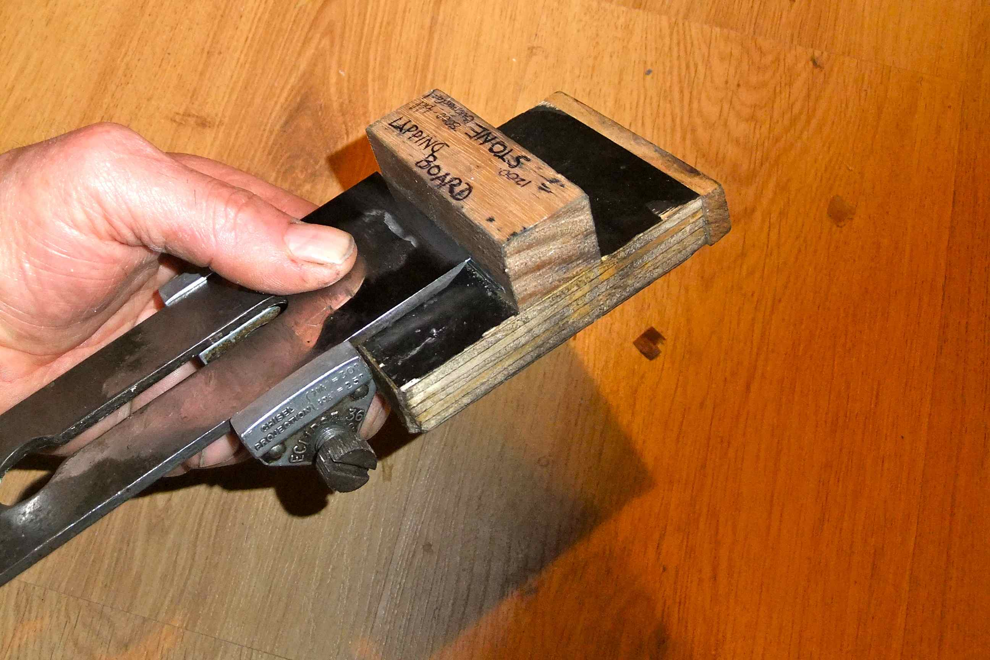
Figure 17. Guide being used to set blade in jig
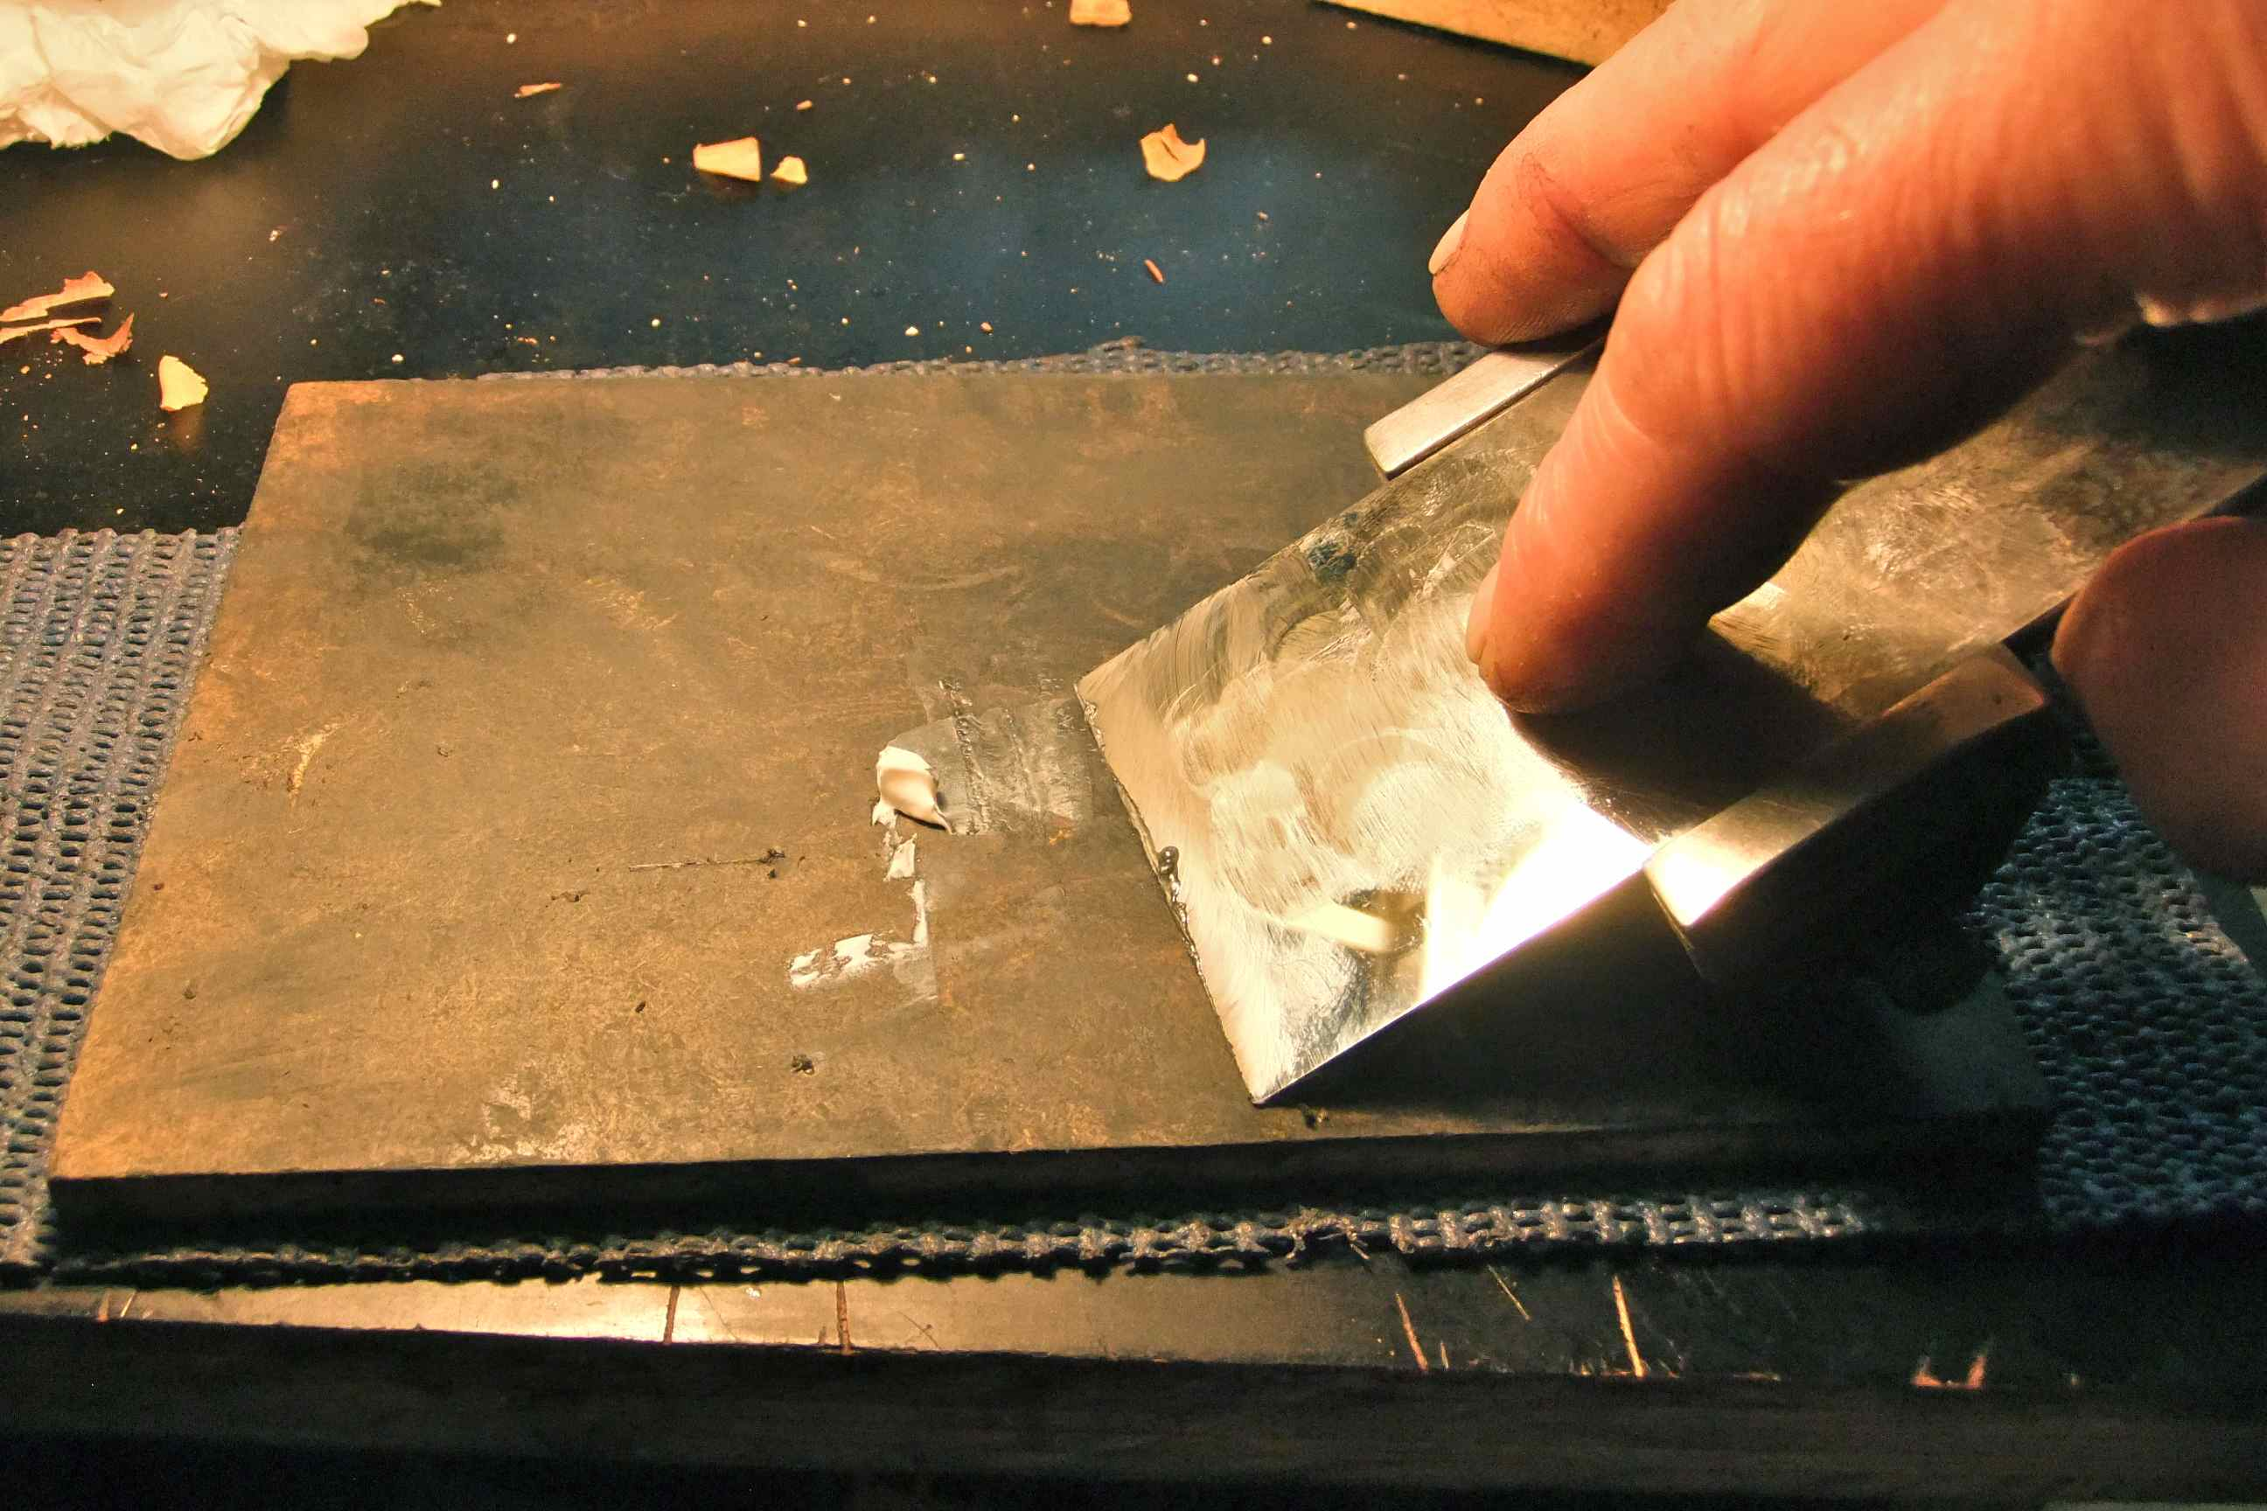
Figure 18. Blade being polished with Autosol on MDF.
Now hold the blade back flat on the MDF (the jig can be left on the blade and should not get in the way) and rub until the burr has been removed – only a few rubs should be needed. If necessary, repeat the last two steps.
Check the blade by first cleaning it with a tissue (rubbing from the blade toward the edge, not the other way!), then try cutting hairs from the back of your hand or wrist without rubbing the blade on your skin, or perhaps just touching. If this works, the blade is almost sharp. If not, go back to honing on the MDF with “Autosol”. You can also check by shining a bright light at the edge while slowly changing the angle to see if there is any rounding off of the edge.
Then, with the guide at the same setting, rub the bevel 5 – 10 times on a thin leather strop glued to another piece of MDF sliding only away from the cutting edge. Repeat with the back of the blade flat on the leather. Do not press hard on the leather or the cutting edge will be excessively rounded.

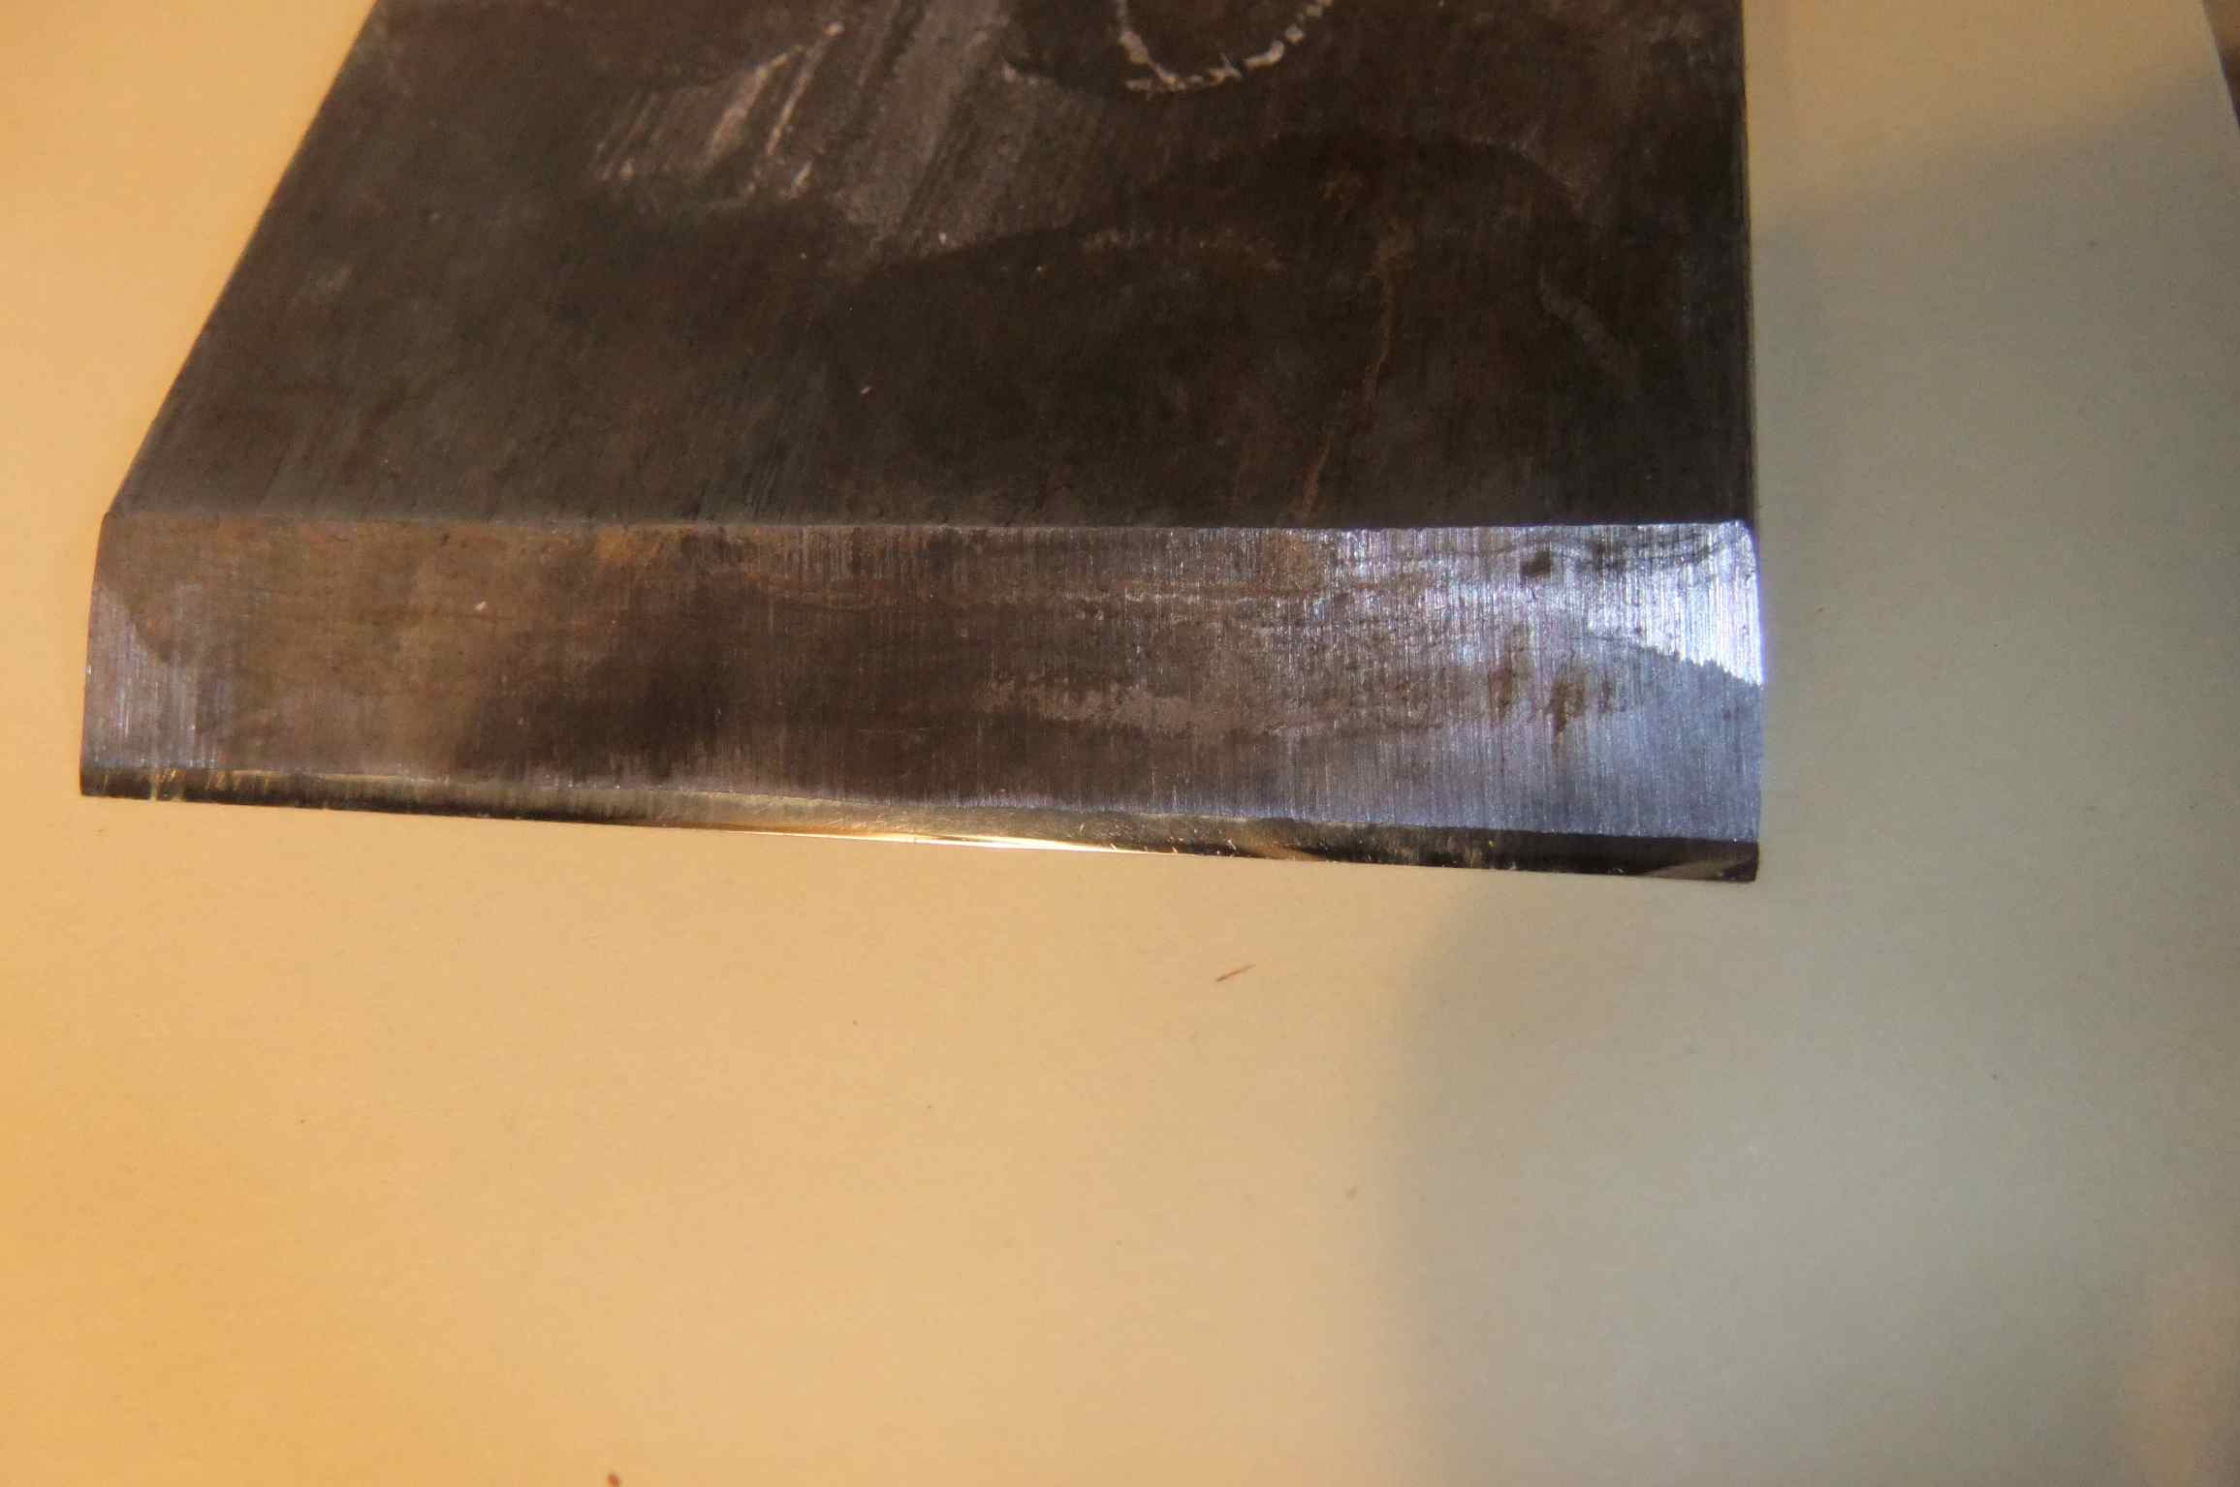
Figure 19. A sharp blade, with the polished bevel just visible at the cutting edge.
Check again by cutting hair. If the blade is sharp, it should now be able to cut hair while held a little above the surface of skin. 1 – 2 mm is not bad. (Some old books on microtechnique say that a sharp blade should be able to cut hair 10 mm from where it is held. I have never been able to achieve that and I do not think that it is necessary for cutting wood.)
The final check is to put the blade flat on the stage of a stereo microscope and with a top light held at various angles, examine the edge. At a magnification of 40x, no nicks or scratches should be visible along the cutting edge, and the edge should look quite polished and shiny and straight.
I have often wondered at the reason for stropping an edge. I have heard it said that stropping ”improves the edge so that it stays sharp longer”. This is possibly because stropping will inevitably round off the edge to some extent, because of the softness of the leather. If not excessive, this will increase the cutting angle or included angle a little, and provided that clearance is still present, will not adversely affect the cutting action, but will make the edge stronger and thus last longer. If excessive, of course, the cutting will be inhibited, probably mainly because the clearance angle becomes negative and consequently the blade has to be tilted up at too high an angle to cut.
After cutting approx. 20 sections, the blade will need restropping (5 – 10 strokes on each side) and after about 40 sections, will need repolishing on the MDF with polish on the bevel and back. This can be repeated until either,
a/ nicks appear on the edge – careless handling or cutting a wood with crystals in it or the wood surface had been sanded.
b/ the polished bevel becomes too wide and repolishing takes too long.
c/ the edge has become excessively rounded either on the back or the bevel or both. This can be checked be shining a light onto the polished bevel or back, and then slowly tilting the blade until no line of light is seen at the cutting edge. The greater the angle that the blade can be moved before the line of light disappears, the greater the amount of rounding at the edge has occurred.

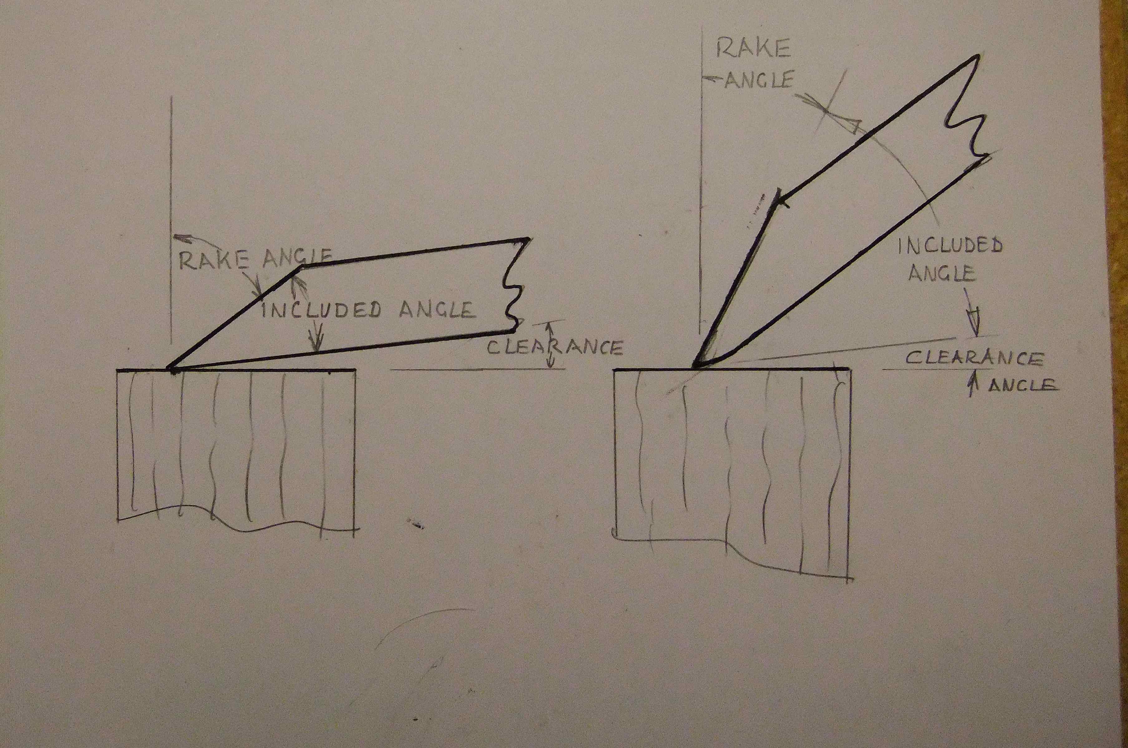
Figure 20. Showing relevant angles of a sharp blade, and one with badly rounded bottom edge.
At this stage, return to the guide and the finest stone and rub the bevel until a burr can be felt or seen with reflected light on the back of the blade. Do not rub the back of the blade on the stone. After the burr has been obtained, continue the steps with the MDF and the strop on the bevel and the flat back.
When the bevel from the 1200 or 8000 grit stone has become too wide and sharpening takes too long, the initial grinding may have to be repeated, but take care not to grind quite to the cutting edge. The back should never need anything coarser than the polish on MDF again, so that the polished surface may be retained.
Store the blade with a protective cover over the edge – to protect you and the edge, and put a light coating of oil or something to protect from rusting. The “Autosol” seems to have anti-rusting properties. Always resharpen the blade immediately after using it for this reason. Corrosion can occur remarkably quickly, especially when the blade is used on some woods (eg Eucalypts) with steam.

A few thoughts.

I try to have two or three sharp blades ready before starting a section cutting session. I use one to make initial cuts to trim the surface of the wood to get it level without tearing, and a second one to make the cuts of usable sections. One more is ready to take over if the other becomes blunt or scratched. It is much easier to reach for another blade than to stop work to resharpen. I find that I am much less likely to continue working with a blade that is no longer really sharp if I have another sharp one available.
All woods are different, and behave in different ways when cutting sections and when mounting. Various problems occur with some woods and disappear with others. If initial troubles are encountered making slides of one wood, try another before giving up in disgust, and come back later. Conversely, just when I think that I have mastered the processes, the next wood will completely destroy my confidence!
Some people recommend using a piece of thick glass for polishing or lapping the cutting edge with polish instead of the MDF I use. In engineering practice, whenever a surface is lapped, a lap of softer material than the object to be lapped is chosen. The reason is that the lapping compound (abrasives or polish) will embed into the softer material to abrade the harder material when the two are rubbed together. Thus, the softer lap will abrade or polish the harder material to be lapped. I believe, therefore, that if a glass lap is used for polishing a blade, the glass is harder than the steel and will be abraded more quickly than the blade, and abrasive particles may be embedded in the blade surface. I have chosen MDF because it is flat, cheap, softer than the steel and readily available. A piece of fine grained solid wood may even be better, but must be made flat, by planing or scraping, not by sanding.
I tested a number of polishes mainly by seeing how quickly they went black when used to polish the back of a blade. I assumed that the polish goes black as fine particles of abraded metal mix with the polish, so therefore the quicker the polish goes black, the faster the polish is working. I will admit that this is a fairly large leap of faith, but the “Autosol” polish does seem to work quickly for me.
A final thought – when I started woodturning about 30 years ago, I read a series of articles about woodturning by F. Pain in “The Woodworker” magazine. The first article I found was in the April 1953 edition in which Pain wrote; “May I quote the late Mr. Middleton of gardening fame: ‘People have done the exact opposite to what I recommend, with most excellent results’”.

Bibliography
Barefoot A.C. & Hankins F.W. “Identification of Modern and Tertiary Woods”
1982 Oxford University Press
Berlyn G.P. & Mitsche J.P. “Botanical Microtechnique & Cytochemistry”
1976 The Iowa state University Press
Corrington J.D. “Working with the Microscope”
1941 McGraw-Hill Book Co Inc.
Dioni W. “Safe Microscopic Techniques for Amateurs. Slide Mounting.”
2014 Onview.net Ltd.
Gartner H. & Schweingruber F.H. “Microscopic Preparation Techniques for Plant Stem Analysis”
2013 Swiss Federal Research Institute WSL Landscape Dynamics/Dendroecology
Heath C.E. “Microscope Slide Making”
Percival Marshall & Co. Ltd.
Hoadley B. “Identifying Wood”
1990 The Taunton Press.
Ilic Y. “A Microtome Knife Sharpening Technique for Cutting Wood Sections”
1985 CSIRO
Ives E. “A Guide to Wood Microtomy”
2001 Ernie Ives
Johansen D.A. “Plant Microtechnique”
1940 McGraw-Hill
Lee A.B. “The Microtomist’s Vade-Mecum”
1913 (7th ed.) Churchill
McClung C.E. “Handbook of Microscopical Technique”
1939 (2nd ed.) Paul B. Hoeber inc
O’Brien T.P. & McCully M.E. “The Study of Plant Structure Principles and Selected Methods”.
1981 Termarcarphi Pty ltd.
Ruzin S.E. “Plant Microtechnique and Microscopy”
1999 Oxford University Press
Sass J.E. “Botanical Microtechnique”
1958 (3rd ed.) The Iowa State University Press
Schneider L. & Gartner H. “The advantage of using a starch based non-Newtonian fluid to prepare microsections”
2013 Dendrochronologia 31(2013) pp 175-178

Copyright 2014 J. Schubert, Adelaide, Australia.
Email: schubertwoodturning AT gmail DOT com

Published in the January – February 2015 issue of Micscape Magazine.
www.micscape.org

