A LUCKY BREAK
How past vandalism favoured modern diatom research
Frithjof A.S. Sterrenburg, Myriam de Haan and Wulf E. Herwig

Frithjof’s story:
In a previous article in this journal (see the first reference below), I described some of the puzzles that arise in diatom studies. To gain an insight into the true identity of the many thousands of different species of diatoms⎯a study called taxonomy⎯it is necessary to examine the material in which the diatom was first described, the “type” material. That implies a search in museum collections to locate a slide of the original material for study in the light-microscope (LM). Because many diatoms have extremely fine structure, it may be essential to also trace the original sample itself, permitting examination in the scanning-electron microscope (SEM). Many diatoms were already described in the 19th century, so the slide and sample (often a little sheet of mica carrying dried material) may be up to 150 years old and extreme care is required in handling them…
One famous diatomist of Victorian times was the Reverend William Smith. His most important contribution was Smith 1853 (second reference below), which included a description of 26 species in a new genus he had earlier called Pleurosigma, with more or less sigmoid valves and “dots” crossing in oblique or perpendicular lines. Subsequently, the genus was split in two, species with oblique lines being called Pleurosigma (with P. angulatum as the most familiar, Fig. 1) those with perpendicular lines Gyrosigma (with G. balticum the most familiar, Fig. 2).
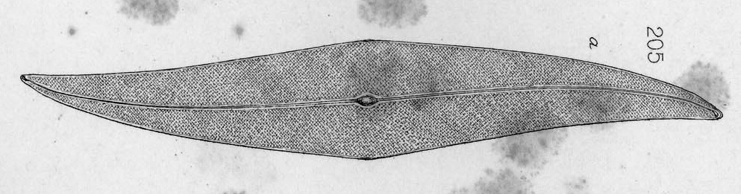
Fig. 1 P. angulatum copied from W. Smith 1853
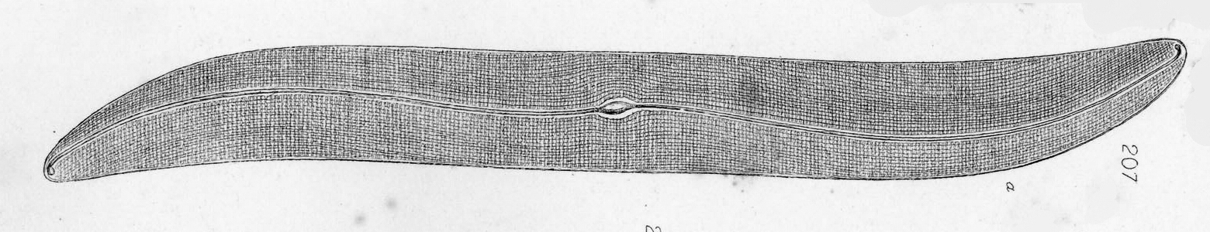
Fig. 2. G. balticum copied from W. Smith 1853
Smith’s work was of high quality, the descriptions were accurate and the drawings (by Tuffen West) were excellent because British objectives of that period were superior to those from the Continent.
Around 1990, I had begun a series of studies on Pleurosigma and Gyrosigma and was puzzled by a Gyrosigma first described in Smith 1853 as “Pleurosigma” tenuissimum⎯very finely structured, hence the species name. Smith stresses that it is “strongly curved” and West draws a valve that is clearly curved throughout (Fig. 3).
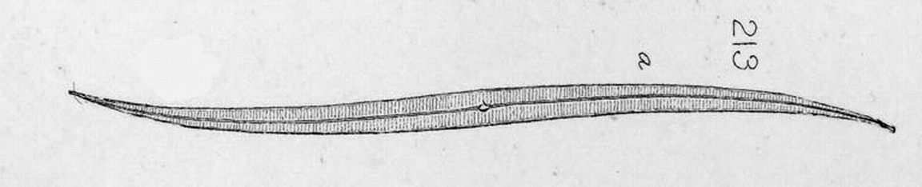
Fig. 3. “Pleurosigma” tenuissimum copied from Smith 1853.
The trouble is that in all modern records labeled “Gyrosigma tenuissimum” the authors show valves that are straight (instead of strongly curved) except near the very ends. In many samples from all over the world I had also seen only such straight valves, never Smith´s “strongly curved” ones. For good taxonomic reasons, strongly curved and straight valves are very unlikely to belong to the same species, so an investigation of Smith’s material (in LM and especially in SEM because of the fine structure) was mandatory. The Natural History Museum in London has many Smith materials, but a search in 1990 revealed that these did not include original tenuissimum material. The famous Van Heurck collection, then in the Antwerp Zoo, also contains a wealth of Smith materials, but at that time the collection was uncurated so the material was not accessible and I simply had to give up…

Wulf’s story:
In 2003 I again took up my hobby of microscopy, with more success than before. I collected all sorts of samples from rivers and lakes in Germany during the holidays. In October 2004 I stayed in a holiday resort in Camarina, Sicily, where I could collect my first diatoms from the Mediterranean and I was surprised by the richly varied diatom flora. A year later, a holiday to Sardinia yielded a sample from the beach at Cala Gonone. My collecting technique consisted of quickly digging a hole with my hands as the wavelets receded and catching the cloudy water in a jam jar. Then I waited until the water became somewhat clearer and decanted it into a second jar, thus separating it from the sediment in the first jar. The procedure to be repeated several times… At home, the material was treated with H₂O₂ and the diatoms were separated from the sand by sedimentation and decanting. Unfortunately, the sediment still contained many minute sand particles, which sink as slowly as the diatoms and this remains a problem!
Among the many pictures I took, I noticed a curious very faint Gyrosigma. I use a Zeiss Universal microscope, mainly with a Planapochromat 63/1.4 and DIC. At that time, my camera was a compact digital colour camera and I used an 80 mm projection eyepiece. The mountant was Naphrax. In the picture (Fig. 4), transverse striae were visible, but you could only guess at the longitudinal striae… Based on the Pleurosigma monograph of Peragallo (1891) I provisionally identified it as Gy. tenuissimum.
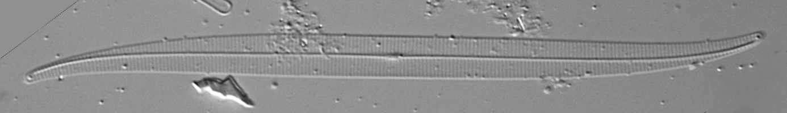
Fig. 4. Gyrosigma species? with modern optics. Zoom in!
In early 2009, I switched to a new technique of photomicrography because I wanted higher resolution by using light of shorter wavelength. As this is not possible with ordinary digital colour cameras because of the built-in Bayer mask, I bought a digital black-and-white camera without optics, as used for quite some time by astronomers. The microscope image was now projected directly onto the camera chip. Using an UV filter, much higher resolution became possible at 420 nm and with stacking and stitching strongly vaulted and very long diatoms could also be photographed in their entirety. For a detailed description see the third reference. In December 2011 I used the new technique for recording my faint Gyrosigma (Fig. 5) and lo! now I could also see the longitudinal striae – no less than 42 in 10 µ!
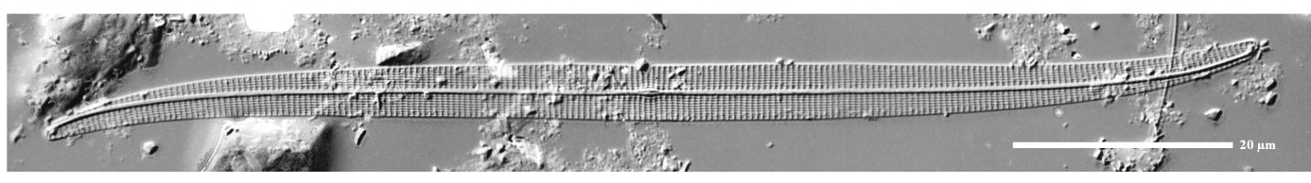
Fig. 5. “Straight” Gyrosigma with special technique. Zoom in!

In August 2008 Frithjof and I had become friends and because Pleurosigmas and Gyrosigmas are his pets, I asked him whether this was Gy. tenuissimum? Then he told me of the problematic situation, but because I had so often found this diatom I urged him to try and solve the riddle!

Frithjof (continued)
With Wulf now stoking up the fire under my bum, I decided to return to this 20-year-old puzzle. The situation looked more hopeful, because in the meantime, the Van Heurck collection had moved from Antwerp to Brussels and was now curated and accessible! So I contacted Myriam de Haan, with whom I had already published a paper.

Myriam’s story:
I work in the Botanic Garden of Meise, Belgium, in the department of Bryophytes and Thallophytes, where we curate a very large collection of herbarium samples. In 2007, the Van Heurck collection was transferred from Antwerp to our care. This contains about 20,000 slides and samples of diatoms collected by this famous diatomist, including a large number of W. Smith materials.
When Frithjof told me of the problem and asked whether there was usable W. Smith material of Gyrosigma tenuissimum, a search in the collection turned up a wrapper (Fig. 6) with W. Smith’s handwriting, indicating that this was indeed the original material of the species.
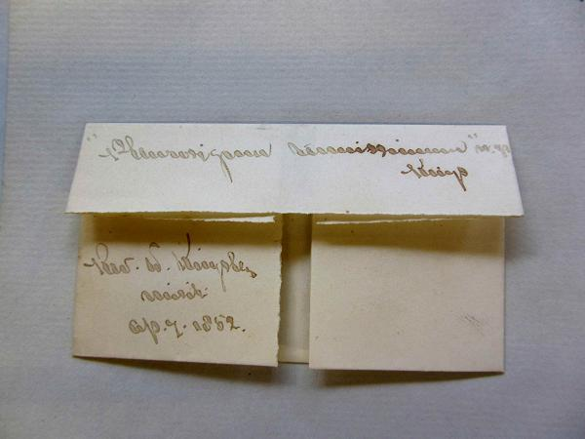
Fig. 6. Wrapper with Smith material, the word that
looks like a centipede reads “tenuissimum”.

The wrapper contained a broken piece of glass, probably the remnant of a slide, Fig. 7. Under normal circumstances, deposited herbarium samples may not be altered – you may not dismantle a preparation, for instance. But in this special case, where the material is seriously damaged, this does not apply and thus it was permissible to lift off a small fragment.
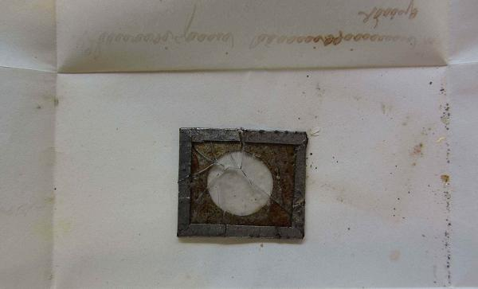
Fig. 7. The Smith material is a fragmented piece of glass.
Because this was a dry mount and the diatoms were not mounted in resin, the fragment was perfectly suitable for examination in the scanning electron microscope! So I sputtered it with a very thin layer of gold as is required for SEM studies and examination immediately showed (Fig. 8) that the original specimens of G. tenuissimum are not “strongly curved” as Smith claims, but almost perfectly straight for most of their length!

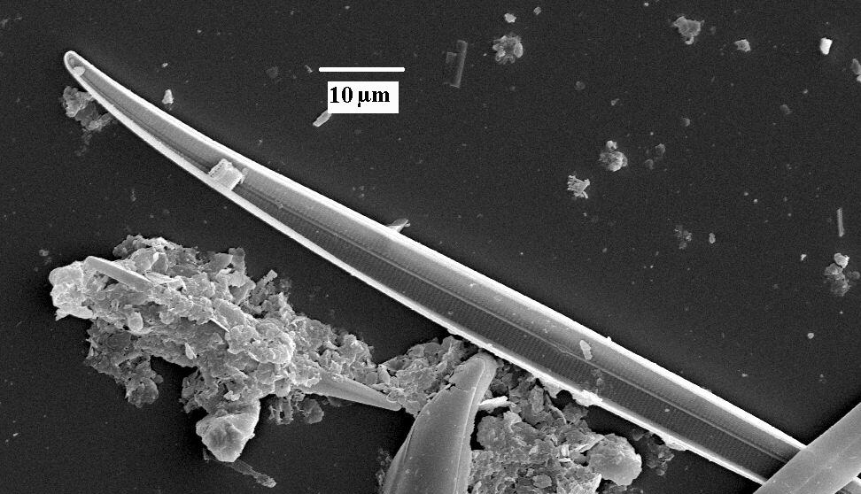
Fig. 8. The valves in the Smith material are not
“strongly curved”.

The moral:
There are two lessons to be learned from this detective story. In the first place, Smith and West goofed: Gyrosigma tenuissimum does NOT have the “strongly curved” valves they stressed. This shows that in taxonomic studies, one may not rely on previous data, even from such a reliable author as W. Smith! The cause of this error is a riddle and it is even more puzzling why subsequent authors for 160 years completely ignored the marked difference between Smith´s “strongly curved” diatom and the straight diatoms they saw in their samples. Together with our colleague Paul Hargraves, we have formally described our findings, see the fourth reference below.
Secondly, although damaging a museum specimen is the worst thing one can do, our study could only be concluded successfully because previous vandalism had supplied a broken preparation so that careful partial dismantling became permissible. Tongue in cheek, that can be called a “lucky break”!

References:
Frithjof A.S. Sterrenburg. (2011). Pandora's box. The diatoms of Sullivant & Wormley 1859. http://www.microscopy-uk.org.uk/mag/artsep11/fs-pandora.html Issue 191, Sept. 2011.
Smith, W. (1853). A synopsis of the British Diatomaceae, Vol. 1, p. 89, pl. 31, London.
Wulf Herwig (2011) Advanced light micrography. http://www.microscopy-uk.org.uk/mag/artmar11/Advanced_Light_Photomicrography.pdf Issue 185, March 2011.
Frithjof A. S. Sterrenburg, Myriam de Haan, Wulf E. Herwig & Paul E. Hargraves (2014). Typification and taxonomy of Gyrosigma tenuissimum (W. Sm.) J.W. Griffith & Henfr., comparison with Gyrosigma coelophilum N. Okamoto & Nagumo and description of two new taxa: Gyrosigma tenuissimum var. gundulae var. nov. and Gyrosigma baculum sp. nov. (Pleurosigmataceae, Bacillariophyta). Phytotaxa, 172 (2): 071–080

