UNCLE WILL: ANOTHER DIMENSION

Peter B. Paisley
Sydney, Australia

Some remarks on status
Art and science have vague boundaries: the status of “artists” or “scientists” varies, and terminology mutates. “Scientists” needed William Whewell to invent the term. Reference to “philosophical instruments”, without illustration, would today baffle most. The nineteenth century (like ours) was variable in how microscopical skills were perceived. It is easy to see commercial mounters as a “lower” class – as opposed to (say) clergy, who contributed more to microscopy than any other group. But Professors Quekett and Tennant were mounters, the latter a commercial one : perhaps some distinction might lie in whether mounting was a full time occupation, and interpretation of what could be seen was another. In which case Cole and Tennant do not neatly fit into any category.

“Art” lies in the eyes of auction bidders and fashionable critics – “craft” usually being relegated to a lower status. Prices today disguise the fact that Durer or Leonardo da Vinci used the tradesmen’s entrance. The Normans too may have done so: but not always – I feel sure the Rev. Dallinger, for instance, would have invited them through his front door. No more poignant example of malleable status exists than Charles Vance Smith. Respected by all levels of society subscribing to the Postal Microscopical Journal, he was advertising there, and praised, in the July quarter of 1884.

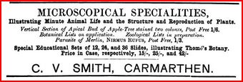

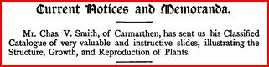

A year later, he was dead – the certificate specified “of no occupation”. Hardly factual, this betrays prejudice. Some of that prejudice continues in how we classify skills: I have seen no book on art history featuring William Norman, but plenty extolling the lesser abilities of many painters.

Two monograms
Compare the two monograms below. If their overall style looks similar, that is probably not a coincidence.


On the right, the initials JN are taken from a corner of a Norman slide label, rotated through 45 degrees for comparison with the example on the left. The initials on the left are WJN, and form the monogram of William Joseph Norman: they are extrapolated from his drawing, below.

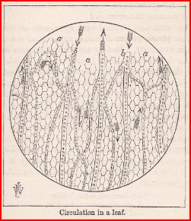

This leaf picture comes from page 165 of James Crowther’s The Microscope and its Lessons (1891). Before now I had no idea that “Uncle Will” was a talented draughtsman. Perhaps it should have been no surprise, given William’s meticulous copperplate handwriting style, seen on many of his slides, from early examples to work done after the turn of the twentieth century.

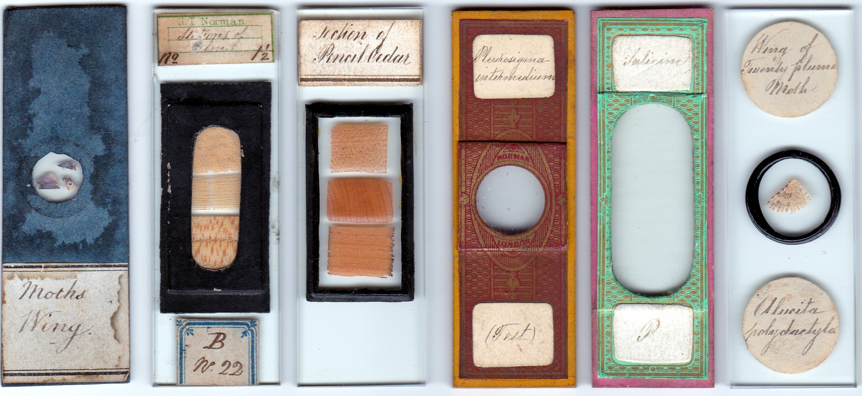
Presentation formats changed down the decades, but William’s handwriting remained immaculate

James Crowther and the Norman family
Crowther visited the Normans at 178 City Road, perhaps many times. He admired the firm’s work, holding J. T. Norman senior in affection, as “a good and clever man” (p.221, op. cit., above). The compliment refers to a visit in August 1869 to collect preparations from Thudichum’s celebrated trichinised rabbit, describing the tongue muscle tissue as “beautifully injected” in Science Gossip of that month.
One of Crowther’s anecdotes may refer to William Norman:
An entomological friend, too honest to deceive anyone, went out from London to Gravesend hunting for nocturnal moths. I need not trouble you with the method employed - he succeeded in finding the specimen which he was searching for, and he carefully secured it alive in a box, which he kept in his pocket. He returned to the City Road where he lived, from Gravesend to London, by the river steamboat, and all the way, he told me, several male moths followed him – and partly, too, in the dark – in search of their female friend which was hidden from human eyes in the dark box inside his coat pocket.
(Crowther, The Five Barred Gate (1881) p.68-9)
The “entomological friend” may have been Uncle Will, who by the 1901 census was describing himself as an entomologist.

The context is alleged wisdom of an ingenious creator, a natural theology theme motivating Crowther’s books. I do not know how far the Norman family shared his belief: but Norman marriages were solemnised in church, and the children were baptised. William probably shared some of Crowther’s views, or he would not have contributed to his books. How far the agreement stretched I do not know: at a time when Darwin’s and Wallace’s evolutionary ideas were thoroughly permeating biology, Crowther had this to say, of the eye, in 1881:
Could mere chance......have developed so singular an illustration of design out of a little gum and water from an original mass having no relation whatever to optics? How monstrous the doctrine! How opposed both to Revelation and Reason!
(The Five Barred Gate, p.102)
Like Frank Buckland and a few others he fought a rearguard action, since by now most (including many clergy) accepted evolutionary principles.

Crowther inscribed his 1887 book The Autobiography of an Acorn as his favourite work – cover and fly leaf below.

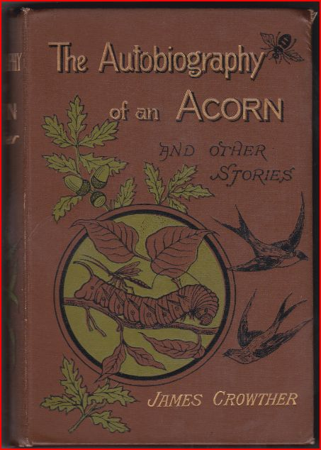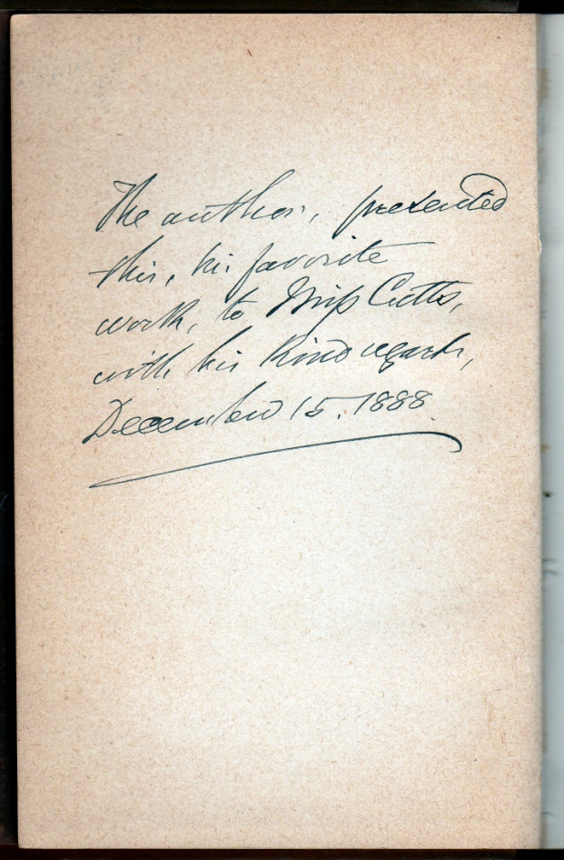

Like other Crowther books, it was published by the London Sunday School Union: the author’s fly-leaf inscription to a Miss Cutts may indicate a Sunday school teacher, although I’ve been unable to trace her. It contains histological illustrations of a bee’s eye, drawn by William Norman.

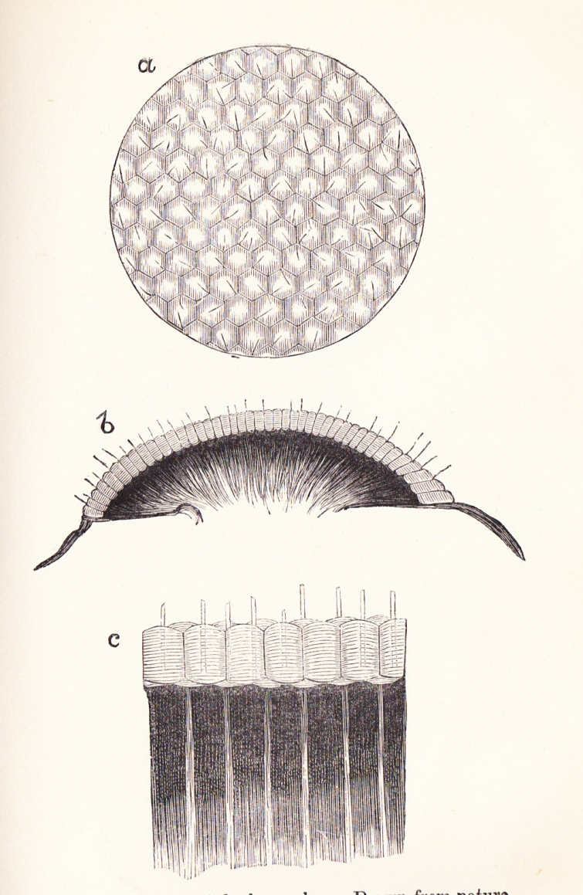
From page 107 of the Acorn book above

The drawing bears no monograph, but Crowther goes to some lengths to acknowledge William’s contribution, in his note on p. 121:
The admirable drawing of the compound eyes of a bee, at p. 107, was made expressly for this work by Mr. W.J. Norman, from sections of the insect’s eye prepared by himself, which sections I have very carefully examined with the microscope, and I can testify to the correctness of his drawing.

By that time William had moved from City Road to his own house in Walthamstow. Uncle Will and James Crowther may have conferred there at the microscope when various books were in their genesis, as the note above on the bee’s eye illustration could imply.

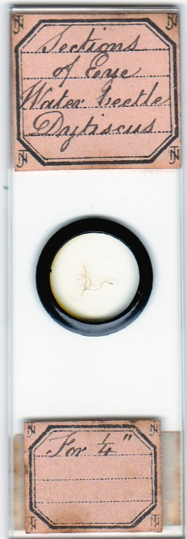
One of Uncle Will’s insect eye mounts (his W is characteristic)

Theology seldom impinged on microscopical details, being left to meta-analytical discussion (if any). Everyone, from combative atheists to ardent believers, could discuss findings on common ground, and might delight equally in the aesthetics of what they found. Crowther’s books quote both Charles and Erasmus Darwin, and contain references to Tyndall (and if Huxley was Darwin’s bulldog, Tyndall was his bull mastiff). More pertinently, the books refer admiringly to William Dallinger’s work: not surprising, since Dallinger was a prominent clergyman – but also the first to confirm Darwin’s natural selection principle by experiment. Exactly where Uncle Will stood on evolution I have not discovered.

Butterflies, moths and art
By the time Crowther was writing his books, Uncle Will was the Norman family doyen at butterfly scale arrangements. Several late nineteenth and early twentieth century mounters made such slides, and Uncle Will was a genius at it. If this isn’t “art”, I don’t know what would qualify.

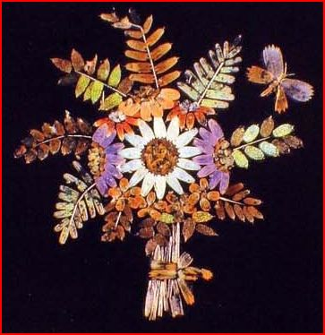
A scale arrangement by W.J. Norman, illustrated in Brian Davidson’s article in the Quekett journal (2008, 40, pp.657-666)

As a client for Norman slides, Crowther marvelled at such skills. Of another scale arrangement, he says:
Here is the choicest entomological specimen I have seen in any one’s cabinet, showing what human ingenuity can accomplish, and illustrating the truth of the proverb about time and patience. It is a bouquet of flowers, in an exquisite vase, around which a group of gay butterflies are apparently enjoying themselves. There are fuchsias, roses, and, for a centre, a sunflower. And all this beautiful, although artificial arrangement, consists of nothing else whatever – flowers and leaves, vase and flies – all arranged, remember, according to their natural colour – but the dust, or scales, or “feathers”, whichever you like to call them, taken from the wings of insects, the total number of scales amounting to twelve hundred.
(From Crowther’s Microscope book, p. 55)
The urge to draw individual scales must have been strong in those who studied them: not everyone however had the artistic facility to record them in accurate detail. While the illustration below is not signed with the WJN monograph, Uncle Will perhaps drew it for Crowther’s Microscope book. Given close co-operation with Uncle Will, such detail is suggestive.

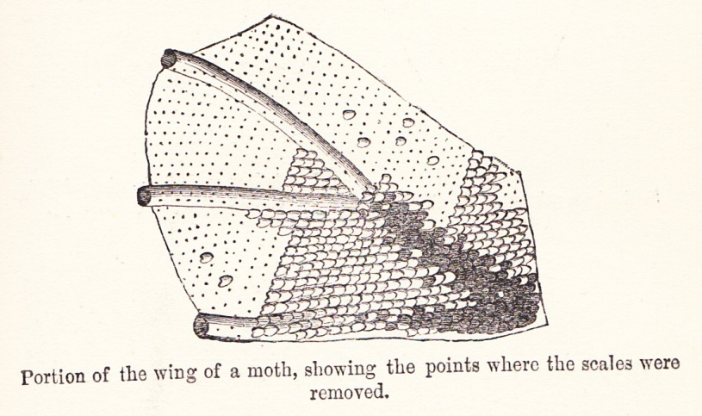
From page 53 of the Microscope book

Other illustrations in the book are problematical. Those below, of morpho menalaus and polyommatus argus scales, are exact copies – without acknowledgement - of drawings in all editions of Carpenter’s The Microscope and its Revelations, from the 1850s on.

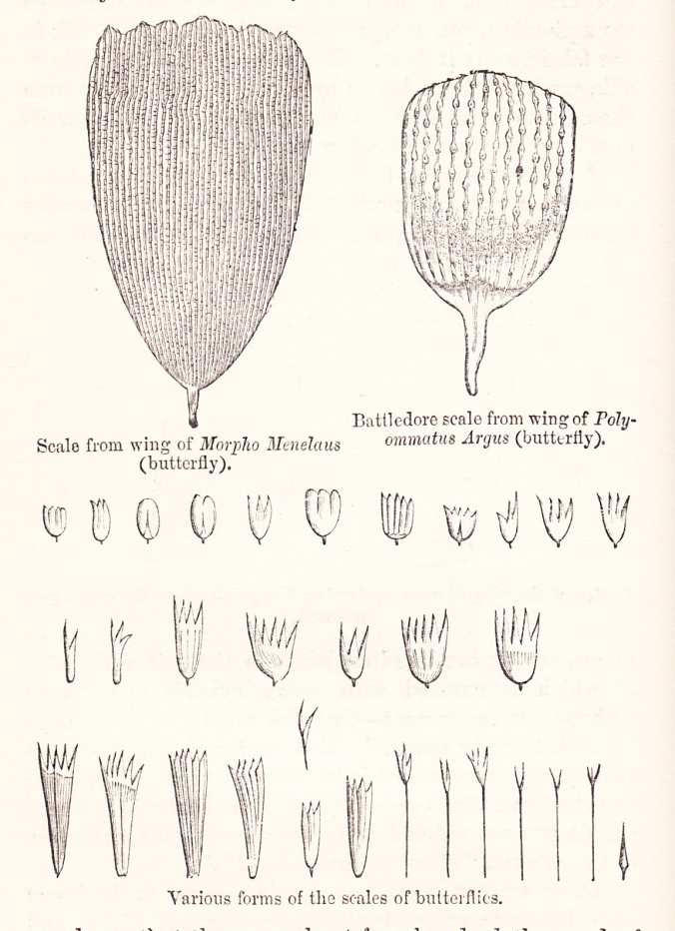
From page 53 of the same book

While I have not pursued similar “poaching” through Crowther’s books, I have little doubt that it occurs. This makes it difficult to ascribe drawings to Uncle Will, when they are not accompanied by notes like the one on the bee’s eye – even when stylistic similarities are strong.

It is easy to see how Crowther, who espoused Paley’s views on natural theology, saw a deity as the genius behind butterfly colours. Whether or not Uncle Will did, it is obvious from much of his work that he found them inspiring. His scale arrangements needed the mediation of lenses, but mounts like those below were attractive to the naked eye.

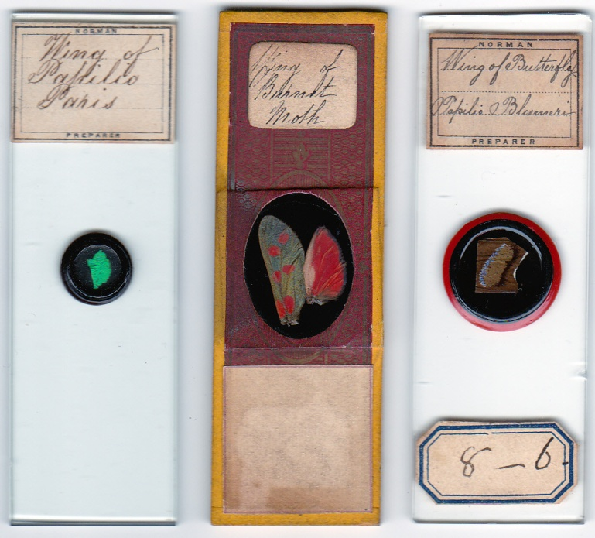
Such slides must have appealed to Crowther, and arranged scales evidently delighted him immensely more. Like most Victorians, Crowther was fascinated by insect morphology in general, and Uncle Will provided him (below) with illustrations of insect tongues.

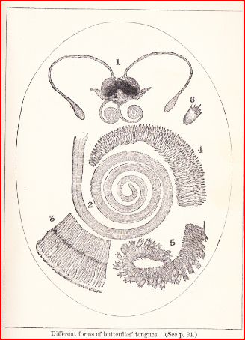

Matters animal and vegetable
The quest for patterns in nature inspired investigators. Their supposed presence provided many with evidence for a creator: not for nothing was Linnaeus hailed as the “second Adam”, and by the time Uncle Will was active, Linnaean taxonomy was enlivened (or perverted, depending on one’s views) by evolutionary considerations. But in the history of thought, old ideas die very hard. We scarcely notice that “sunrise” or “blood lines” linger in our everyday speech, terms contrary to long since known fact. Mediaeval notions like the doctrine of signatures lurk in the shadows of some of Crowther’s discourse, and Uncle Will contributed another illustration, to show parallels between plant seeds and insect eggs.

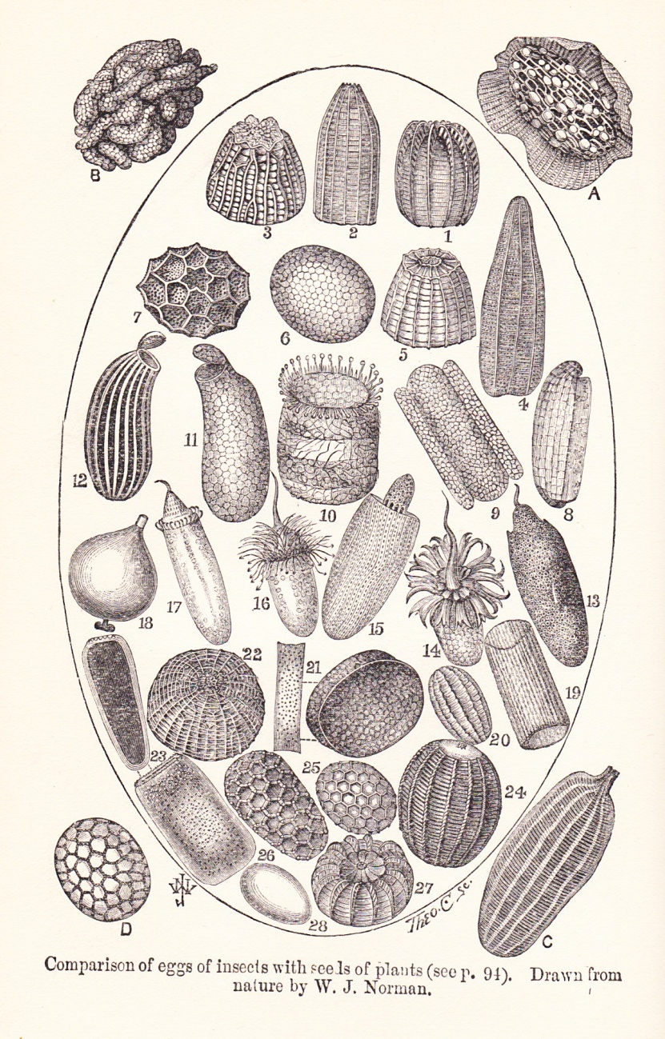
From page 44 of the Microscope book

Regarding the drawings above, it is worth reproducing in toto what Crowther says on page 94: clearly he and Uncle Will were in close co-operation.

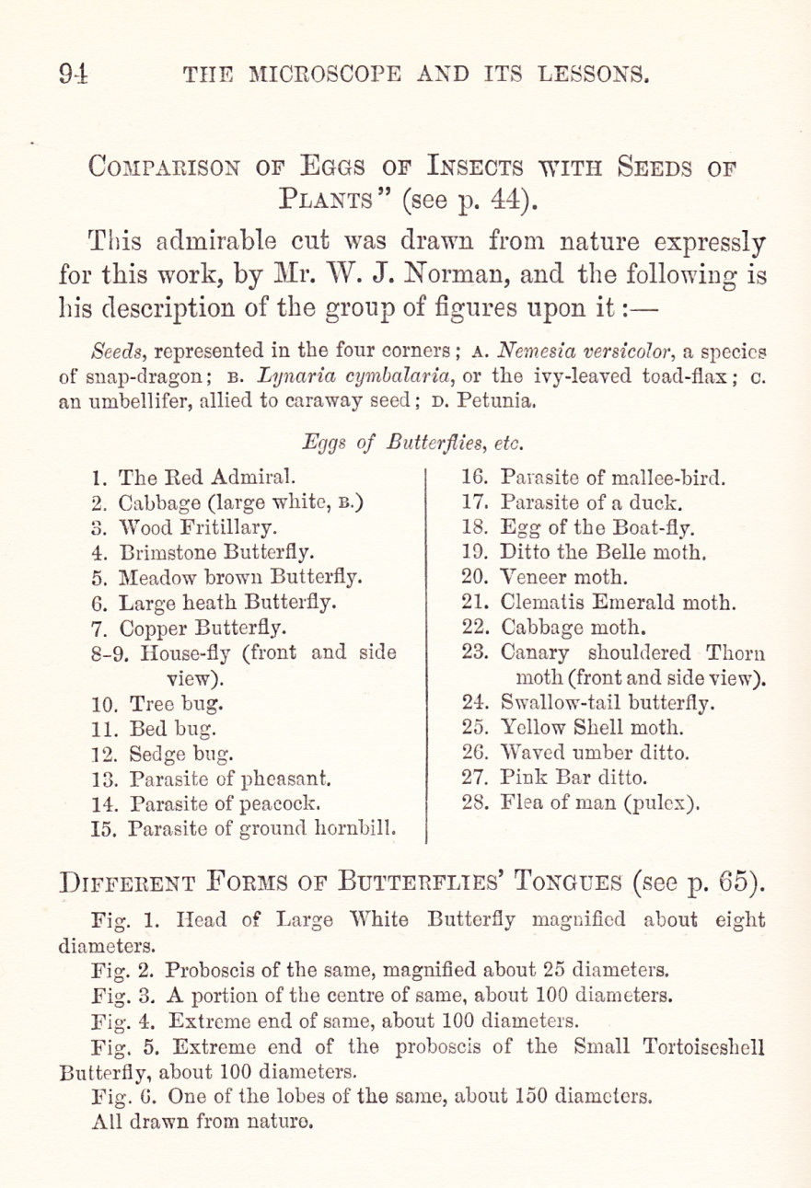

Slides for children?
Small Norman mounts rarely seem to turn up these days: the slides below lack proprietary labels, but bear William’s handwriting.

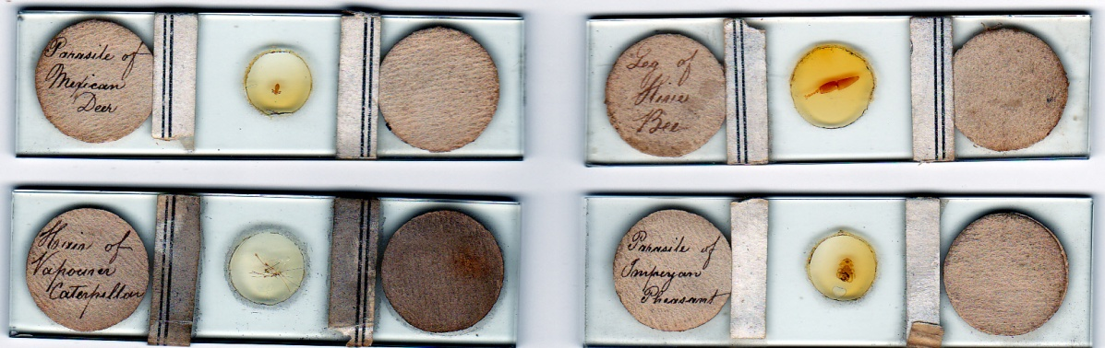

Less than half the size of standard slides, they must have cost considerably less, and may have been made for children. The addition of paper strips would make them easy to centre on small cheap microscopes – more so if placed in a spring loaded pocket microscope. William may have made such slides for his brothers’ children (and grandchildren): equally, they could have been produced at Crowther’s request, for use in Sunday schools. It is clear from Crowther’s books that he recommended instruction in microscopy there.

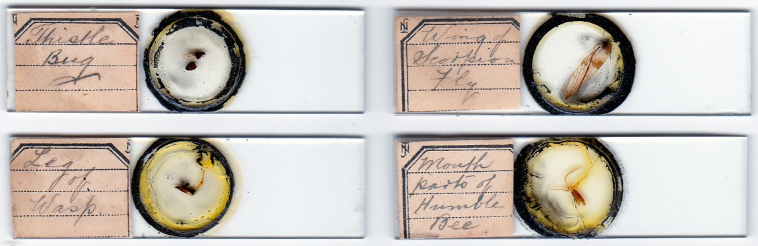

Other Norman family members also made small slides, as evidenced by different handwriting on those shown immediately above. If they reached a juvenile market, and youngsters who acquired them graduated to more sophisticated instruments, that would explain why they seldom turn up now – probably most would have been discarded.

A kindly spirit
“Uncle Will” is the affectionate family synonym for William Joseph Norman, enduring until today. He and his wife were childless: like many such couples, they probably “adopted” children and grandchildren of others in the family, perhaps also those of unrelated friends. James Crowther also styled himself “Uncle James” in various articles and a book, written for children (more specifically Sunday school children). I have as yet to see evidence that William Norman was a Sunday school teacher, but it seems possible, given his association with Crowther. Whatever the details, by 1901 his “Uncle Will” status seems firmly established, evidenced by how he presented to the census taker.

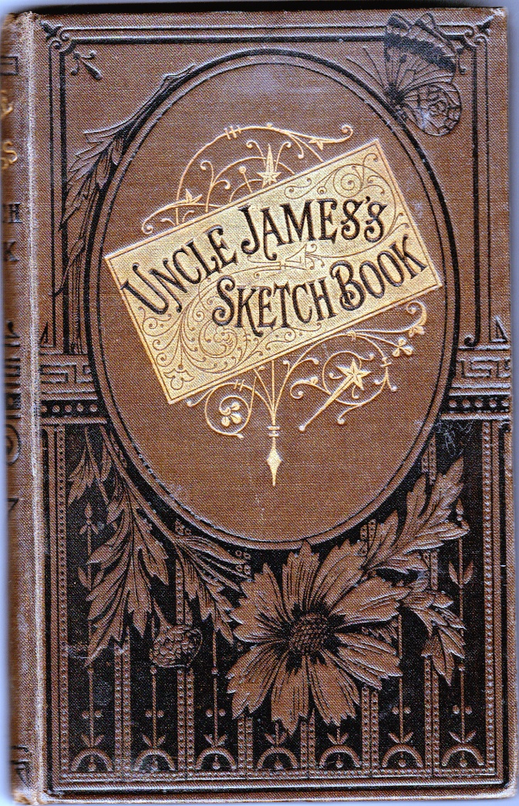

For his first book (above, ca.1880), Crowther presented vignettes taken from subjects of natural history, and drew “many a lesson in morality and religion”. Given his connection with Crowther, it is tempting to think “Uncle Will” had similar Aesopian views.

Someone who certainly shared them was Frank Buckland, son of the Bridgewater Treatise author (Crowther uses a quotation from Chalmers, another treatise author, to open his Microscope book). Buckland’s Log Book of a Fisherman and Zoologist (1883) contains the drawing shown below, on page 37. The monogram on the left looks like one of Uncle Will’s.

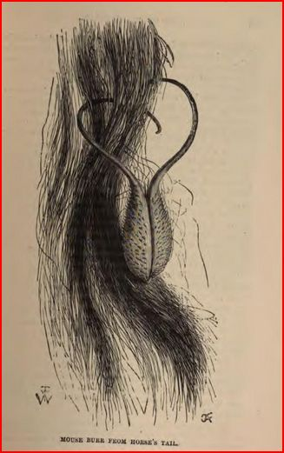

“Art”, “Science” – or “mere” technical facility?
The work below is clearly a study in natural history. It ranks with the best flower studies like those of Elizabeth Twining, or the lithographs in many nineteenth century botanical volumes stemming from antipodean exploration. These are rarely described as “Great Art”: but the work below is. Why? Because it was done, in 1503, by Albrecht Durer: and he was a “great artist”, ergo this is “The Great Piece of Turf”.

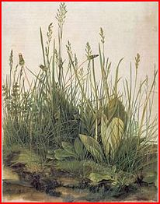

Centuries of analysis from Vasari on have conditioned us to boundaries of “great art”. That conditioning prevents us from seeing – for instance – Will Norman’s scale arrangements (and those of some others) as “art” at all, because of illogical (largely subconscious) assumptions. I do not seek to rank Will with Durer, but an artist he certainly was, by any standards: I hope this article extends perception of his abilities.

Envoi
There has been no documentation of William Joseph Norman as an illustrator. There may be more of his work to be discovered: from what I have seen so far, it is unlikely to be found in works normally consulted by microscopists or collectors of slides. Micscape readers who have collections of children’s books, or religious publications, may find examples.

Sources
Science Gossip, August 1869, p.183
Books by James Crowther:
The Five Barred Gate: a Story of the Senses, 1881, London, Sunday School Union
The Autobiography of an Acorn and Other Stories, 1887, London, Sunday School Union
The Microscope and its Revelations, 1891, London, George Cauldwell
Uncle James’s sketch Book, ca. 1880, London, Sunday School Union
Crowther also wrote articles for Kind Words, a juvenile religious periodical: so far I cannot find copies reproduced on the web.
Frank Buckland: Log Book of a Fisherman and Zoologist, 1883, London, Chapman & Hall
Crowther’s book Solomon’s Little People has an illustration of bee eye histology strongly suggestive of Uncle Will: unfortunately it is unascribed. This work is a lengthy essay in natural theology: its opening section is a vigorous frontal attack on evolutionary ideas in general, and on Charles Darwin in particular.

Email author: lois737 AT bigpond DOT com

Published in the June 2012 issue of Micscape Magazine www.micscape.org

