Microscope slide maker “W M P”
probably William Melville Paterson, 1856-1884

by Brian Stevenson
Kentucky, USA

Microscope slides by “W. M. P.” are relatively scarce (Figure 1 and B. Bracegirdle’s Microscopical Mounts and Mounters plate 41, slide H). The few I have seen are all of diatoms. Two labels are present, of the same style as William Firth, the Barbour Brothers, and several other late-1800s diatomists. The upper label is machine-printed “diatomaceae”, while the lower label has the maker’s printed initials. The handwriting is tidy and unique. Searches of historical documents indicate that the most probable maker of these slides was William Melville Paterson, a chemical engineer who lived on the east coast of England and had a strong interest in microscopic studies of diatoms. His slides date from a brief period in the late 1870s.
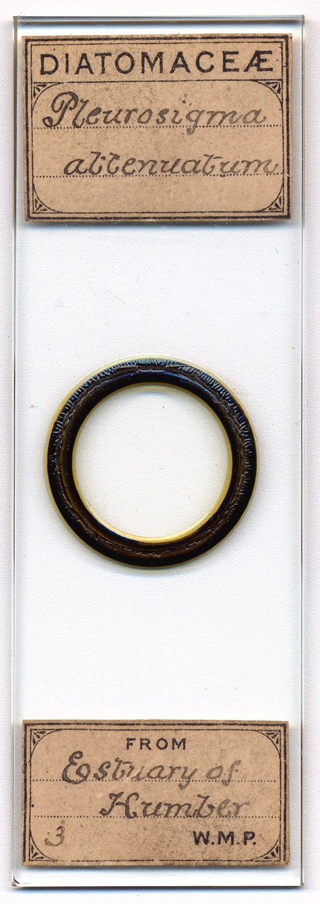
Figure 1. A microscope slide by “W.M.P.”, a strew of mixed diatoms rich in Pleurosigma attenuatum collected from the Humber estuary. The Humber is about 80 miles (approximately 130 km) south of William M. Paterson’s home in Loftus, Yorkshire.

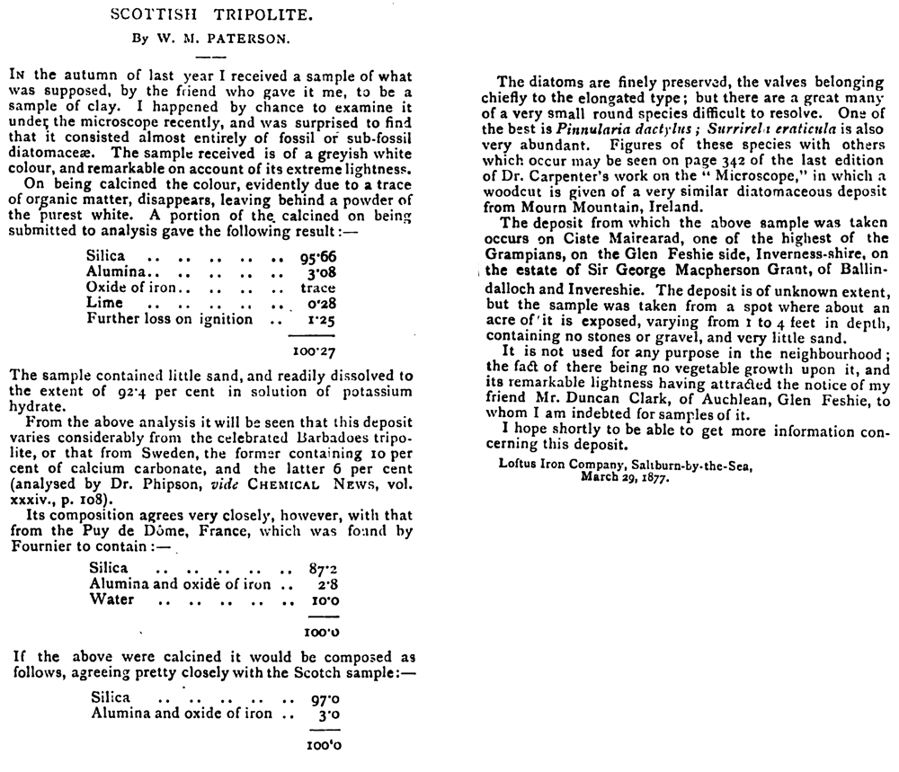
Figure 2. Chemical and microscopical characterization of a diatomaceous earth, from 1877. Written when Paterson was about 21 years old, this is the earliest known evidence of his interest in diatoms and microscopy.

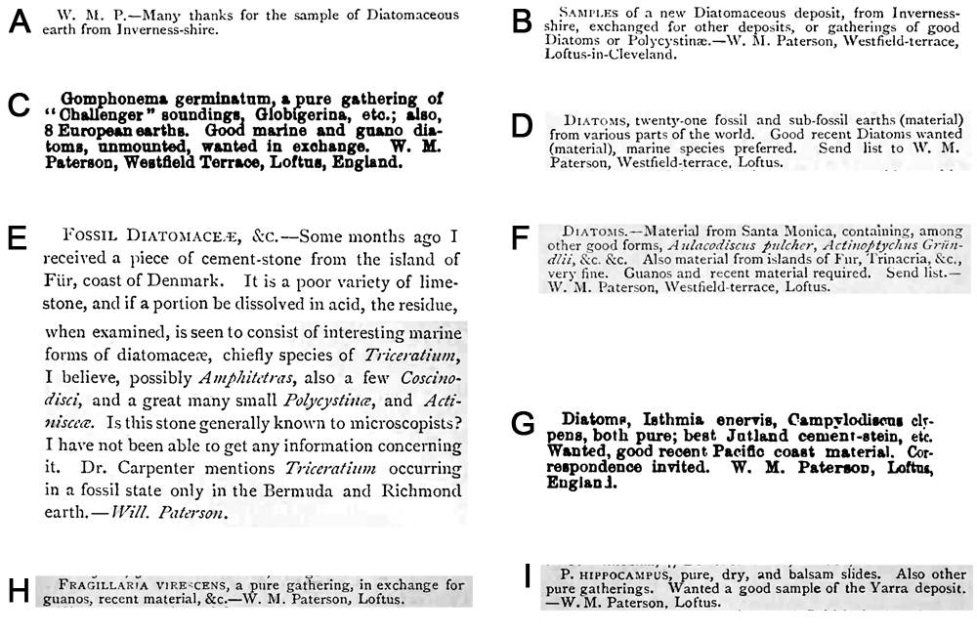
Figure 3. Advertisements and notes from William M. Paterson, regarding diatoms for microscopy. (A) A note from the editors of ‘Hardwicke’s Science-Gossip’ thanking Paterson for a gift of diatomaceous earth, 1877. (B) An exchange advertisement by Paterson, from the same 1877 issue of ‘Hardwicke’s Science-Gossip’ as A. This diatomaceous earth was presumably the same characterized by Paterson in Figure 2. (C) Exchange offer from an 1878 issue of ‘The American Microscopist’. (D) Exchange from an 1878 issue of ‘Hardwicke’s Science-Gossip’. (E) A descriptive note on the diatoms found in ‘cement stone’ (‘cementstein’) from Für island, Jutland, Denmark. This became a well-known source of diatoms for microscopists. From ‘Hardwicke’s Science-Gossip’, 1878. (F) Another exchange from an 1878 issue of ‘Hardwicke’s Science-Gossip’. (G) Exchange request from ‘The American Microscopist’, 1879. (H and I) Exchange offers from two different issues of ‘Hardwicke’s Science-Gossip’, 1879.

William Paterson was born in Minories, Middlesex, during the winter of 1856. His father, also named William, was a merchant. William and his younger brother, James, appear to have lived a fairly comfortable life for a while, as the 1861 census recorded a live-in maid. Life probably took a drastic turn in 1862, when father William died in April. For the next 15 years, the whereabouts of the two boys and their mother, Ellen, are unknown, as they have not been located in the 1871 census or other records. Both parents were originally from Scotland, and Paterson later mentioned having Scottish friends, so it is possible that Ellen took the boys home. However, they are not identifiable in the 1871 Scottish census.
Paterson turned up again in 1877, writing from Loftus, Yorkshire, England, near the North Sea coast (Figure 2). His letter and the 1881 census indicate that he was a metallurgical engineer for the Loftus Iron Company, in Saltburn-by-the-Sea. Paterson’s letter to The Chemical News described both chemical and microscopic investigations of a diatomaceous earth sent to him by a friend in Inverneshire, Scotland. He also posted offers to exchange that raw material with other microscopists (Figure 3 A and B).
William Paterson apparently had a fair bit of experience in making microscope slides by 1877, claiming to “have mounted many”. That year he published two brief notes in Hardwicke’s Science-Gossip on cleaning and preparing microscope slides:
“On Cleaning Microscopic Slides - For removing Canada balsam from spoilt or useless slides, turpentine is, I believe, in general use. If the slides be immersed for about two minutes in strong sulphuric acid, heated to about 100º Fahr., the balsam will be decomposed into a filmy substance, easily got rid of by washing with cold water. If the acid is cold, the time will be somewhat longer. Circles of asphalt and rubber, the deposit of carbon from a lamp, which is sometimes very difficult to remove by other means, turpentine from beakers, bottles, &c., may be done in the same manner.—W. M. Paterson.”
“Dry Mounting - I would like to draw the attention of those readers who are in want of a good method for mounting objects dry, with asphalt cells, to a method I found out some time ago, and which I have since used with complete success. The methods to be found in text-books, at present, are briefly as follows : I. Make a ring, dry it, warm over a lamp until slightly soft, and having placed the object in position, adjust the cover. 2. The former method is sometimes varied by making two rings; the second after the first has dried. 3. Narrow rings of paper are introduced between the ring and cover, and a few other modifications of these processes. The whole of the foregoing methods are liable to the objection that the medium employed for making the cell, asphalt and rubber, or whatever else it may be, runs in by capillary attraction, and either spoils the object or renders the slide unsightly. Of the above-mentioned methods, I decidedly prefer the first one, but I could not depend on it six times out of ten, and have many a time spoiled both slide and temper. Most microscopists seem to have battled against the material ‘running in’, a propensity which I have, to some degree, taken advantage of. Take a slide, and with the turn-table make two narrow concentric rings of asphalt-and-rubber varnish, the inner one-half, and the outer seven-eighths of an inch in diameter, and fill up the space between the two with varnish, so as to make a thin cell of varnish, with an interior a half-inch in diameter. Dry the slide in an oven, slightly warmed, and when quite dry, make a narrow ring of varnish on the extreme outer edge of the cell, and having placed the object in position, or, according to circumstances, before the first ring was made, adjust a cover, pressing it down slightly. The varnish is generally only flattened out, and only occasionally spreads to the edge of the cell encircling the object. The reason for its not ‘running in’, is simply because very little capillary attraction is offered to the film of varnish by the dry cell and cover, compared with the capillary attraction offered to varnish by two plain surfaces of glass, as is the case when the old methods are employed. When the cover has become fixed, the slide should be finished by making a ring on the cover, corresponding with the cell beneath. My experience with this method relates to diatoms and chemical salts, and I have succeeded so well that I have not yet spoiled a single slide - and I have mounted many - even including those used in performing the test experiments. In mounting chemical salts, care must be taken that the level of the ring is above that of the object.—W. M. Paterson, Loftus.”
Paterson continued to post exchange offers for the next two years, in magazines in both England and the US (Figure 3). By 1878, he had acquired a “gathering of ‘Challenger’ soundings”, those being deep water collections of microscopic marine life collected by the HMS Challenger between December 1872 and May 1876. He also offered at least 21 different diatom gatherings from “various parts of the world”.
I have not located any exchange offers or other documents of Paterson’s involvement with microscopy after 1879. The 1881 census located him in Loftus, working as a “metallurgical chemist” and living with his widowed mother.
William Paterson died April 18, 1884, at the age of 27, in Loftus. He was buried, however, at St. Andrews, Fifeshire, Scotland. The 1891 census recorded mother Ellen living in Dover, Kent, with her younger son, James, and his family. Ellen died in Scotland during October, 1896, and was buried in St. Andrews, Scotland, beside her elder son.

This and other histories of early microscopy can also be read on the author’s web site, http://microscopist.net

Resources
American Journal of Microscopy (1878) Exchanges, Vol. 3, pages 48 and 120
American Journal of Microscopy (1879) Exchanges, Vol. 4, pages 24, 48, 72, 96 and 188
Bracegirdle, Brian (1998) Microscopical Mounts and Mounters, Quekett Microscopical Club, London, pages 103 and 186-187, plate 41, slide H
Find-a-Grave (accessed January 2012), William Melville Paterson, http://www.findagrave.com/cgi-bin/fg.cgi?page=gr&GRid=68847084
Paterson, William M. (1877) Dry mounting, Hardwicke’s Science-Gossip, Vol. 13, pages 160-161
Paterson, William M. (1877) On cleaning microscopic slides, Hardwicke’s Science-Gossip, Vol. 13, page 38

Paterson, William M. (1877) Scottish tripolite, Chemical News and Journal of Industrial Science, Vol. 35, pages 151-152
Paterson, William M. (1878) Fossil diatomaceae, &c., Hardwicke’s Science-Gossip, Vol. 14, page 112
England census, birth and death records, accessed through ancestry.co.uk
Hardwicke’s Science-Gossip (1877) Notices to correspondents, Vol. 13, page 120
Hardwicke’s Science-Gossip (1877) Exchanges, Vol. 13, page 120
Hardwicke’s Science-Gossip (1878) Exchanges, Vol. 14, pages 72 and 168
Hardwicke’s Science-Gossip (1879) Exchanges, Vol. 15, pages 96 and 264
Scotland census records, accessed through ancestry.co.uk

Published in the March 2012 issue of Micscape magazine, www.micscape.org

Author's email: brian.stevenson AT uky DOT edu

