Constructing High Power, Low Cost LED lighting for Stereo Microscopes
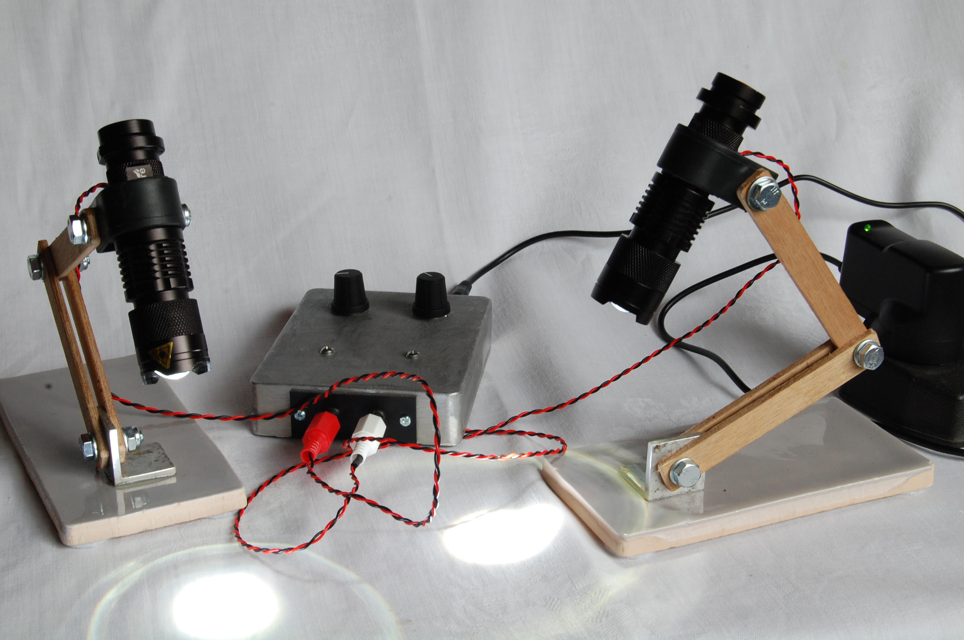
Fig. 1 – The finished project.

Introduction

I needed lighting for examination of spiders with my stereo microscope, and faced by the high cost of a dual arm fibre–optic illuminator used by professionals I looked for a cheaper solution. Some of the features that I wanted for my application were:

- High intensity. Spider work requires magnification of up to x100 combined with the large working distance needed to manipulate specimens, so bright illumination is needed.
- Small illuminator diameter. I often use a 2x auxiliary lens with a 30 mm working distance to resolve fine detail, and was looking for something that could get close in this gap.
- Illumination from any angle. Spiders have complex 3D structures which are key in determining species. The angle and intensity of illumination varies how easily these structures are seen.
- Compatible with cameras. I wanted to avoid stroboscopic effects caused by the interaction of rapid on-off switching used by some control electronics and the cameras’ scanning or shutter systems.
- Cold light source. Spiders are typically examined under alcohol (or sometimes alive). A cold light source is desirable to prevent evaporation and convection currents in the alcohol.
- High colour temperature. The alcohol quickly gets contaminated with debris from the spiders. Light with shorter wavelengths is scattered less by suspended solids, hence the image contrast is higher.

LED torches

After a number of false starts my attention was drawn to modern high intensity single LED torches. I looked for the cheapest available which cost around £2.50 from popular online shopping outlets. The search term “Q5 LED torch” should allow you to find one easily. The torch has a single high power LED mounted on an aluminium heatsink module. Early examples were branded “Cree”. I’m not sure if they were genuine Cree, but they certainly worked very well. Recently the branding has disappeared, so presumably they are now copies of original Cree designs, but they appear equally bright. In front is a plastic plano-convex lens (focal length about 1 cm), the position of which can be adjusted by moving the front part of the torch. With the lens pulled to the forward position, the torch produces an approximately parallel beam, such that the square image of the LED die is projected upon a distant wall. Finding these remarkable torches made the project possible.

The LED characteristics

The original torch runs the LED at 1A, via a small power driver circuit. I removed this driver circuit to measure the characteristics of the LED directly. I drove the LED from a current limited power supply. A graph of the measured current vs. voltage is shown in Fig. 2. This curve comes in handy later if you want to build the illuminator at a fixed output. The characteristics are quite similar to a white Cree X-lamp XPE (see http://www.cree.com/LED-Components-and-Modules/Products/XLamp/Discrete-Directional/XLamp-XPE ). I did not have the equipment to measure the light output, but it was noticeable that the LED is already quite bright at I_{F} = 100 mA. For I_{F} = 500-1000 mA the LED appears little brighter but generates a lot more heat.

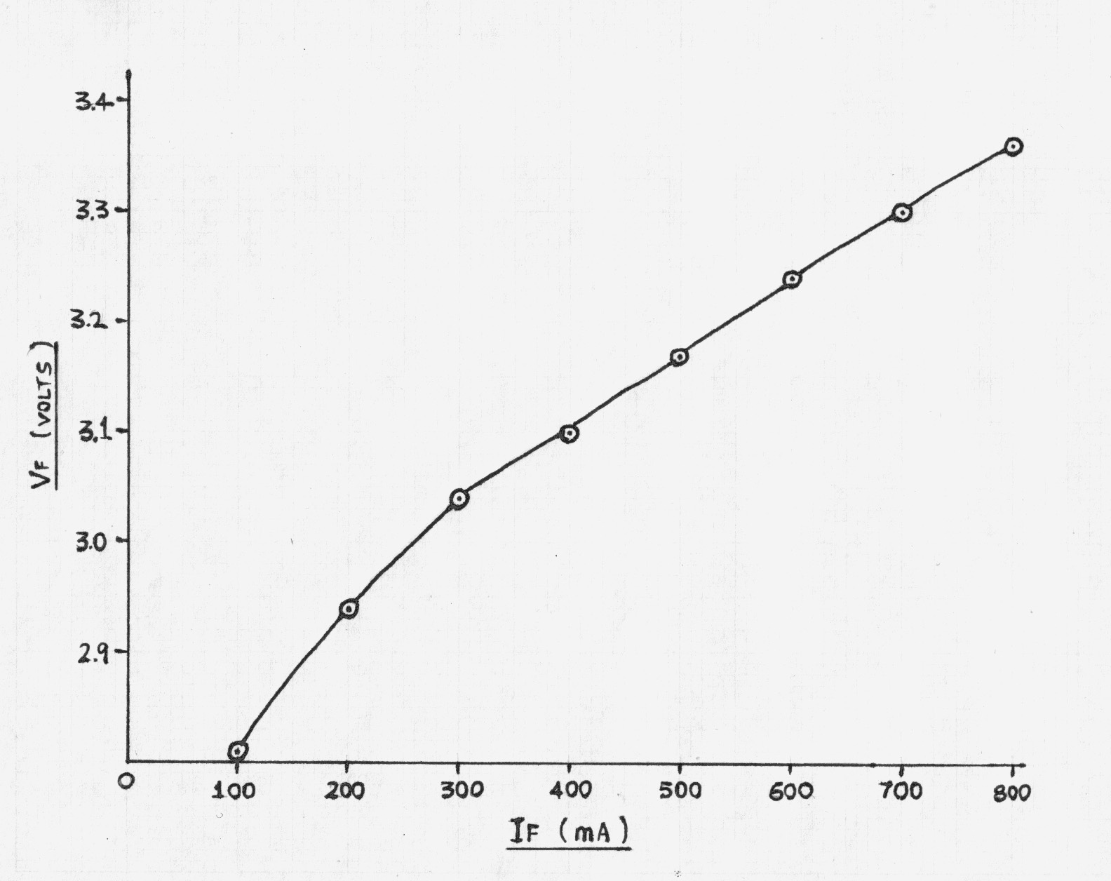

Fig 2 – LED characteristic
Modifying the Torch

The torches LED driver will try to run the LED at 1A, from any supply it is given. To allow fading of the LED it if necessary to bypass the driver module and connect leads directly to the LED.

To dismantle the torch, first unscrew the lens (Fig. 3b). All threads used are right handed. This gains access to the “front assembly” of which the LED module and driver module are part. On recent examples two slots allow the aluminium housing (Fig. 3a) to be unscrewed from the torch. These were missing on earlier examples, but the assembly is usually very loose and can be removed by improvised method, or even comes loose with just fingers. The front assembly and knurled focusing ring (Fig. 3c) can now be removed from the body. A small semi-circular gap at the edge of the driver module (Fig. 3h) allows it to be prised from the rear of the housing. The wires can be clipped through.

The method of holding in the LED module has varied, but recent examples use a push-fit plastic ring (Fig. 3g), with metal and nylon washers (Figs. 3e &f ). The ring can be prised out to free the LED module.

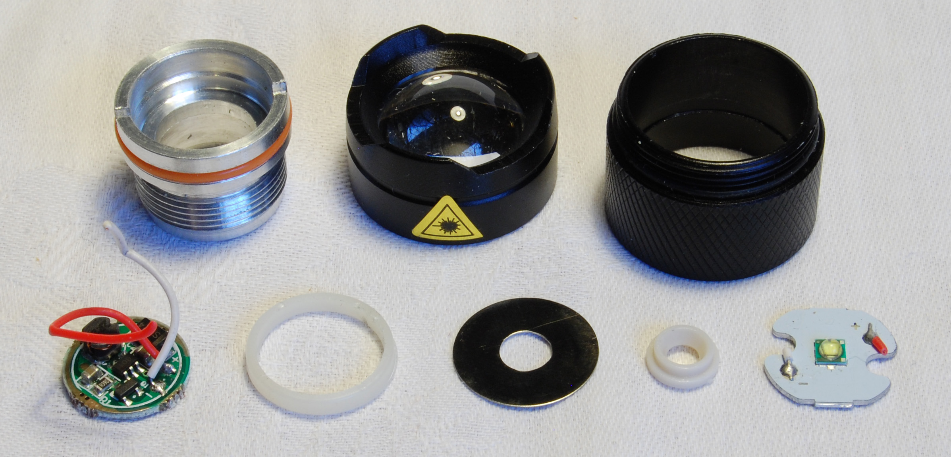
a
b
c
h
g
f
e
d

Fig. 3 – Torch components dismantled. Clockwise from top left a) aluminium housing b) lens c) knurled focusing ring d) LED module e) plastic washer f) metal washer g) retaining ring h) driver module

Longer leads can now be soldered to the LED module and the torch rebuilt. Good thermal contact is made between the aluminium of the housing and the LED module, which is an improvement upon some of the earlier designs. There is no need to worry unduly about heat-sinking in this project as the LEDs run at most half of the rated current, and stay quite cool. If you plan to run the LEDs at the full rated power then it might be wise to use thermal paste between the LED module and the housing.

A hole drilled into the flat portion of the torch body allows the leads to exit from the side. The push button end cap is screwed back in for a neat appearance. Phono plugs connect the leads into the fader box. The metal clip is not needed and is removed by undoing two small hexagon screws. This requires a 1.5 mm hex key.

Parts List for Illuminator

2 Q5 LED torches
2 small rubber grommets
2 phono plugs
1 meter red insulated multi-strand wire
1 meter black insulated multi-strand wire

The Fader Electronics

The circuit diagram of the fader is shown in Fig. 4. LEDs are current controlled devices and the fader tries to fix the current for the right LED at a value set by the position of the potentiometers VR1. Transistor TR2 supplies the LED current. TR2 is turned on by TR1 drawing the small base current from TR2. In turn TR1 is turned on by a very small current drawn from its base by VR1. TR1 acts as a current amplifier. The base current of TR1 is small compared with the current down potential divider chain of R1, VR1, and R2, and this makes it easy to calculate the values of components in the circuit. The current through R3 is approximately the same as the current through the LED, and it provides the feedback enabling the circuit to actively control the LED current. If the LED current rises a little the voltage at the emitter of TR2 drops, causing the current through TR2 to reduce. Similarly if the LED current drops a little, everything moves in the opposite direction to effectively stabilise any changes.
+5V in
PL1
0V
R2
1.5kΩ
R4
560Ω
R6
1.5Ω
R3
1.5Ω
R5
1.5kΩ
R1
560Ω
VR1
1kΩ
VR1
1kΩ
TR2
TIP32A
TR3
BC213L
TR1
BC213L
TR4
TIP32A
SK1b
Left output
SK1a
Right
output
Fig. 4 – Circuit Diagram of the two channel fader

Constructing the Fader

The layout of the fader inside its diecast metal box is shown in fig 5. Any kind of metal box to hand can be used. First cut out holes to mount the connectors, potentiometers and power transistors. TR2 and TR4 use the box as a heatsink. An insulation kit, consisting of a mica and plastic washer is needed to isolate the collector of the transistors from the case. Strips of 1.6 mm printed circuit (PCB) were used as bus-bars for the supply and ground. The circuit is very simple and little else is needed to mount the rest of the components. A small plug-top supply powers the fader box.

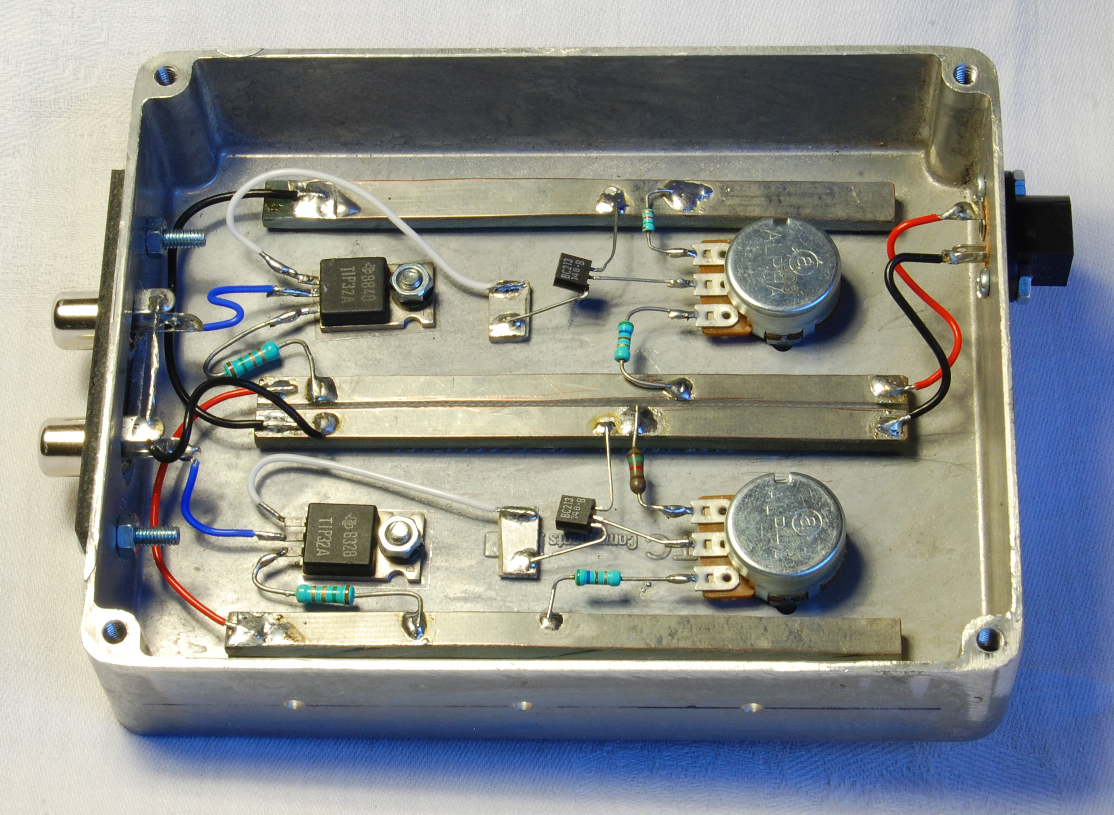
TR4
TR2
TR1
TR3
R2
VR2
PL1
SK1a
SK1b
R1
R5
R4
R6
R3
VR1
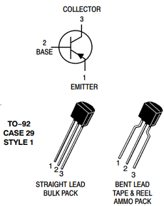
Fig. 5 – Layout of the two channel fader

Fig. 6 – Transistor Pinouts

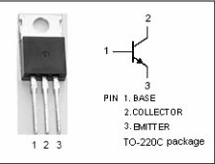

Parts List for Dual Channel Fader

2 off 1.5 Ω ½ W resistors

2 off 560 Ω ¼ W resistors

2 off 1.5 kΩ ¼ W resistors

2 off 1KΩ lin potentiometers

2 off TIP32A or similar PNP power transistor

2 off BC213L or similar PNP small signal transistor

Diecast aluminium box 120 x 90 x 25 mm, or similar

2 off Insulated mounting kits to suit power transistors

Chassis mounted power socket to suit plug-top power supply

2 off M2.5 x 8 mm screws

2 off M2.5 nuts

4 off M3 x 8 mm screws

4 off M3 nuts

Dual chassis mounted phono sockets

Knobs to suit potentiometers
1.6 mm copper clad printed circuit board material
small amount of insulated wire
5V, 2A plug top power supply
multi-strand wire

The Stands

The stand assembly is shown in Fig. 7 below. The illuminator is held by a 23 mm plastic pipe clamp. This diameter is slightly too large so sheet rubber from an old bicycle innertube is used to fill the gap. The small tube between the ends of the pipe clip allows greater friction at the joint without distorting the pipe clip. Those with access to a lathe will be able to turn this part, others will have to improvise by drilling a hole through the centre of a wooden dowel. It may be difficult to obtain exactly the same clamp but it is possible to improvise a suitable clamp in many ways. The author has a small supply of the original clips.

The arms are cut from 4mm thick plywood. The original arms are 100 mm x 15mm, but this can be changed as required, as long as the base is heavy enough to avoid toppling with longer arms.

Friction between the various sections is provided by M6 bolts. A washer is included beneath each bolt head and each nylock nut. Once the nuts are adjusted to the correct friction they will stay in place, and only occasional tightening will be needed to allow for wear.

A ceramic tile makes a weighted base. A piece of aluminium L-section glued to the base using epoxy resin, hold the plywood arms.

Rubber

Sheet

Spacer tube
M6 x 22 Bolts
Plywood arms

Ceramic tile
Aluminium L – section

Felt pads

M6 x 45 bolt

M6 nylock nut

23 mm Pipe clip

M6 washer
(6 places)

M6 nylock nuts

Fig. 7 – Stand Assembly

Fixed Output

Parts List for Stand

23 mm Plastic pipe clip
Rubber bicycle innertube
Spacer tube, 6 mm hole x 10 mm long
4 mm thick plywood
Aluminium L section 25 x 25 x 25 mm, about 4 mm thick
Ceramic tile 150 x 70 x 10 mm
4 off felt pads
M6 x 45 mm bolt
2 off M6 x 22 mm bolts
6 off M6 nylock nuts
6 off M6 plain washers
Epoxy resin

Often running an illuminator at full power is all that is needed, and this saves the cost and time of building the fader box.

The simplest way is to add a fixed resistor in series with each LED module to limit the current. First decide the current I_{F} that the LED will run at and consult Fig. 2 to find the voltage, V_{F} across the LED. The resistor value, R, is found from Ohms Law by

R = (V_{supply} – V_{F}) / I_{F}

For I_{F} = 500 mA, which is approximately the same as the fader at maximum brightness, a resistor of about 3.6 Ω is needed. The resistor will dissipate about 1W so it needs to be suitably rated. Four 15Ω, 0.25 W resistors in joined in parallel could be used.

David Jewsbury, Basingstoke UK, February 2015
Email: david.jewsbury AT ntlworld DOT com

Published in the March 2015 issue of Micscape Magazine.

www.micscape.org

