A SUTER MISCELLANY
Peter B. Paisley
Sydney, Australia

Recent finds enhance our knowledge of Richard Suter, the prolific Tottenham mounter. Fresh data partly concern his mounts: but more, they expand appreciation of the man and his interests, in the contexts of his extended family, historical environment, and local circumstances. Evidence comes from several sources. Much information is from Helen Reed (a descendent of Daisy Suter, Richard’s sister) and her family heirlooms and memorabilia. Some comes from recent sales in the USA and the UK, my own collection, and those of others.
Suter and photography
It has long been known that Suter acquired much of Dancer’s material after the latter’s death, but little light has been cast on this aspect of Suter’s activities. Many assume that Dancer’s negatives lay idle, implying that Suter acquired little micro-photographic skill. New evidence however may suggest otherwise.
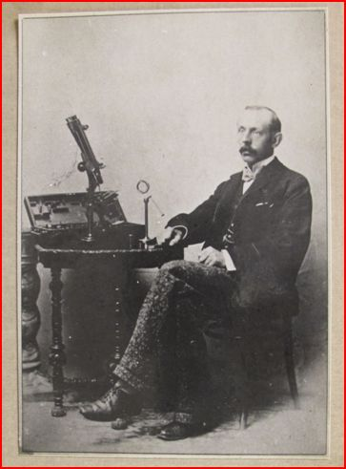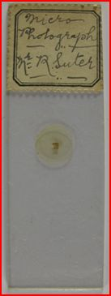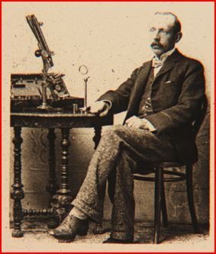
A posed photographic portrait of Richard Suter with (middle) a micro-photographic slide and (R) the image thereon
Family heirlooms include the photograph and slide above: the micro-photograph was made by Suter himself (the label bears his handwriting). The pose may have been in a studio, or in a corner of a room in the Suter house. The microscope shown is not that which has survived as a family heirloom, which means little - Suter advertised microscopes, acting as selling agent for at least eight makers, including R&J Beck (the instrument in the photograph may be an R&J Beck travelling microscope.) We do not know who made the posed study for the micro-photograph, and it may have been done by Suter himself, using a time delay mechanism: alternatively, another family member may have taken the picture. His younger brother Thomas ran a shop selling photographic accessories, and may have made the posed study, as an early essay in photography.
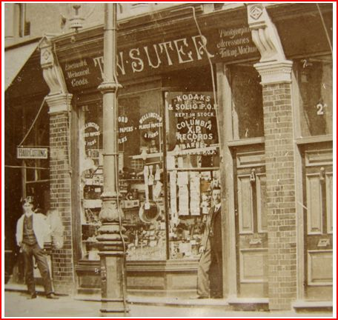
A postcard featured a shop at The Parade, Bruce Grove, Tottenham. The man in the doorway seems to bear a family resemblance to Richard Suter, and is probably Thomas Suter.
Much Bruce Grove streetscape remains today, in a somewhat dilapidated state. Premises have been re-numbered since the days of the Suters: there is more than one possibility, but the illustration below (R) shows what was probably once the shop.
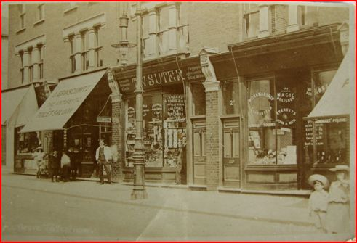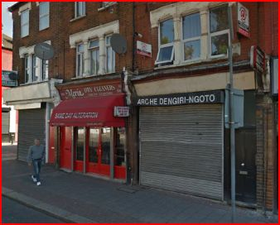
Bruce Grove streetscapes, then and now
The “Kodak” and “photographic accessories” inscriptions prove the shop sold photographic material – could that have included some of the Dancer survivals? The 1901 census shows Thomas still living at 10 Highweek Road, and Kelly’s London suburban trades directory of the same year also shows him there, as “Thomas William”, an electrician. By 1911, the census shows Thomas living in Bruce Grove – but working as a postman. Columbia XP records, which the shop sold, were cylindrical, made for phonographs, and around 1910 they were being supplanted rapidly by gramophone discs. The exact dates between which the shop flourished are as yet unknown.
Thomas Suter, as he appears under the category of “Electricians” in the 1901 trades directory
If Thomas Suter’s advertisement (below), and the trades directory, are anything to go by, the house bulged at the seams for a time!
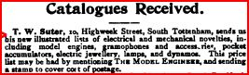
From The Model Engineer and Amateur Electrician, September 15, 1902
Small wonder that, before the 1901 census was taken, he had moved out of 10 Highweek Road, presumably to Bruce Grove.
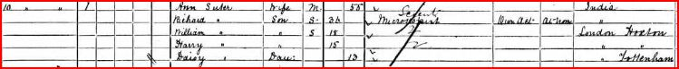
The Suter household at 10 Highweek Road, in mid-1901, when the census was taken
Richard’s business continued, without encumbrance of Thomas’ goods: by now, as per the census above, William and Harry were assisting in the mounting.
Thomas Suter and family in Bruce Grove, in the 1911 census
It seems business as an electrician was unkind to Thomas for a time (one recalls the parallel case of John Thomas Norman junior a couple of decades earlier). But after an initial setback, apparently he returned to it, since his shop featured “electrical and mechanical equipment”. Whether or not the shop sold Richard Suter’s mounts is unknown. Thomas’ entrepreneurial instinct was strong: by 1911 he had moved three doors away, to a shop now specialising in bicycles – then very much an up and coming commodity. That business must have prospered – in 1926 the electoral records show Thomas continuing business at Bruce Grove but living at 686 High Road, so he probably owned one or both of those premises. (His son continued the business, and the bicycle shop still existed in 1986, now moved to 686 High Road and offering mopeds as well as bicycles.)
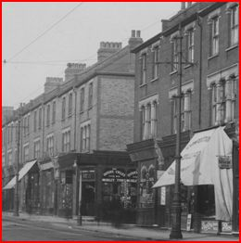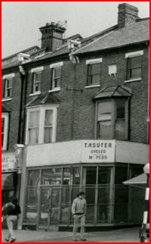
The corner bicycle shop in 1911 (L) and the bicycle and moped shop in 1986 (R)
The Dancer legacy
What may have been furniture originally belonging to Dancer has survived down several generations of the Suter family. The illustrations below show the piece, which has been cleaned recently (it had been painted white.)
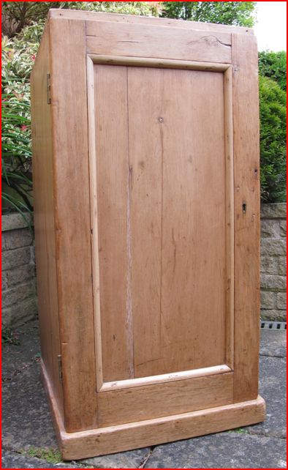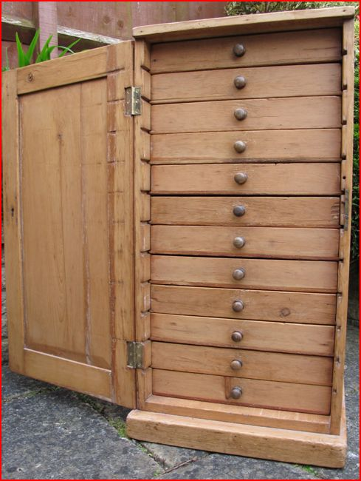
At various times the cabinet has been used to store tools, and more recently, sewing equipment: hence, the integrity of the original drawer compartments has suffered, with only one drawer now containing full partitioning.
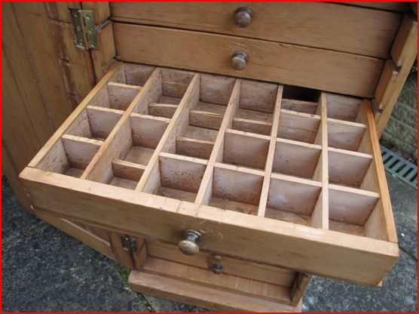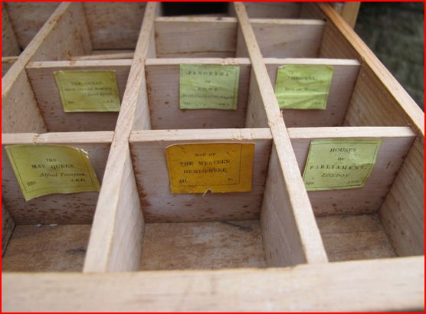
Fortunately, many Dancer labels were removed and kept prior to cleaning the cabinet: some are shown above, re-positioned with blue-tac in their original compartments. Of the labels, more presently. That the cabinet once belonged to Dancer cannot be assumed: but, given that Suter secured the sale of much Dancer equipment in 1896 – notably the negatives - it seems likely. Another likely Dancer piece also survives – a small box containing further material related to the negatives.
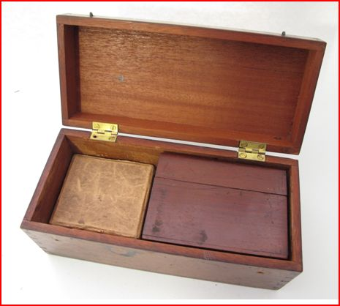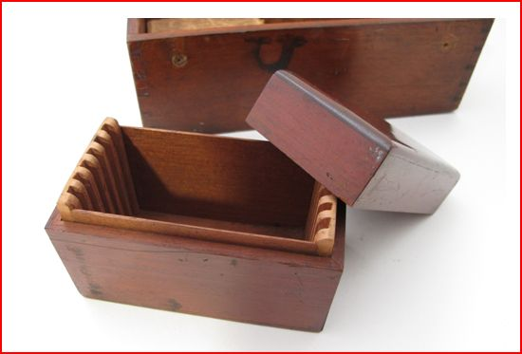
The box may have been intended to hold each batch of six negatives currently awaiting conversion to micro-photograph slides. Micro-photograph slides with Suter’s handwritten labels, if they exist, have not emerged at auction sales or internet sites like eBay, and the example shown already seems unique, intended for personal and family entertainment. In 1900 Suter issued a Revised Catalogue of Microscopical Slides etc., offering no less than 512 micro-photographs. None bearing Suter’s labels seem to turn up, and one explanation is that micro-photographs were indeed made by Suter from Dancer negatives, and sold with original Dancer labels. Many labels survive among Richard’s effects owned by a family descendant, Helen Reed. Other family descendants may have more, or a lot may have been thrown out down the years. What is shown below may be the tip of Suter’s original label iceberg.
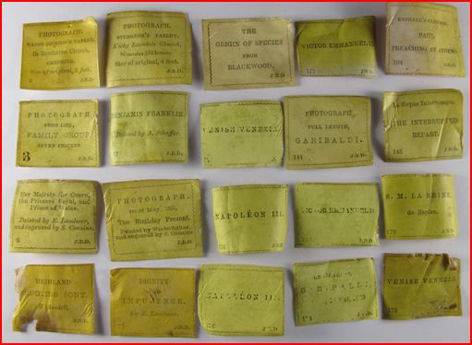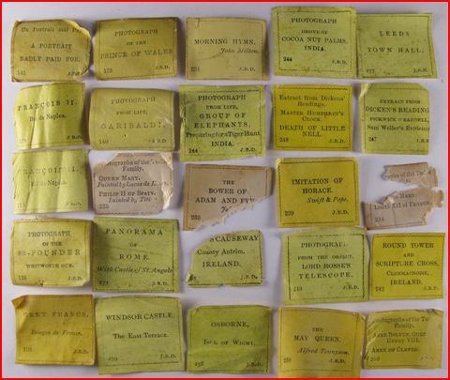
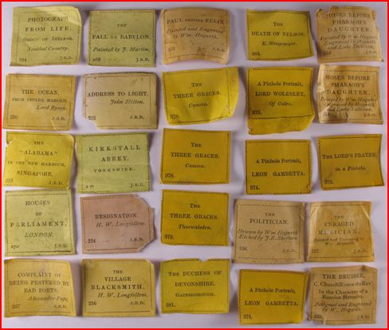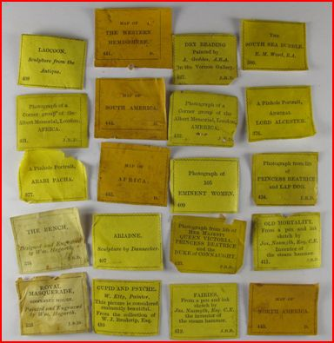
Today’s surviving Dancer labels
Many (including myself) have thought that Suter did little with Dancer negatives - echoed by Bracegirdle in Microscopical Mounts and Mounters, (p.89) who says he “perhaps never used them”. The new evidence, including the Suter self-portrait micro-photograph, seems to give the lie to such assumptions. 512 micro-photographs were hardly in his catalogue for nothing! The negatives were acquired by Suter in 1896, and his revised catalogue appeared in 1900, the years between presumably yielding the 512 micro-photographs.
“Uncle Dick”
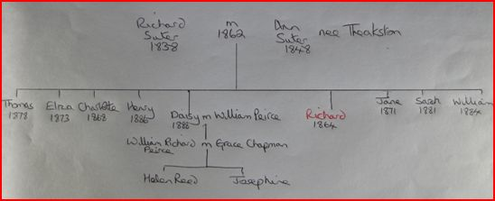
Above is a family tree compiled by Helen Reed, the inheritor of the artefacts illustrated so far. As can be seen, Richard Suter junior (our preparer) was by far the eldest of nine children. The female siblings fared less well than their brothers, since two (Jane and Sarah) died in infancy. Both were born in Shoreditch, and inner London was a hazardous place with high infant mortality: their deaths may have been a major factor influencing the family’s move to then semi-rural Tottenham (Daisy was born in Tottenham). Richard, by contrast, continued mounting into the twentieth century, and died in 1959 at the age of 95. As attested by Helen Reed, he became a father figure for other members of the family. Never married, lacking children of his own, he was affectionately known as “Uncle Dick”. (The parallel with William Joseph Norman – “Uncle Will” - is obvious, since both were accomplished mounters, both had additional artistic abilities, both were childless, and both became father figures for younger family members.)
Daisy Suter, our mounter’s sister, younger by 24 years, married William Peirce, and their son William’s wedding to Grace Chapman is shown below. “Uncle Dick” can be seen directly behind the bride, and his sister Daisy stands to the groom’s right.
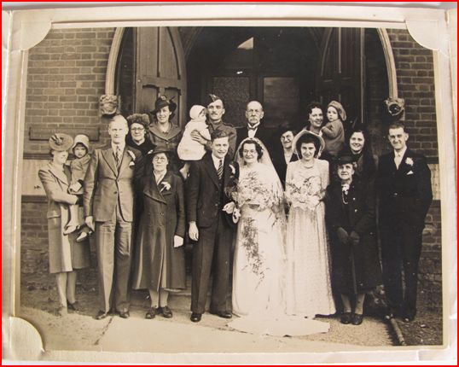
Helen Reed recalls,
“This photo is how I remember ‘Uncle Dick’. I was 11 when he died in 1959 aged 95. He lived with my grandmother Daisy and my father, still at 10 Highweek Road, until his death.”
She also states that,
“My grandfather died when my father was 2, so ‘Uncle Dick’ was his father figure and role model.”
Before mounting full time, Richard Suter had been a schoolteacher, and William Peirce junior became a school science teacher: the father figure influence was strong. “Uncle Dick” as a grand patriarch is seen below at a party, probably a church Christmas celebration (Helen Reed comments that he looks “fed up”, but the picture, if it shows a congregation, indicates his continuing adherence to religion.)
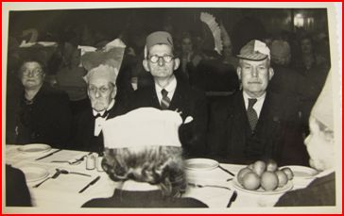
Richard Suter (second from left) in his advanced years
Another wedding photograph, according to Helen Reed taken in the late 1920s, shows him in the back row, with bow tie and wing collar.
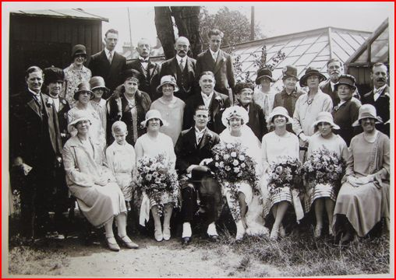
To the end he remained “Uncle Dick”, his failing eyesight evident in handwriting on the back of a photograph below.
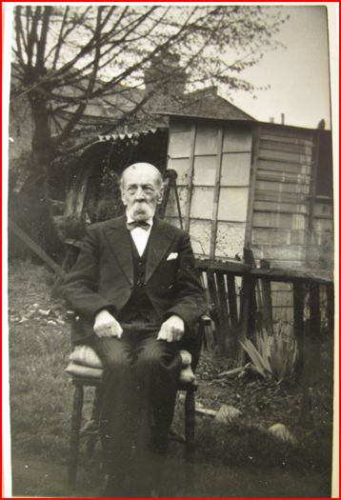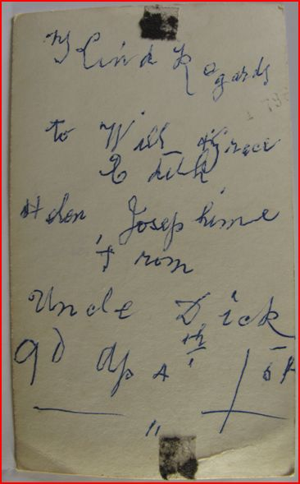
Photograph of Richard Suter in the back garden of the family home at 10 Highweek Road, Tottenham, with an inscription on the back
The inscription, dated April 4th, is addressed to William Peirce junior and his family, and was given to them in 1954. Apparent remains of a world war two Anderson air raid shelter appears behind Suter. The photograph may have marked his 90th birthday - the number 90 seems to be written in the bottom left hand corner, and the year 1954 fits. An outhouse, and the remains of a shelter, seem to be behind a boundary fence, hence next door to 10 Highweek Road. There was probably another such assemblage in the back garden of no.10 – most people seem to have set up such things during the world war 2 blitz.
Exactly when Suter’s eyesight deteriorated badly is unknown. Images of Suter in his advanced years do not show him wearing spectacles: surgery was available for cataracts, so they are unlikely to have been the problem. Late onset macular degeneration seems a possible cause of his visual impairment, and that would certainly curtail work with the microscope. His death certificate at age 95 certified a stroke as the cause: if one seeks a link between this and his impaired vision, perhaps poorly controlled hypertension springs to mind. But unless clinical details turn up in diaries or the like, one can only guess at causes, or their time of onset.
Suter the artist
Recently, Helen Reed sold a paintbox on eBay, to an antique dealer in the USA. Examples of Suter’s art work have also survived among family heirlooms. The paintbox was awarded as a prize to Suter as a schoolboy, by the Department of Science and Art: it is tempting to think that observing the artistic skills in arrangements of butterfly scales or diatoms on slides later inspired his move from school teaching into full time mounting.
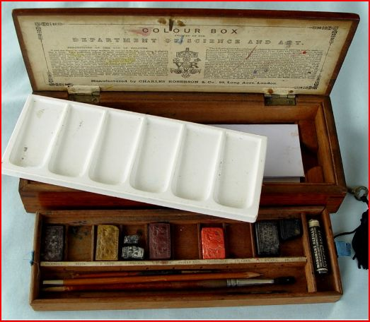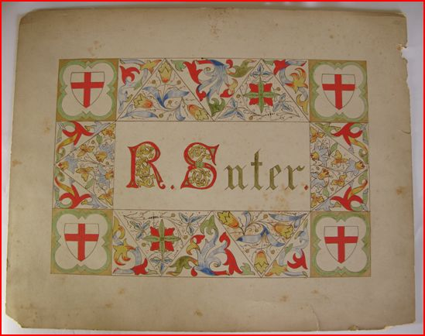
The paintbox, and a watercolour design by Richard Suter
Arranged mounts are no less art than painting or sculpture, and Suter produced many “exhibition” mounts. None that I’ve seen equal one which has survived as another family heirloom: it is as elaborate as any made by mounters like William Norman or Harold Dalton.
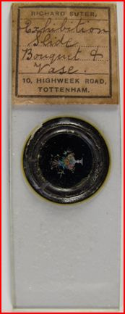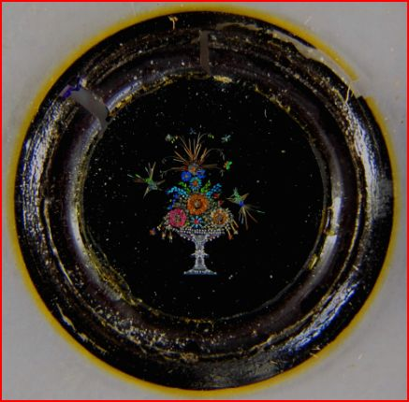
A Suter tour de force: a vase with a bouquet of flowers, with insects and birds
The “bouquet and vase” mount corresponds exactly with the entry in Suter’s 1900 catalogue:
“Exceedingly fine Bouquet with Vase, richly ornamented with Butterflies and Birds”.
Priced at three pounds sterling, a considerable sum for the time, it is a great rarity: how many have survived beyond this family heirloom is unknown. The dealer who acquired the paintbox made vague mention of “exhibitions”, but no details have been forthcoming. It is possible that Suter exhibited paintings locally either when he was still in inner London, or later in Tottenham (or both). But his finest art work, on surviving evidence, is the “bouquet and vase”: it entails as much skill as any watercolour (and more complex specialist expertise).
A man of piety
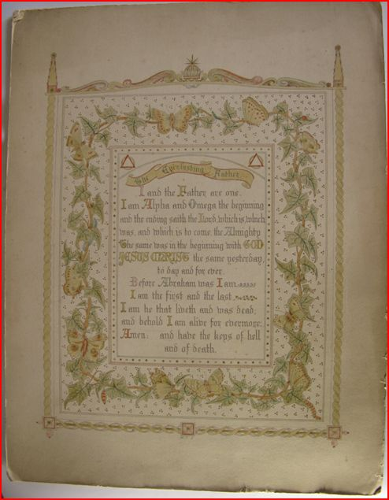
Another surviving watercolour is an illuminated religious tract shown above (both this and the other watercolour are on card, measuring around a foot square.) A tract decorated with such care cannot but be the work of a man with strong Christian faith. The tract is from the Book of Revelation, which may indicate that it was done amidst Luftwaffe assaults on London during either of the world wars, which had eschatological implications for some. In 1915 a Zeppelin, encountering anti-aircraft fire from Tottenham, dropped bombs there: later, the raids were repeated – with a vengeance – during world war two. Neither watercolour can be dated: but airborne assaults certainly left marks on Tottenham.
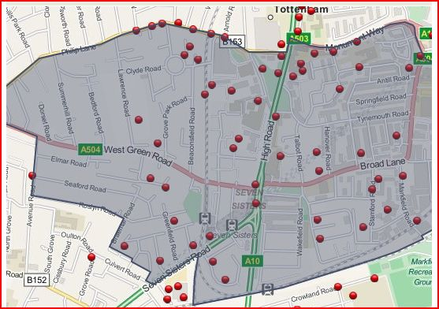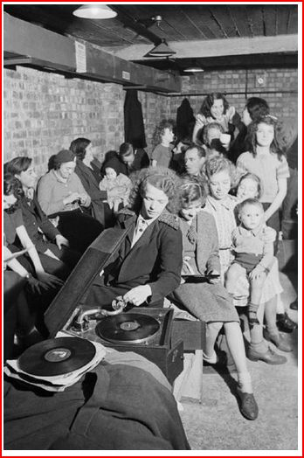
Spot map of bombs dropped on the Tottenham Green Ward, October 1940 – June 1941, with a scene from an underground air raid shelter in Tottenham. One parachute mine demolished several streets.
Some air raid shelters could not withstand the blitz - in the Tottenham area of Downhills more than 40 civilians died as the result of a direct hit on a shelter. Tottenham children were evacuated to the country, and barrage balloons appeared above the district. It would not have been surprising if such things inspired thought of world’s end. As it turned out, both Richard Suter and 10 Highweek Road survived the war, and outlived its end by many years, whatever the psychological impact of the blitz.
In my previous article on Suter’s work (see Micscape, June 2010) I guessed that Highweek Road may have been bombed: but it was completely spared, and still intact in the early 1970s: the picture below shows it just before demolition in preparation for re-development.
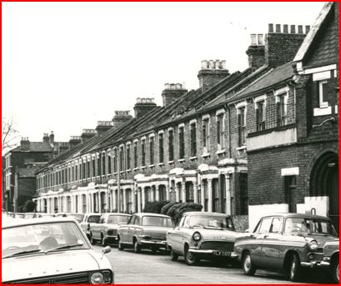
The Suter House at number 10 is towards the left end of the terrace row shown above.
Sales via optical firms
Most surviving Suter mounts are devoid of secondary retail labels: Brian Davidson’s extensive collection – on which Brian Bracegirdle’s Microscopical Mounts and Mounters significantly relies – does not contain any, and others have seen only a few, like those below.
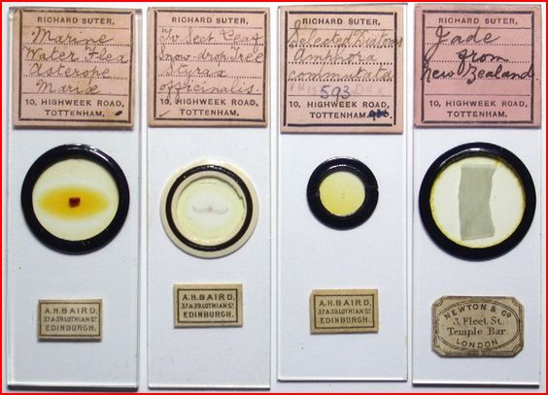
Suter mounts with secondary retail stickers: image courtesy of Howard Lynk
In my own collection of around five hundred Suter mounts, only a handful (below) have secondary retail labels.
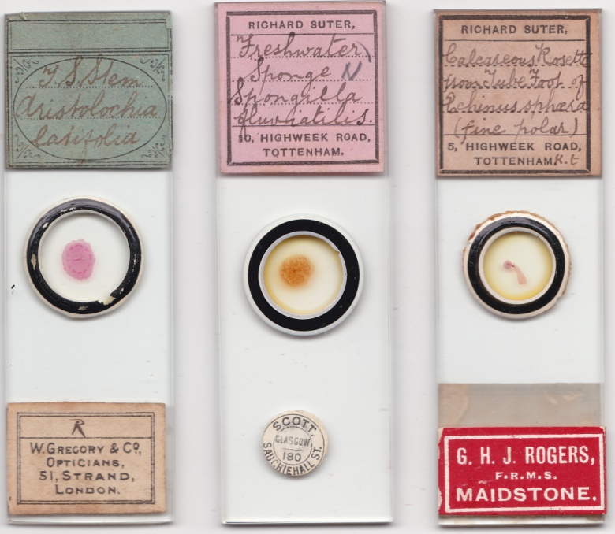
Such labels – apart from Newton’s – are seldom seen today, particularly those of Baird, Gregory and Scott: the double rarity – those labels, and Suter slides carrying them – may belie the existence of more examples awaiting discovery. More likely though, the paucity of such labels suggests that Suter’s sales were largely via “word of mouth” networks, or to individuals responding to his Science Gossip entries, although optical shops may have bought sporadically from his catalogues and on-sold at a profit.
Some mounts have “primary” retail labels, where optical firms but not preparers are specified (but can be identified by handwriting). Slides sold by Cole and Angus, for instance, have labels bearing several handwritings - some that of identifiable preparers, some not. Baker’s 1901 catalogue is more overt, and lists no less than thirty preparers: it includes “Cole” for a physiological series, and examples of this series in Microscopical Mounts and Mounters (plate 4, E and G) have Martin Cole’s handwriting. Cases like this imply contractual arrangements, with company labels supplied to preparers. Interestingly, Baker’s list features neither Ernest Hinton nor W. A. Firth, but “primary” labels with their handwriting occur, as in the examples below.
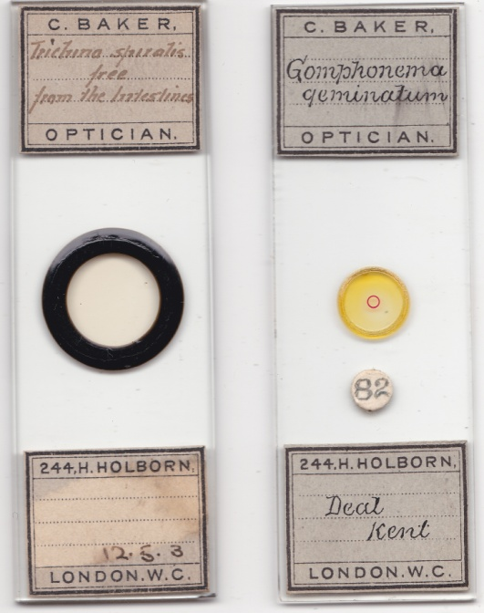
Hinton (L) and W.A. Firth (R) mounting for Baker, presumably under contract
The Suter mount below is a rarity, and implies a contractual arrangement with Dollond, as also seems the case for Martin Cole.
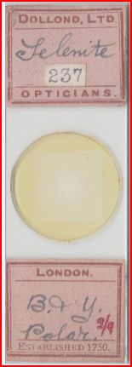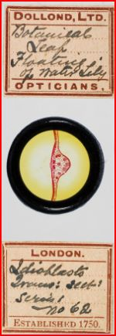
Mounts by Suter (L) and martin Cole (R), retailed by Dollond: image of the Martin Cole mount courtesy of Brian Davidson
Other “primary” Dollond labels in my collection bear different handwritings to those above, so Dollond, like Baker and others, evidently had several preparers under contract, including, at least for a time, Suter. Dollond labels themselves seldom turn up at auction, but a few Dollond/Suter mounts may linger in cabinets yet to reach salerooms.
Suter’s microscope
According to his 1900 catalogue, Suter was a sales agent for microscopes made by Watson, Swift, Ross, Reichert, Beck, Leitz, Zeiss and Lancaster (neither I nor others have seen Suter mounts with – for instance – Watson or Ross retail labels). A microscope is among the family heirlooms, presumably that preferred by Suter himself, possibly subsequently passing to William Peirce junior, the science teacher. It came, not from any of the above mentioned firms, but from S & B Solomons of Albermarle Street.
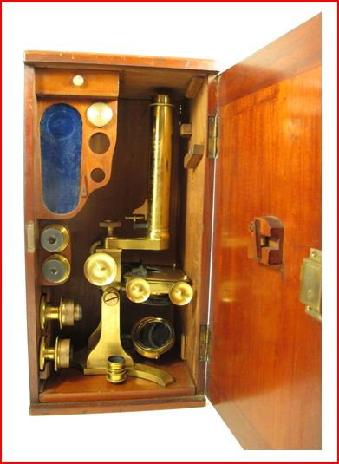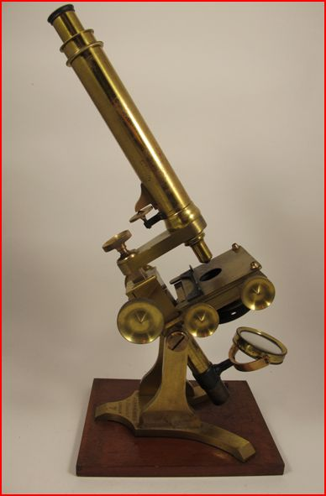
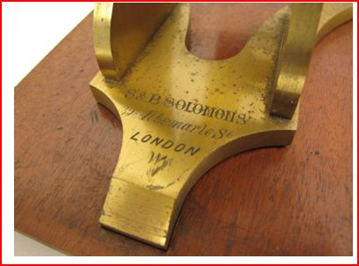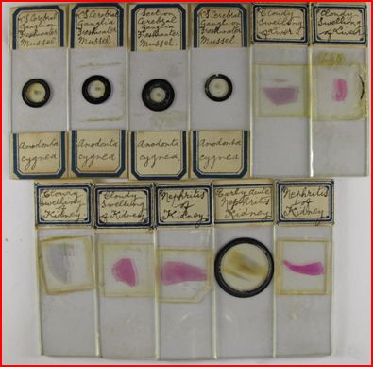
The Solomons microscope, and some Suter slides which survived with it
This raises the question, where, when and why Suter obtained a Solomons microscope? Benjamin Solomons was still listed at the 39 Albermarle St. Address in 1871, but must have ceased business (and died) not long thereafter. It was very much a family concern, with Benjamin, his wife Elizabeth, and a “widow” – his sister-in-law Sophia – all listed as opticians at that address. The three remaining “opticians” were all in their seventies by 1871, and do not appear in the 1881 census.
Elderly, but apparently still active: Solomons optical business partners in the 1871 census
The “S” in “S&B Solomons” was presumably Sophia. Suter’s microscope could have been made many years before 1871, of course. I cannot find the family in the 1841 census: Sophia appears in the 1851 census as a widow and lodger. She, along with Benjamin, his first wife “Mar” (?Margaret), and his daughters Nina, Louise and Lucy, are all specified as “opticians”.
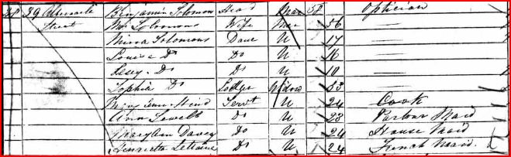
This was a family “cottage industry”: as seen above, 6 people, some as young as 10, joined the enterprise. I have not discovered when Benjamin moved from Yorkshire to London- perhaps just after the 1841 census, since his youngest child was 10 years old in 1851 - but the “why” seems his marriage to his first wife, since she was born in Middlesex.
The Solomons optical firm advertised in the Ecclesiastical Gazette (an Anglican publication) in the 1860s.
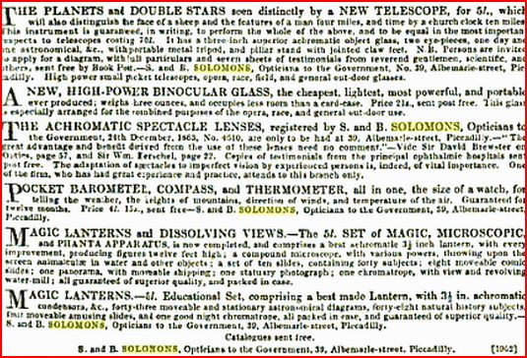
From the Ecclesiastical Gazette, June 13, 1865
The firm enjoyed prestigious support, as evidenced above. Sir William Herschel wrote guidelines for Her Majesty’s ships dredging for biological material, and “opticians to the government” probably implies sales of compasses, barometers, telescopes and binoculars to the armed forces. Mid-century, Sir David Brewster also sat at the pinnacle of the English scientific establishment; Herschel originally worked in England as an influential church organist, hence was doubly well regarded by microscopically inclined clergy.
The Solomons business was strategically placed. John Murray, publisher of scientific works – including those of Charles Darwin – was a few doors away. Nobility and gentry from far and wide stayed at Brown’s Hotel, where T.H. Huxley’s “X Club” met to discuss the latest ideas in biology. Albermarle Street also housed the Royal Institution which featured public lectures by luminaries like Faraday: regular access to most leading scientists of mid-19th century Britain, and many from beyond, presented golden opportunities for instrument sales.
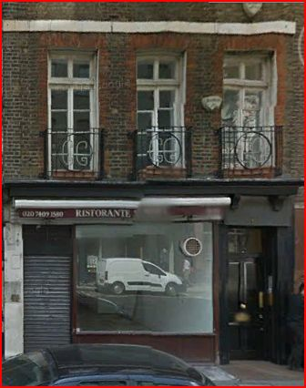
The Solomons house at 39 Albermarle Street has been replaced by a modern complex, but no.38, opposite, is still there. It is a five story building, giving some idea of the style enjoyed by the Solomons business and household, here in the middle of fashionable Mayfair.
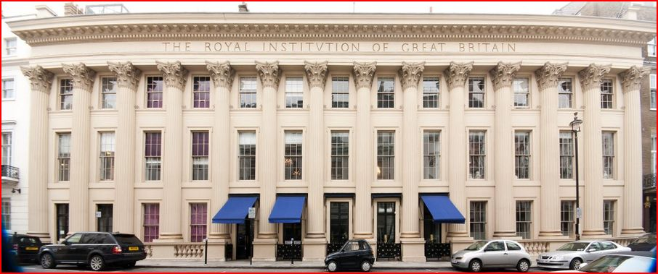
The Royal Institution in Albermarle Street, little changed externally from when the Solomons’ lived within a stone’s throw.
Suter, born in India in 1864, was not yet even in his teens when the Solomons firm ceased to be. He must have had his microscope by 1887, well after the demise of the Solomons firm: by then, and probably before then, he was at 5 Highweek Rd., Tottenham – still school teaching, but advertising in Science Gossip, in October, seeking specimens.
So: why did he have a Solomons instrument? I suspect the answer may lie with Suter’s father’s association with the printer and lithographer Isaac Joseph. Isaac moved to Highweek Road, Tottenham, from inner London around the same time as the Suter family, and his daughter was a bookbinder’s apprentice there, almost certainly under Richard Suter senior: I think Isaac was the printer for our mounter’s labels at no.5, and then no.10, Highweek Road (although I cannot prove it). While still in London, Isaac probably acquired Solomons instruments via connections with local Jewry, possibly from Solomons’ deceased estate: knowing of young Richard Suter’s interest in things scientific, a microscope then was given or sold to him. That is speculative, of course: Richard Suter may have bought the instrument in a second hand shop, or his father may have owned it and passed it on. One thing is certain – Suter cannot have bought it with his own money from the Albermarle St. shop, since he was a very young boy when it ceased trading.
Networking
It seems that the bulk of Suter’s work did not reach the optical shops. His mounts continue to appear on eBay in quantity, and only a few contemporaries rivalled his output (the Flatters outfit springs to mind). Interestingly, both John E. Barnett and Suter made the move from central London to Tottenham: the two men’s time there may have briefly overlapped, and Suter could have inherited Barnett’s list of clients (and, of course, the Solomons microscope) after the latter’s death in 1882. Barnett’s mounts sold as far away as the antipodes, and Suter certainly had global ambitions for his own business. His catalogue claims that his histology slides were
“used at almost every Science Class and Medical School in the British Empire” –
a claim unlikely to have been based on substantial evidence, but doubtless written in hopeful anticipation.
Given sparse sales via retail shops, what were Suter’s commercial networks? There are some likely answers. His 1900 catalogue features boxed sets of 72 histology slides, aimed at science and medical students, educational institutes, and presumably clubs such as Mechanics Institutes, Schools of Arts, and the like. Suter was a school teacher in both central London and then in Tottenham, so would have had contacts in the teaching profession, probably augmented when William Peirce junior became a science teacher. Tertiary educational institutes may have been customers during his early mounting career, but from the last quarter of the 19th century onwards these increasingly satisfied their requirements internally by appointing full time technical staff. That seems to be borne out by a page from his 1900 catalogue, where the sets are marked as cancelled, presumably by Suter himself.
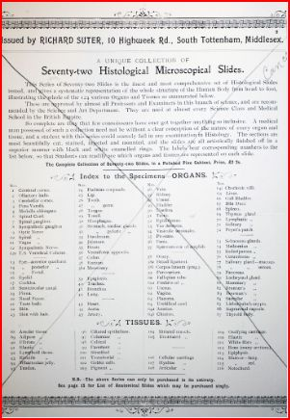
The “cancelled” page from Suter’s catalogue: image courtesy of Brian Davidson
Suter’s mounting: where was it done, and who helped?
Suter probably worked alone during much of his mounting career. But for a time, anyway, he was assisted by younger family members.
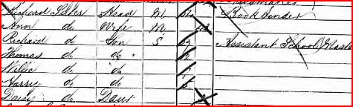
The 1891 census extract above shows the Suter household at 5, Highweek Road, Tottenham. Richard junior, our mounter, was still school teaching, but by now (as discussed already) he almost certainly had his microscope, and probably included microscopy in his school lessons. He certainly began mounting within a few years, as evidenced by his 1887 Science Gossip entry. His brothers were all much younger (Suter was born in India, where his mother Ann had been a child bride aged 14) and doubtless grew up listening to Richard’s talk of things scientific, including microscopy. Ten years later, two of Richard’s brothers – William and Harry - were assisting in the mounting business, and Thomas possibly also helped while still at 10 Highweek Road.
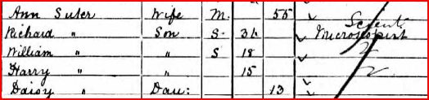
The Suter household in 1901
By 1901 at 10 Highweek Road the census extract above shows William and Harry as mounting assistants. When that census was taken, Thomas was staying with his aunt Sarah in Hampshire: by 1903 he was married, and presumably had moved to Bruce Grove. Ten years later, the census at 10 Highweek Road shows two of the other boys working for chemists: if they continued assisting with mounting, perhaps they brought some chemical knowledge to the activity. (Richard senior is absent from the entry – at the time of the census he was visiting his sister in Portsmouth.)
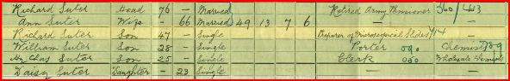
The 1911 census, above, now shows Richard alone as a mounter: younger siblings may or may not have helped, part time.
As to exactly where the mounting took place, matters are not well supported by definitive evidence. In Micscape, June 2010, I suggested that Suter may have used a back garden shed for his mounting, and there is now tentative support for that possibility. Air raid shelters were sometimes improvised by adding Anderson metal cladding to pre-existing structures like garden sheds: one example is shown below.
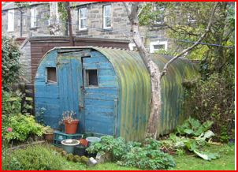
In the back garden photograph of old Suter, previously shown in this article, one can see some interesting details.
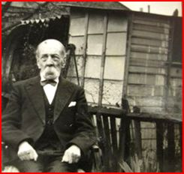
A shed of some sort is seen in the next door garden, with what look suspiciously like storage cabinet drawers on its right, and curved Anderson shelter corrugated metal sections lying behind. The cabinet – if that is what it is – is not the same one previously shown in this article, but it looks similar. Can Suter have been renting space in the next door garden? And was there a similar shed in the back garden of no.10 Highweek Road? And if so, were both sheds used?
Even if mounting took place entirely within the houses at no. 5 and no.10 Highweek Road, there was seldom a large number of people living there until late in Suter’s mounting career. Daisy was still single in 1911, and did not marry William Peirce until 1919 (William previously lived in inner London, married to Daisy’s sister Elizabeth, who died in the “Spanish Flu” epidemic of 1919). Exactly when they moved to Highweek Road is unknown: whatever the case, Suter had something like three decades’ worth of mounting time in a relatively uncrowded house (if indeed the mounting took place indoors at all).
In Microscopical Mounts and Mounters, Bracegirdle comments on Suter’s mounting activity:
“If one ever saw 10 Highweek Road, it was to wonder how all this could ever have been produced and stored, while he was living with his sister and her family!”
But for around 30 years of Suter’s mounting career, his sister Daisy had no family, there were not very many people living at Highweek Road, and in any case back garden facilities probably supplemented Suter’s mounting space.
Mounting and money
Helen Reed’s recollection is that there never seemed to be much money around at Highweek Road. Richard’s mounting business, despite prolific output over some decades, cannot therefore have brought riches to the household. On the other hand, his father’s bookbinding activities, along with Richard junior’s school teaching, and later mounting, would not have left them in poverty: they never employed servants, an economy compared to many households of the time, and at various times one or other of Richard junior’s young brothers also brought income to the household. While never affluent, no.10 Highweek Road therefore seems to have enjoyed a reasonably comfortable life style. Richard Suter’s work probably made him as well off as other microscopists of the time, and he had no wife and children to support, so that others in the family presumably shared the fruits of his labour.
A sad end
By the time he died, Richard was long past any mounting activity, and - judging by his handwriting around 5 years before his death – probably blind. He died intestate, and lies buried in a pauper’s common grave in the northern section of Tottenham graveyard, with no headstone or marker of any sort. By the time he died, he had only two surviving siblings – Daisy, at Highweek Road, and William, who was mentally retarded and living in a Salvation Army home. His brother Thomas had died 10 years earlier, in 1949, and various other family members had emigrated to the USA and Canada. Someone – we do not know who – must have paid the four guineas burial fee. He died, not at home, but in St. Ann’s General Hospital.
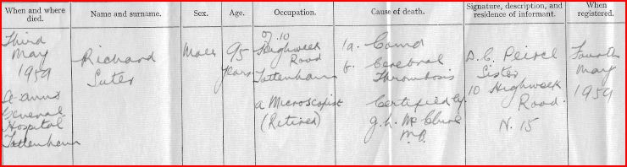
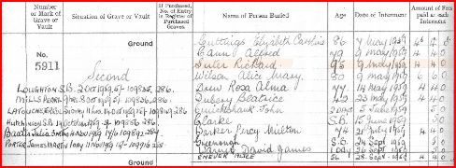
Richard’s death certificate, above, seems to specify cancer (it does not say what sort), so he may have been an in-patient at St. Ann’s Hospital for quite some time before a stroke finally carried him off. Men 95 years old suffer close to 100% prevalence of prostate cancer, and this seems the likeliest reason for his initial admission to St.Ann’s Hospital. It may be that the hospital were unable to contact family members, and paid the four guinea burial fee. Whatever the case, it was a sad end to an illustrious mounting career.
Concluding remarks
This article has dealt with comparatively few of Suter’s mounts: many of his arranged and “exhibition” mounts, for instance, remain undocumented – although none are quite as splendid as the one illustrated here. My own collection includes several such arranged mounts, which may form the basis of some future article. I may seem to have included a surfeit of information on the Solomons microscope: but little has been written about this firm, and it remains a mystery how Suter acquired his instrument: so it seemed worthwhile to include what I have discovered. Readers may be able to “fill in the gaps”.
Overall, my purpose has been to place Richard Suter in his time and circumstances, and I hope readers whose collections include mounts by him will now have a much more vivid picture of the man.
Ackowledgements
Thanks to Helen Reed for comments, and information on the Suter family.
Thanks to Helen Reed and Richard Courtiour for supplying images of the Suter family artefacts.
Thanks to Richard Courtiour for visiting Bruce Castle Museum.
Thanks to Brian Davidson and Howard Lynk for images from their slide collections, and to Brian Davidson for the Suter catalogue image.
Thanks to Howard Lynk for the image of Thomas Suter’s 1902 advertisement.
Thanks to the staff of Bruce Castle Museum for useful data.
The microphotograph of Suter is now in the collection of Trevor Gillingwater.
Sources
www.ancestry.com for census details
www.archive.org for Suter’s Science Gossip entry
Local historical material supplied by Bruce Castle Museum
For those interested in an overview of Suter’s mounts, see my article Those Other Suter Slides in Micscape, June 2010.
Comments to the author are welcomed. Email - lois737 AT bigpond DOT com

Published in the March – April 2015 edition of Micscape Magazine.
www.micscape.org

