Alexis Anastay Julien, 1840 – 1919
Brian Stevenson, Kentucky, USA

Microscope slides that were produced by 19th Century Americans are not often encountered in auctions or in many people’s collections. One possible reason is that many modern collectors are not very familiar with early American mounters. The most significant reference book on early slide-makers, Brian Bracegirdle’s Microscopical Mounts and Mounters, is heavily geared toward English mounters, an understandable bent for an English collector such as Dr. Bracegirdle. An unfortunate side effect, though, is that even American collectors tend to focus on English microscopists, and neglect our native mounters. Yet there were many Western Hemisphere makers of microscopes and slides who were highly acclaimed on both sides of the Atlantic during the Victorian era. Their high quality productions should be welcome in any collection. It is my hope that by raising awareness of the excellent slides crafted by skillful Americans, Canadians, and others, general interest will increase among collectors and stimulate current owners to make such slides more readily available.
Among the finest early U.S. slide makers was Alexis Julien. He was a Professor at the Columbia College School of Mines (New York) and a noted expert on many aspects of chemistry, geology and mineralogy. Julien was a founding member of the New York Microscopical Society, and was a Fellow of the Royal Microscopical Society. He was also a professional maker of thin-sectioned mineral microscope slides, producing slides that are on par with those of the best English and European lapidaries of the Victorian era (Figure 1). Julien was producing and selling mineralogical slides by 1878, offering both pre-made and custom slides (Figures 2-5). In addition, he sold microscopes customized for mineralogy, mounting supplies, lathes, and all sorts of tools for the rockhound.
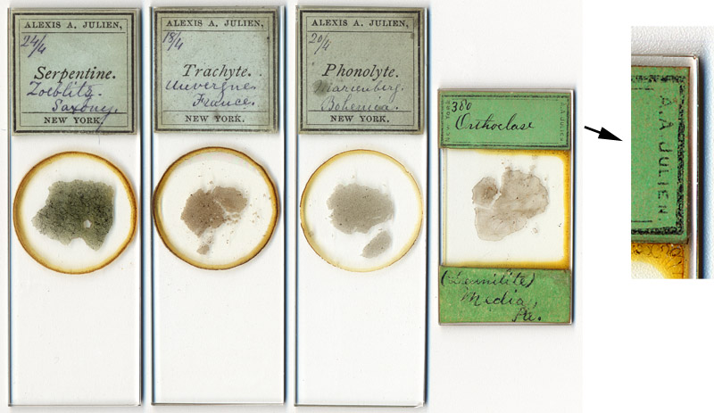
Figure 1. Lapidary microscope slides prepared by Alexis Julien. He produced both standard 1 x 3 inch slides and smaller, 1 x 2 inch slides. Julien’s name is in very small print on the side of the 1 x 2 inch slide’s upper label. Those “short” slides were also favored by German lapidaries of the era. The mineral serpentine was a major focus of Julien’s academic research.

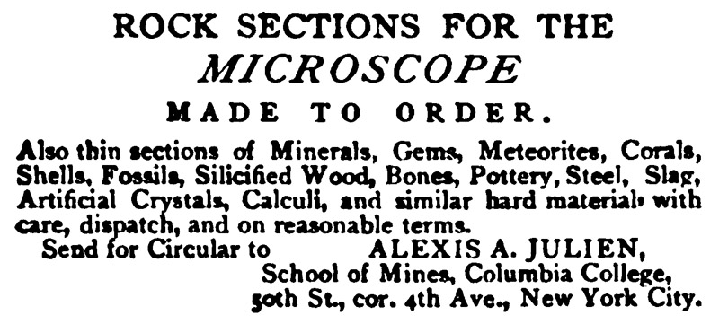
Figure 2. An 1878 advertisement by A.A. Julien, from ‘Science News’.

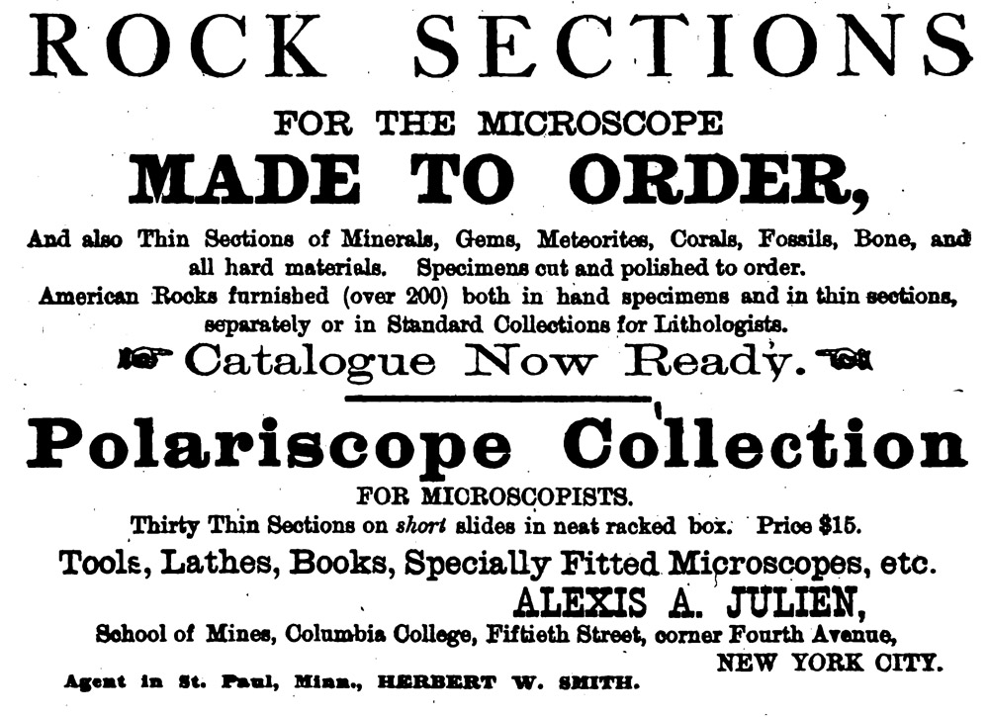
Figure 3. An 1878 advertisement from ‘The American Journal of Microscopy and Popular Science’.

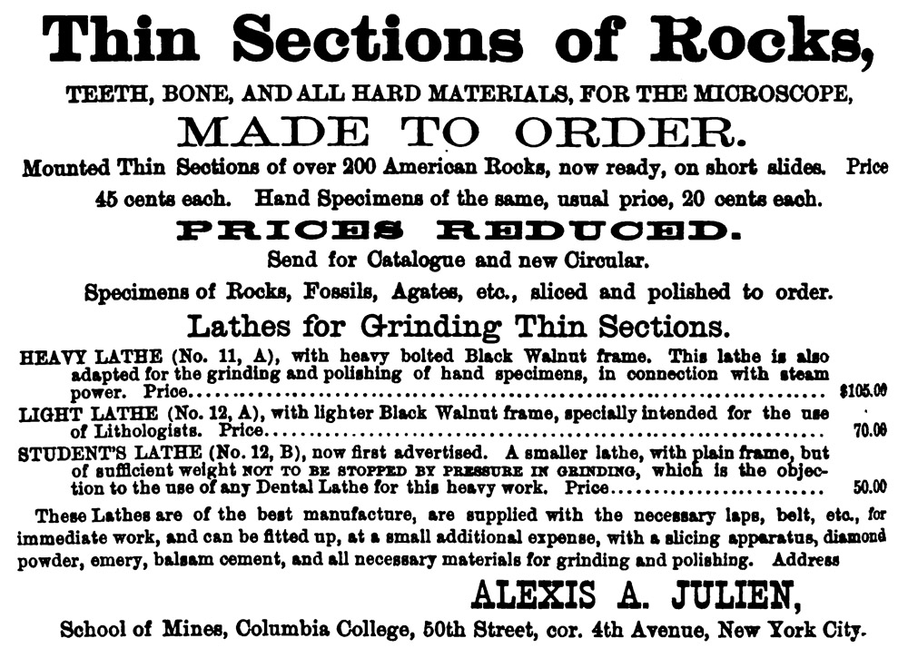
Figure 4. Another 1878 advertisement from ‘The American Journal of Microscopy and Popular Science’.

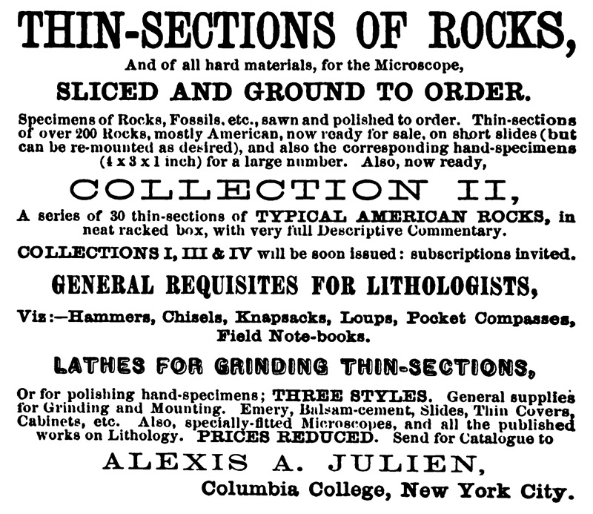
Figure 5. An 1878 advertisement from ‘The International Naturalists’ Directory’.

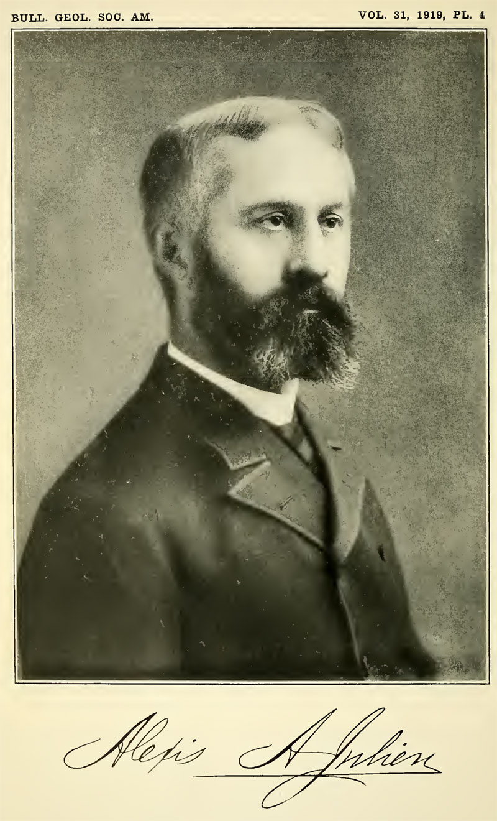
Figure 6. Undated photograph of Alexis A. Julien. From his 1919 Bulletin of the Geological Society of America memoriam.

Details of the life of Alexis Julien are best provided by his colleague James Kemp, who wrote the following memorial shortly after Julien’s death:
“In the loss of Alexis Anastay Julien May 4, 1919, the Fellowship of the Geological Society was diminished by one of the pioneer American petrographers, if indeed he was not actually the very first of American-taught users of the polarizing microscope. His report on the lithology of 259 rocks from the Huronian and Laurentian of the Upper Peninsula for volume II of the Michigan Geological Survey, published in 1873, is, so far as known to the writer, the earliest contribution in which this indispensable aid to investigation was employed in this country. In the subsequent years of the decade of the seventies, those American students who followed microscopic petrography in the more advanced courses of our colleges were trained upon sets of slides and collections of rocks emanating from Dr. Julien's laboratory. In these latter days of the universal employment of thin sections we may hark back in respectful and appreciative memory of one who blazed a pioneer trail through regions then unexplored.
Dr. Julien was born in New York, February 13, 1840. His father, Pierre Joseph Denis Julien, had come to America from Lourmarin, Provence, France; while his mother, Magdalene Cantine, was a member of an old Huguenot family, long settled in Ulster County, New York. The parents educated their son at the Mount Washington Collegiate Institute in New York, and from it, in 1856, entered him as a sophomore in Union College, where he graduated in 1859, salutatorian of his class. He was elected to Phi Beta Kappa, and, having manifested the special interest in chemistry which he never lost during his later years, he was appointed assistant in the chemical laboratory the following year, under Prof. Charles F. Chandler.
In July, 1860, Alexis Julien became chemist of a company exploiting the guano deposits of the island of Sombrero, in the West Indies, and passed the next four years in its service. He had peculiar advantages for the study of the natural history of the lime phosphates and of the reactions produced by waters descending through bird guano to encounter limestones lower down. The year following his return to New York we find the results of his observations published in the American Journal of Science, as cited below in the first contribution of his bibliography. While on the Key of Sombrero he also studied the birds and shells and sent collections to the Smithsonian Institution. He likewise kept meteorological observations for the Smithsonian's records, maintaining thus the most southern of its stations. In 1862 he made a geological survey, for the Swedish Government, of the islets around the island of Saint Bartholomew, West Indies, and forwarded his report to the governor, Carl Ulrich. In 1863 he received from the King of Sweden the gold medal which is given by that monarch to those whose work deserves it - ‘Illis quorum meruere labores.’ He returned to New York in 1864 and prepared for publication the results of his observations in the West Indies. Union College gave him the degree of A.M. in the same year.
In 1865 he was appointed assistant in charge of the quantitative laboratory, in the recently established School of Mines of Columbia College, to which his old chief at Union, Dr. Charles P. Chandler, had been called. In the same year he became a member of the New York Academy of Sciences, then the Lyceum of Natural History, and was an active worker in it all the rest of his life. In the last five years of the sixties microscopical petrography, first developed by H. Clifton Sorby, in England, had its chief nurture and expansion under Ferdinand Zirkel, then in Vienna. By 1872 Alexis Julien had mastered its methods of work and undertook the studies for the Michigan Survey mentioned in the opening paragraph above. In 1875 he undertook a similar engagement for Prof. W.C. Kerr, State Geologist of North Carolina, and spent three successive summers in the field. A very detailed report resulted, which has been the subject of revision in recent years, so as to bring it within the means of publication of the North Carolina Survey, and is stated to be now in process of issue.
Although attached to the Department of Chemistry, Dr. Julien thus became more and more drawn away from chemical research by his interest in the microscopic study of rocks and in the investigation of geological phenomena. In 1880 he published one of his most important and most widely quoted papers, ‘On the geological action of the humus acids,’ in the Proceedings of the American Association for the Advancement of Science. The paper was of unusual value in bringing to the attention of observers the work of this little appreciated agent in the weathering of rocks.
In 1881 he reverted to his early studies of the guano deposits of the West Indies, and visited the islands of Bonaire, Curaçoa, and Aruba, West Indies, making a study of the guano resources and of their general geology. At the commencement of 1882 the degree of Doctor of Philosophy was conferred upon him by New York University.
During this period Dr. Julien was also preparing an extremely important report for the Tenth United States Census, on ‘The durability of building stones in New York City and vicinity,’ which is published in volume X of its reports. This larger report was suggested by several shorter contributions … and in the end led to the investigation of the causes and cure of the alarming disintegration of New York's priceless relic of antiquity, the Egyptian obelisk, one of the features of Central Park. In these early years of the decade of the eighties, Dr. Julien became interested, along with his friend the late H. Carrington Bolton, in the curious musical note given out by certain beach-sands under the pressure of footsteps, a note which has attached to them the name ‘singing sands.’ A very extensive collection of sands from, one might almost say, all over the world was made for investigation and several contributions resulted on their microscopic characters. Soon afterward Dr. Julien took up the study of the two species of sulphide of iron, pyrite, and marcasite, especially with regard to their decomposition, and several papers were published which have been much quoted. While many geologists were more or less thoroughly convinced of the organic nature of Eozoon canadense, Dr. Julien's petrographic studies led him very early to the conclusion that it was a purely inorganic product of contact metamorphism; but his interest became excited in the development of serpentine, and continued active all the rest of his life. Years afterward he brought out the importance of brucite, deweylite and some minor transition products, and serpentine became the subject of his later labors. He had prepared a manuscript embracing the results of many years of reading and investigation, which was unfortunately destroyed in a fire which consumed his home, just a week before his death.
Having become transferred in 1898 from the Department of Chemistry in Columbia University to the Department of Geology, at the time the university removed to its present site, he entered into the discussions which were active in the meetings of the officers and students of the latter. Among these the recasting of the analyses of rocks was one. Prompted by his studies of the serpentines, Dr. Julien was led to apply the methods of recasting to the analyses of a variety of doubtful species of minerals and with extremely fruitful results, which are set forth in his paper on ‘The determination of mineral constitution through recasting of analyses’ (1908).
In the above review the endeavor has been made to emphasize the subjects to which Dr. Julien made contributions of especial importance. Perusal, however, of his bibliography will show a number of other topics on which he wrote. His interest was especially keen in microscopic work and he was one of the original founders of the New York Microscopical Society, in 1880. He was one of the original members of the American Society of Naturalists at its establishment, in 1883. In 1878 he was elected honorary member of the Louisville Microscopical Society and in 1889 was made Fellow of the Royal Microscopical Society. He became Fellow of the Geological Society of America in May, 1889, in the second year of its organized activities.
Upon retirement from active university work, at the age of seventy, Dr. Julien vigorously continued his scientific work and was busy with his writings up to his final illness. The disastrous fire which destroyed his home, as mentioned above, played havoc with the results of years of work. It is tragic that they could not have come to issue while yet he was able to see the fruition.
In 1882 Dr. Julien married Annie Walker Nevius, daughter of the late Peter J. Nevius, of New York City, and still living at their home of recent years in South Harwich, Massachusetts. To Mrs. Julien the writer is greatly indebted for incidents in the life of her husband, which have supplemented a personal friendship of nearly forty years.”

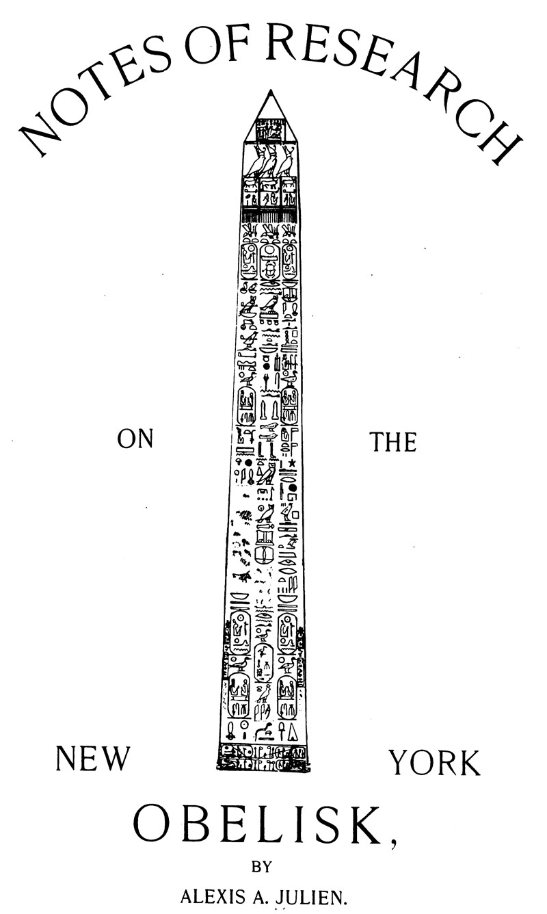
Figure 7. Title page from and 1893 work by Julien.

This and other essays on early microscopy can also be read at the author’s web site, http://microscopist.net

Resources
American Journal of Microscopy and Popular Science (1878) Advertisements by A.A. Julien, Vol. 3
Bolton, H. Carrington and Alexis A. Julien (1885) Musical sand, its wide distribution and properties, Proceedings of the American Association for the Advancement of Science, pages 408-413
Cassino, Samuel E. (1878) The Naturalists’ Directory (International), Advertisement by A.A. Julien at the back of the book
HistoricMeteorites.com (accessed May, 2013), Mystery Alexis A. Julien 19th Century thin-section, http://www.historicmeteorites.com/I-Iowa.html
Journal of the Royal Microscopical Society (1889) Election of Alexis Julien, January 9, 1889, page 168
Julien, Alexis A., and H. Carrington Bolton (1885) Notice on the microscopical examination of a series of ocean, lake, river and desert sands, Proceedings of the American Association for the Advancement of Science, pages 413-415
Julien, Alexis A. (1885) A study of “Eozoon Canadense”, Proceedings of the American Association for the Advancement of Science, pages 415-416
Julien, Alexis A. (1886) The Microscopical Structure of the Iron Pyrites, New York Microscopical Society, New York
Julien, Alexis A. (1893) Suggestions in microscopical technique, Journal of the New York Microscopical Society, Vol. 9, pages 23-43
Julien, Alexis A. (1893) Notes of Research on the New York Obelisk, New York
Kemp, James F. (1919) Memorial of Alexis Anastay Julien, Bulletin of the Geological Society of America, Vol. 31, pages 80-88
Science News (1878) Advertisement by A.A. Julien, Vol. 1, November issue
Wilson, Wendell E. (accessed May, 2013) Alexis Julien, Mineralogical Record Biographical Archive, at www.mineralogicalrecord.com

Email author: brian.stevenson@uky.edu
Published in the May 2013 issue of Micscape Magazine
www.micscape.org

