UNUSUAL MICROSCOPES:

THE BAUSCH & LOMB WIDE-FIELD TUBE

Manuel del Cerro & Dietmar R. Krause

Princeton, NJ, USA

It has been noted that there are ‘Dead Ends” in the evolution of the microscope [1]; instruments that although useful, and even interesting in design, never became popular. We plan, if longevity allows it, to run a short series dealing with some examples of “Dead Ends.” In this article we visit one of these Dead Ends. The microscope shown in figures 1A & 1B is the instrument # 062 in the MdC Microscope Collection, presently at the National Museum of Health and Medicine, Silver Spring, Maryland. This model was produced by Bausch & Lomb during the late 1920s and the early 1930s, and officially called the Wide-Field Tube Attachment. That name is a partial misnomer because, as we will discuss later, the instrument was a low power microscope on its own, not just an attachment. In fact, The Tube could be used hand-held, or mounted on its own tripod stand (Figure 1A), or inserted in place of the body tube of a regular microscope. In the first instance, it acted as a surface inspection instrument. Mounted on a microscope stand, it could be used for very low power examination of slides, Petri dishes, or other objects. In this configuration it took advantage of the microscope mirror for illumination; we will come to this point later on. The Wide-Field Tube was offered in eight different versions ranging in magnifications from 6.1x to 20x, with or without tripod stand, and at prices from $15.00 to $21.75.

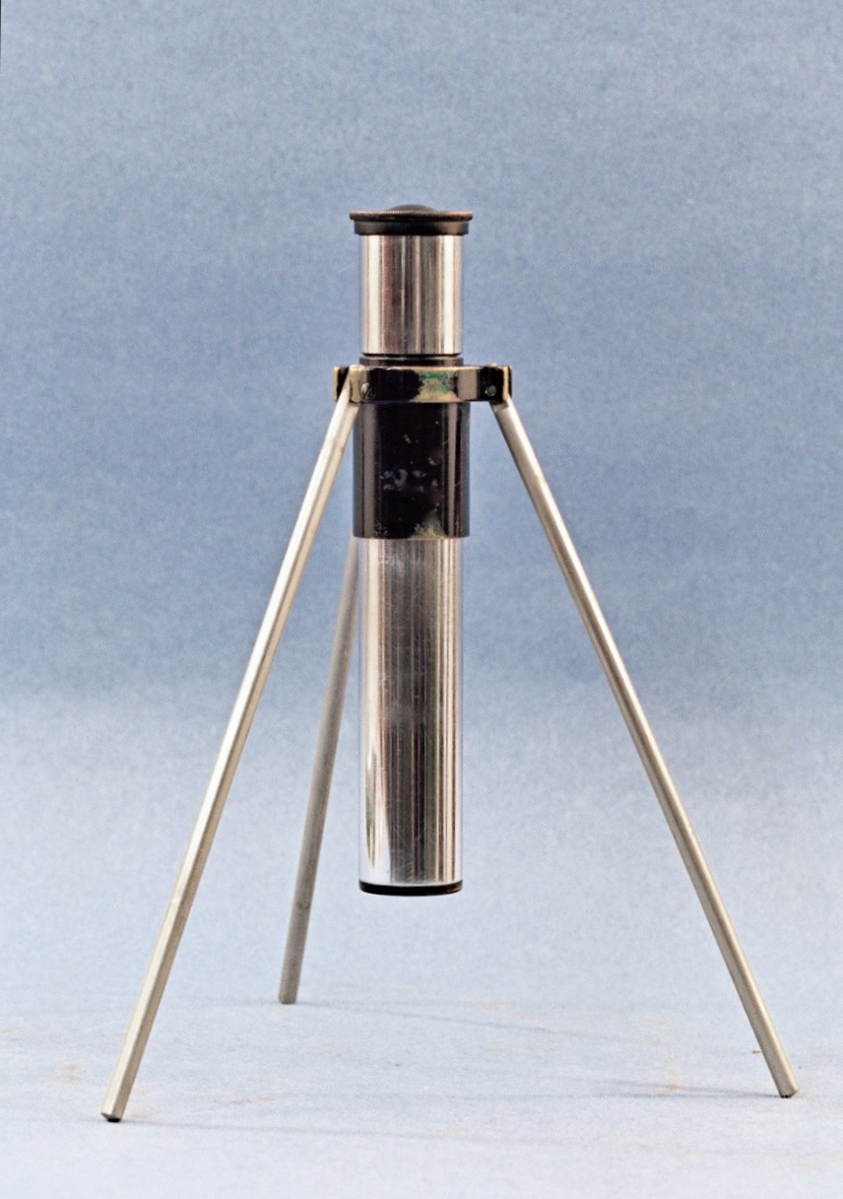

Figure 1A, above. A circa 1930, 20x Bausch & Lomb “Tube” in its tripod mount.

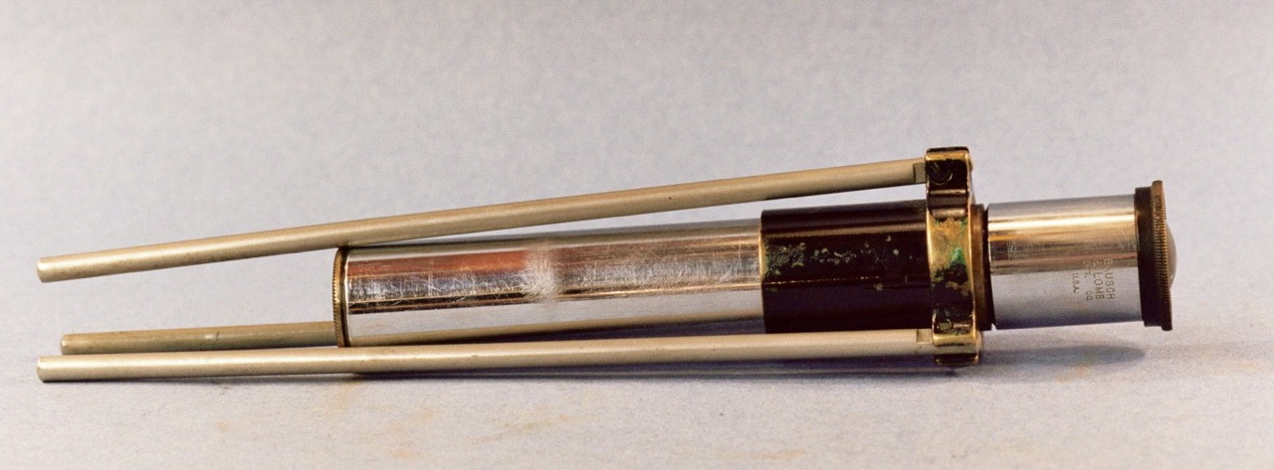

Figure 1B. The Tube with its legs folded for storage or transportation. This is an instrument that was extensively used as indicated by the numerous superficial scratches on the barrel and signs of wear on the supporting ring.

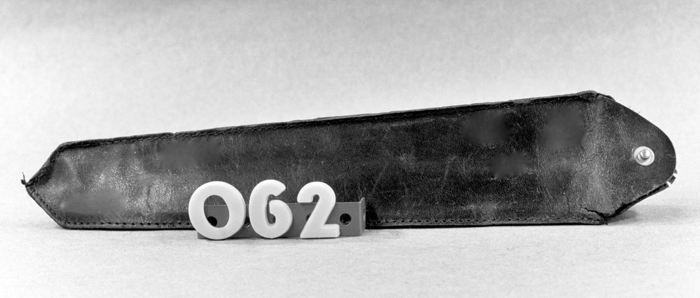

Figure 2. The well-used leather pouch of The Tube shown above. This was an optional item in the B&L Catalog.

DESCRIPTION AND PERFORMANCE: The model we tested is a 20x version. The instrument is signed on the barrel “Bausch & Lomb Opt. Co. U.S.A.”, but it carries no serial number. The legs of the microscope shown in figures 1A & 1B, are 17.5 cm long and are attached to a short U-shaped projection from a metal ring that encircles the body tube. The body tube is 15 cm long; the barrel of the 20x ocular forms its upper portion. Mounted on its tripod, the microscope has a generous field of view of 1.5 cm. Unfortunately; severe field curvature rendered the image totally out of focus at the borders. Although curvature of field was an accepted limitation for light microscopes until the last decades of the 20th century, the curvature in this system is far more accentuated than that seen in contemporary instruments. The reason for it may have to do with the formulation of an optical system that allowed a large working distance (8.0 cm) while reaching a magnification of 20x. At any rate, the area that is in focus shows an image as sharp and as clear as it was possible to obtain with non-coated lenses. In other words, the image was of the quality that one expected from a leading microscope manufacturer at that time. This microscope and its black leather pouch (Figure 2), show signs of extensive use.

REFERENCES: The Bausch & Lomb 1931 Catalog “Balopticons [and] Microscopes for Educational Institutions” lists this instrument as “The Wide-Field Tube”, pp. 48-49; it was said to “increase microscope usefulness.” This is based on the fact that The Tube could be inserted as a replacement for the ocular into the drawtube of a microscope. Then, with the objective removed, it could be used for very low magnification work, taking advantage of the mirror for illumination, and of the coarse focus mechanism for optical adjustment. It is doubtful, however, that this application of “The Tube” ever became popular; we have never found a single published evidence of it ever been used in conjunction with the stand of a conventional microscope. Instead, there is documentation of its use as a surface inspection microscope. The July 1935 issue of Popular Mechanics Magazine, p. 14, [3] shows a worker using a B&L Tube as a surface inspection microscope to examine a piece of the motor of an overhauled Boeing airplane operated by United Airlines.

WHAT WENT WRONG? The earliest indication of the production of The Tube we have found was its description in the 1929 Bausch & Lomb catalog of Microscopes & Accessories [4]. The instrument is still mentioned in the 1931 Bausch & Lomb catalog of Balopticons and Microscopes for Educational Institutions. As we will discuss below the dates of these two Bausch & Lomb publications are significant. Up to now, we have not seen a later reference to it anywhere.

The Wide-Field Tube Attachment was a serviceable instrument of ingenious design, why did it become a “Dead End”? Why it never became popular, and why its production was limited to only a few years? There may have been a number of factors. To begin with, tripod-based microscopes have not being successful in modern times. They have been re-introduced again and again, but there is something to the design that discourages wide acceptance. It may be the relative lack of stability, the fact that the legs seem often to come in the way of the operator hands, or just that the configuration looks unappealing to the modern user. Whatever it is, the fact remains. We think that there was another, and possibly more damming factor in precipitating the demise of The Tube: Price. The Tube was introduced in 1929, the year the Great Depression started. The last reference to it that we have found is in 1931, at a time when the Great Depression was raging. Significant is the fact that by 1931 the prices of three of the four hand-held models (10x, 15x, and 20x) had dropped to $15.00 from the 1929 price of $18.00. The models equipped with tripod had also seen a price reduction; all of them sold for $21.75 instead of the original $25.50. Even after price reduction, this was not an insignificant sum to expend in the days when millions of people were asking: “Brother, can you spare a dime?” [5]

The issue of cost may have brought into focus the fact that, original and useful as this instrument was, it delivered magnifications at par with those provided by a hand magnifier or a simple dissecting microscope. In price and magnification, the Wide Field Tube was competing with the Coddington 14x and the 20x Hastings triple aplanatic magnifiers, which in 1931 were offered by Bausch & Lomb for $1.75 and $5.75 respectively. Also, a Bausch & Lomb simple dissecting microscope could be purchased for $3.00 at that time.

Another detail may have conspired against the wider acceptance of this instrument, and that was its official name: Wide Field Tube Accessory. One understands the emphasis on “Wide Field” since this feature is the raison d’être of the apparatus. However, the name “Tube” is hardly descriptive, and that of “Accessory” is confusing if not misleading. Why it was called a “Tube” an instrument that is in fact a low-magnification compound microscope in its own right? We may never know. As for “Accessory,” it should suffice to say that this instrument is capable of independent operation without being attached to anything else. B&L’s marketing department was an aggressive and extraordinarily successful unit that helped to gain a world place for the Company’s products; in the case of The Tube, however, they under performed.

CURRENT STATUS: The Wide Field Tube appears only rarely in today’s antique instruments market. We are aware of two of such instruments that were auctioned during recent years. This fact, and the history pertaining to The Tube, makes of it a very desirable item for the collector. Happy hunting!

REFERENCES
1. Kreindler, R. Jordan and del Cerro, Manuel (2012). Ten Tantalizers: Microscopes that Continue to Fascinate. Micscape, November Issue.
2. Bausch & Lomb Optical Co. (1931). Balopticons [and] Microscopes for Educational Institutions.
3. Popular Mechanics Magazine 1935. July issue, p. 14
4. Bausch &amp; Lomb Optical Co. (1929). Microscopes & Accessories. Photomicrographic and Micro-projection Apparatus. Microtomes. Colorimeters. Optical Measuring instruments and Refractometers.
5. http://en.wikipedia.org/wiki/Brother,_Can_You_Spare_a_Dime%3F

Author contact: mdcmicroscopes AT gmail DOT com

Published in the May 12th 2014 issue of Micscape.
www.micscape.org

