WILLIAM’S LITTLE PEOPLE
Peter Paisley
Sydney, Australia

That assiduous advocate of natural history as childhood education, William Norman’s friend James Crowther, often deployed insect life to prove the supposed genius of a creator. “Consider the ant, thou sluggard!” inspired Solomon’s Little People – a whole book describing imagined talents and virtues of ants – hence my title. Most of Crowther’s works advocated moral improvement of Sunday school children by study of the natural world, especially by means of microscopy, of insects in particular. How far William shared his friend’s detailed religious views I do not know: but both delighted in insect microscopy, and “Uncle Will” helped to illustrate Crowther’s The Microscope and its Lessons (see my article in Micscape, June 2012). I think William often trapped his own insects, especially in his later career: insect behaviour may tempt observers to anthropomorphism, and some, like Crowther, develop this with fanciful elaboration.
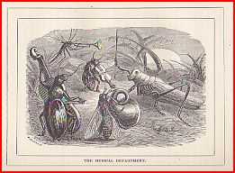
Crowther’s insect orchestra – a typical example of his anthropomorphic whimsy, guaranteed to delight many children- and, quite possibly, “Uncle Will”, too. (From his book “The Lady-Bird’s tea Party”)
I have suggested “Uncle Will” was probably Crowther’s “entomological friend” who lived in City Road, and told Crowther the story of how he was followed, all the way there by steamboat from Gravesend, by
“several male moths.....in search of their female friend.... which was hidden from human eyes in the dark box in his coat pocket” (Crowther, The Five-Barred Gate, pp. 68-9).
If this was “Uncle Will”, he already sought specimens as far away as Kent before his move to Walthamstow. Certainly the two men shared a common interest in entomological microscopy after William’s move to Essex, by when William was becoming a specialist insect man. As well as mounting insects, and parts of them, by the 1880s “Uncle Will” was supplying butterfly scale arrangements to Baker and probably other major retailers (A Baker butterfly scale arrangement has a label with the same handwriting as in William’s notebook.)
Young William Joseph Norman
Beginning in his teens, John T. Norman’s second son became thoroughly immersed in his family’s business. Like other full-time mounters, he prepared a wide variety of material. Judging by my collection, and what I have seen illustrated, he developed a bias toward living material. Examples exist of rock mounts (the slide shown in Bracegirdle plate 27 O just may be his), but they seem rare: I have yet to acquire more than a few (readers may be able to narrow this evidential gap). This is in contrast for instance to his brother Alfred, who early in his career described himself as a “microscopical lapidary”, and made many rock mounts over the years (I hope to document them in a future article).
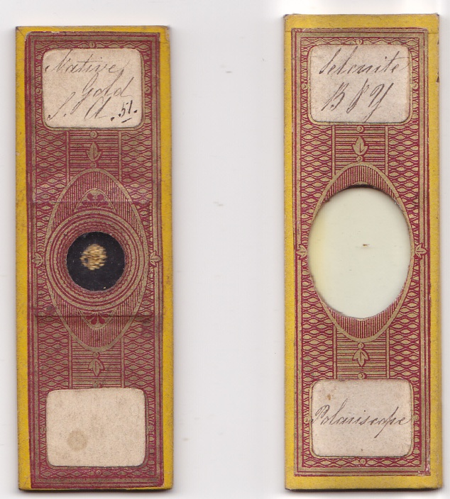
A selenite mount by William Norman with (left) one of native gold, material which he also mounted later in his career. Unlike ground rock mounts, such mounts required few lapidary skills.
His slide below, by contrast, has a ground section of moss agate. Mounts like this by William seem rare (but perhaps most of his ground rock slides have long since been snapped up by keen collectors).
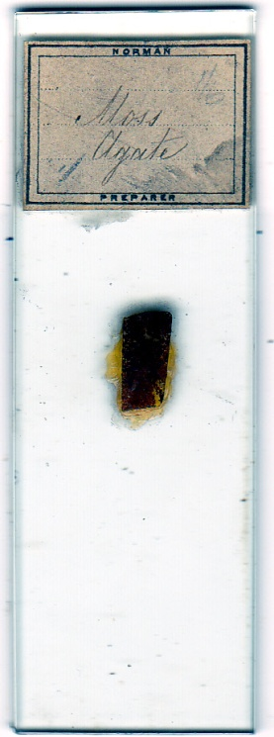
Like many others, young William made wood slides, using (but not always) the three-direction section format, as in the examples below.
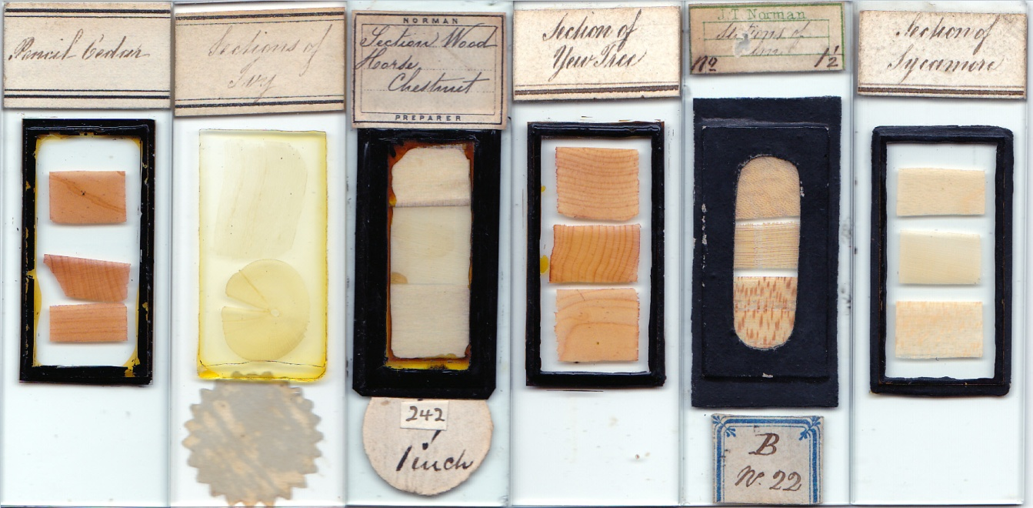
All the labels above seem to bear William’s handwriting: some carry the Norman name, some not
Like most successful commercial mounting firms, the Normans made chemical slides: highly popular with enthusiasts, these generated significant income: as was probably expected of him, young William contributed substantially, as in the examples below.
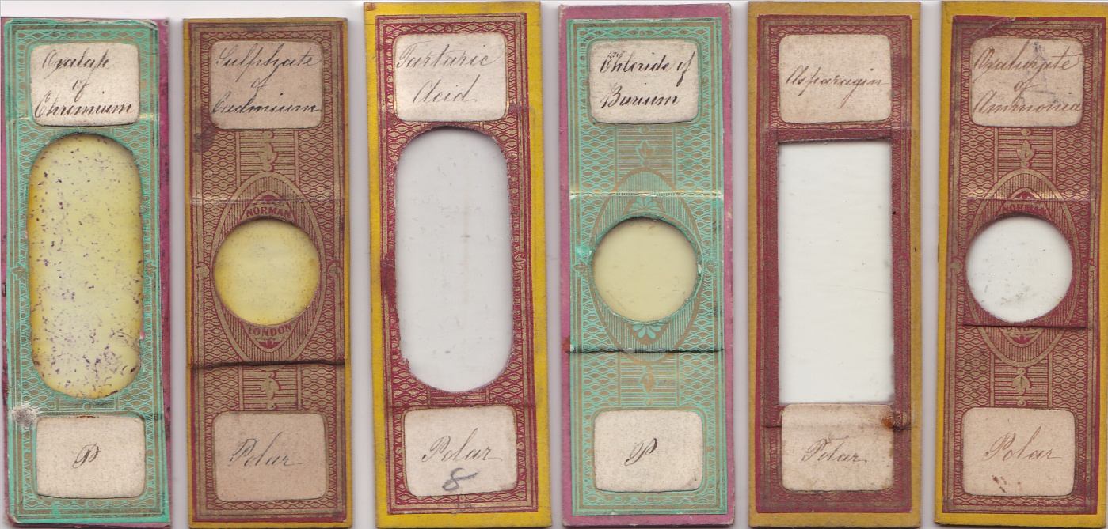
Another favourite – the humming bird feather – was also a good money-spinner, and once again young William contributed.
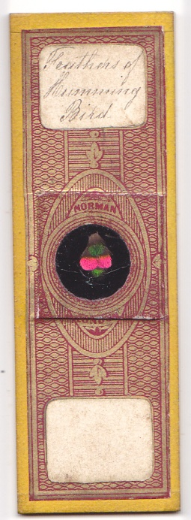
A nicely presented humming bird feather by William Joseph Norman
Early insect expertise
Since Hooke’s descriptions of flea anatomy, just about anyone with a microscope, or in a microscopical club, studied insects. Entomology was a major academic discipline: clubs attended by amateurs and professionals alike thrived in Britain. The Normans in Fountain Place, City Road, lived beside the British Entomological Society’s rooms, and John T. Norman senior presented material there. In 1852, he donated 276 insect specimens to the Society: I suspect these were insects rather than mounts, but so far evidence either way seems lacking. By then twelve years old, William was thus becoming familiar with insects, and his insect part mounts were among the Normans’ early output, as illustrated below.
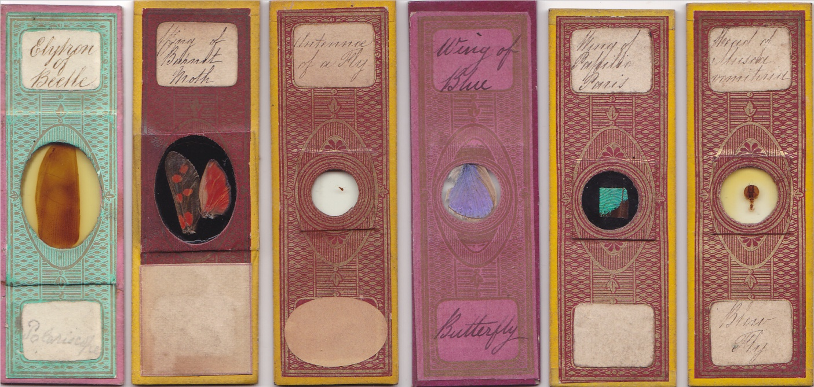
Insect parts by William Norman
William also demonstrated early skill at insect dissection.
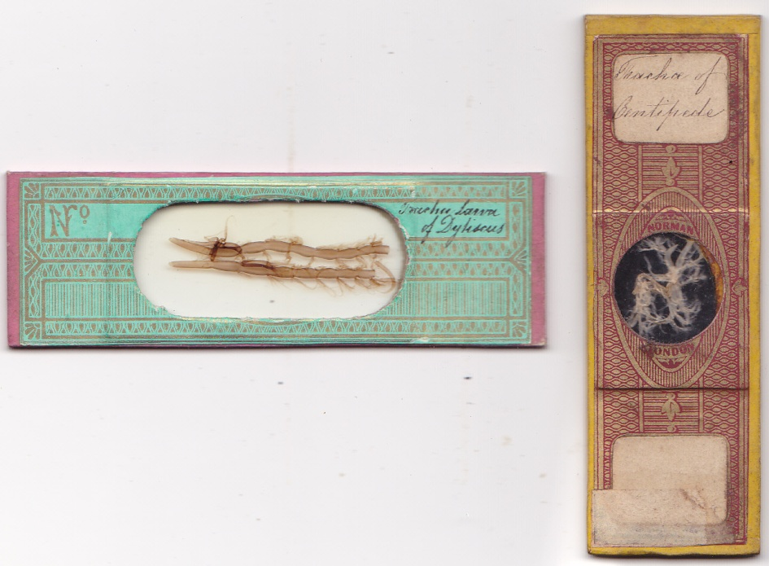
Dissections by William Norman of the trachaeata of water beetle and centipede
Slides shown thus far presumably date from before 1862, since after this the Norman firm seem to have ceased papering. During most of the papering phase therefore, William Norman was in his teens, or at most just into his twenties. The paper on the dytiscus slide above does not seem to have been used by other members of the Norman firm, and may indicate William’s early independence of spirit. The same individuality may be true of my next illustrations. Whole insects mounted without pressure seem uncommon amongst Norman slides, and the mounts below may be rarities. At an early age then, William may have emerged as a pacesetter for Norman whole insect mounts.
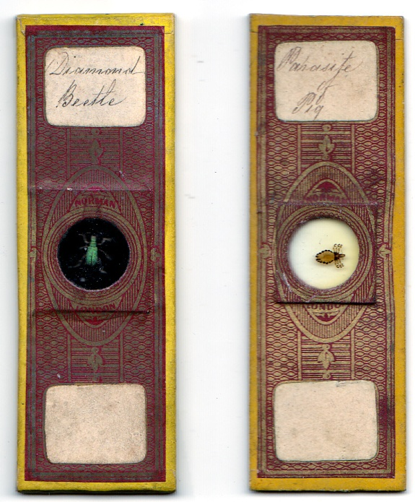
A diamond beetle and pig parasite mounted without pressure by the young William Norman
William’s English intellectual environment
When William was five years old, Chambers’ best selling Vestiges of the Natural History of Creation fuelled renewed evolutionary controversy in biological academia, as well as attracting opposition – sometimes furious – from religion, established and otherwise. When Darwin’s Origin of Species appeared, William was nineteen, and he can hardly have been unaware of the even greater stir this book caused. Natural theology, hitherto a dominant (and especially English) orthodoxy, accepted by many if not most biological researchers, now gave ground to new evolutionary interpretations, engendering extensive debate which sometimes produced more heat than light. Natural selection converted many to a fresh perspective: Gosse’s Omphalos, probably the last significant work by an FRS attempting to combine rigid fundamentalism with modern geological data, “fell stillborn from the press”, its assumptions eclipsed within months by the Origin.
When William was eight, the revolutions of 1848 had swept through Europe, and seemed at times dangerously close to overtaking England. Sitting at a reading desk around a decade later, not very far from the Norman home, a German exile was completing his own magnum opus, and hailed Darwin’s Origin as a vindication of its ideas. The author requested permission to dedicate his Das Kapital to Darwin, but Marx was disappointed when Darwin declined. William grew up in exciting times.
The same year as publication of The Origin of Species, memory of the excesses of the French revolution was vividly refreshed by Dickens’ equally best selling Tale of Two Cities: the fact that Lamarck had been a scientific darling of immediate post-revolutionary France did little to dispel English unease over evolutionary materialism. Cuvier, subsequently, may have gone out of his way to suppress evolutionism in France, but suspicion of things French was endemic in England - political and military expedience produced a totally uncharacteristic reversal of enmity in the Crimean War. Napoleon imported revolutionary ideas into every country he overran, and it took his victor Wellington to quell unrest in the political ferment of early nineteenth century England, well before the revolutions of 1848. And Napoleon’s scientific advisor Laplace, asked about God, had declared that there was no need for “that hypothesis”.
Religious orthodoxy, losing ground to the new biology, could still provide reassurance – perhaps shakily – for some caught in intellectual confusion. Literalist fundamentalism was exposed as ridiculous, particularly where geology was concerned, but modified natural theology stuck to its guns, and continued to thrive among many experts in microscopy, lay and clergy alike. Frank Buckland was an ardent anti-evolutionist all his life, but also England’s acknowledged expert on the biology and ecology of fish. These days, it is perhaps too easy to forget that the most prolific contributors to advances in post Darwinian microscopical knowledge, particularly entomology, continued to be the clergy: as a group, they were prolific on the pages of learned books and journals, as well as in popular publications like Science Gossip.
Faith among the Norman family
Unusually, John T. Norman’s two eldest children John and William were baptised together - not until William was seven, John a year older. Their mother’s premature death from tuberculosis must have caused severe distress in the household: when she was fatally ill, John had lived with his grandparents (I have not discovered when he returned to the family in City Road, except that it was before the 1851 census). John Norman senior’s re-marriage in 1850 presumably created more upheaval for the two boys. (The new wife, a milliner, had a gardener father, and one wonders if he obtained insects for William).
A third son, Thomas, seems to have died in early boyhood. All this was an unsettling backdrop for a family: John Thomas Norman senior probably stuck to his Anglican faith throughout. If so, he presumably derived consolation from religion: he married in church, and his children were baptised, and later married, in church. This could have been purely for the sake of convention, but I doubt it.
Crowther visited the Normans to obtain preparations, notably injected trichinised rabbit material, and speaks of his “entomological friend” (probably William), as “too honest to deceive anyone”. He also described “Mr. J.T. Norman of the City Road” as “a good and clever man”, and as “my friend” (Crowther, The Microscope and its Lessons, pp.221-2). This could have been J.T. Norman senior or junior: I think it was probably the former, although I have no evidence either way.
He chose William to illustrate his example of the bee’s eye as the work of an ingenious creator. I do not know to which denomination Crowther belonged, except that it was protestant (his book Across the Channel is sharply critical of Catholicism). At any rate, he was an ardent Christian apologist, and it seems unlikely that he would have befriended the Normans, and spoken of them as he did, had they been suspect in this regard. Whether or not they were anti-evolutionist I do not know: Crowther was emphatically so, but he was not a totally rigid literalist fundamentalist, since at least to some extent he paid attention to the geology of his day.
An aside on handwriting
I found examples of handwriting and signature by William Norman in 1911: the slope and letter formations are consistent with that seen on early Norman papered slides – William was always neat in his style. In English censuses witnesses were called upon to verify the integrity of the record: this was the case with William Joseph Norman. It was also so with his brother Alfred and at least one other mounter, J.W.D. Hume. Hume was a pharmacist, but the other two were full time mounters: their choice as census witnesses probably says something about their community status by 1911 – there were plenty of professional people nearby, in both cases, who could also have acted as witnesses.
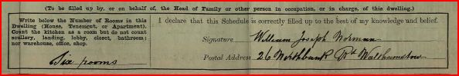
William’s signature to the 1911 census
Not much doubt about who wrote these census entries in 1911 (and it wasn’t the census taker)
The upper case W, and lower case r and f, in particular, are the same as those on early papered slides: the style is consistent - the slope, for instance (a largely involuntary habit) varied little. The above, written within six years of William’s death, helps to identify slides made after his move to Walthamstow. (So - who wrote the butterfly scale notebook? I still think it was his wife – but whoever it was, it wasn’t William.)
Family mounting and independent operations
John Norman senior’s bequest of his business to Edwin and Alfred, and the subsequent agreement between Edwin, Alfred and Charles, mention neither John Junior nor William, and the reasons are probably simple. By the time those documents were written, John was probably dead: William, certainly, was long since thriving on his own, away from the family, and no longer using labels with Norman insignia. There was therefore no need to name them. Charles’ case is more problematical: however, by the time of the business handover to Edwin and Alfred, he had set up as an “optician” quite near the family home in City Road. There may have been commercial complications, had he continued to trade or use labels under the John T. Norman aegis, if he was about to create his own proprietary brand (as seems possible). The agreement with Edwin and Alfred seems to have been amicable, hence may have been a purely pragmatic business formality.
John T. Norman senior’s bequest to Edwin and Alfred in 1892, long after William’s independence in Walthamstow, arose inter alia “out of natural affection for my children”. Another (unstated) motive was in all probability preservation of the Norman trade brand, thus the memory of his name, and that of his son John T. Norman junior. This accords with my suggestion (Micscape, July 2012, on John T. Norman junior) that continued use by Alfred of a box bearing a variant of John junior’s logo (from the time of the failed business in Whitecross Street), was prompted by similar sentiments.
Transitions in label formats
Except for some small slides, I have not seen John Norman junior’s work lacking Norman identification, either by name or by initial logos. By contrast, his near contemporary William’s labels have many formats, and some have no overt maker identification at all. Before and after 1862, papered and unpapered slides bear his writing on (not always) overtly Norman labels: examples are shown below of insect mounts, made while he was still working with the family at City Road. (I have seen no papered slides made after William moved to Walthamstow).
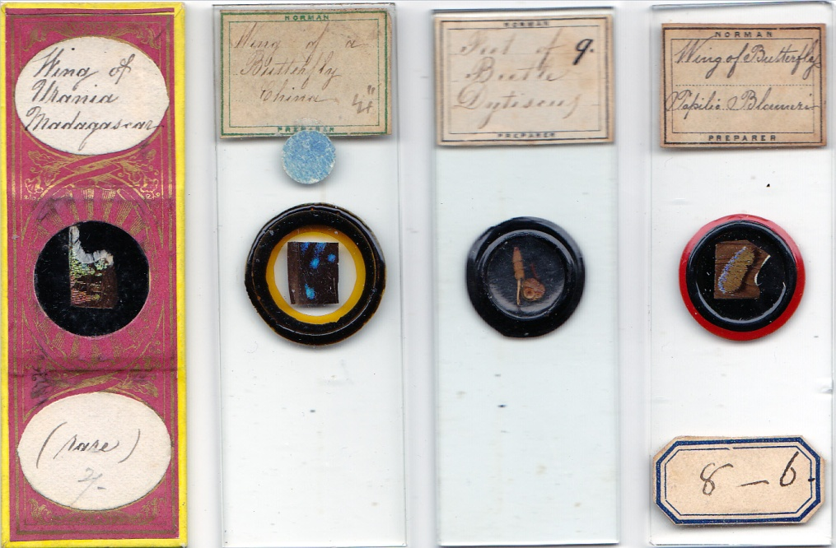
The papered (and unascribed) slide is “rare” in more ways than one, since it has a pattern not used (as far as I know) by others in the Norman clan. Another example, perhaps, of young William as an independent spirit. The exotic urania species is also somewhat unusual in William’s output as a whole – most of William’s later insects were probably trapped in Epping Forest.
Cases occur of, I think, originally overt Norman labels, now with the family name removed, apparently deliberately, as in those shown below.
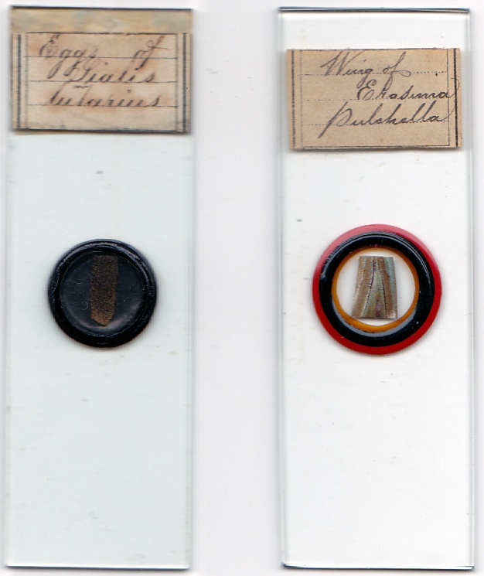
Insect mounts by William, with the labels truncated
Why was this so? I have not discovered exactly when William moved to Walthamstow, but it was probably around 1875 (he is not mentioned in Kelly’s 1874 Post Office Directory for Essex). These labels may indicate their use shortly after his arrival there, still with a supply of labels which he modified to avoid confusion with the family firm at City Road. The Norman extended family never lacked printers: another label example is shown below, printed with an identical size and pattern to that of many Norman labels but without any name or initials. Two of William’s sisters – Mary Ann and Sarah – married printers.
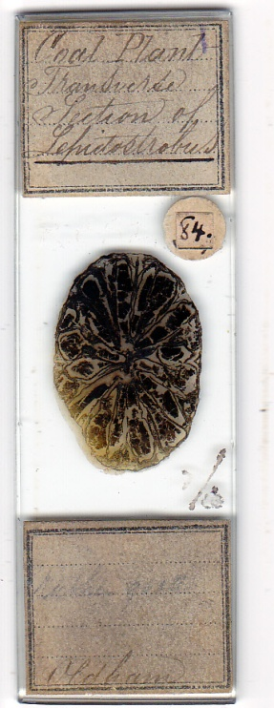
This fossil slide of Oldham coal is interesting in several ways, apart from its label. It has a diamond inscription “RCSL”, which I take to indicate that it was formerly in the Royal College of Surgeons, London. Norman slides are rarely dateable, except in very broad terms: this one’s coal material probably originated in the family firm’s series from the mid eighties, since that is when they were advertised. The inscription “Plant” does not look like William’s or John junior’s, and it could be that the slide was sold by the elusive Charles, striking out on his own as an independent “optician”, hence, like William, modifying his labels. If so, it would echo the agreement made with Edwin and Alfred. I would be most interested to see readers’ opinions on this. William certainly mounted fossils, as on the slide below, where the handwriting is his.
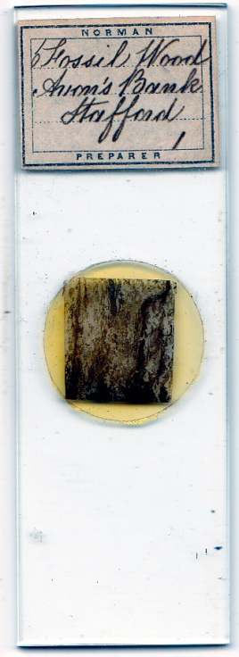
I have not seen the truncated labels illustrated in the literature. Much more frequent in my collection are the round, sometimes oval, labels like those below, with no maker’s name but identifiable as William’s by their handwriting (and also absent from the literature).
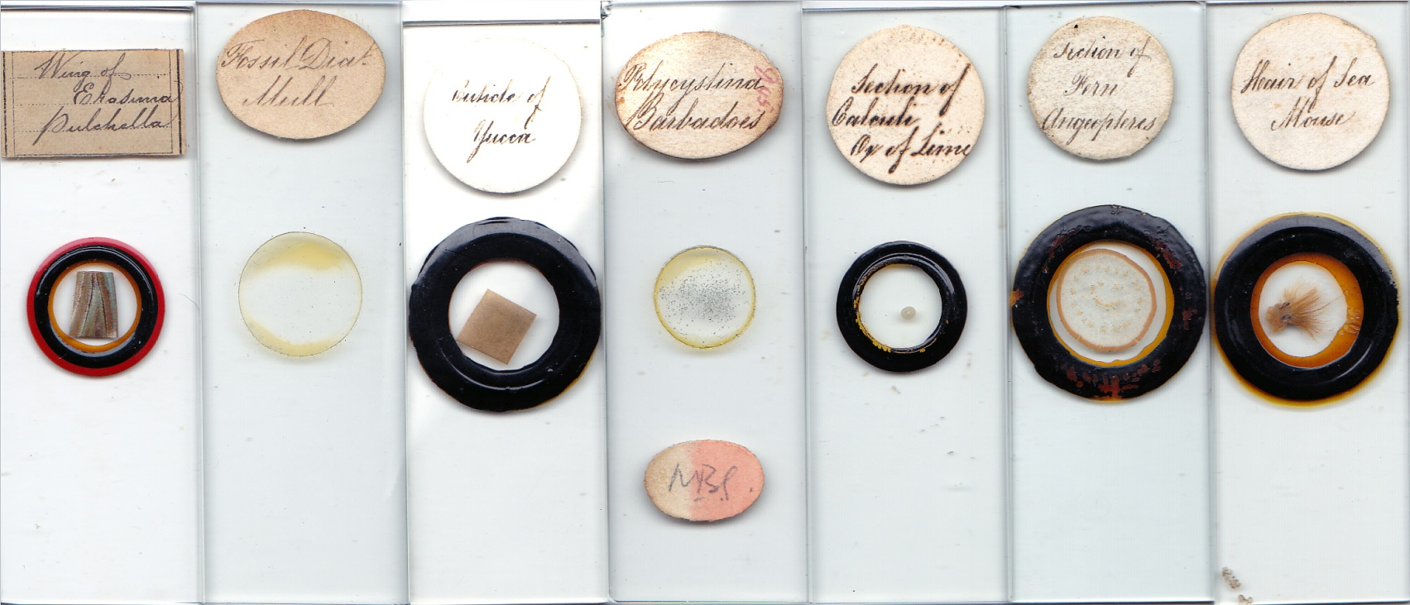
A variety of material mounted by William Norman: six slides with round or oval labels, contrasted with one using his cut down label: this reflects the proportion found in my collection.
Slides lacking overt maker’s identification, with labels like those on the coal slide illustrated above, look like his.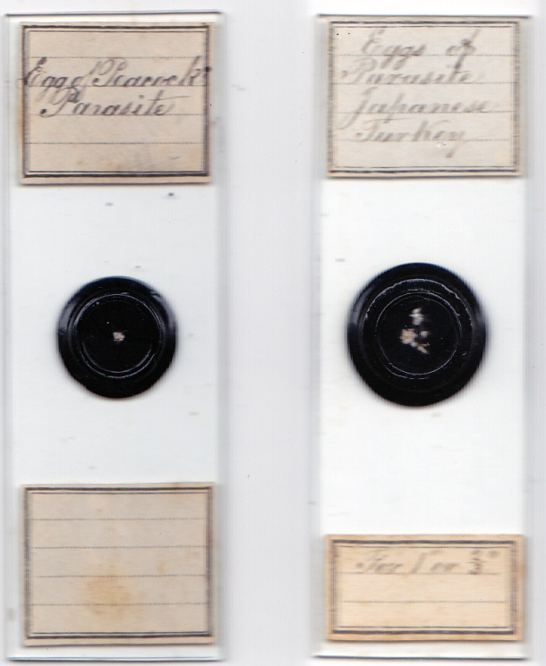
Yet more variation may be another example of left over material from his time in the family business – compare the small stickers used on the two slides below.
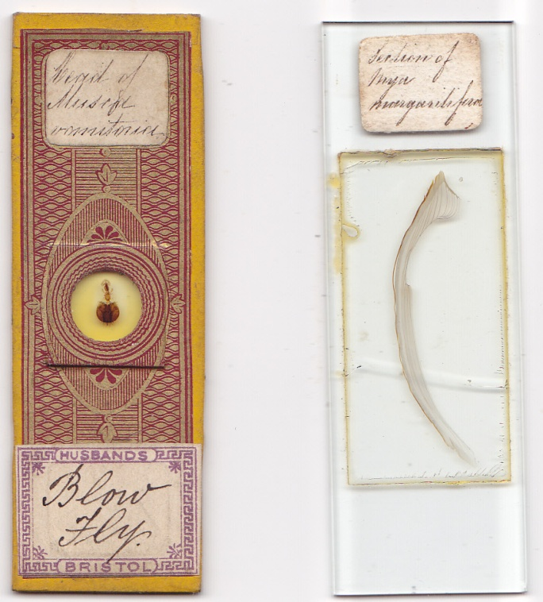
Occasionally he may have run out of labels altogether – witness the diamond inscribed example below.
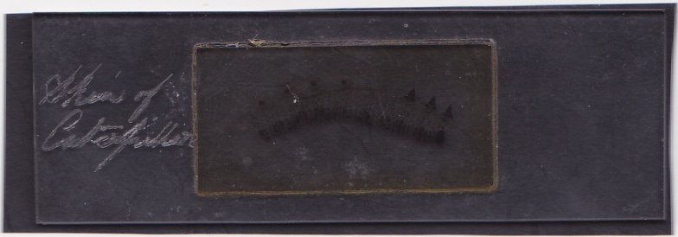
A whole caterpillar skin
William’s Walthamstow
In William’s time, Walthamstow was becoming suburbanised: but it lay on the edge of Epping Forest, and included part of it, and much more open land than today. The adjoining suburbs were also still incompletely built out. It is easy to see the area’s appeal to an insect mounter: Walthamstow - “place of welcome” – certainly welcomed William with rich sources of insect material within easy reach. If his wife helped him in his work, I like to envisage them sallying forth with nets by day and illumination by night, seeking butterflies and moths for William’s mounts. Such activities are more readily undertaken by a couple with few domestic duties – there is no evidence they had any children.
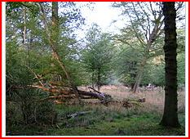
A clearing in Epping Forest, even in today’s reduced form still London’s largest open space at around 6,000 acres. In Uncle Will’s time, there was plenty of scope for trapping invertebrates there.
As remarked previously, he may have gone as far as Kent in search of moths, and his time in Walthamstow overlapped with his sister’s residence in Kent – more opportunities, perhaps, for specimen collecting.
After a boyhood in inner London, Walthamstow must have felt like an idyllic rural retreat. Early times were not forgotten, though, since many contacts acquired during William’s time with the family firm seem to have been maintained: the Uruguayan species included among the four below was sold through Browning, and other slides of material sent from Montevideo (but not with William’s writing) had been made by the Normans at City Road.
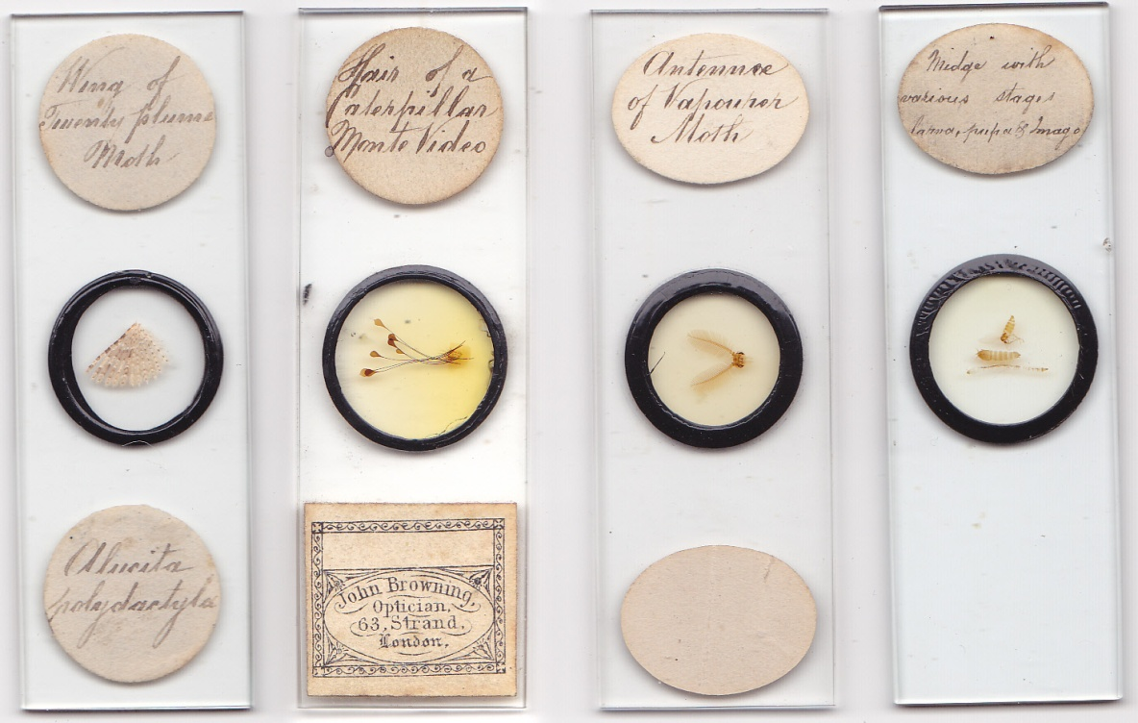
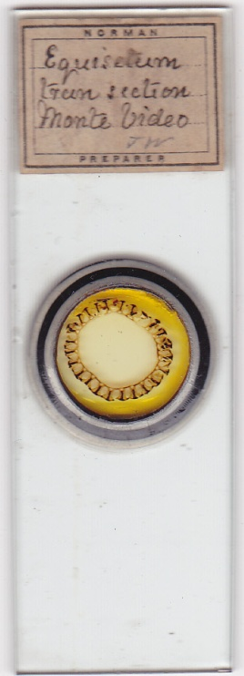
One of several Norman slides in my collection from Montevideo: the label handwriting may be that of John Norman senior. The “Challenger” spent ten days at Montevideo, and this may be the provenance of material on this and other such Norman slides.
I have mentioned a butterfly scale arrangement sold via Baker: other retailers continued to be involved in sales, as in the examples below.
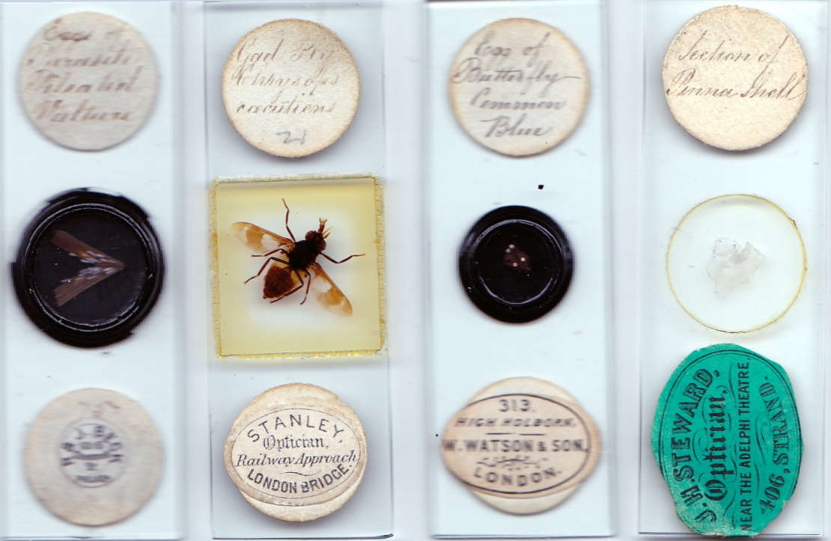
Another specimen from afar (there were not many vulture parasites in Epping Forest), sold via Beck in the USA, with an insect sold via Stanley, insect eggs sold by Watson before 1882 and a shell mount sold via Steward
As shown, mounts include some exotic species, but he probably caught most of his later specimens close to his home. The slide below seems to emphasise this, being may fly exuvia unlikely to survive more than a short journey from collection to mounting.
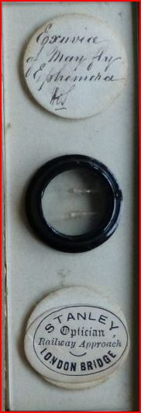
Those below he may have caught in his own house.
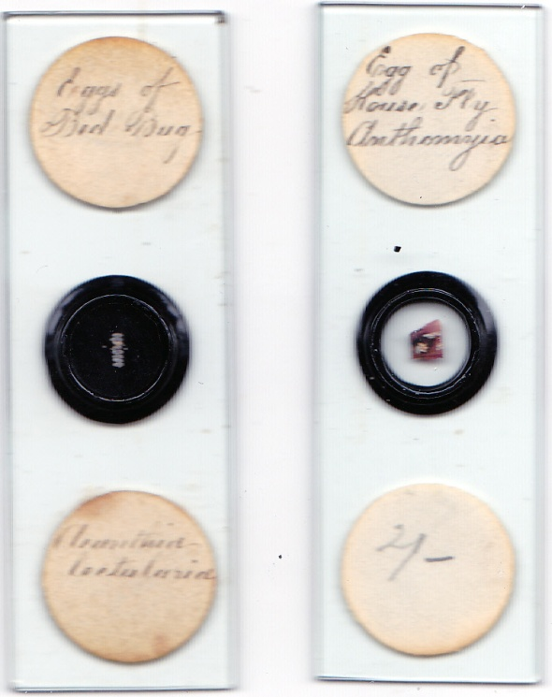
Bed bug and house fly eggs – found around William’s house?
An entomologist’s progress
Tracing William’s progress through censuses is informative: in 1861 he was with the family as a “maker of microscopic objects”, as was his brother John. By 1871 he was an “optician”, like his father, which could indicate that he now also assisted in making instruments, while continuing to make mounts. In 1881 he was a “histologist”, indicating perhaps a more accomplished knowledge of the material he mounted. By 1901 and 1911 however he was a “histologist and entomologist”, in other words a versatile mounter with a specialist focus.
By the early 1880s, as the surviving notebook shows, he was already making a steady income from butterfly scale arrangements. Most slides though from his business in Walthamstow are well nigh impossible to date, but he made many insect mounts there, and the later census entries suggest deepening entomological knowledge. While scale arrangements were his most artistically sophisticated mounts, the market they satisfied was one primarily interested in aesthetic novelty. He continued making more conventional mounts of insect material for the mainstream enthusiasts – many of these slides also displayed artistic merit in their presentation, of course.
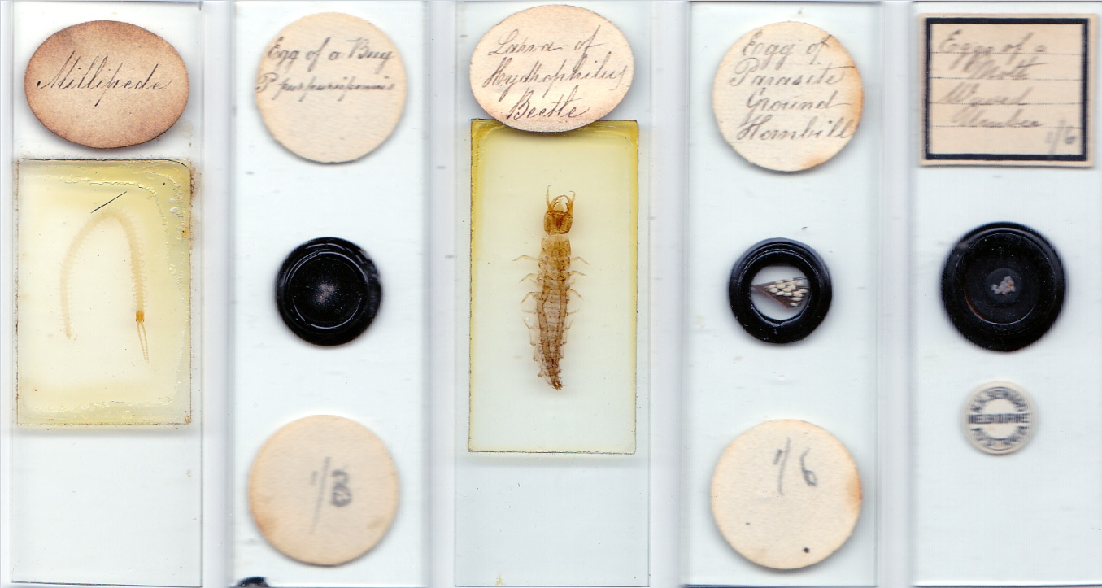
Various later insect mounts: that on the far right sold as far away as Melbourne, via Seward’s optical shop.
Where was William in 1891?
William disappears from the 1891 census: but he can be found in Walthamstow in 1881, 1901 and 1911. An exotic species mount with a round label, characteristic of his Walthamstow work, raises the possibility that he and his wife may have taken a European holiday, indulging in a little moth-hunting. Tenuous perhaps, but the only tangible clue I have found which might support an overseas absence from the census.
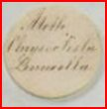
The genus chrysoclista cannot be found in England outside museums. (I hope readers will excuse my lack of camera skills, here and at the end of this article.)
The 1882 notebook suggests steady income from scale arrangements, and a childless couple might spend some of it on an overseas trip. In 1911, William and his wife were at 26 Northbank Rd., and in 1901 they were at 123 Maynard Rd., both in Walthamstow. In 1881 they also were on Maynard Rd.: searches are bedevilled by the fact that between 1881 and 1891, Maynard Rd. was re-numbered. In 1881 the road was split into multiple small addresses such as “terrace”, “cottages” (William lived at 4, Laburnum Cottages) and the like (akin to the Norman family home address in Fountain Place, City Road), and this had vanished by 1891. I found no evidence that in 1891 any of the houses in Maynard Rd. were empty: William and his wife do not show up in Walthamstow, nor in any UK census in that year. None of this proves they were abroad, but it raises the possibility.
Last days
After the political and intellectual upheavals of William’s boyhood and early youth, his days in Walthamstow were largely marked by stability and tranquillity. The Boer War briefly scarred those times, but compared to the carnage to come, casualties were few. Age old enmity seemed to be dissolving in the entente cordiale with France, and on both sides of the channel elaborations in art nouveau seemed symptomatic of the new relaxed style and panache of Edwardian society.
Early twentieth century calm was deceptive and short lived. William’s last few years must have been hugely saddened by the mindless carnage on the Great War’s Western Front. Even more disturbing: there was nothing new about aerial warfare on civilians – it had occurred during the Franco-Prussian War, in the siege of Paris – but now it came to England, with the Zeppelin blitz all down the east coast, and then on London. Slaughter of Irish soldiers in the ill conceived and even worse executed Gallipoli campaign was a powerful spur to encourage the 1916 abortive Easter Rising in Dublin (“better to die ‘neath an Irish sky”, as the poem went), heralding the all-out war with England which was to follow. And when a Zeppelin crashed in flames in Essex, even William’s little people were incinerated in their thousands, perhaps millions.
It must have seemed that the Great War’s human anthill was as ruthlessly Spencerian as the world of insects, the mass destruction of a male generation all the more brutally stupid because it was self-inflicted. William – regarded affectionately to the end as “Uncle Will” – must have wondered whether he witnessed human morality sinking lower than that of the miniature world of his little insect people. After such a long quiet interval since the intellectual and political turmoil of his youth, one can imagine the dismay this caused in such a kindly soul.
Uncle Will’s little people
As I have shown, William was making whole insect mounts, with and without without pressure, from his early days. Possibly, his whole insect mounts from Walthamstow were in part a response to Fred Enock’s commercial success, but it seems just as likely that his work arose purely from fascination with these “little people”. That he mounted plenty of insect material both before and after he left the family firm is amply attested by surviving slides, a selection of which is shown below.
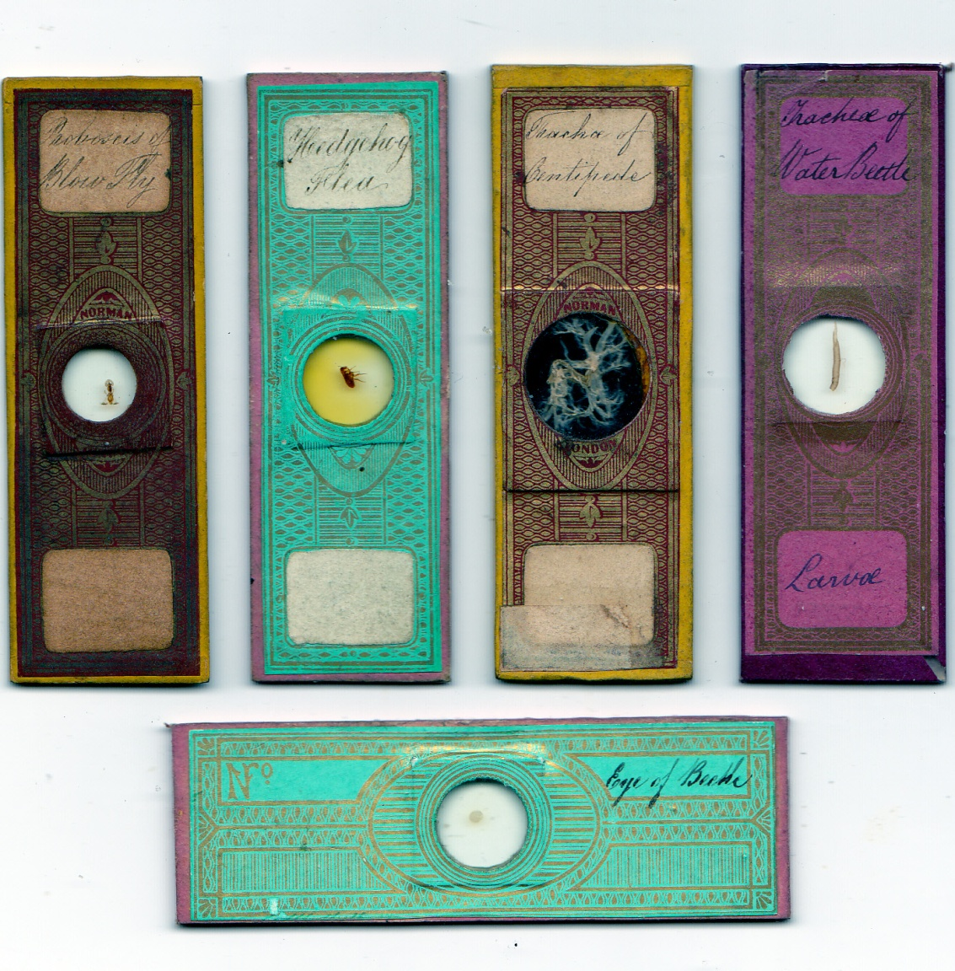
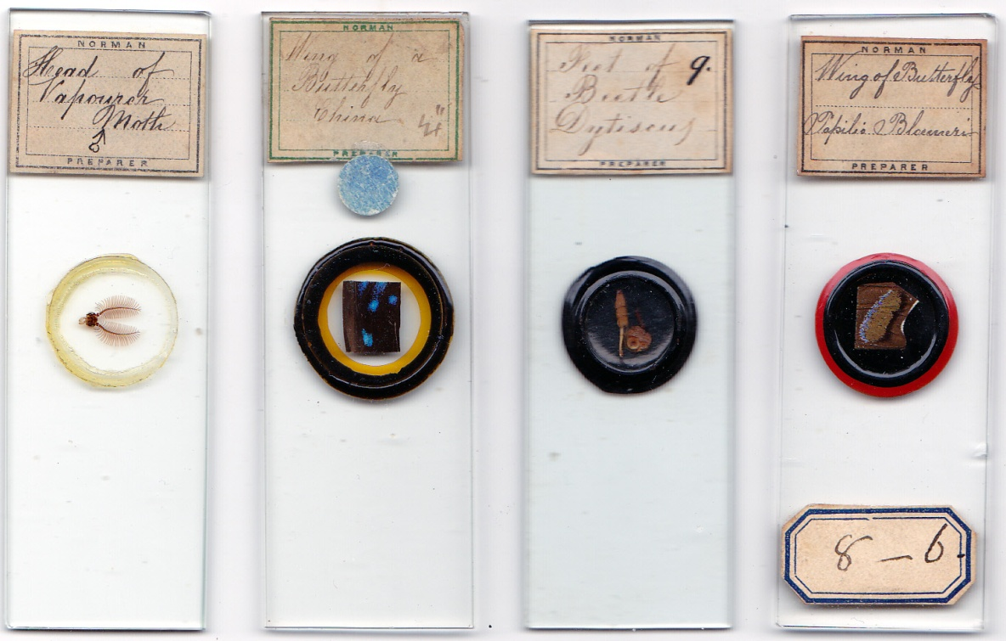
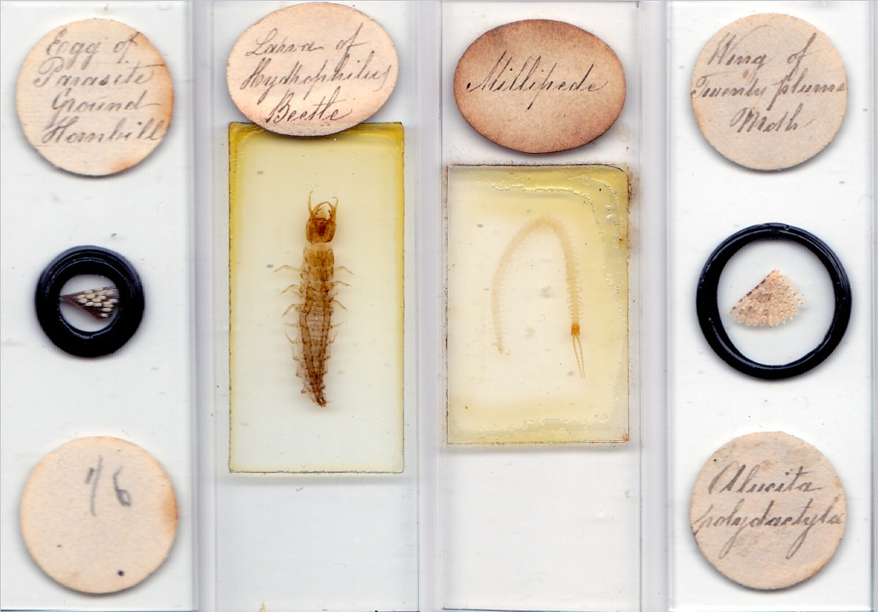
William Norman’s work, down the years
He excelled at mounting whole insects, as attested by some slides already shown: more, very attractive, examples are shown below.
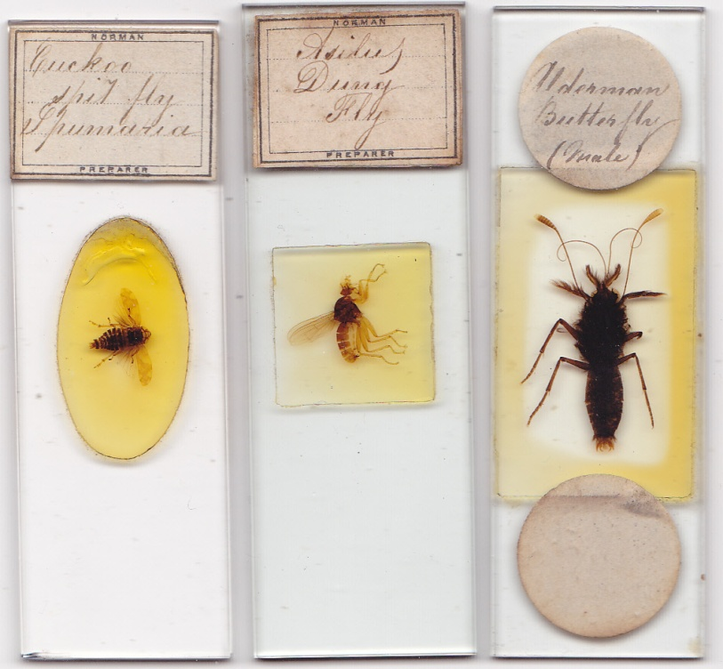
Most if not all of the Norman family prepared insect material from time to time, of course. But William’s long career marks him, I think, as the doyen. Neither his father nor any of his brothers produced scale arrangements in significant number, nor (so far as I can discover) did any of them mount so many whole insects without pressure, like some later William specimens shown below. Such mounts can be viewed to advantage from above or below, under a magnifying glass or medium power objective lens.
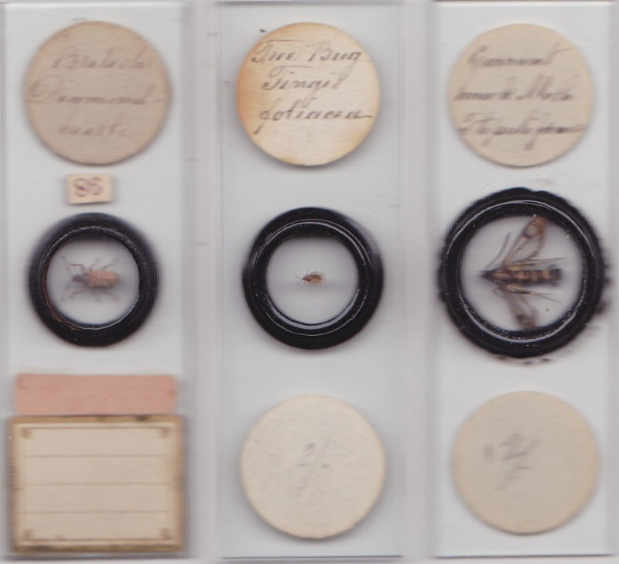
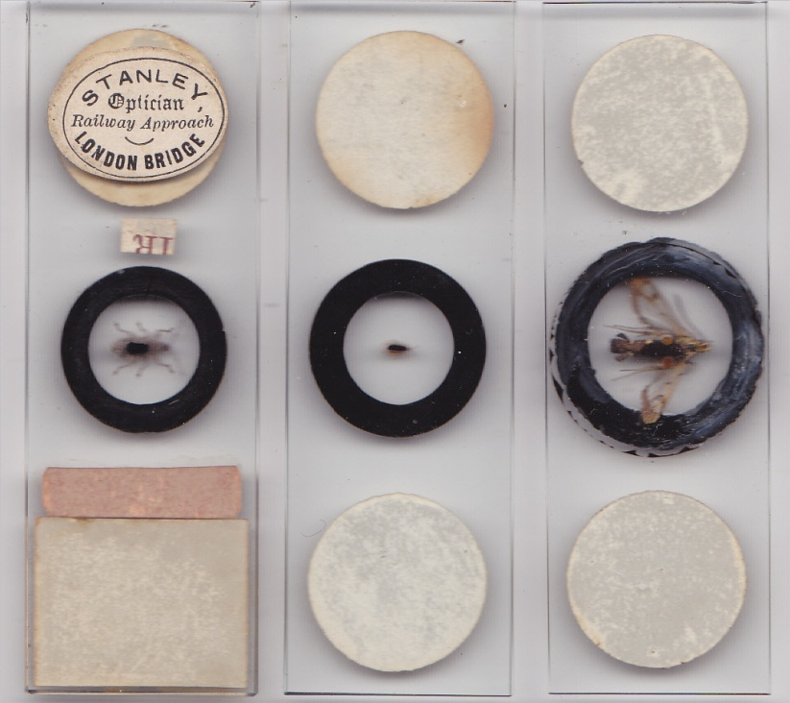
Left to right: British diamond beetle, tree bug and currant hawk moth, with the same mounts seen from below
I have not seen any of William’s whole insect non-pressure mounts with fluid in the chambers: this is in contrast to many Enock mounts from around the same period, or somewhat later balsam filled whole insect mounts by Clark & Page.
A true amateur
Concerning slides, the terms “amateur” and “professional” are unsatisfactory. Rightly or wrongly, “amateur” carries somewhat pejorative baggage, as if non-commercial preparations are perforce less accomplished than those made to sustain a living. “Commercial” and “non-commercial” are better: but then, many mounters who sold slides made their principal incomes in quite different ways – Shillington-Scales, Hume, and others, spring to mind. I suppose “full-time-commercial” and “non-full-time-commercial” conveys a valid distinction, but repeated deployment of such designations would be obtusely cumbersome.
William Norman was a true amateur, in the best sense. He may have made a steady income from mounts featuring a wide range of material, but with insects, he took obvious extra pride in his work, and his designation “entomologist”. My last illustrations are of work which could have been undertaken only by one who treasured his material: those of us who are fortunate to own examples can have no doubt that William loved his “little people”.
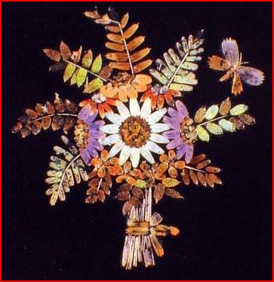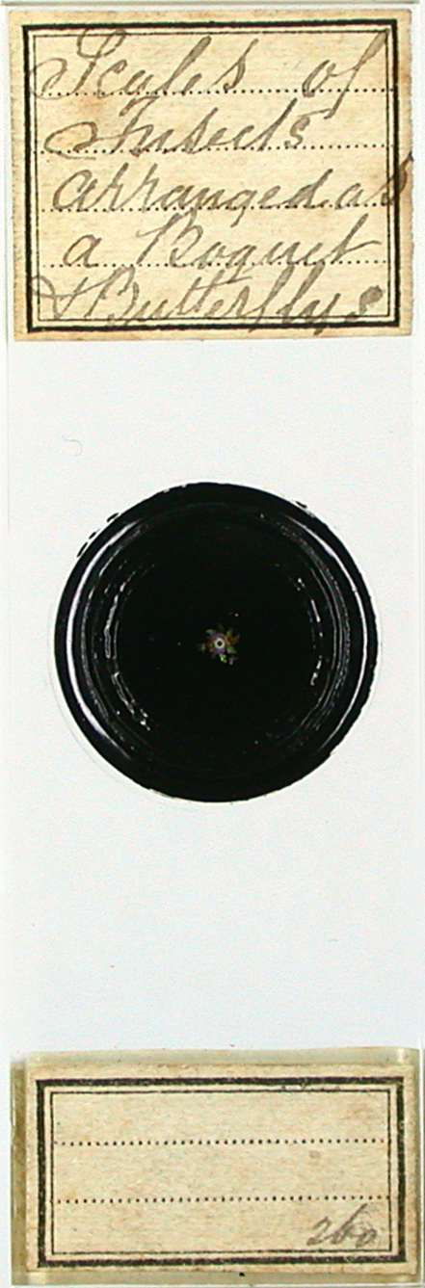
One of Uncle Will’s scale arrangements - judging by the slide label, made at Walthamstow: images courtesy of Brian Davidson
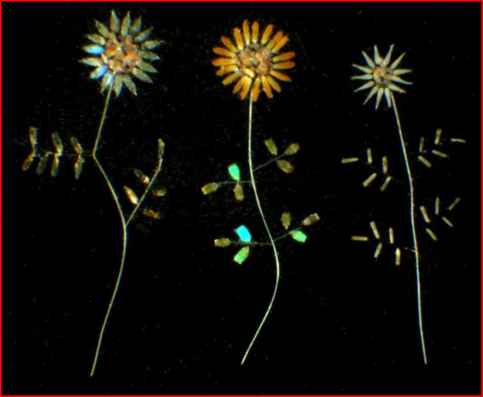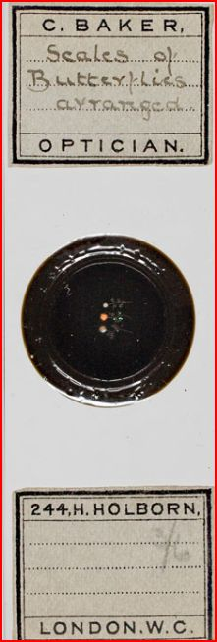
Another arrangement: the Baker slide label has the handwriting of Uncle Will’s notebook. Images courtesy of Brian Davidson
Lastly, I show a slide whose format I have never seen on any other Norman mount. I have shown its label already: it is a whole insect, mounted dry, with a removable transparent cap. The species – chrysoclista linnaella – lived in central and southern Europe.
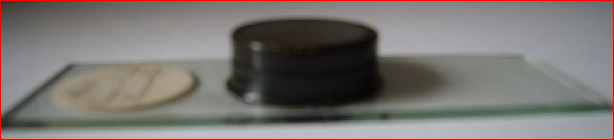
The mount chamber, with its cap, is 8mm. deep: this rarity proclaims the enthusiasm of its maker, and the slightly irregular cut on the right side of the mount glass might suggest some excitement during its preparation.
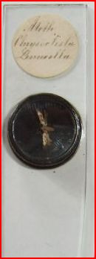
Sadly, the moth has suffered loss of colour; not surprising perhaps in a specimen over a century old. It shows every sign of an insect captured by its mounter, and it is easy to see why William would have wanted such a brilliant prize. It seems appropriate to emphasise the point with an illustration of chrysoclista linnaella from the work of the Rev. W.F. Kirby, regarded by James Crowther as “that Prince of entomologists” (The Microscope and its Lessons, p.119).
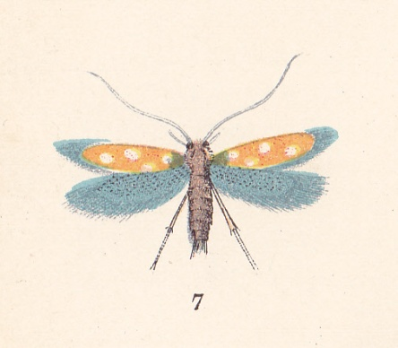
From plate CLVI in Lloyd’s Natural History (1897), Butterflies & Moths, Vol.V, by W.F. Kirby
Envoi
The most independent - and only solo - worker of the Norman family (unless we count his wife, who I think helped him), his insect work has been overlooked somewhat by those of us who try to research old mounts. Not least is this so, I think, because much of his later mounting has gone unrecognised, or has been overshadowed by better known work like Enock’s. William’s little people deserve a more prominent place in the canon of historical mounts than has been the case.

Acknowledgement
Thanks to Brian Davidson for helpful discussion, and for the illustrations of butterfly scales
Sources
Except for the butterfly scales arrangements, all illustrations are of slides in my collection.
www.ancestry.com
Wikipedia
www.historicaldirectories.com
Bracegirdle, Microscopical Mounts and Mounters
For a list of James Crowther’s books, see my article in Micscape, June 2012

Author contact: lois737@bigpond.com
Published in the November 2012 issue of Micscape Magazine.
www.micscape.org

