AN ARTHROPOD OBSERVATION GARDEN

Part 2. The Arthropods

David B. Richman, Mesilla Park, New Mexico, USA

The arthropods I observed and often photographed in my garden and surrounding area this year were quite diverse. I am certain that the species observed are but a fraction of the whole, as I generally did not include the microlepidoptera and a number of other tiny species, including soil mites. While this is not a natural habitat, it is what I have and what most suburban areas have, if they are not too heavily treated with pesticides. My garden was not so treated (see: Part 1) and thus the problem was minimized, although I have no control on what my neighbors do. Even so I found over 100 species without too much effort.

Observing arthropods has become much easier since Fabre’s day as we now have both close-focus binoculars and excellent digital cameras with macro capability. Both are priced within a few hundred dollars. The hobby can thus be cheaper than many and if a small plot of land is available, along with seeds and plants, as well as water, a nice arthropod-friendly garden can be produced (see my first article.) Mainly one needs patience and enthusiasm.

The Isopoda (once part of the Crustacea) is represented by numerous examples of the roly-poly, Armadillidium vulgare, one of the most abundant of arthropods on the property. I have discovered the sowbug-eating spider, Dysdera crocata (Dysderidae) occasionally with these European imports (the spider is also a European import) and this year is no exception. Dysdera will also attack beetles, but as the roly-poly sowbugs are still fairly numerous, they seem to be more likely to occur near them.

The other arachnids on the property are limited to mainly spiders, although in past years we have had spider mites and this year I discovered a soft tick (Argus sanchezi) on the outside of the house. This probably dropped off one of the birds that frequent the garden area.

The spiders are somewhat varied in species, but not as much as I would like. I have seen more jumping spiders species this year, but the rest of the fauna is not as numerous. The native squint-eyed spider, Physocyclus enaulus (family Pholcidae), used to be abundant, but in the last ten years it has been replaced by the Mediterranean squint- eyed spider, Holocnemus pluchei. These aggressive invaders have pretty well eliminated the native species and their haphazard webs are found everywhere they can place them, from the shed to the agaves in the cactus garden. Both the native and the invading pholcids appear to be death to small widow spiders and black widows are limited to a few peripheral areas of the property. Still a few western black widows (Latrodectus hesperus – family Theridiidae) can be fairly easily found in shrubbery or under bricks if one looks hard enough. Of the rest of the spider fauna, Neoscona oaxacensis (family Araneidae, or orb-weavers) builds its orb-webs in the insect garden and the oxyopid or lynx spiders live on the various plants there, with Oxyopes scalaris favoring the desert willows and O. salticus preferring the shorter plants. Funnel-web building spiders, Hololena hola, are fairly common, where they can build their sheet and funnel-webs. The tiny oecobiids were quite numerous on the house outside walls where they built their tiny sheet webs. Two spiders that I have missed this year, but have found in the past include the bright orange crab spider Misumenoides formicipes (family Thomisidae) and the orb-weaver Argiope aurantia (family Araneidae).

The jumping spiders (family Salticidae) have always been my major interest (I co-authored the chapter and key to this family in “The Spiders of North America.”) These spiders are usually from 3-10 mm in body length and have very large anterior median eyes (most spiders have eight eyes and jumping spiders are no exception) with which they are able to see color, patterns, shapes and movements. The squared-off front of the cephalothorax is characteristic of these fascinating spiders. One of the most abundant in the yard is the tree-dwelling Thiodina hespera, This is a special favorite because I published the description and named this species with my co-author Rick Vetter. I often have these voracious little arboreal predators drop on my from a mulberry tree when I am sitting in the back yard. In earlier studies I did on the courtship behavior of the related Thiodina sylvana, I had only a little luck as the females almost always tried to kill and eat the males! The members of the salticid genus Habronattus, such as H. hirsutus, seem to be much less aggressive and I rarely saw them attack each other during my studies of their courtship behavior. I found a male of this species on my chain-link fence, he first of these I have seen here. Although this year it was not found, I have also seen Habronattus klauseri on the ground in the past.

The true insects include over a million species worldwide and are probably the most diverse of animal classes. They range in size from a fraction of a mm to giants nearly 300 mm long. However in the garden and surrounding area the sizes probably range from around 1 mm to 75 or so mm. Herbert E. Lutz once bet his employer that he could find 1000 species of insects in his yard and it is likely that our yard may have at least 500. However I did not certainly observe any more than a fifth of these. Many tiny parasitoids, micro-Lepidoptera, tiny beetles, and various flies that exist on the property were not observed or observed only in passing.

I did not see any of the endognathous Hexapoda (proturans, springtails and diplurans.) The most “primitive” of the insects noticed were the Thysanura in pine litter. Of the Odonata I observed three species at least – one in the family Aeshnidae and two in the family Libellulidae. The green darner, Anax junius was observed at least twice and in one of these the large dragonfly had a sparring encounter with a female black-chinned hummingbird. Both left undamaged. Last year I saw a male Libellula saturata, but not this year. Two damselflies in the family Coenagrionidae showed up late in the season. I had never seen these before in the garden.

Of the mantids, only Stagomantis limbata was seen. Their egg masses turned up on shrubs and trees around the yard. Several years ago I saw on catch a female black-chinned hummingbird, which in this case I rescued. At the time I unfortunately had no camera.

True orthopterans were fairly common, including the bane of our former vegetable garden, Melanoplus differentialis. These large melanoplines seem to eat everything but grass. The pallid-winged grasshopper, Trimerotropis pallidipennis, became especially abundant in September-October. I saw several individuals eating weed grasses around the observation garden. One slant-faced grasshopper, Syrbula admiriabilis, was occasionally found. The broad-winged katydid, Microcentrum rhombifolium, was evident by the minor damage done to potted plants, especially by the nymphs, and an adult occasionally drawn to the lights. These strange leaf-like katydids are as remarkable as the leaf insects of Southeast Asia in my opinion.

Of the cockroaches, all of our species are foreign in origin. We are fortunate in that we only see occasional roaches in the house, mostly male Turkistan cockroaches, Blatta lateralis, which can be found outside wherever I bury compost. Blattella vega, the field cockroach, is occasionally found outside under boards. It closely resembles the German cockroach, but does not invade houses. When we first moved into our house there was an infestation of German cockroaches, but it was eliminated with boric acid. Both the American cockroach and the Oriental cockroach are occasionally encountered and these have been associated mostly with septic lines.

The only earwig, Euborellia annulipes, was a European import and it was fairly common in leaf and pine-needle litter.

The web-spinners are represented only by the introduced species Oligotoma nigra, which are found around lights occasionally. Only males fly and I have not yet found the silken tunnels of the females.

The true bugs in the order Hemiptera (now including Homoptera) were not too numerous in species, but several were super abundant, especially the grape leafhopper, Erythroneura ziczac, which decimated the grapes as usual. Lace bugs (Corythuca sp.) were equally numerous and caused severe damage to the sunflowers. The lesser milkweed bug, Lygaeus kalmii, was fairly common on the ground for a time, but was never numerous. The bark stinkbug, Brochymena sp., was seen only rarely on tree branches and the perimeter fence. One one was observed to have its beak in dried bird feces!

The net-winged insects were common, but only two species were seen. The most abundant were the antlions and I only saw the pits of the larvae so I am not absolutely sure of the identity of the species. Occasionally green lacewings, Chrysopa sp., showed up after dusk in the back yard.

Beetles (order Coleoptera) are the most diverse of any order of insects. The garden and surrounding yard was fairly well supplied. Probably the most spectacular was the fig eater, Cotinis texana, which often buzzed around the yard and into the garden. Although I had observed a tiger beetle, Tetracha carolina, in the yard before, none were seen in 2013. The flea beetle, Altica sp., was uncommon on sunflower leaves. Carabid beetles were rare under boards and litter, and the buprestid beetle Acmaeodera disjunctus showed up occasionally on sunflowers and Cosmos. Tenebrionid beetles of several species were observed commonly walking on the surface of the ground.

The flowers I planted drew a fairly large number of butterfly species (over 20), but, with the exception of the cabbage white, Pieris raphae, they usually showed up one at a time. The checkered white, Pontia protodice, which had been common in past years, did not show up in the garden this year until late October, when several suddenly appeared. Gone are the days when groups of the giant cloudless sulphur, Phoebis sennae, would stream over the back fence. The beautiful red admiral, Vanessa atalanta, would show up suddenly in a sunny patch near the west fence line to rapidly disappear the moment I got my camera. One attacked me, as they often do, by flying directly at my face. While most butterflies showed up singly, I did have them appear several days in a row or spaced out. This was true for both the gulf fritillary, Agraulis vanillae, and the variegated fritillary, Euptoieta claudia, the former appearing as if by magic the day I planted a passion flower, the larval host plant. Although I observed a female black swallowtail, Papilio polyxenes, laying eggs on fennel in the insect garden, no caterpillars appeared. Still of the two swallowtails observed, the pipevine, Battus philenor, was much more common, although again only one at a time. Only one bordered patch butterfly, Chlosyne lacinia, showed up this year, even though I had dozens of examples of its larval host plant, sunflower. In the past a few sunflowers might host dozens of the caterpillars. The Texas crescent, Phyciodes texana, which had been common on some years, did not appear this year. Queen butterflies, Danaus gilippus, were commonly seen, again only singly, but the monarch, Danaus plexippus, which had been seen in the past, was absent until late October, when one suddenly appeared, along with a host of other butterflies!

I only recorded a few moths this year, but there were certainly more. Still they seemed to be rarer than they should have been. Sometimes I would find Mediterranean geckoes at our outside light probably feasting on the few that came.

By far the most abundant fly was of course the house fly, Musca domestica, Late summer and early fall also brought hoards of the yellow fever mosquito, Aedes aegypti A few years ago I was recorded as being the first person documented to be attacked by these invaders to New Mexico, which had not been seen in this area prior to 2000 in recent years, although first reported in New Mexico in 1939. Fortunately we lack both yellow fever and dengue (although the latter is not far away, having been found in a mosquito in Juarez, Chihuahua, only about 65 km from Mesilla Park. In past years I have found at least two species of Culex as well, but the yellow fever mosquito seems to have become dominant, possibly because of our weird rainfall pattern this year. The Calliphoridae (blow flies) was represented by Lucilia sericata, and the Sarcophagidae by a large species of Sarcophaga. I also noted two species of Asilidae (robber flies) and one species of Bombyliidae (bee flies).

The Hymenoptera were among the most fascinating of insects in the garden. However the ants were much less numerous in species than in the past. The yard was dominated by Forelius nests and a few nests of Pheidole diversipilosa. Occasionally I would see a lone worker of the red and black carpenter ant (Camponotus sp.), especially at night – they are nocturnal predators. This year the garden seemed to be devoid of the southern fire ant, Solenopsis xyloni, while every year previous seemed to involve huge colonies of these fierce stingers and biters. I am not sure what happened to them. At one time in the past the edge of the garden had a single invasion of the native army ant, Neivamyrmex swainsoni, but these have never been seen since, although I could have easily missed them as they are mostly subterranean and nocturnal. The males, called sausage flies, have not come to our lights, so I suspect that they have gone from the area. This species is mainly a predator on other ants.

The bees are interesting from a number of standpoints. For one they are vital to the pollination of a number of flowering plants. For another the evolution of sociality, as exhibited by the European and African honey bees (Apis millifera - we have both subspecies.) The honey bees in our back yard could be either or both, since the fierce African bee arrived a decade ago. Fortunately they are not very aggressive while foraging. The very colorful Agapostemon bees in the family Halictidae were fairly rare, but I did see them occasionally. This was also true of the apid bumble bees (Bombus sonorous), although a few years ago a colony was living in one of our tomato beds, since turned into the back bed of the insect observation garden. On the other hand I saw at least two species of the large carpenter bees (family Apidae), one with brown fuzzy males and another with black males. All females were black, so I could not tell the females apart. The long-horned bees (family Apidae) in the genus Melissodes and the leaf-cutting bees, Megachile sp., the latter of which left rounded holes in my rose bush leaves and nested in holes along the edge of the flower beds (they completely rejected my attempts to make them home sites in cut river cane stems!) were fairly common, but not always present. They were easily identified by the pollen they carried under their abdomen, rather than in pollen baskets on their hind legs, as in Apidae.

The wasps, especially the Vespidae (Polistes sp.), often visited the flowers in the garden, and I occasionally saw a large scoliid wasp on the flowers as well. Other wasps included one pompilid and a mud dauber in the genus Sceliphron. Paper nests of Polistes and one mud nest of Sceliphron were found under the roof of our house, although none seemed to be active.

This has been only a sketch of the arthropods that were attracted to the garden and yard. Many of my identifications are tentative because of the difficulty of identifying arthropods from photographs, but those with specific names are more certain. Fortunately I am fairly well acquainted with the local butterfly fauna, having been involved with the North American Butterfly Association (NABA) butterfly counts for a total of 19 years. Dragonflies are for the most part also reasonably easy to identify from photos, as are some spiders and beetles. Certainly there were many species that I either did not see or was unable to determine. As I noted earlier, Lutz (1941) found over 1000 insects on his property in New York. There are probably at least 300-500 species on my lot, mostly small moths, parasitoids, beetles and mites. Most non-pesticided yards and gardens probably have as many.

A few references: (For identifications I also used the Arthropod Museum at New Mexico State University, Las Cruces, NM, where I used to be curator. One of the graduate students, Ryan Reynolds, identified Pheidole diversipilosa from major workers. Otherwise the identifications are all mine.)

Bradley, Richard A. 2012. Common Spiders of North America. University of California Press, Berkley, CA.

Eaton, Eric R., and Ken Kaufman. 2007. Kaufman, Kaufman Field Guide to Insects of North America. Houghton Mifflin, New York.

Fisher, Brian L., and Stephan P. Cover. Ants of North America. University of California Press, Berkley, CA.

Glassberg, Jeffrey. 2001. Butterflies Through Binoculars: The West. Oxford University Press, USA

LeBuhn, Gretchen. 2013. Field Guide to the Bees of California: Including Bees of the Western United States. University of California Press, Berkley, CA.

Lutz, Frank E. 1941. A Lot of Insects: Entomology in a Suburban Garden. G.P. Putnam's Sons, New York.

Paulson, Dennis. 2009. Dragonflies and Damselflies of the West. Princeton University Press, New Jersey.

Peckham, George, and Elizabeth Peckham. 1905. Wasps Social and Solitary. Houghton Mifflin, New York.

Teal, Edwin Way. 1942. Near Horizons: The Story of an Insect Garden. Dodd, Mead & Company, New York.

Teal, Edwin Way. 1949. The Insect World of J. Henri Fabre. Dodd, Mead & Company, New York.

Ubeck, D., P. Paquin, P. E. Cushing and V. Roth (eds). 2005. Spiders of North America. American Arachnological Society.

Wolf, Theodore A., and Lewis T. Nielsen. 2007. The Mosquitoes of New Mexico. University of New Mexico Press, Albuquerque.

Table 1. Arthropods of the Garden (*) and Surrounding Yard (ca. 0.1 hectares)
Class/Order/Family Latin Name Native? Exotic?
________________________________________________________________
Malacostraca

Isopoda
Armadillididae
Armadillidium vulgare* X

Arachnida

Araneae
Agelenidae
Hololena hola X
Araneidae
Neoscona oaxacensis* X
Dysderidae
Dysdera crocata X
Filistatidae
Kukulcania sp. X
Gnaphosidae
Gnaphosa sp? X
Micaria sp. X
Lycosidae
Hogna sp.
prob. coloradensis X
Oecobiidae
Oecobius navus X?
Oxyopidae
Oxyopes salticus* X
Oxyopes scalaris* X
Pholcidae
Holocnemus pluchei X
Salticidae
Habronattus hirsutus X
Metacyrba taeniola X
Phidippus audax* X
Phidippus comatus X
Thiodina hespera X
Theridiidae
Latrodectus hesperus X
Steatoda grossa X
Acari
Argasidae
Argus sanchezi X?
Insecta

Thysanura
Lepismatidae
Lepisma sp.? X?
Odonata
Aeshnidae
Anax junius* X
Coenagrionidae
Enallagma sp.* X
Libellulidae
Orthemis ferruginea X
Pantala hymenaea* X
Sympetrum corruptum* X
Mantodea
Mantidae
Stagmomantis limbata* X
Orthoptera
Acrididae
Melanoplus aridis* X
Melanoplus differiantialis* X
Syrbula admiriabilis* X
Trimerotropis pallidipennis*X
Gryllidae
Unknown (heard only) X
Tettigoniidae
Microcentrum
rhombifolium* X
Blattoidea
Blattellidae
Blattella vega* X
Blattidae
Blatta lateralis* X
Blatta orientalis X
Pariplaneta americana X
Dermaptera
Anisolabididae
Euborellia annulipes X
Embiidina
Oligotomidae
Oligotoma nigra X
Hemiptera
Aphididae
At least two unidentified* X?
Cicadellidae
Empoasca sp.* X?
Erythroneura ziczac* X
Lygaeidae
Lygaeus kalmii X
Pentatomidae
Brochymena sp.* X
Reduviidae
Zelus sp.* X
Tingidae
Corythuca sp.* X
Neuroptera
Chrysopidae
Chrysopa sp. X?
Myrmeliontidae
Scotoleon sp.? X
Coleoptera
Buprestidae
Acmaeodera disjuncta* X
Carabidae
Scarites sp.?* X
Chrysomelidae
Altica sp.* X
Coccinellidae
Hippodamia convergens* X
Curculionidae
Unidentified* X?
Scarabaeidae
Cotinis texana* X
Tenebrionidae
Bothrotes sp.* X
Eusattus reticulatus X
Stenomorpha marginata X
Note: A very small species was also seen, but not identified.
Lepidoptera
Hesperiidae
Erynnis funeralis* X
Hylephila phyleus* X
Pyrgus commonis* X
Lycaenidae
Brephidium exile* X
Celastrina ladon* X
Leptotes marina* X
Strymon melinus* X
Noctuidae
Cut Worms
(at least two sp.) X
Nymphalidae
Agraulis vanillae* X
Chlosyne lacinia* X
Danaus gilippus* X
Danaus plexippus* X
Euptoieta claudia* X
Vanessa atalanta X
Vanessa cardui* X
Paplionidae
Battus philenor* X
Papilio polyxenes* X
Pieridae
Colias eurytheme* X
Colias philodice* X
Eurema nicippe* X
Nathalis iole* X
Phoebis sennae* X
Pieris rapae* X
Pontia protodice* X
Zerene cesonia* X
Sphingidae
Hyles lineata X
Zygaenidae
Harrisina brillians X

Diptera
Asilidae
Diogmites angustipennis * X
Mallophora faurix * X
Bombyliidae
Paravilla sp. X
Calliphoridae
Lucilia sericata X?
Culicidae
Aedes aegypti* X
Dolichopodidae
Condylostylus sp.* X
Muscidae
Musca domestica* X?
Sarcophagidae
Sarcophaga sp.* X
Syrphidae
Syrphus? sp. * X
Copestylim mexicanum* X

Hymenoptera
Andrenidae
Perdita sp. X
Apidae
Apis millifera* X
Bombus sonorus* X
Melissodes sp.* X
Xylocopa californica* X
Xylocopa varipunctata* X
Note: At least one species of digger bee was seen, but not identified.
Formicidae
Camponotus sp*. X
Forelius sp.* X
Pheidole diversipilosa X
Halictidae
Agapostemon sp.* X
Ichneumonidae
Unidentified genus X
Megachilidae
Megachile sp.* X
Pompilidae
Anoplius sp. X
Pteromalidae?
Unknown parasitoid* X
Sphecidae
Sceliphron
(caementarium?) X
Vespidae
Polistes sp.* X
________________________________________________________________

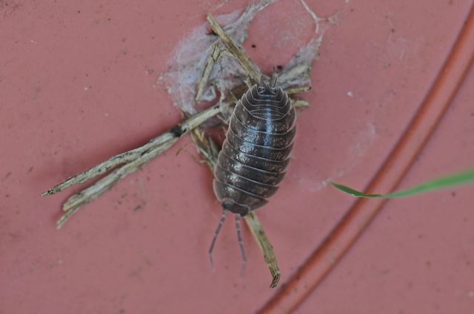

Figure 1. Armadillidium vulgare (family Armadillididae) on plastic pot dish.

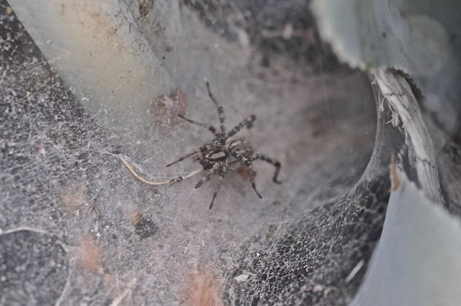

Figure 2. Hololena hola (family Agelenidae) on web in Agave leaf.

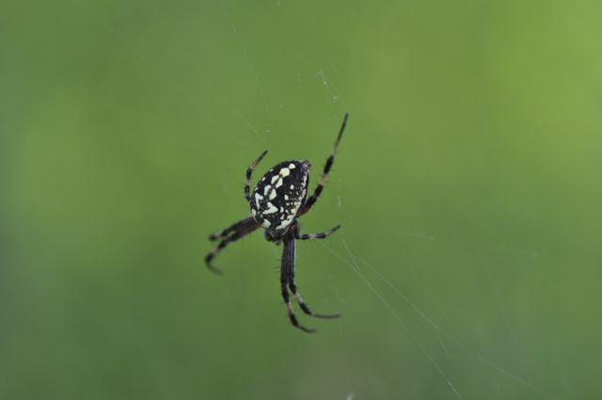

Figure 3. Neoscona oaxacensis (family Araneidae) on web.

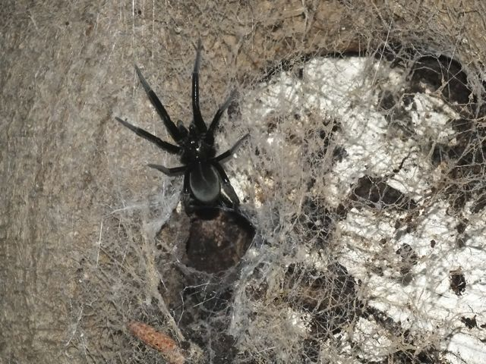

Figure 4. Kukulcania sp. (family Filistatidae) on web in mulberry knothole.

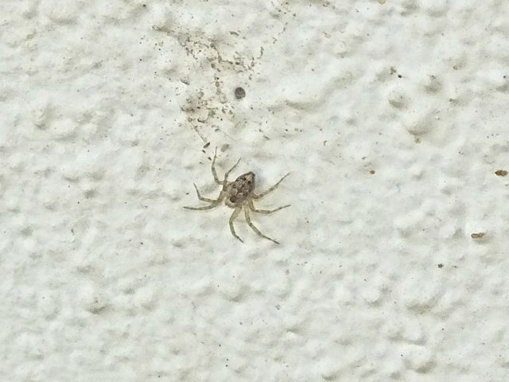

Figure 5. Oecobius navus (family Oecobiidae) on house wall. Possibly the most abundant spider on walls.

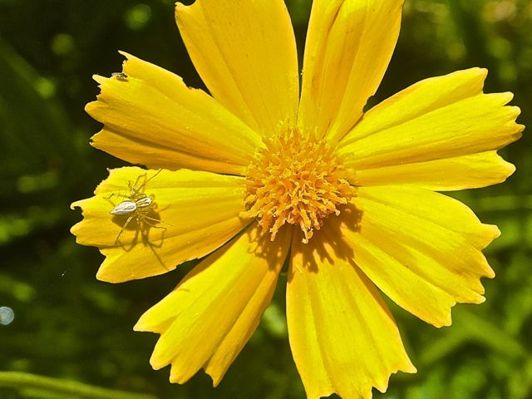

Figure 6. Oxyopes salticus (family Oxyopidae) on Coreopsis. The most abundant spider in the garden.

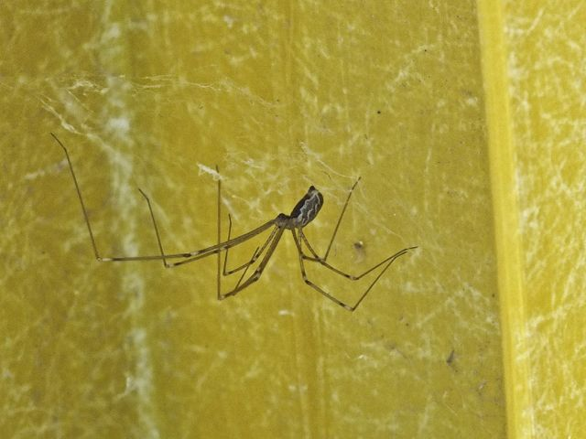

Figure 7. Holocnemus pluchei (family Pholcidae) female in web on ladder. This Mediterranean species has pretty well taken over from another pholcid, Physocyclus enaulus.

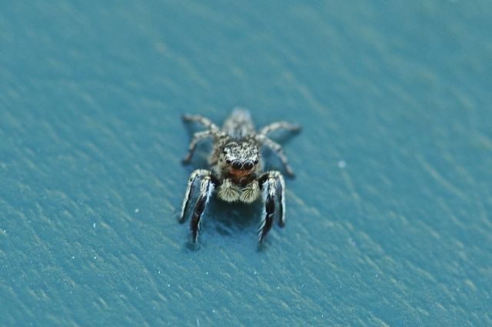

Figure 8. Habronattus hirsutus male (family Salticidae) on plastic surface.

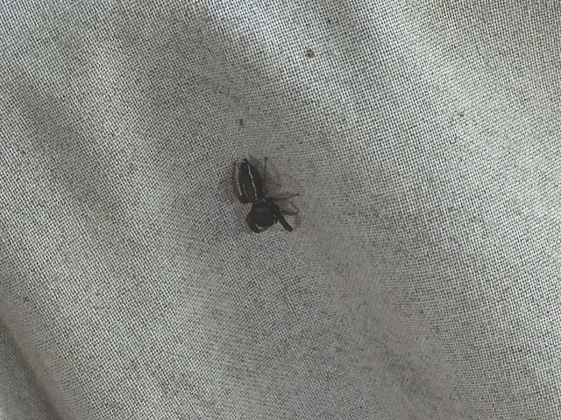

Figure 9. Metacyrba taeniola (family Salticidae) female. This is one of the most common ground-dwelling jumping spiders in the yard and ranges from the Southwest across the United States to Florida.

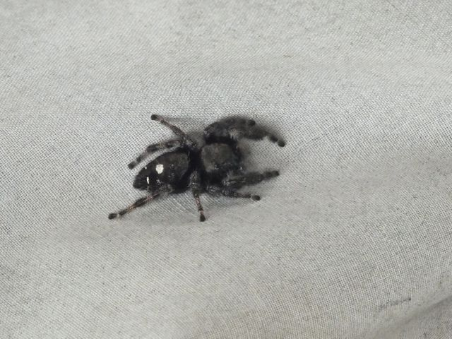

Figure 10. Phidippus audax (family Salticidae) female on sheet. The most abundant jumping spider in the garden and surroundings.

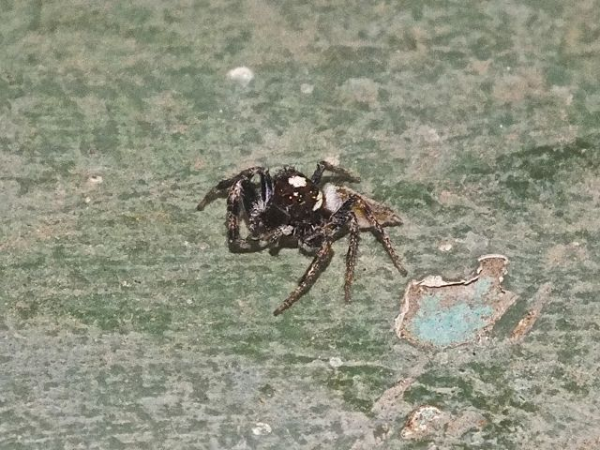

Figure 11. Thiodina hespera (Family Salticidae) male on concrete surface, I described and named this species with Rick Vetter of the University of California – Riverside. This species is apparently totally arboreal and often drops from trees, such as the mulberries on our lot.

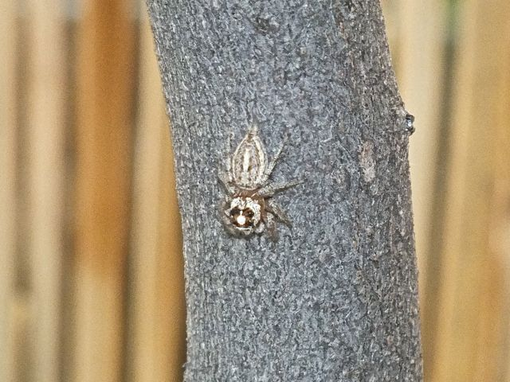

Figure 12. Thiodina hespera (Family Salticidae) female on small tree trunk.

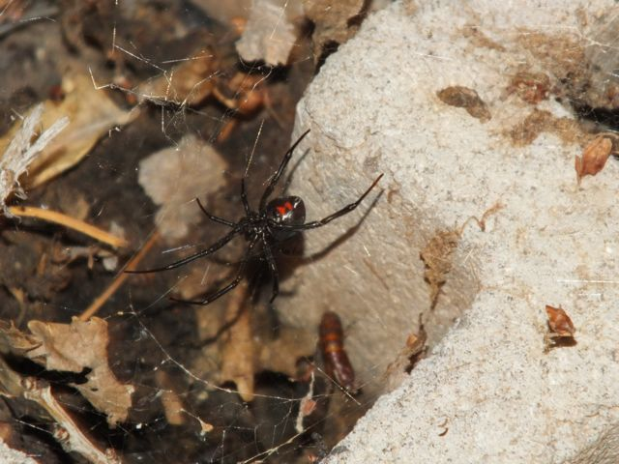

Figure 13. Latrodectus hesperus (family Theridiidae) on web at night.

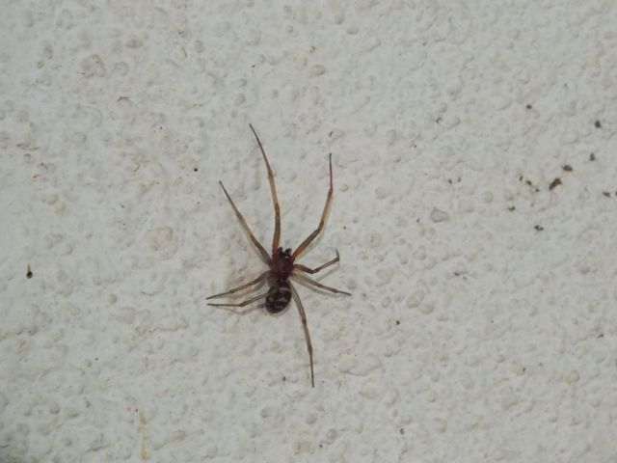

Figure 14. Steatoda grossa (family Theridiidae) male on house wall.

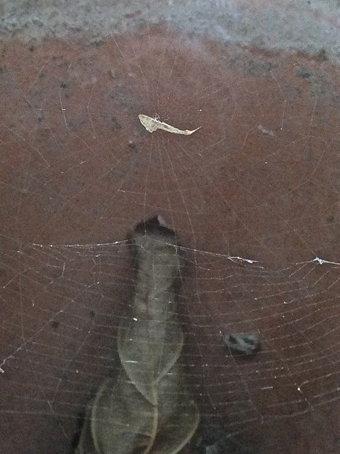

Figure 15. Uloborus glomosus (family Uloboridae) in plant pot.

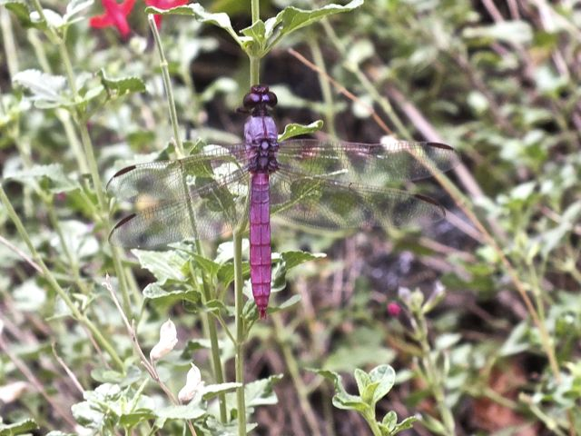

Figure 16. Orthemis ferruginea (family Libellulidae) male on Salvia greggi plant.

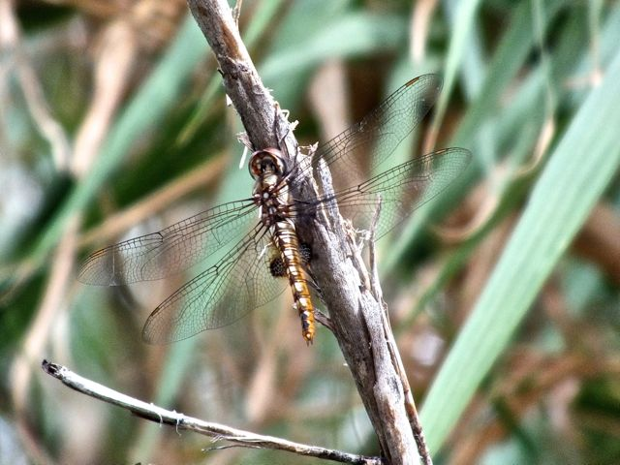

Figure 17. Pantala hymenaea (family Libellulidae) male perched on a river cane stem..
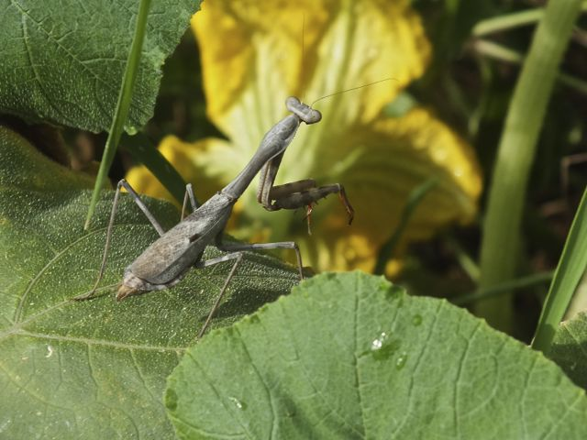

Figure 18. Stagmomantis limbatis (family Mantidae) brown female on a pumpkin vine.

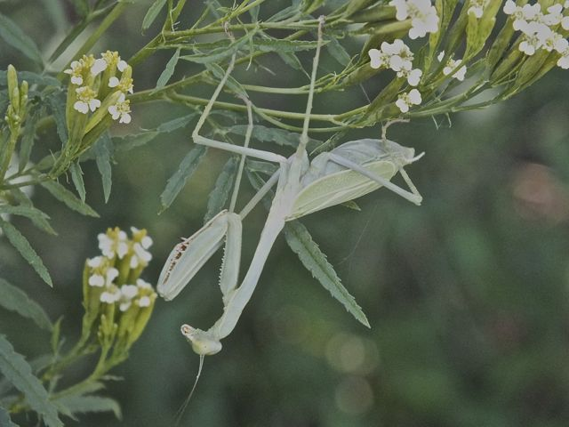

Figure 19. Stagmomantis limbatis (family Mantidae) green female on Mexican marigold.

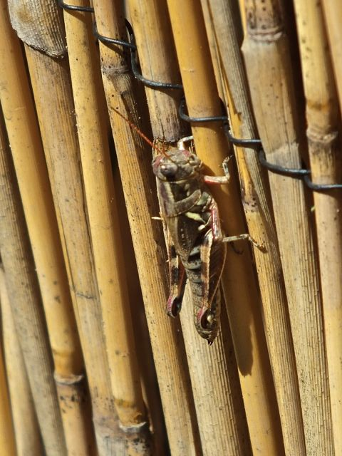

Figure 20. Melanoplus aridus (family Acrididae) on bamboo screen.

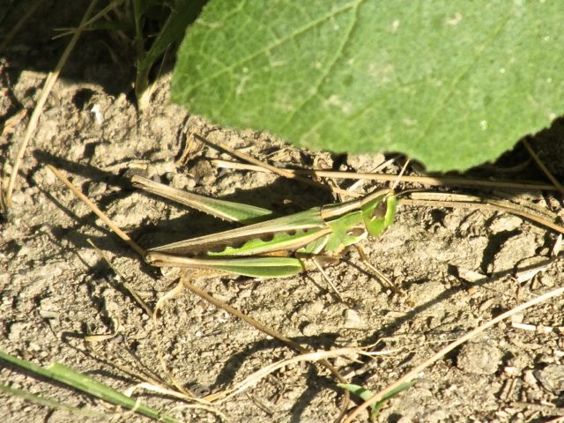

Figure 21. Syrbula admiriabilis (family Acrididae) female near pumpkin leaf..

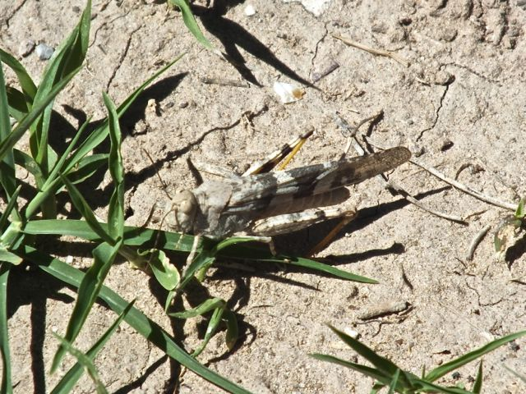

Figure 22. Trimerotropis pallidipennis (family Acrididae) female, eating weed grasses.

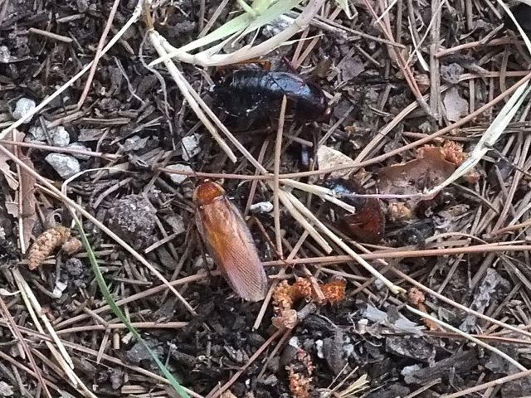

Figure 23. Blatta lateralis, the Turkestan cockroach (family Blattidae), male (bottom) and female.

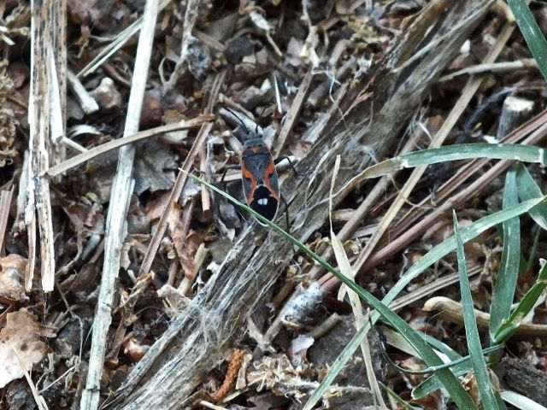

Figure 24. Lygaeus kalmii (family Lygaeidae) on ground.

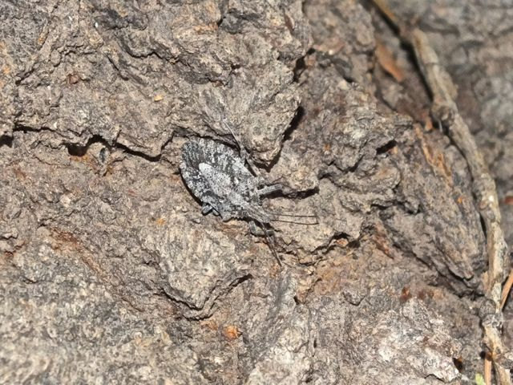

Figure 25. Brochymena sp. (family Pentatomidae) on mulberry bark.

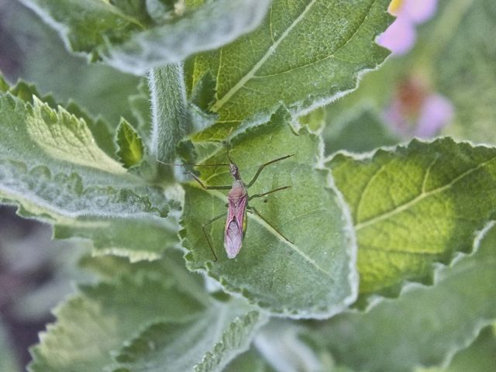

Figure 26. Zelus sp. (family Reduviidae) in garden.
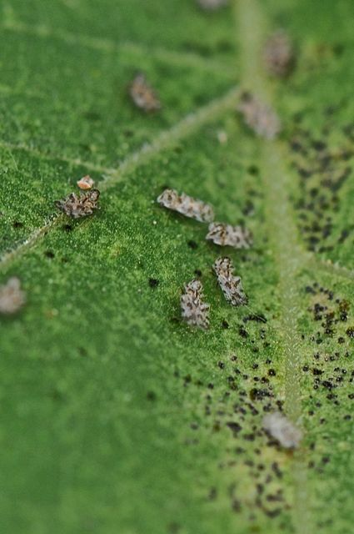

Figure 27. Corythuca sp. (family Tingidae) on sunflower leaf.

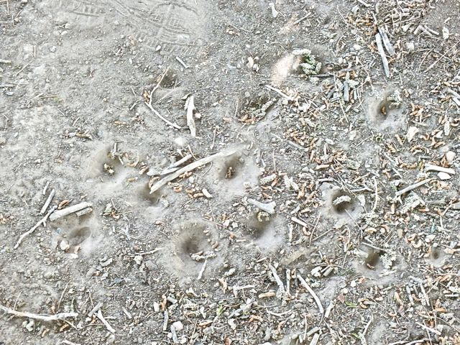

Figure 28. Pits of antlions (family Myrmeleontidae) under mulberry tree.

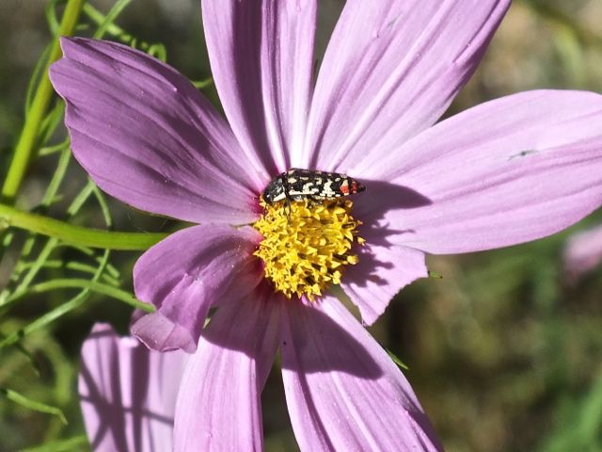

Figure 29. Acmaeodera disjunctus (family Buprestidae) on Cosmos.
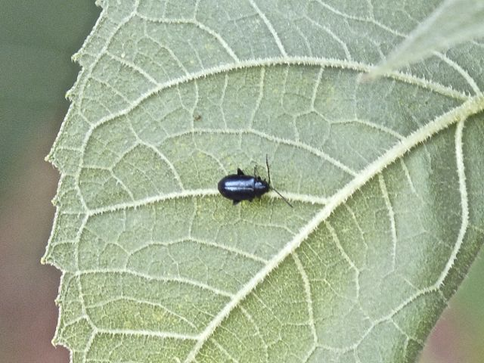

Figure 30. Altica sp. (family Chrysomelidae) on sunflower leaf.

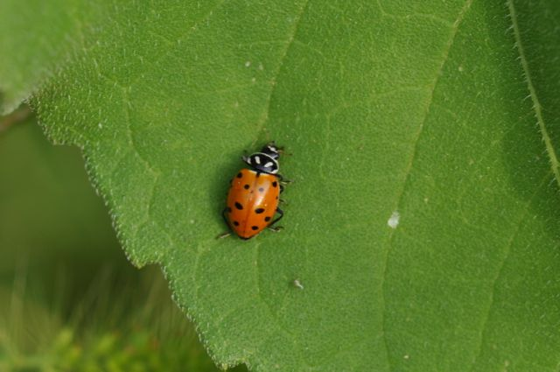

Figure 31. Hippodamia convergens (family Coccinellidae) on sunflower leaf.

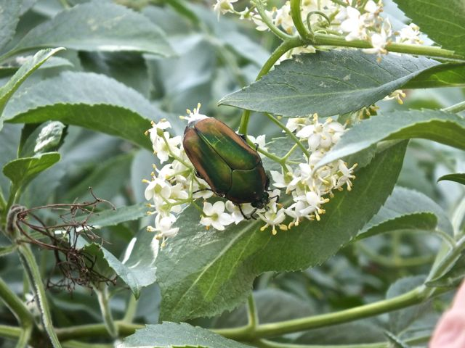

Figure 32. Cotinis texana (family Scarabaeidae) on Mexican elder.

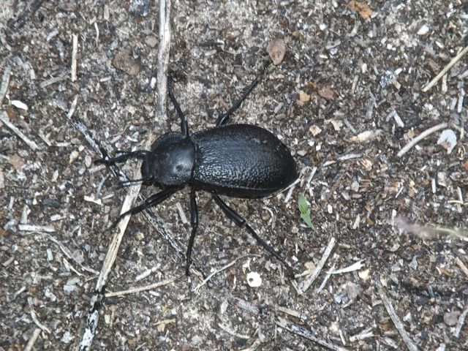

Figure 33. Stenomorpho marginata (family Tenebrionidae) on ground.
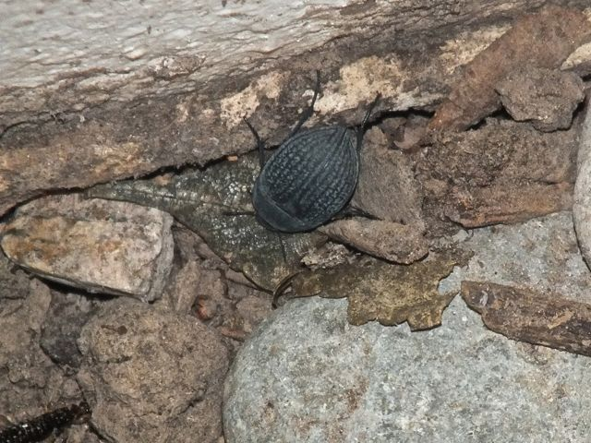

Figure 34. Eusattus reticulatus? (family Tenebrionidae) at edge of house foundation.

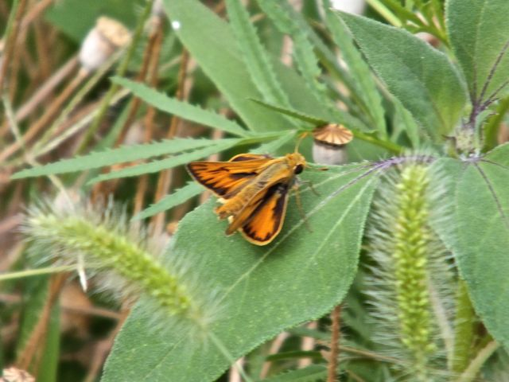

Figure 35. Hylephila phyleus (family Hesperiidae) on sunflower leaf.
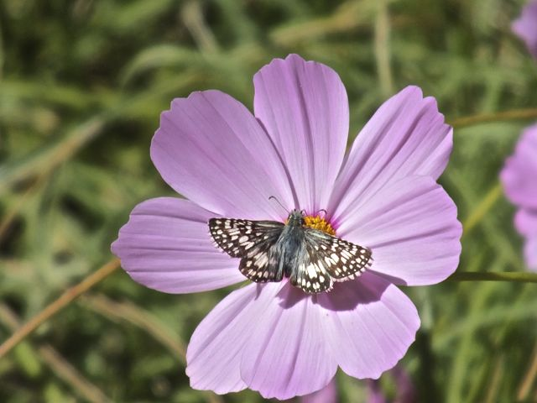

Figure 36. Pyrgus communis (family Hesperiidae) on Cosmos.

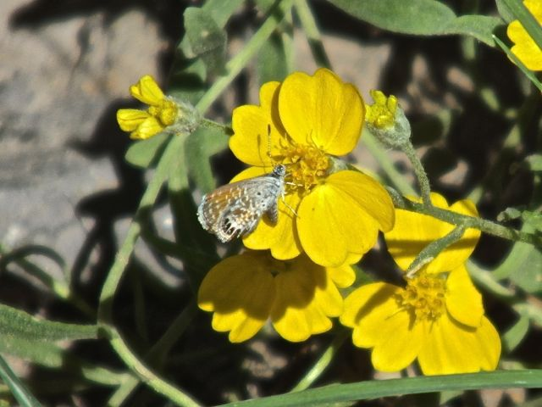

Figure 37. Brephidium exile (family Lycaenidae) on paper flower. Our smallest butterfly.

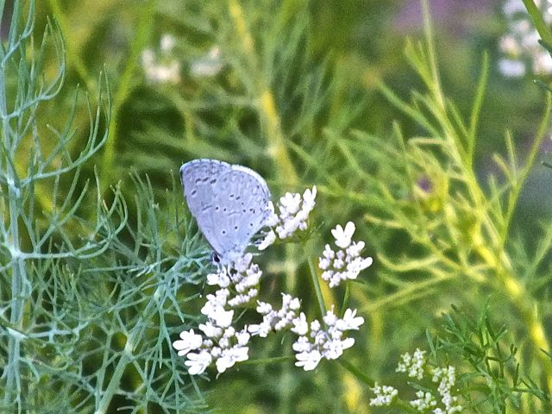

Figure 38. Celastrina ladon (family Lycaenidae) in garden.

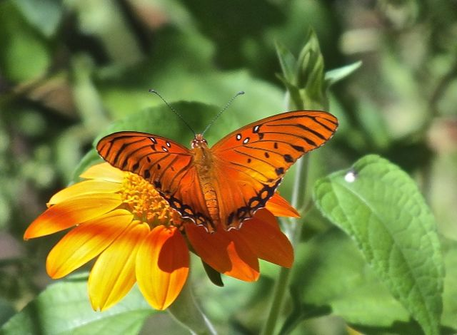

Figure 39. Agraulis vanillae (family Nymphalidae) on Tithonia.

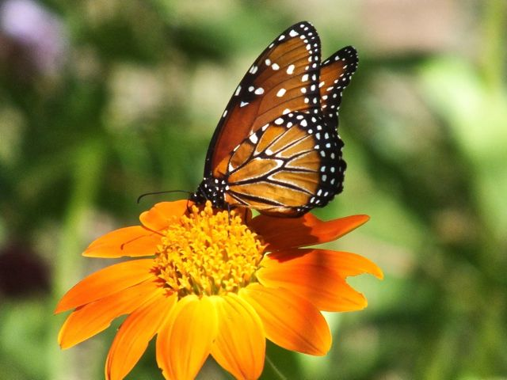

Figure 40. Danaus gilippus (family Nymphalidae) on Tithonia.

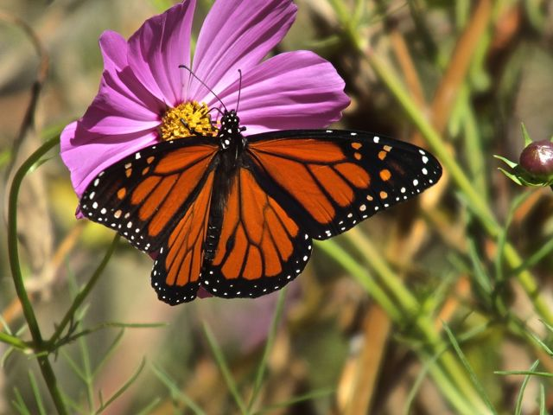

Figure 41. Danaus plexippus (family Nymphalidae) on Cosmos.

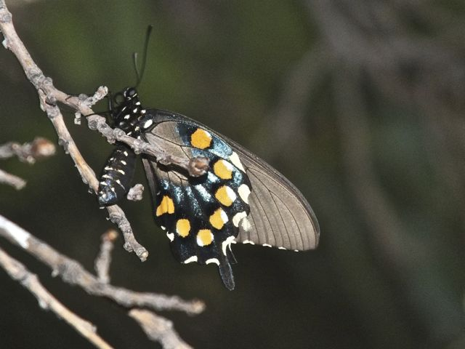

Figure 42. Battus philenor (family Paplionidae) on a dead mulberry branch.

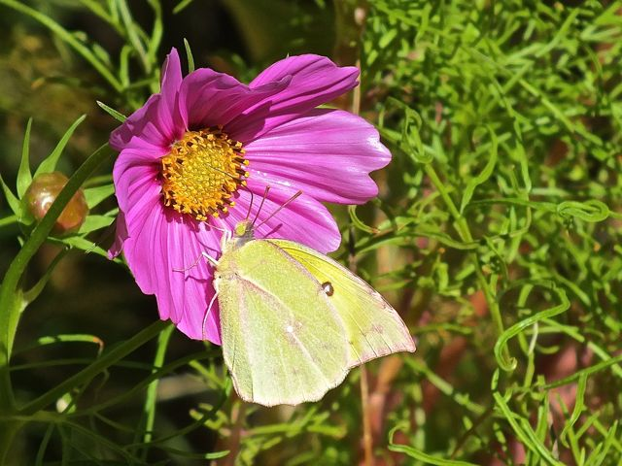

Figure 43. Zerene cesonia (family Pieridae) on Cosmos.

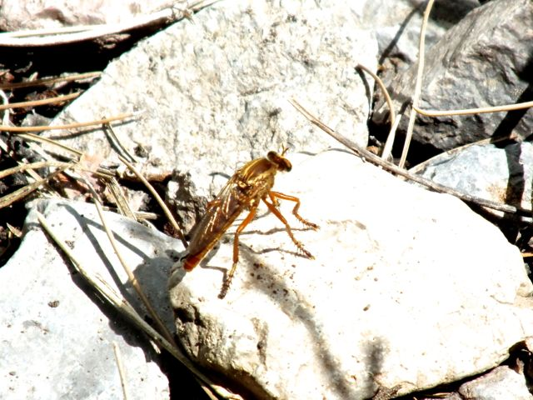

Figure 44. Diogmites angustipennis (family Asilidae) on rock.

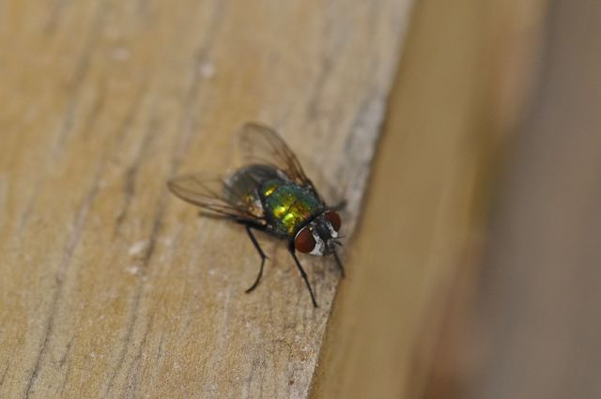

Figure 45. Lucilia sericata (family Calliphoridae) on wooden frame.

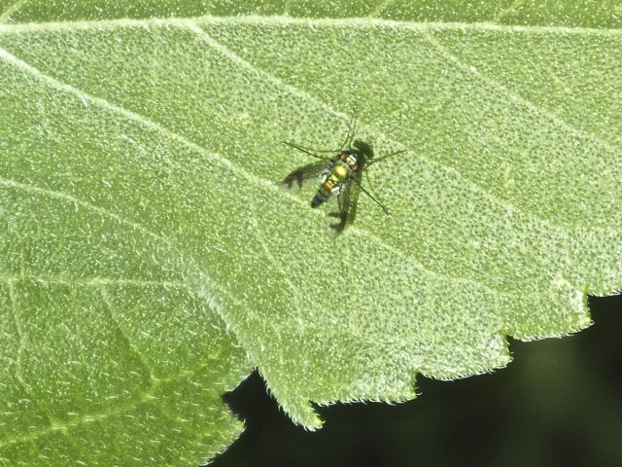

Figure 46. Condylostylus sp. (family Dolichopodidae) on sunflower leaf.

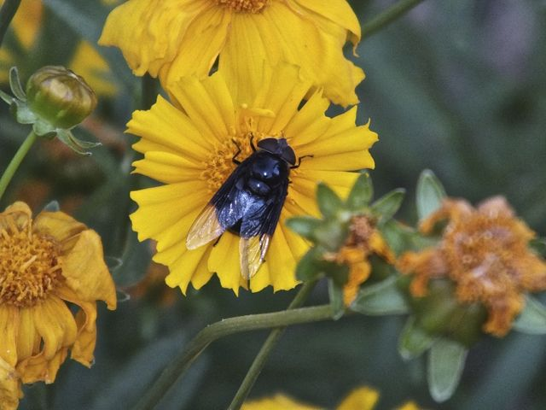

Figure 47. Copestylim mexicanum (family Syrphidae) on Coreopsis flower.

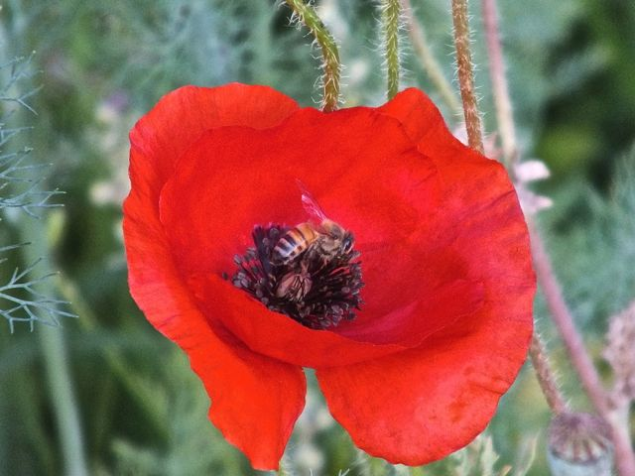

Figure 48. Apis millifera (family Apidae) on Flanders poppy.

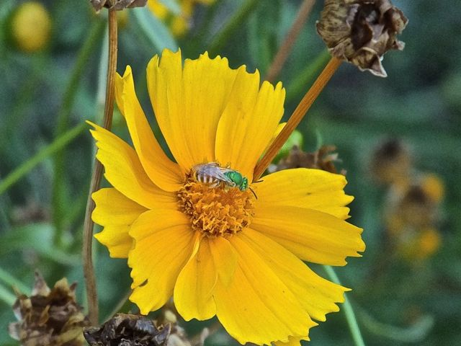

Figure 49. Agapostemon sp. (family Halictidae) on Coreopsis.

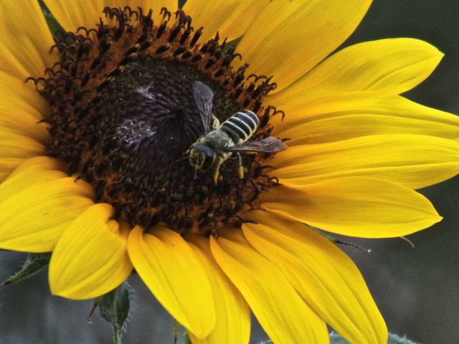

Figure 50. Megachile sp. (Megachilidae) on sunflower.

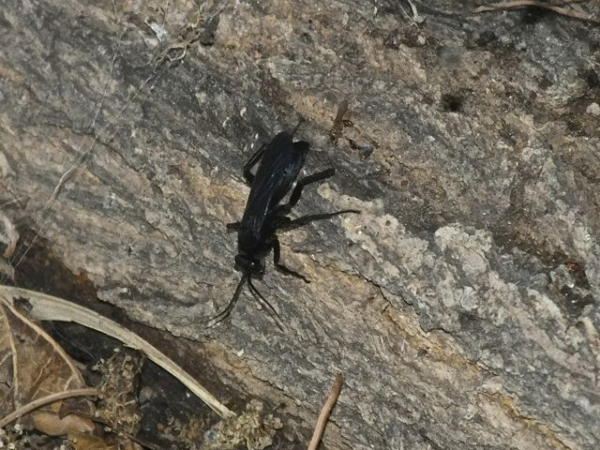

Figure 51. Anoplius sp. (family Pompilidae) on tree trunk.
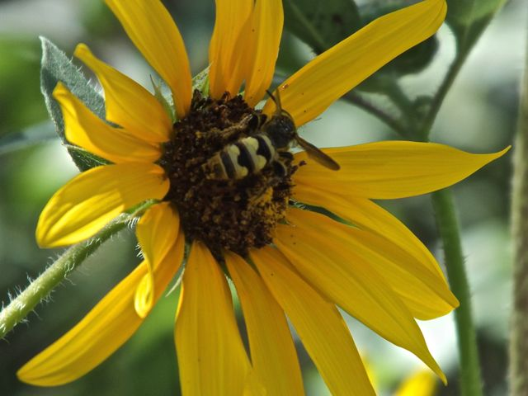

Figure 52. A scoliid wasp (family Scoliidae) on sunflower

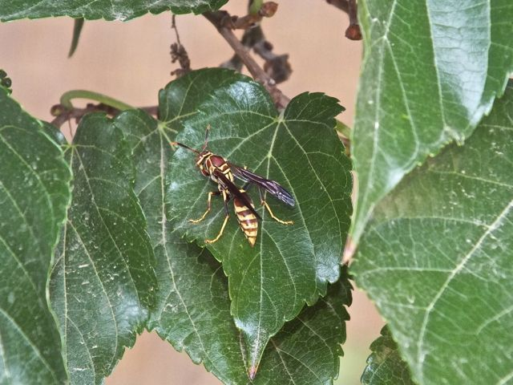

Figure 53. Polistes sp. (family Vespidae) on mulberry leaf.

All photographs were taken by me.
Contact author David Richman. Email tithonia65@gmail.com

Published in the November 2103 issue of Micscape magazine.
www.micscape.org

