Arrowroot

Peter B. Paisley

Sydney, Australia

Curious claims
By chance, I read an allegation that Napoleon Bonaparte said arrowroot was designed to sustain England’s colonial empire: hence (presumably) to help prop up France’s chief rival as a world economic and military power. Whether or not he said it, it seemed significant that anyone even thought he had: so mounts of arrowroot seemed worthy of some analysis.

An arrowroot specialist?
Rummaging through the slide collector’s Old Testament, Bracegirdle’s Microscopical Mounts and Mounters, I saw only two arrowroot illustrations, both Hume slides. Furthermore, they were the only Hume slides illustrated in MM&M.

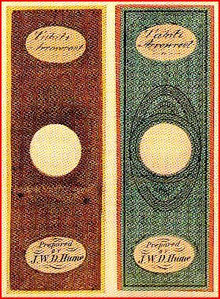

The two Hume arrowroot slides, from Microscopical Mounts and Mounters, plate 21.

My Hume slides suggest he was very interested in arrowroot: there is little evidence he was a commercial mounter, but Tahitian duplicates may indicate supply to other pharmacists. Tahiti’s position vis à vis Europe was slow to resolve - from Cook and Bougainville on, there were colonial efforts by both Britain and France. In 1842 Admiral Thouars, with no official sanction, coerced Tahiti into protectorate status, expelling a protestant English missionary in the process: a position disowned by Louis-Phillipe, but later confirmed by Napoleon (the third). War by French troops on Tahitian locals continued until 1880, when colonial status was consolidated. The traditional enemy famously inspired the ailing Lord Raglan to awake at his Crimean campaign table, ordering “Attack the French at once!” His aide protested, “The French, sir, are our allies”. In the 1870s France was at war in Europe, with Prussia – at a time when Hume began his pharmacy training, and his mounting career: his first public mount exhibition was in 1875, all featuring starches. Was Tahitian arrowroot somehow suspect, due to mutual Anglo-French mistrust? Various British colonies, in the Caribbean and then in Australia and South Africa, made arrowroot flour – perhaps this was considered the “good stuff”.

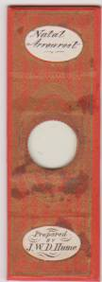

A Hume South African arrowroot slide

Hume always had an interest in starches - in general - as evidenced by the slides below.

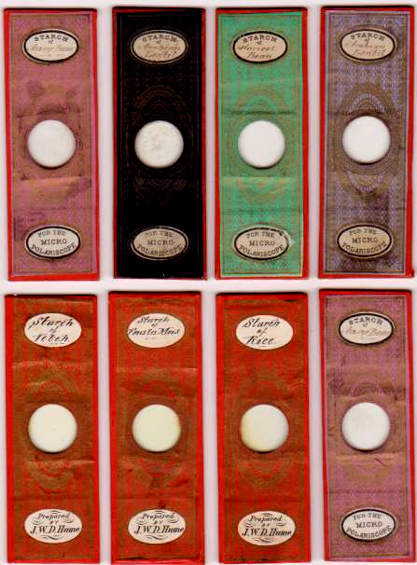

To be sure, Hume studied other chemical subjects, both inorganic and organic and human, as in other slides, below.

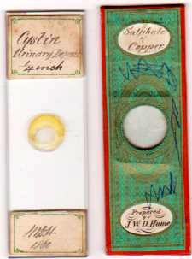

However I believe his interest in starches, and arrowroot in particular, ran somewhat deeper.

How important was arrowroot?
Widely used in cooking, arrowroot had a market in Britain, Europe and the USA: starches in general also were used in glue and clothing manufacture. As a commodity however it lacked the importance of (say) coal, and sugar supplanted it in culinary importance – yet various factors sustained its continued use. In some Caribbean locations, notably St. Vincent, it remains the dominant economic influence. In the food industry more than gastronomy was involved, since it had traditional home medical application: for most of the nineteenth century, sick children, or adults convalescing from almost any illness, were often prescribed arrowroot jellies and elixirs as a bland diet to aid recovery. The trouble was, sometimes it appeared beneficial, sometimes the opposite, and sometimes neutral. But why?

Ancient ailments re-discovered
In 1856, the Sydenham Society published Francis Adams’ translation of the works of Arataeus, a physician with pneumatist inclinations: his floruit remains uncertain, but most place him around the time of the Emperor Vespasian. It was widely read, and included description of a syndrome, “the coeliac affection”. To quote Adams’ translation,
It is a very protracted and intractable illness…..it relapses again without any obvious cause, and comes back upon even a slight mistake…..children are subject to continued diarrhoea, from an ephemeral intemperance of food.
Arataeus’ hitherto forgotten account included dietary measures (few are likely to have had much effect). The translation drew attention to heterogeneous clinical presentations, which Arataeus suggested might conceal one, or a few, specific diseases: which held out prospects of specific treatment or cure. Parents came to doctors and pharmacists for advice on children’s “failure to thrive”, seemingly due to some kind of food intolerance. Various foods came under suspicion: in 1888, the physician Samuel Gee gave an account summarising features of a condition to which he re-gave Arataeus’ term, coeliac disease. This now entered standard nosology, formalising what some practitioners already empirically suspected. Precise knowledge of aetiology lay many years ahead, but as Gee said,
If the patient can be cured at all, it must be by means of diet.
What is arrowroot and what is not?
Powder labelled “arrowroot” may be deceptively marketed. Commonly, arrowroot flour is adulterated with potato, rice or maize starch, which, arguably, may not be critical – but in earlier times it might be mixed with wheat flour, which matters much, since this introduces gluten. Ordinary buyers could not easily tell the difference, but a gluten sensitive consumer could become very sick as the result. Compounding the confusion, even unadulterated “arrowroot” can originate from several different plant species – succinctly illustrated by a remark on a current internet site, www.henrieteesherbal.com, that tous-les-mois starch is “preferred by many to other kinds of arrowroot”. In 1846, Beck complained
A cheap imitation of arrow-root is manufactured from potato starch
And added
This fraud can be detected by the microscope
Beck specified the West Indian variety, derived from maranta arundinacea, as the genuine article: and it is obvious that polariscopy was early up and running for critics of the industry. Every microscopical work on starches emphasised their easily distinguishable features under the polariscope. Despite all this, “arrowroot” is a pretty fuzzy term, even today. And in the nineteenth century “arrowroot”, if mixed with wheat flour, made some sick children much sicker.

Chemical mounts: entertainment or utility?
Following microscopic observation of chemicals under polarized light at the Bristol medical school, commercial slide mounters produced large numbers of chemical slides. To quote Bracegirdle (p.21), they
are often sought after to elicit a gor-blimey reaction…….all mounters supplied them, for they are easy to make

While “all mounters” may be an exaggeration, firms like the Normans, and many others, made mounts from a great variety of compounds, and the Victorian penchant for novelty soon produced a thriving market. Before even looking through their microscopes, buyers were doubtless captivated by exotic names on slide labels. Given choice between (say) “starch” or “magnesium platinocyanide”, most would probably opt for the latter. Starches though had their collectors, and slides of tous-les-mois seem to have been particularly popular.

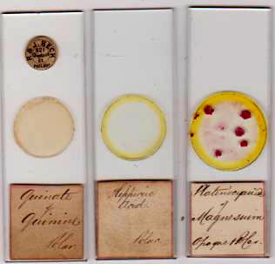

Some chemical slides by an as yet unidentified commercial mounter: his quinate slides continue to turn up as duplicates, and sold internationally via Smith & Beck

The Victorians delighted in all manner of visual diversions, witness the success of the oxyhydrogen projector, magnifying images by a million or more on screen (the resolution must have been dreadful!), “magic lantern” shows of every sort, patterns produced by the pendulograph, or variations shaken up by kaleidoscopes. Where serious analysis was done, it often ran almost to neo-Pythgorean mysticism, as with the pendulograph, or abstruse mathematical exegesis, as for the kaleidoscope. There were those however, like Hume, whose mounting activities leant more in the direction of applied chemistry, as one might expect from practical occupations dealing with the public, like pharmacy.

The conscientious pharmacist
A good pharmacist took care to ensure the purity of what he sold. With his expertise in polarising microscopy, Hume went further than many. Like Beck, he was suspicious of some big business and its products. Mustard, for instance, came under his critical scrutiny, with a brickbat thrown at Colman’s company.

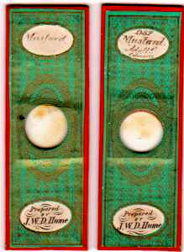

Mustard mounts by Hume: the Colman’s sample on the right is labelled as adulterated (with what, he does not specify).

Perhaps particularly where sick children were involved, parents who could not afford a doctor (and there were many) trusted pharmacists for advice. Knowing the popularity of home remedies, and the common use of arrowroot mixtures for convalescents and sick children, Hume would have made every effort to ensure the purity of anything he sold. Three slides in particular are evidence for this: he was judging the qualities of various arrowroots.

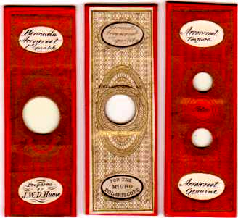

“First and second quality” Bermuda arrowroot, and a double cell to distinguish between “genuine” and “impure” arrowroot.

This is more than ordinary attention to arrowroot. Was Hume “on to something” regarding some children with chronic intermittent diaorrhoea? He, or his medical clientele, may well have been. In addition, Hume probably dispensed for homeopathic doctors, so would have gone to some lengths to ensure purity and exact formulation of his stock.
Then as now, many a humble GP empirically knew things not yet formally announced by the academic and clinical élite. Sick gluten sensitive children on a temporary diet of jellies and arrowroot mixtures would respond well, if this involved pure arrowroot: people surely noticed that. Samuel Gee, in Harley Street, in 1881 had a children’s nursemaid, Edith Boon, who came from Suffolk, where Hume practised. Maybe she knew a thing or two.

Envoi
Hume’s interest in arrowroot was hardly provoked by anxiety over the efficacy of his glue or the stiffness of his shirt collars. While I cannot prove that his mounting focus was sharpened as much by clinical concern as by pure curiosity, it seems likely. I leave readers to decide. Meantime, I think I’ll have a cup of tea. And a couple of nice arrowroot biscuits.

Acknowledgement
Many thanks to Brian Davidson for locating some Hume slides.

Sources
B. Bracegirdle: Microscopical Mounts and Mounters, Quekett Microscopical Club, Oxford, 1998
The extant works of Aretaeus the Cappadocian: translated with annotations by Francis Adams, Sydenham Society, London, 1856
Lewis Beck: Adulterations of various substances used in medicine and the arts: Samuel & William Wood, New York, 1846
Samuel Gee, in Reports of St Bartholemew’s Hospital, London 1888
Wikipedia
www.anccestry.com

Email author: lois737 AT bigpond DOT com

Published in the October 2011 issue of Micscape Magazine.

www.micscape.org

