AN ARTHROPOD OBSERVATION GARDEN

Part 1. The Construction and Flora of the Garden and Surrounding Area.

David B. Richman, Mesilla Park, New Mexico, USA

My main project for the year was to create a pesticide free garden that would allow me to observe and photograph arthropods freely. My old insect garden (See: An Insect Garden in New Mexico, Micscape, Sept. 2004) was not designed to allow ease of entry in several areas and had to allow space for my wife’s vegetable garden. Still we never used pesticides, save pyrethrum twice for grape leafhoppers on our grape vines and it has been at least ten years since we used that. When we gave up on the vegetable garden, primarily because of the work it entailed, I decided to convert the whole area into a butterfly and bee friendly garden that I could enter without a machete and would allow observation and photography of its inhabitants.

The layout of the garden was dictated to some extent by the presence of a large Afghan pine, a desert willow, and a Mexican elder (only the second is shown in the rough map of the garden below.) A white Lady Banks Rose had invaded the pine tree years ago, but the rose was severely burnt back in the -5 degrees F frost of early February 2011, as was the Mexican elder. Both have slowly recovered, but not before the elder and rose were both severely pruned.

The map below does not show all the plants involved, even within the confines of the main garden, but it does give a rough idea of the original layout for the latter. To the east of the main garden there is a cactus garden with a barrel cactus, a huge pencil cactus, a very large cow-tongue cactus, several hedgehog cacti, a native agave and a huge American agave (a Mexican native), plus a Mexican bird of paradise. To the south of this is a large stand of river cane, along with another bird of paradise and a skunkbush sumac. The three circles on the south edge of the small desert willow are two small barrel cacti and a tiny ocotillo. To the north and northeast is a stand of river cane and to the north and northwest are morning glory and moonflower vines, a Mexican elder, a Afghan pine and an herb bed with rosemary, cherry sage and a few other herbs. To the west against the west fence are roses, a passionflower, several yaupon holly plants, a small Gambel’s oak, a lace vine and a yellow jessimine vine. Various spring bulbs were also planted in the area. In the middle of the back yard is a roughly oval area with two very large cherry sages, a small wolfberry plant, two yerba mensa plants, skullcap, various irises, a large sacred Datura, yarrow, Cosmos, butter and eggs, Coreopsis, and a few other plants. The middle to front yards are shaded by large mulberry trees and two Afghan pines, while the east and south fences have are partly covered with honeysuckle. A pomegranate tree (almost lost in the freeze), a Rose of York shrub (tough as nails) and a Scotch broom round out the garden, except for two medium-sized and four tiny palm trees in beds on the west side, along with periwinkle, New Mexican locust, an arborvitae, two dwarf junipers and a redbud along the fence.

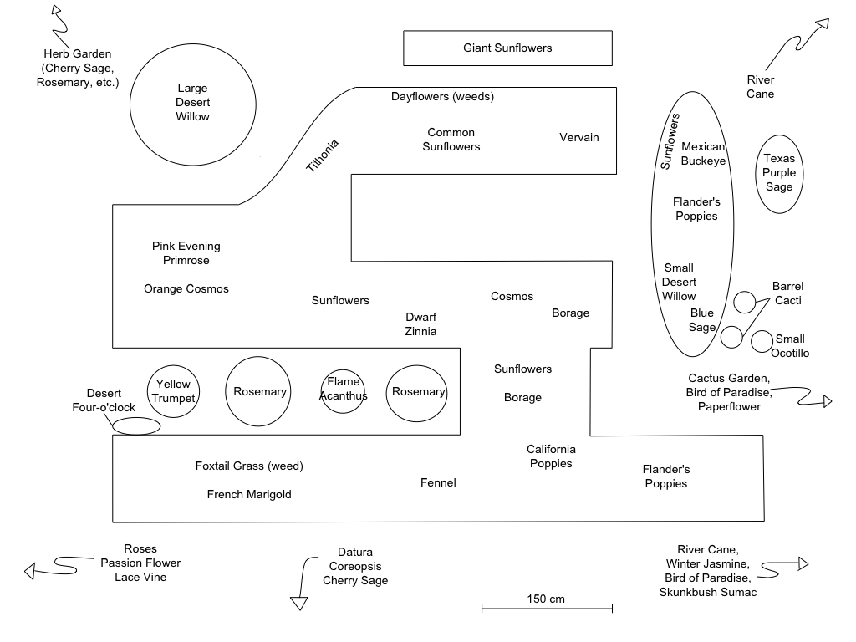
Rough map of the Main Observation Garden (prepared by Rebecca Richman from sketch by David Richman)

The poppies, various wildflower mixes, fennel, giant sunflowers, French marigold, dwarf zinnias, borage, cosmos, etc. were planted after the beds were readied. The large desert willow was already there, as was the Mexican elder, pink evening primrose, rosemary and cherry sage, as well as the cacti, bird of paradise, agaves and skunkbush sumac. The Mexican buckeye, the second (paler-flowered) desert willow, the ocotillo and the two barrel cacti in the map were planted around the same time as the seeds were sown. The foxtail grass and the dayflowers, as well as common sunflowers, came up on their own as weeds. I had to remove numerous silver-leaved nightshade plants (a losing battle!) and bristle foxtail. The passionflower, lace vine, flame acanthus, and yellow trumpet were planted after the garden had gown. All were in my census of the garden and surrounding yard (total about 0.1 hectares, with about 0.04 hectares as garden area) had over 130 species of vascular plants in 55 families. Most of these are planted and many of the “natives” were also planted, as the backyard was full of Palmer amaranth, Russian thistle, Kochia, and puncture vine, when we moved in 23 years ago and had minimal natives, including globe mallow and silver-leaf nightshade.

We do live in a desert river valley and in addition watering was a special problem this year as by the first day of September we have had all on 9.3 cm of moisture. This is not unusual in a drought year, but the current drought has also dried up the Rio Grande because of minimal snow melt from the Rocky Mountains and this is much more worrying. I do not have irrigation rights and the well on the property is inactive so I use city water anyway. Unfortunately this comes from the Mesilla Bolson aquifer. This aquifer has been replenished by the Rio Grande flow in the past and thus is sinking. I have had mixed feelings about this, but I pay for the water and my garden provides food and water for a fairly wide variety of wildlife in addition to arthropods. These include lesser gold finches, house finches, curve-billed thrashers, northern mocking birds, American robins, black chinned-hummingbirds, white-winged doves, mourning doves, Inca doves, an occasional striped skunk, several Coach’s spadefoot toads and several racerunner lizards. In addition several migratory bird species passing through during spring and fall migration, such as rufous hummingbirds, Swainson’s thrushes, ruby-crowned kinglets, dark-eyed juncos, cordilleran flycatchers, American crows, and others, also use the garden. Occasional visitors include summer tanagers, Cooper’s hawks, turkey vultures, roadrunners, and others. I thus don’t feel quite so guilty about water use.

The following list is based on my best attempt to identify every species of vascular plant found this year in our yard. I did not include potted plants, but only ones that were in the ground. A few of the names are tentative, but most are correct I believe. Some, such as Salsola (Russian thistle), Kochia, Amaranth, and all Euphorbiaceae and Brassicaceae, were ruthlessly destroyed. There is a constant ongoing war with Bermuda grass (Cyanodon dactylon – one of the worst weeds worldwide, it was imported from Africa via Bermuda and is still used as a lawn grass), seedlings of Siberian elm (Ulmus pumila) and bristle foxtail (Setaria verticillata). .

I would encourage anybody who is interested in arthropods to develop such a garden. In addition to serving as a great source for photography and observation such a garden provides needed pollen and nectar for pollinators, many of which are stressed and declining in numbers. These include butterflies, moths, bees, wasps, and some beetles. Thus in addition to providing subjects for both macro- and photomicrography and study, the garden can be a great help in the effort to provide habitat for these important organisms. I cannot emphasize too much how vital this is as most of our crops, ornamentals, and wildflowers are dependent on these creatures for reproduction.

Plants of The Observation Garden (*) and Surrounding Yard (ca. 0.1 hectares)
Family Name Native? Exotic? Weed?
________________________________________________________________
Conifers

Cupressaceae Cupressus arizonica X
Juniperus sp. X
Thuja sp. X
Pinaceae Pinus eldarica X

Monocots

Agavaceae Agave parryi X
Agave americana X
Alliaceae Ipheion uniflorum X
Amaryllidaceae Narcissus sp. hybrids X
Arecaceae Butia capitata X
Chamaerops humilis X
Rhapidophyllum hystrix X
Sabal minor X
Sabal sp. (Mexico) X
Trachycarpus fortunei X
Asperagaceae Hyacinthus sp. hybrids X
Muscari sp. X
Scilla siberica X
Commelinaceae Commelina erecta* X
Cyperaceae Cyperus esculentus* X
Iridaceae Iris germanica X
Iris reticulata X
Liliaceae Hemerocallis flava X
Tulipa greigii X
Tulipa suaveolens hybrids X
Orchidaceae Bletilla striata X
Poaceae Arundo donax X
Bouteloua curtipendula X
Cynodon dactylon* X
Eriochloa gracilis* X
Hesperostipa comata* X
Panicum virgatum X
Poa pratensis X
Setaria glauca* X
Setaria verticillata* X
Sorghum bicolor* X
Stenotaphrum secundatum X
At least two species of unidentified annual grass.

Dicots

Acanthaceae Anisicanthus quadrifidus
var. wrighti* X
Ameranthaceae Ameranthus palmeri * X
Aizoaceae Trianthema portulacastrum * X
Anacardiaceae Rhus trilobita X
Apiaceae Anerhum graveolens* X
Foeniculum vulgare* X
Apocynaceae Vinca minor X
Asclepiadaceae Sarcostemma cynanchoides* X
Asteraceae Achillea millefolium X
Berlandiera lyrata X
Centaurea cyanus* X
Coreopsis lanceolata X
Cosmos bipinnatus* X
Cosmos sulphureus* X
Erigeron sp. X
Gaillardia pulchella * X
Helianthus annuus* X
Lactuca serriola* X
Machaeranthera tanacetifolia*X
Psilostrophe tagetina X
Ratibida columnifera X
Sonchus asper* X
Tagetes minuta* X
Tagetes patula* X
Taraxacum officinale X
Verbesina encelioidea X
Zinnia x hybrida* X
Bignoniaceae Bignonia capreolata X
Chilopsis linearis* X
Tecoma stans* X
Boraginaceae Borago officinalis* X
Brassicaceae Descurainia pinnata X
Sisymbrium irio* X
Cactaceae Echinocereus triglochidiatus X
Echinocereus fendleri X
Ferocactus wislizenii* X
Opuntia arbuscula X
Opuntia ficus-indica X
Opuntia imbricata X
Opuntia lindheimeri
var. linguiformis X
Caprifoliaceae Sambucus cerulea X
Celastraceae Euonymous japonicus X
Chenopodiaceae Chenopodium berlanderi X
Kochia scoparia X
Salsola iberica X
Convolvulaceae Ipomoea alba X
Ipomoea batatas X
Ipomoea sloteri X
Ipomoea tricolor X
Cucurbitaceae Cucumis melo X
Cucurbita pepo X
Euphorbiaceae Chamaesyce albomarginata* X
Euphorbia prostrata* X
Fabaceae Cercis occidentalis? X
Cytisus scoparius X
Medicago lupilina* X
Melilotus alba* X
Robinia neomexicana X
Fagaceae Quercus gambeli X
Gelsemiaceae Gelsemium sempervirens X
Lamiaceae Lamium amplexicaule X
Lavandula angustifolia X
Mentha sp. X
Polimintha incana X
Rosmarinus officinalis* X
Salvia chamaedryoides* X
Salvia elegans X
Salvia greggi X
Salvia officinalis X
Scutellaria suffretescens X
Lythraceae Punica granatum X
Malvaceae Sphaeralcea coccinea* X
Hibiscus sp. X
Mimosaceae Caesalpinia gilliesii X
Moraceae Morus alba X
Nyctaginaceae Mirabilis longiflora* X
Oleaceae Jasminum nudiflorum X
Ligustrum sp. X
Onagraceae Oenothera speciosa * X
Oxalidaceae Oxalis sp. X?
Papaveraceae Escholtzia californica* X
Papaver rhoeas* X
Passifloraceae Passiflora incarnata X
Poygonaceae Polygonum aviculare X
Ranunculaceae Delphinium sp. X
Rosaceae Rosa alba X
Rosa banksiae X
Rosa hybrids X
Sapindaceae Ungnadia speciosa* X
Saururaceae Anemopsis californica X
Scrophulariaceae Penstemon superbus* X
Solenaceae Datura wrightii X
Lycium sp. X
Physalis philadelphica* X
Solanum elaeagnifolium* X
Ulmaceae Ulmus pumila* X
Verbenaceae Verbena sp. (Vervain)* X
Zygophyllaceae Kallstroemia grandiflora X

Contact author David Richman. Email tithonia65@gmail.com

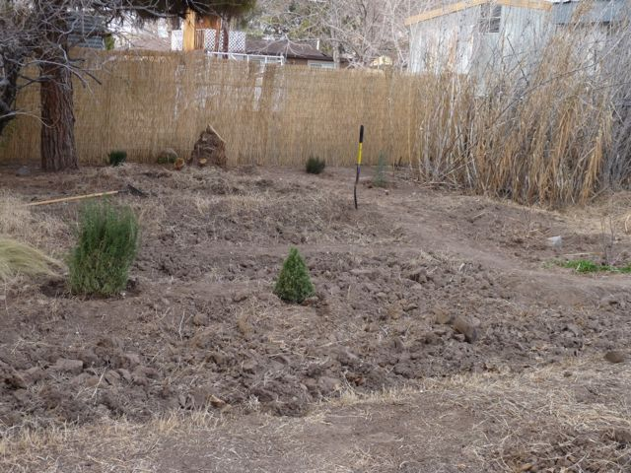

Figure 1. Insect Observation Garden on January 31, 2013. The digging of the main garden

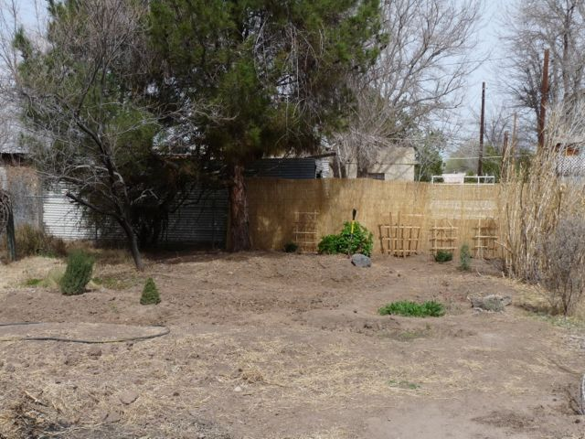

Figure 2. Insect Observation Garden on March 20, 2013. Note recovering Mexican Elder center against fence.

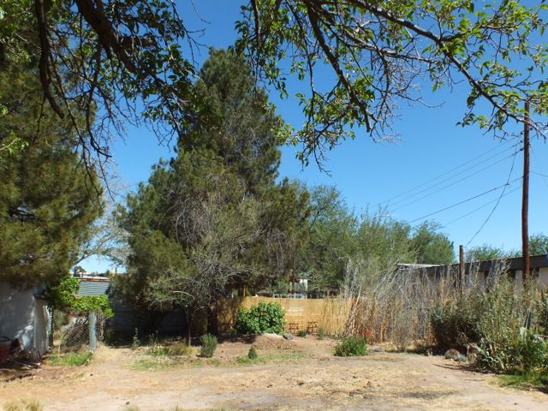

Figure 3. Insect Observation Garden on April 18, 2013. Beginning of first batch of Flanders Poppies in bloom, right of center.

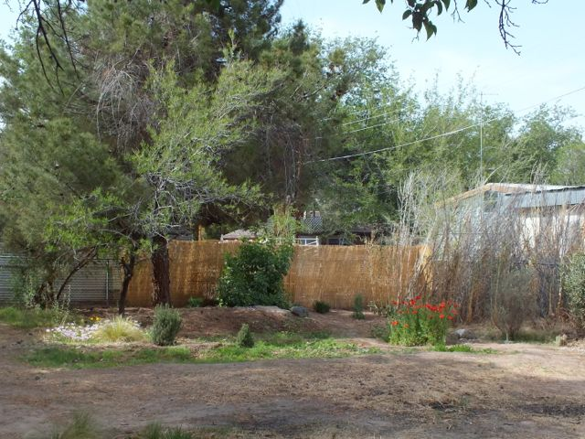

Figure 4. Insect Observation Garden on May 4, 2013. First batch of Flanders Poppies in full bloom.

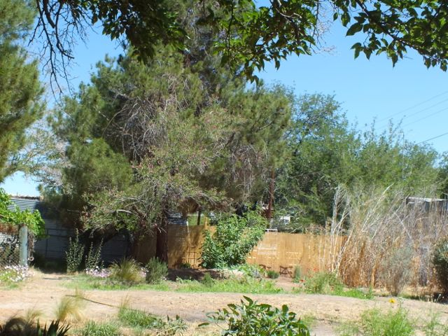

Figure 5. Insect Observation Garden on May 20, 2013. First batch of Flanders Poppies finished.

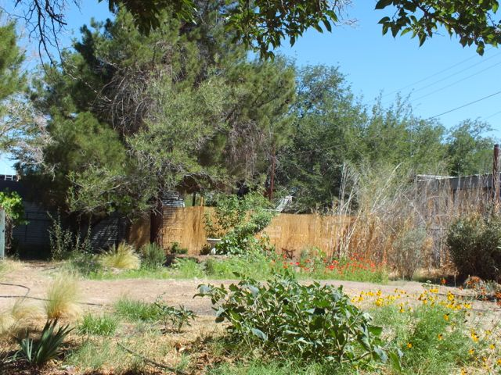

Figure 6. Insect Observation Garden on June 5, 2013. Second batch of Flanders Poppies. Note new birdbath left of center near Mexican Elder. In center foreground is a sacred Datura clump.

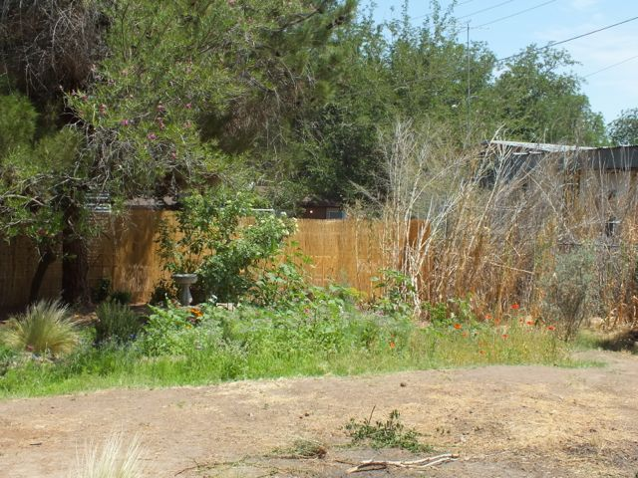

Figure 7. Insect Observation Garden on June 16, 2013. Second batch of Flanders Poppies nearly finished.

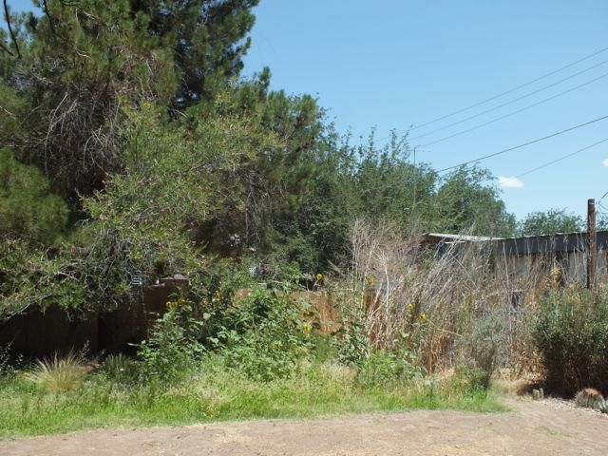

Figure 8, 2013, Insect Observation Garden on July 13, 2013. Sunflowers starting to bloom.

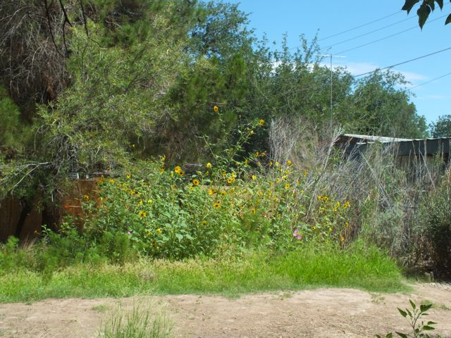

Figure 9. Insect Observation Garden on August 6, 2013. Sunflowers in full bloom.

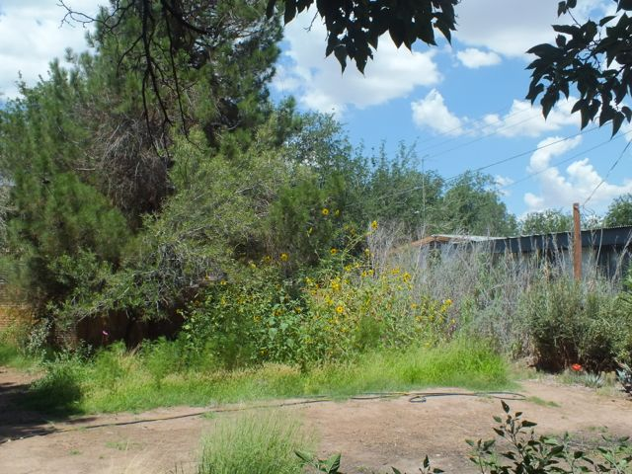

Figure 10. Insect Observation Garden on August 14 2013. Sunflowers in full bloom. Note blooming barrel cactus to far right.

Some of the more important plant species are in the following photographs. All photos taken by me in our yard during 2013.

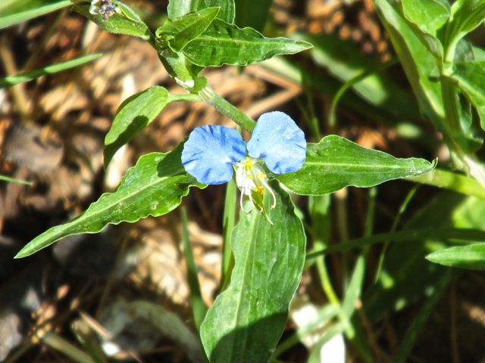

Figure 11. Dayflower (Commelina erecta).

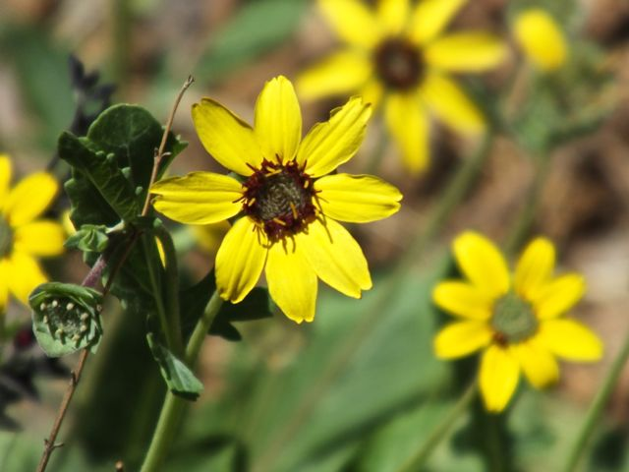

Figure 12. Chocolate Flower (Berlandiera lyrata).
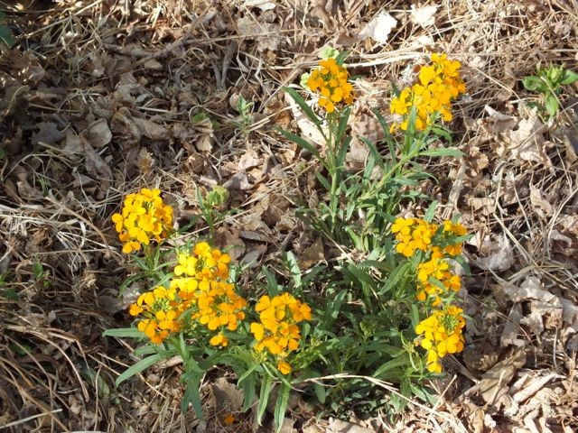

Figure 13. Paper Flower (Psilostrophe tagetina).

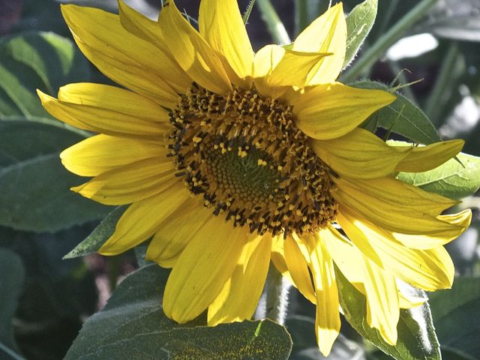

Figure 14. Giant Sunflower (Helianthus annuus hybrid).
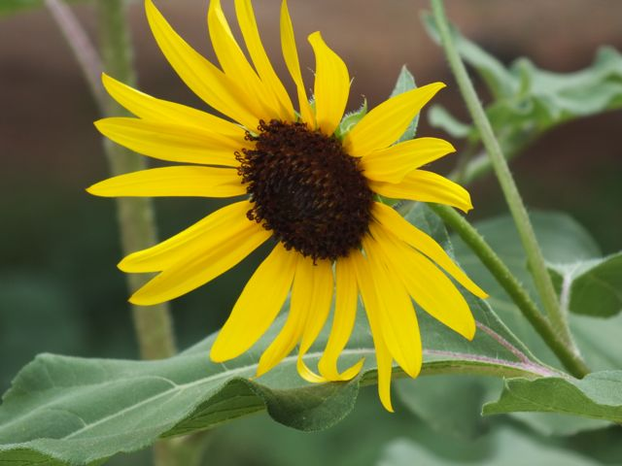

Figure 15. Native Sunflower (Helianthus annuus)

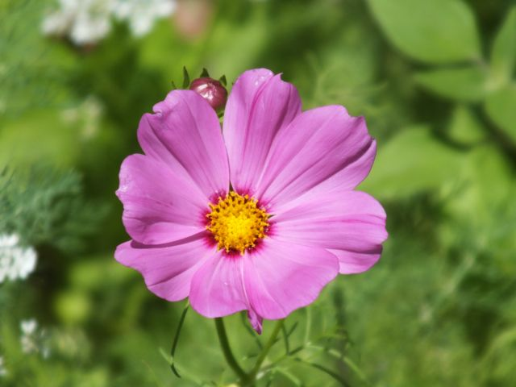

Figure 16. Garden Cosmos (Cosmos bipinnatus).
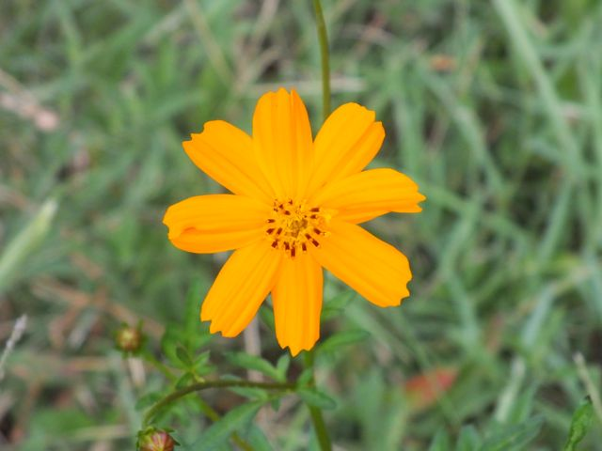

Figure 17. Yellow Cosmos (Cosmos sulphureus).

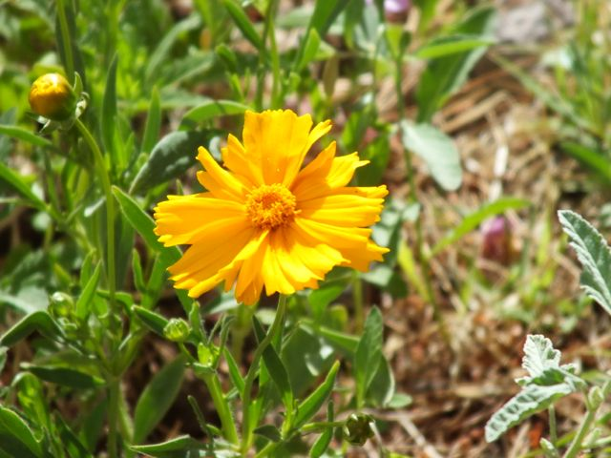

Figure 18. Garden Coreopsis (Coreopsis lanceolata).

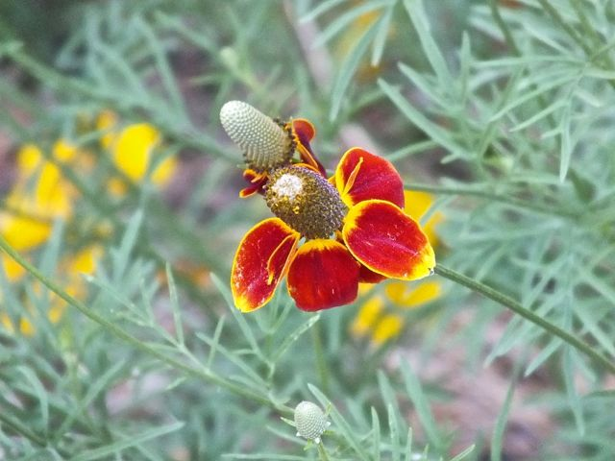

Figure 19. Prairie Coneflower (Ratibida columnifera).

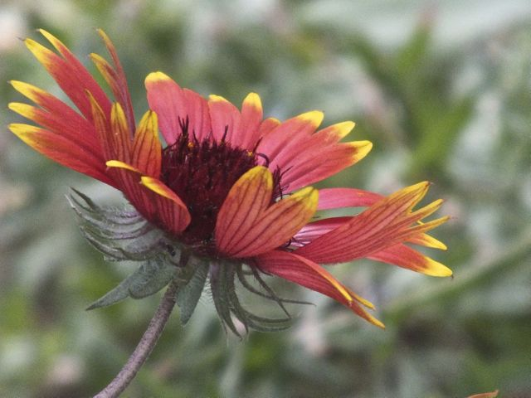

Figure 20. Indian Blanket (Gaillardia pulchella).
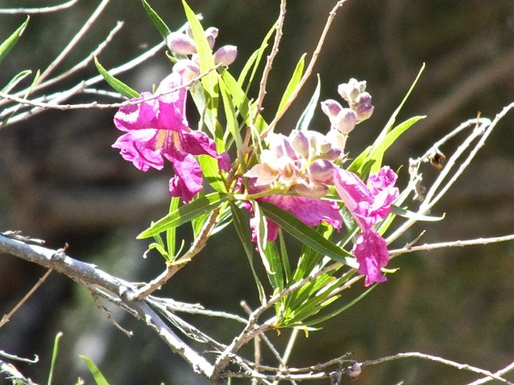

Figure 21. Desert Willow (Chilopsis linearis).

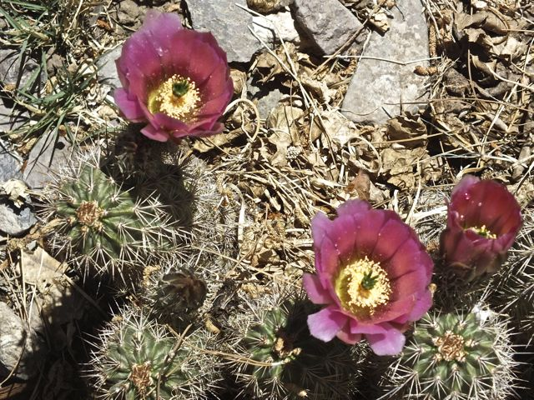

Figure 22. Pink Hedgehog Cactus (Echinocereus fendleri).
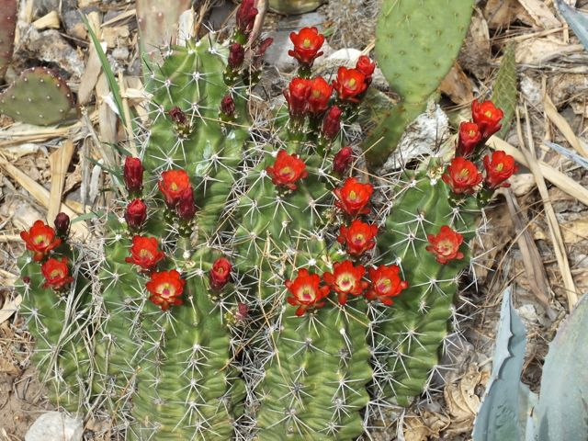
Figure 23. Claret Cup Cactus (Echinocereus triglochidiatus).

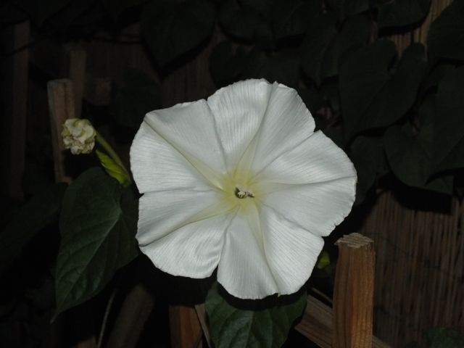

Figure 24. Moon Flower (Ipomoea alba).
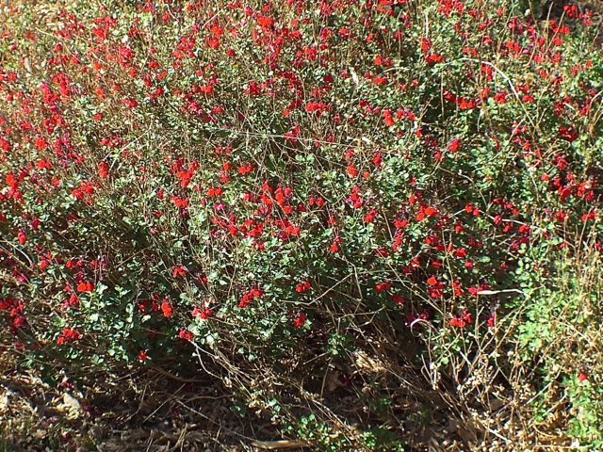

Figure 25. Autumn Sage (Salvia greggi).

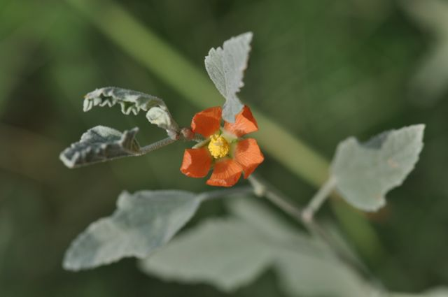

Figure 26. Globe Mallow (Sphaeralcea coccinea).

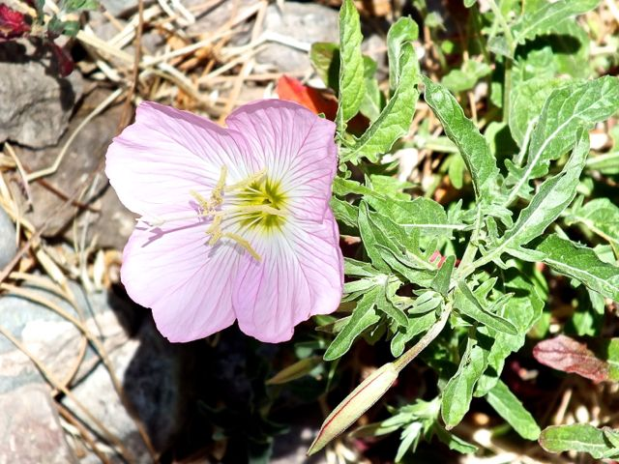

Figure 27. Pink Evening Primrose (Oenothera speciosa).

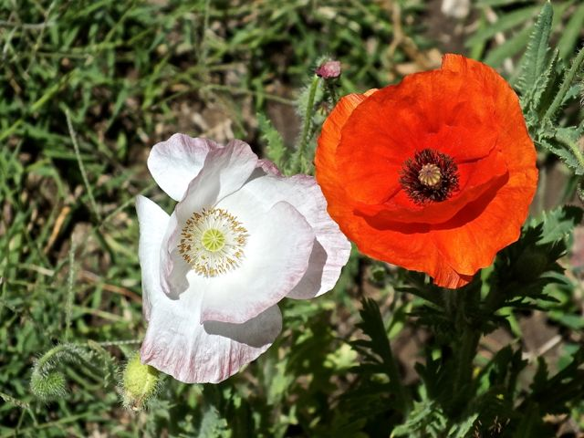

Figure 28. Flanders Poppy (Papaver rhoeas).

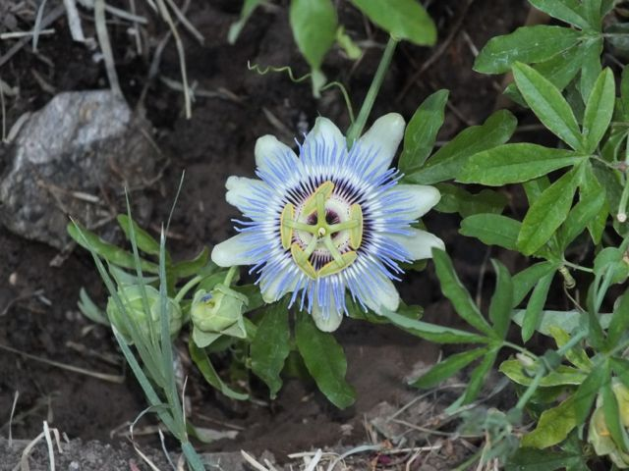

Figure 29. Passion Flower (Passiflora incarnata).

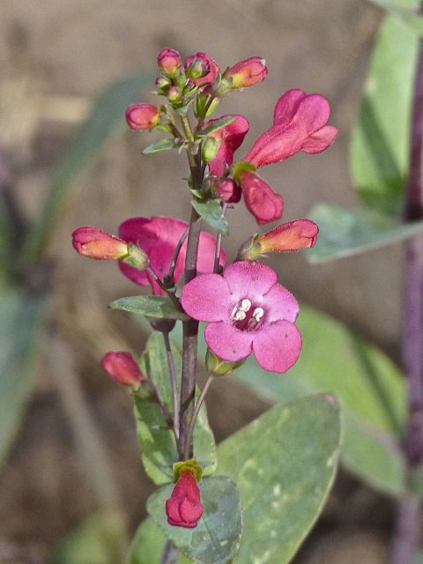

Figure 30. Superb Penstemon (Penstemon superbus).

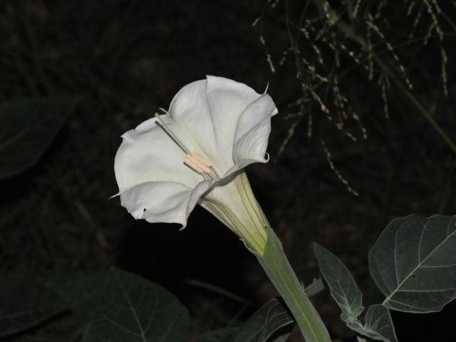

Figure 31. Sacred Datura (Datura wrightii).

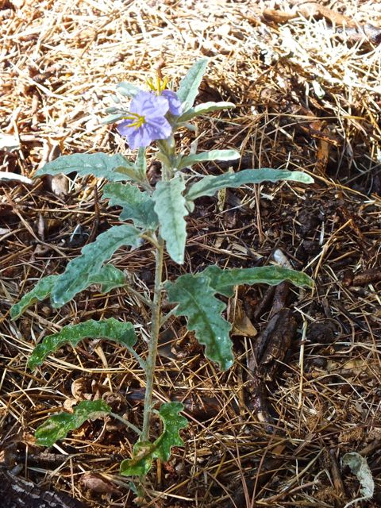

Figure 32. Silverleaf Nightshade (Solanum elaeagnifolium).

Published in the October 2103 issue of Micscape magazine.
www.micscape.org

