SOME NOTES ON WATSON’S EARLY MOUNTERS
Peter B. Paisley
Sydney, Australia

A recent paper by Stanley Warren and Brian Davidson (Quekett Journal of Microscopy, Summer 2012, pp.641-648) discussed microphotographs sold by Watson before 1882, when the firm changed its title from “Watson & Son” to “Watson & Sons”. Prior to reading their paper I had never thought much about mounters on-sold by Watson, nor about when sales occurred.
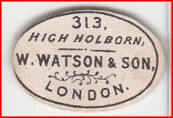
The label used by Watson until 1882, when an identical design followed except for “Sons” replacing “Son”.
Warren and Davidson comment briefly on the well known sale of Wheeler stock to Watson in 1884, but do not discuss possible earlier (non microphotographic) slide sales. This set me thinking about slides in my collection, and it did not take long to confirm that many mounters – some well known, others as yet unidentified - were on-sold by Watson before 1882.
Conventional wisdom has it that the Watson firm began retailing slides only from 1884, after the Wheeler sale. The date is given by Bracegirdle (Microscopical Mounts and Mounters, 1988, p.98) and has continued more or less unchallenged. But, not infrequently, slides turn up with pre-1882 Watson retail labels. The firm was at 313 High Holborn from 1867, and possibly sold slides there from around that time onward.
At any rate, pace the commonly accepted terminus post quem of 1884, many examples occur of slides retailed by Watson well before 1884, and before 1882. Some mounters are identified by retention of names on their original slide labels, while others are detectable by handwriting alone, nonetheless unequivocally. I illustrate a variety of examples, and readers can probably add to the list on scrutiny of their collections.
James Bond
Bond was one of the earliest mounters to gain a wide reputation for skills with balsam. He was assiduous in seeking sales: judging by the amount of his small early slides which continue to turn up today, he was highly successful. Some of his larger slides were inserted in wooden frames, for use as lantern slides. From its inception, the Watson firm had prestige as a maker and supplier of lanterns, and it would have been odd if lantern slide sales were not included. Whether Bond thus established an early commercial relationship with Watson I cannot say, but as the slide below attests, such a relationship existed when Watson was at 313 High Holborn, and prior to 1882 (Bond died in 1887).
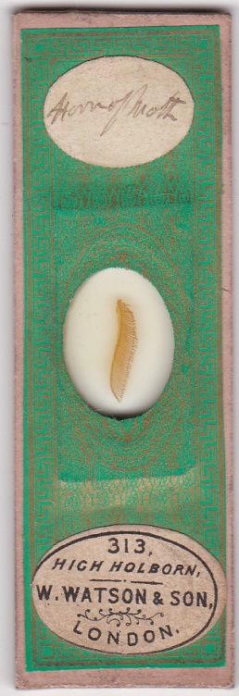
A mount by J.W. Bond, whose JWB monogram appears on the paper beneath the oval cut-out
John Barnett
Slides by Barnett are shown below, interspersed with others bearing no secondary stickers but with his familiar “JB” logo. The handwriting is distinctive and consistent.
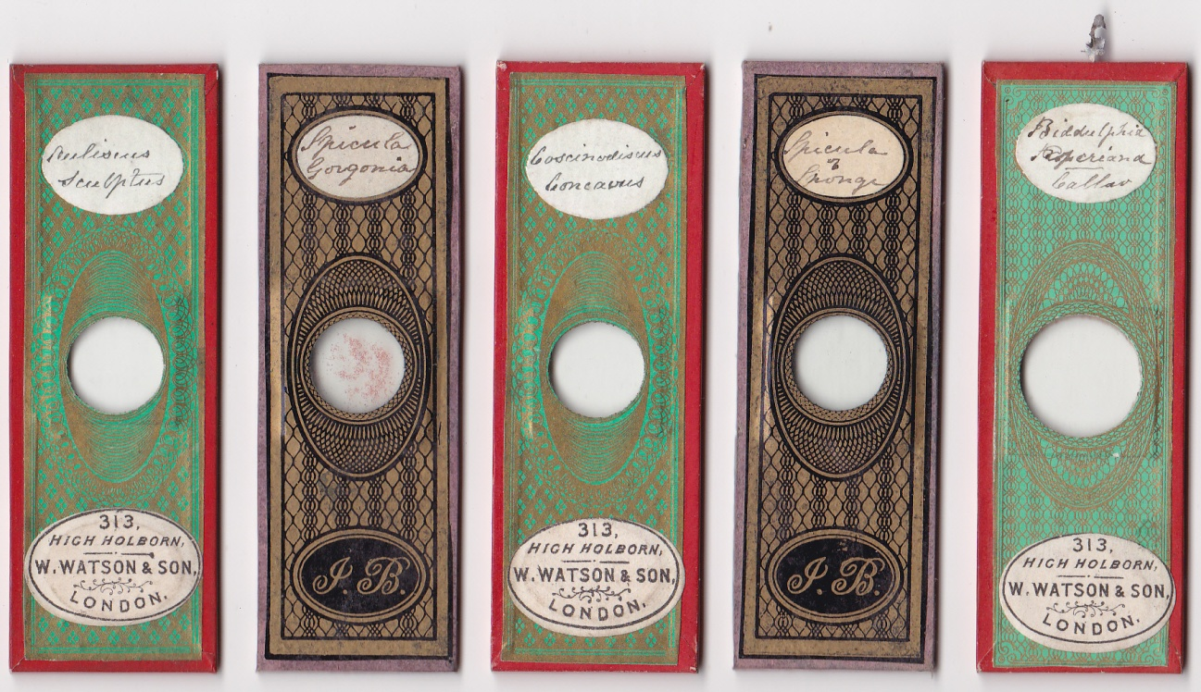
Barnett died in central London in 1882, having lived in Tottenham for many years. A period of illness probably preceded his move to the Middlesex Hospital, where he died from bowel cancer: hence, retailing of his slides by Watson probably preceded 1880. Possibly, Watson also acquired material from his estate. Unpapered Barnett slides are not common, at any rate by comparison with his prolific papered output: several in my collection bear his handwriting, but no monograms or secondary stickers. One however does have a pre-1882 Watson label. Another is illustrated by Brian Stevenson at his www.microscopist.net . I assume such unpapered slides are from late in Barnett’s career.
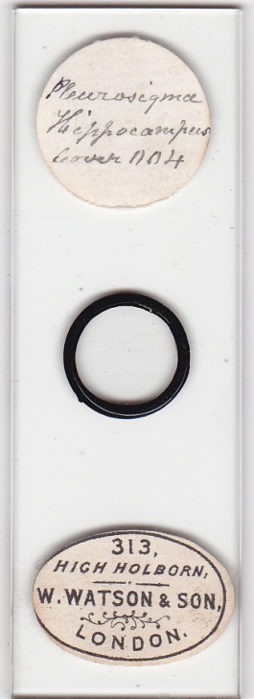
A late Barnett diatom mount retailed by Watson
Topping
As renowned a mounter as C.M. Topping could hardly have been ignored by Watson, and the slides below, sold pre-1882, seem to bear his handwriting on their labels. Since Topping died in 1874, this implies sales in the early 1870s, or even the 1860s.
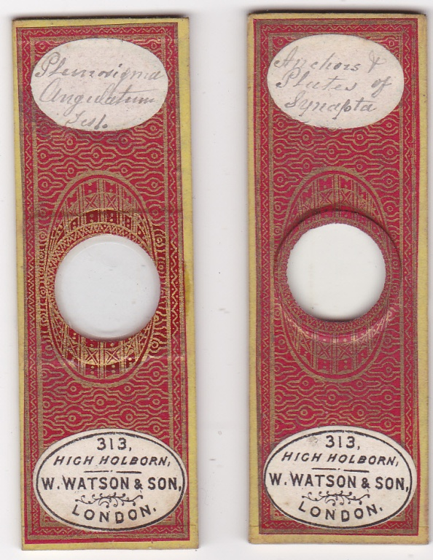
Amos Topping also sold slides via 313 High Holborn, prior to 1882 - his slides were retailed by Watson both before and after 1882, as evidenced by their secondary labels.
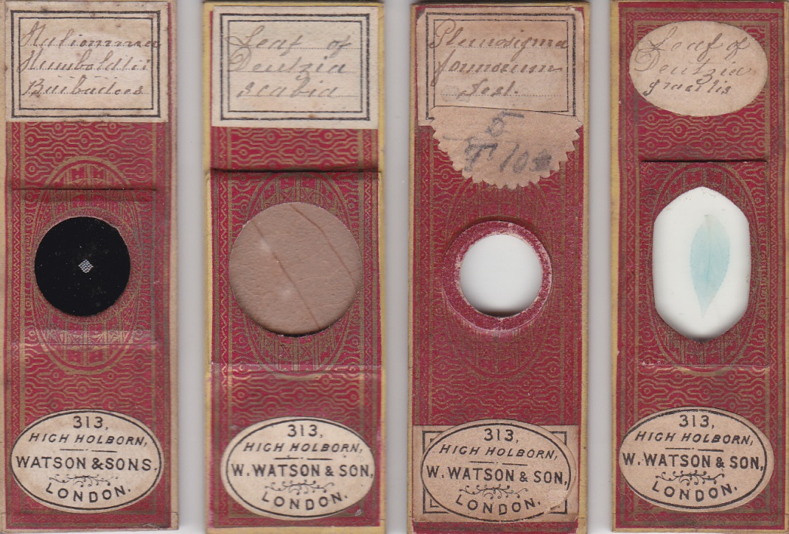
Various mounts by Amos Topping: on the left, sold after 1882, with three others sold before 1882
The handwriting, paper colour and pattern, and top labels are characteristic of Amos Topping’s mounts.
Cole
As the slides below show, Cole was also selling via Watson before 1882.
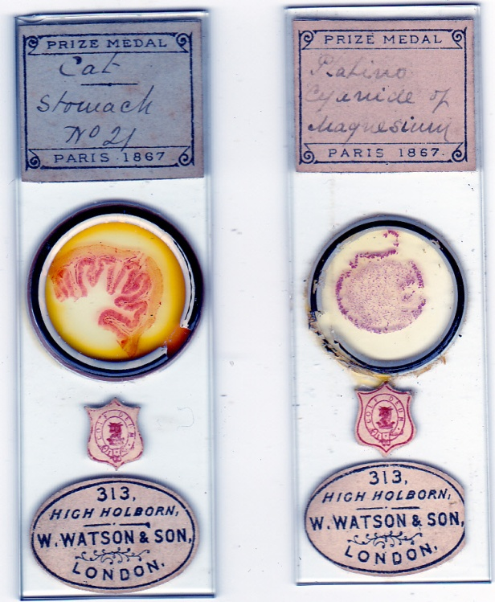
Martin Cole is known to have mounted for Watson, and that relationship was doubtless established while Cole senior was selling there.
“Greenpapers”
This as yet unidentified mounter made a prodigious amount of slides in the mid to late nineteenth century. Examples are found with secondary retail labels from a variety of firms, including Watson, whose pre 1882 sticker is seen on one of the slides illustrated below.
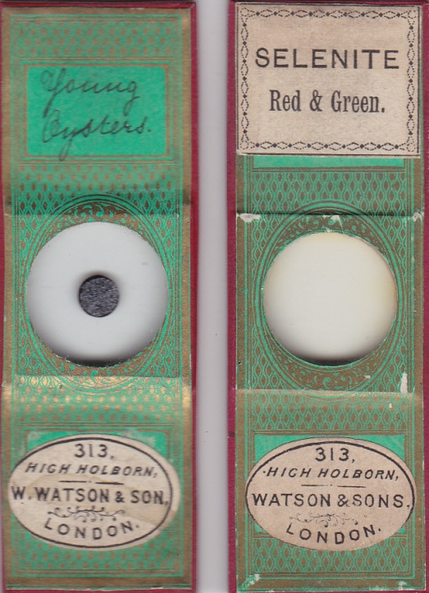
The post-1882 slide on the right is interesting. Its upper label is suggestive of some from Smith & Beck sales: “Greenpapers” was well established with them by 1865, as evidenced by the slide illustrated in Bracegirdle (MM&M, plate 5D), and such labels may have been on hand with the mounter, for slides likely to sell through them. Such a prolific mounting concern was unlikely to have escaped Watson’s attention, nor did it, and the S&B-like slide ultimately sold via Watson, but after 1882. Possibly, Watson offered competitive prices.
The Wheeler firm
Like the Norman family, the Wheelers formed a cottage industry: Edmund Wheeler and several of his children were involved, and his nephew Frederic Enock joined the firm for seven or eight years from 1870. Ernest Hinton was taken in by the family at a young age, and mounted for the firm until 1884, when he set up on his own. While neither Enock’s nor Hinton’s handwriting appears on papered and unpapered Wheeler slides, their work must have entered the Watson retail repertoire via slides under the Wheeler aegis: whether sales occurred before 1882 I cannot tell, but the slides below are of interest in this context. Cole moved to London around 1879: the two Wheeler slides, re-badged by Cole, are of uncertain date. It may be that negotiations were going on for sale of Wheeler’s stock, spurring Watson eventually to make the successful bid.
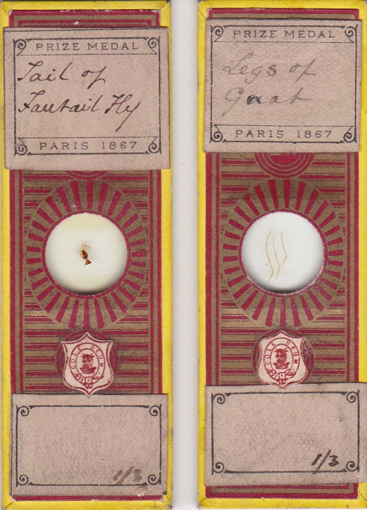
Enock enjoyed overt sales via Watson’s: the slide below was presumably made by him after he left Wheeler and set up on his own, but well before Watson’s buy out of Wheeler stock in 1884, since it bears the pre-1882 sticker.
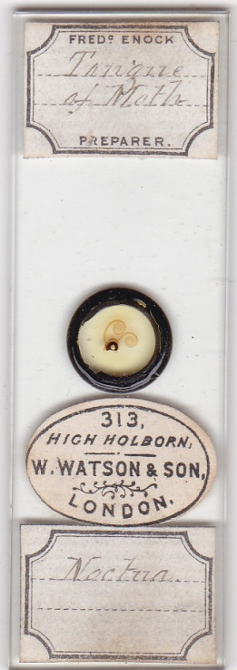
The Normans
Several of the Norman family sold via Watson prior to 1882. John Norman junior’s distinctive handwriting is seen on the slides below.
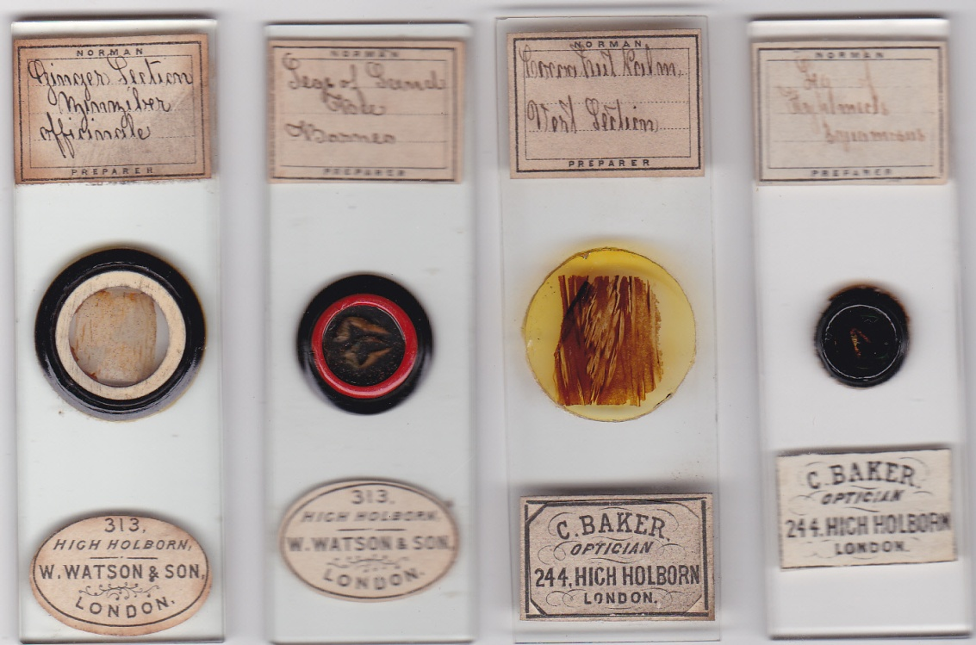
With Baker (above) offering Norman slides almost opposite Watson’s front door, it would have been strange indeed if Watson did not compete. William Norman also had slides retailed by Watson before 1882, as in the examples below.
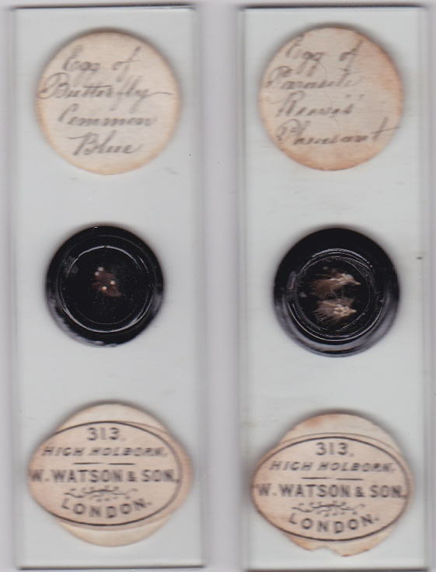
The handwriting is William Norman’s, and the circular labels are seen on many of his later mounts
A multitude of mounters?
More slides with the pre-1882 Watson label are shown below. Their preparers are not overtly identifiable, although at the time of sale those “in the know” may have recognised the individuals involved. None of the handwritings are those of the mounters already discussed in this article.
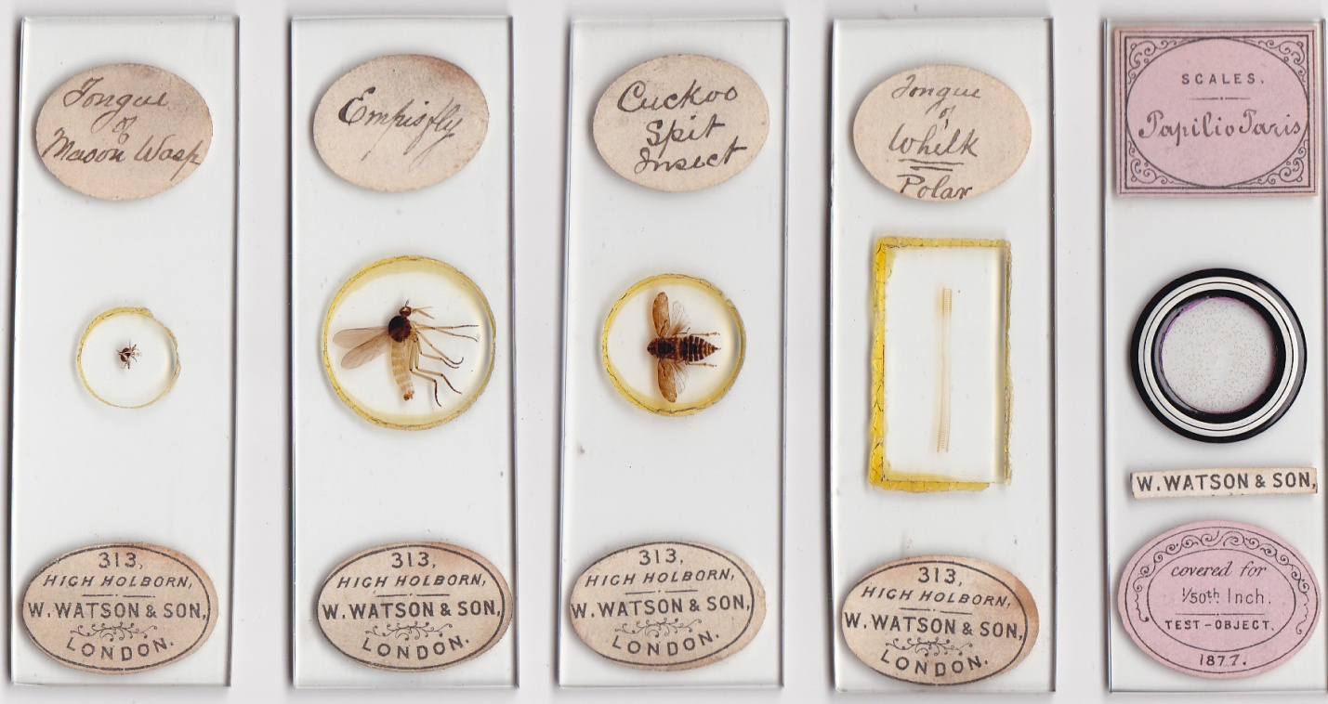
There seem to be five different handwritings on the labels above. The papilio slide at the end (right) has a most unusual Watson sticker, and is dated 1877.
How early did Watson start retailing slides?
The evidence above suggests sales of slides by many mounters as far back as the mid to late 1870s, and the history may well go much further back.
The firm thrived as an optical shop in central London from the late 1830s. Photographic equipment built them a reputation – a logical succession perhaps to lanterns – but all manner of instruments were sold. Inner London had many optical shops: as the nineteenth century wore on it was boom time for microscope and slide sales. Baker was well established in High Holborn when Watson moved there, a stone’s throw away: the arrival of Smith & Beck, first at Coleman Street and then at Cornhill, within walking distance, or a very brief cab ride away, added another big optical shop rival nearby.
Aside from big retailers, many inner London suburbs had opticians, and some had several, as scrutiny of nineteenth century trade and post office directories reveals. Doubtless some sold slides, and as microscopical clubs proliferated everywhere, competition must have intensified.
The Watson firm may not have made microscopes themselves until around 1876, but given the rapid success of these, the firm was already intimately familiar with their design. Sales of instruments made by others prior to 1876 would almost inevitably involve sales of slides, and as with other big retailers, good mounters as well as good microscope makers would be sought.
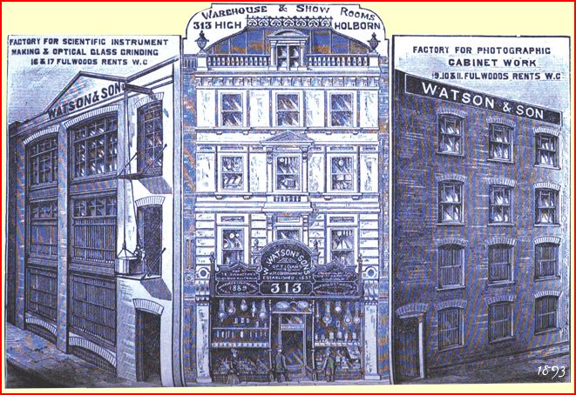
Would a competitive optical establishment of this size fail to offer both microscopes and slides? I think not. Readers with large collections may find evidence for how far back slide sales at Watson’s took place, as well as other mounters whose work was retailed there. What is sure is that sales did indeed occur, probably in large volume, before 1882: the conventional terminus post quem of 1884 can be discarded.
Email author: lois737 AT bigpond DOT com
Sources
Stanley Warren & Brian Davidson (2012): The Punch Line in Microphotographs, Quekett Journal of Microscopy, vol.41 pt.7, 641-648
Brian Bracegirdle (1998): Microscopical Mounts and Mounters
All slides illustrated come from my collection.

Published in the September 2012 edition of Micscape magazine.
www.micscape.org

