THE TUFFEN YOU PROBABLY MISSED, AND SOME YOU’VE NEVER SEEN
Peter B. Paisley
Sydney, Australia

Most devotees to nineteenth century microscopy have seen Tuffen West’s illustrations in books like Jabez Hogg’s The Microscope, or Wood’s Common Objects of the Microscope. Much of his work, however, is probably unfamiliar to microscopy enthusiasts. This article shows some in this less known category, with some hitherto never published.
Tuffen’s neurology
I have long known of Tuffen’s collaboration with Jonathan Hutchinson as the illustrator of some New Sydenham Society volumes (I have a set of the Society’s books in my library.) Tuffen illustrated the Society’s fourth volume, an English translation of Schroeder van der Kolk’s work on fine structure of the human spinal cord and medulla (1859), and illustrated the same author’s chapter on cerebral atrophy in the Society’s eleventh volume (1861). Two West brothers – Tuffen and William – collaborated in the lithography. For most Micscape readers, I fancy this is unfamiliar Tuffen territory, so it seems worthwhile to show his illustrations in extenso.
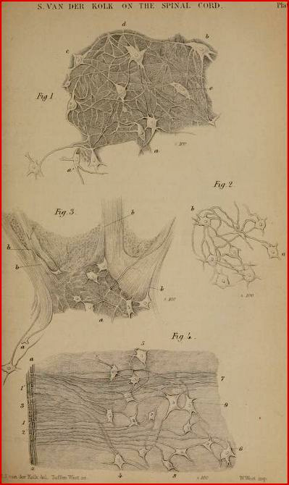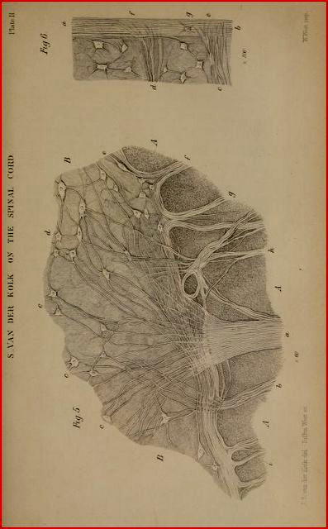
The above drawings, originally by Schroeder van der Kolk, were converted by the West brothers for lithographs in the New Sydenham Society volume. The same is true of all those shown below, which follow in the same book.
The depiction of individual neurones with their axonal and dendritic processes is outstanding for the time, and van der Kolk was a good choice to keep English readers up to date with developments in Europe.
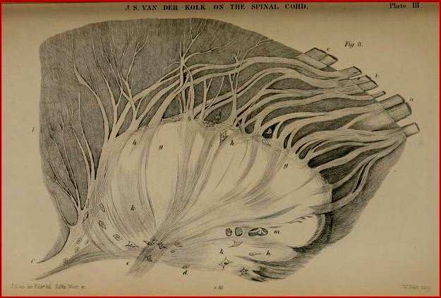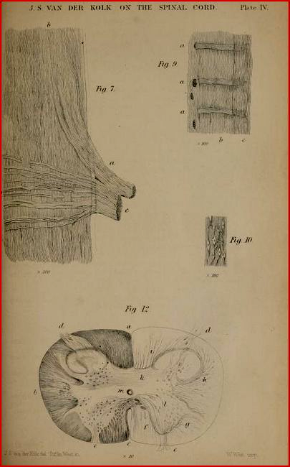
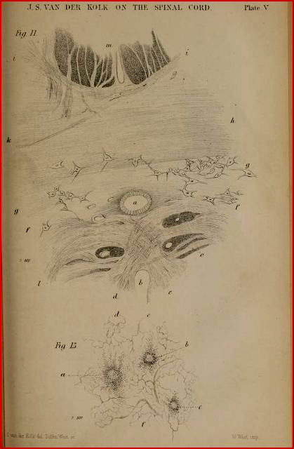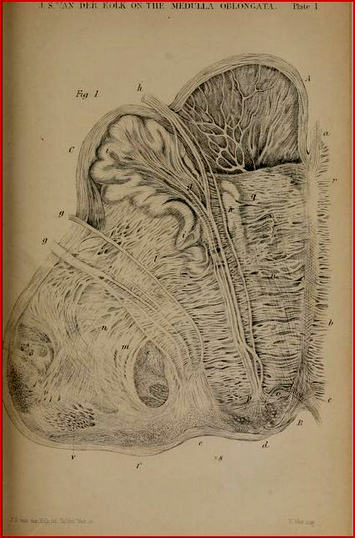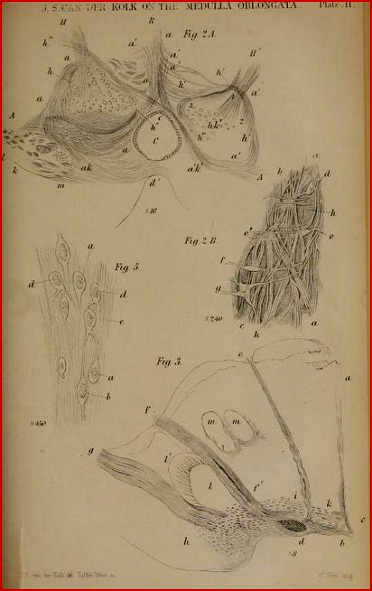
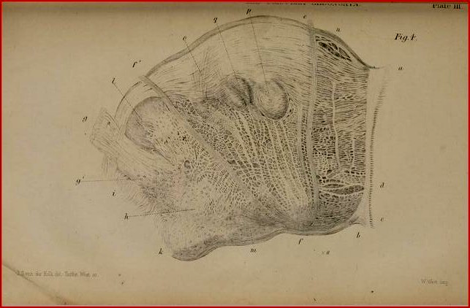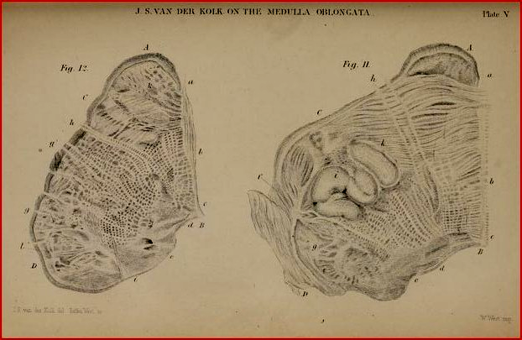
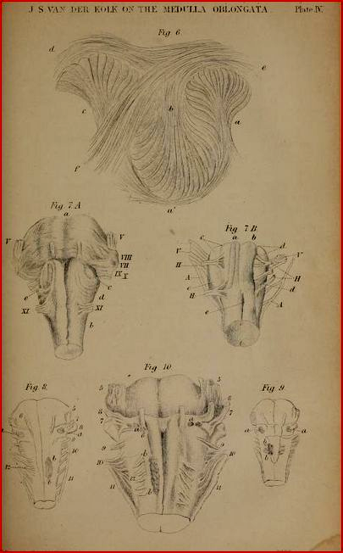
Tuffen West and Jonathan Hutchinson
Much biographical material on Hutchinson can be found on the Internet: most of it conveys no hint of any marriage, nor does it mention the New Sydenham Society at all. Hutchinson was indeed married – to Tuffen West’s sister – and was the driving force behind the New Sydenham Society. When the original Sydenham Society was wound up in 1857, with no further publications, Hutchinson convened a rebel group which immediately formed the New Sydenham Society, which continued publishing under his leadership until 1907.
Relationship by marriage was not the only thing the two men had in common. Both were Quakers, remaining so until their deaths – but both accepted evolutionary theory while holding to their faith. Both trained as surgeons. Too often the nineteenth century has been labelled with a sharp and simple collision between religion and evolutionary theory, but that distorts the facts. William Dallinger, after all, oversaw the first experimental demonstration of evolution: and on becoming head of his branch of the Methodist church, he used his presidential address to urge the assembled ministers to read the works of Charles Darwin. Tuffen West and Jonathan Hutchinson seem to have been like minded, and Tuffen’s Quaker brother William contributed lithography to the first edition of Darwin’s Origin of Species.
Unlike Hutchinson, Tuffen West had only scattered biographical fragments in various places until a recent outline sketch of his life appeared in the winter 2014 Quekett Journal of Microscopy, as part of an article on his work on Acari. Much remains to be told, and I shall be filling gaps in forthcoming Micscape articles.
In 1859, Tuffen West had not long finished some years’ work illustrating the Rev. William Smith’s 2 volume work on diatoms, and was completing his study of the foot of the fly for the Linnean Society: he was already well respected and in demand as an illustrator of biomedical work, so it is hardly surprising that his brother-in-law engaged him to illustrate the English translation of van der Kolk’s work.
More neurology
The New Sydenham Society’s 1861 volume of selected monographs included a chapter by van der Kolk on a case of brain atrophy, again with lithographs by the West brothers.
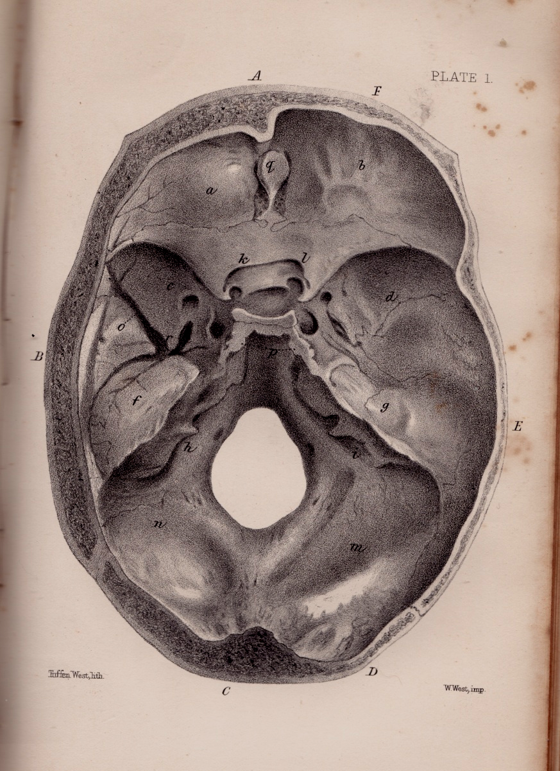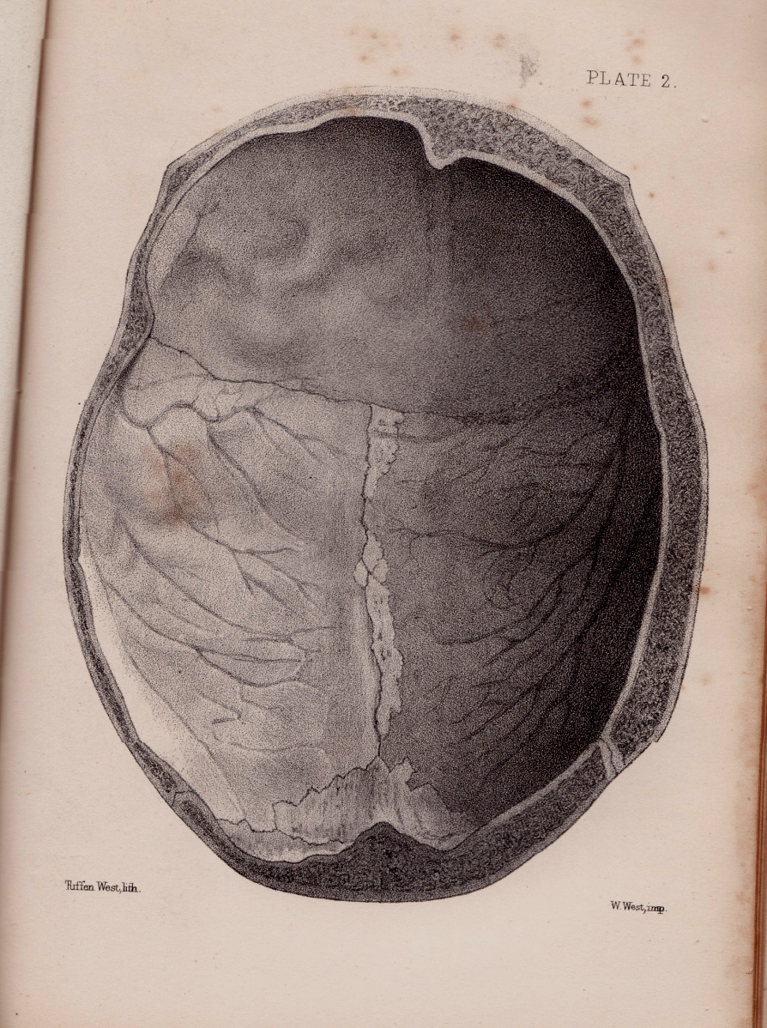
Base (L) and vault (R) of a skull examined by van der Kolk: below, corresponding brain specimens taken from the skull
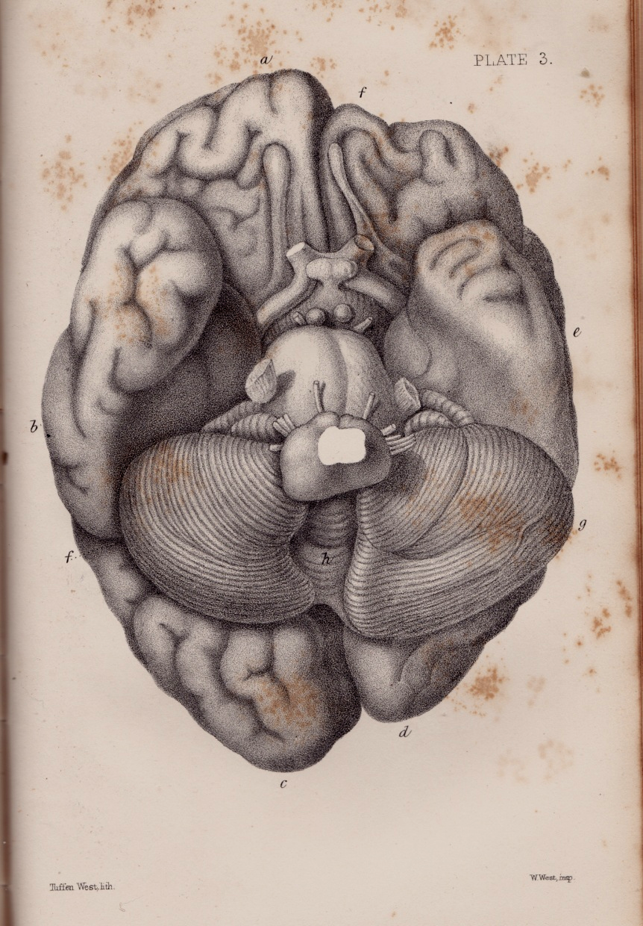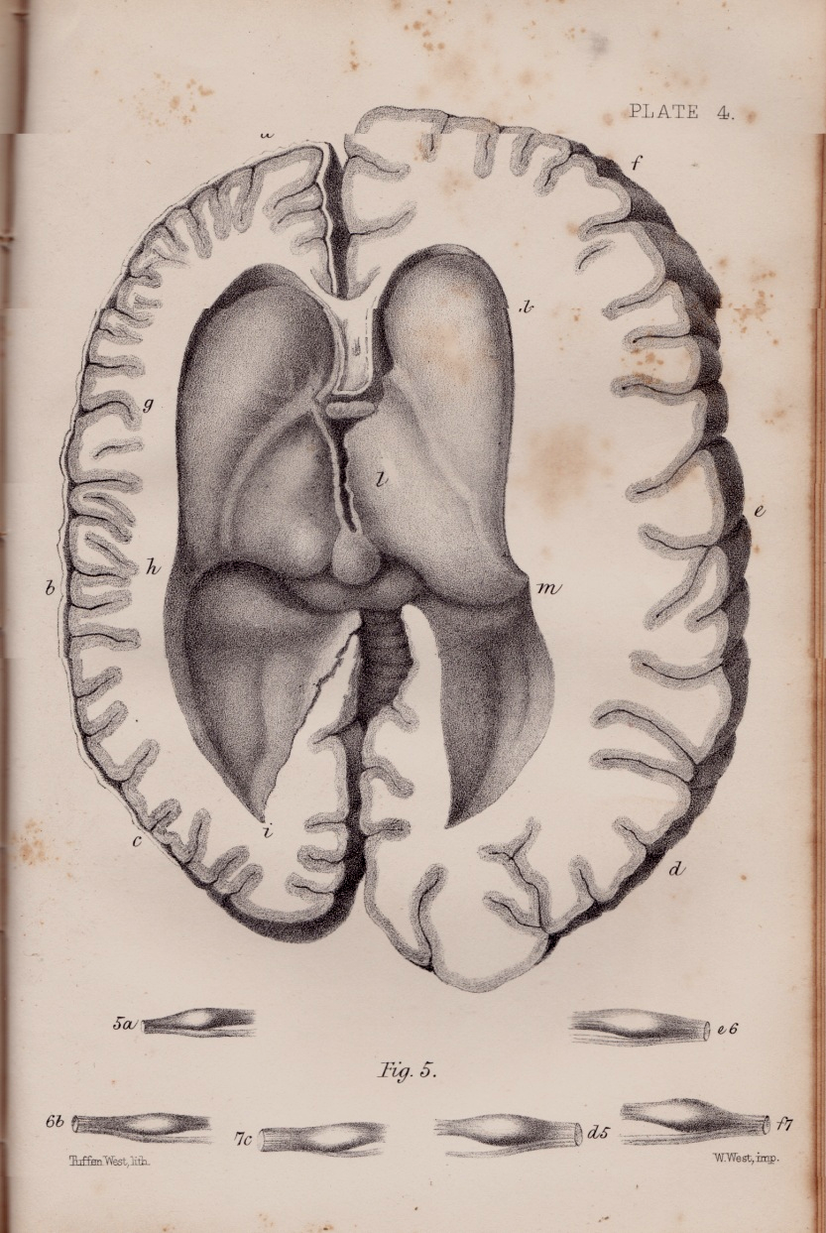
The illustrations above – albeit transcriptions from van der Kolk’s originals – would have been everyday fare to a trained anatomist and surgeon like Tuffen West, who was already constructing bird skeletons while still a schoolboy.
My previous mistake: and some Tuffen first editions.
Some time ago I attributed a drawing to another (much less prolific) illustrator, William Joseph Norman (Micscape, June 2012). I assumed that a monogram on an illustration in Frank Buckland’s (1883) Log-Book of a Fisherman and Zoologist was a variant of Norman’s “WJN”. I now think the monogram (bottom left) actually is Tuffen West’s: the illustration in question is shown below.
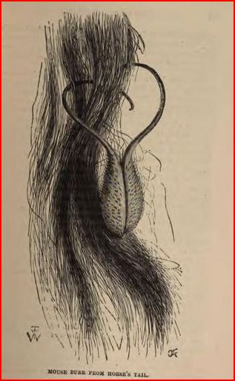
The monogram seems to be a variant of that on (unpublished) work by Tuffen West, as shown below.
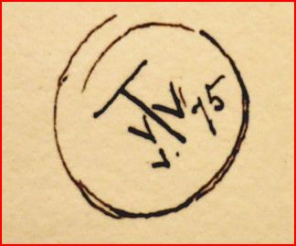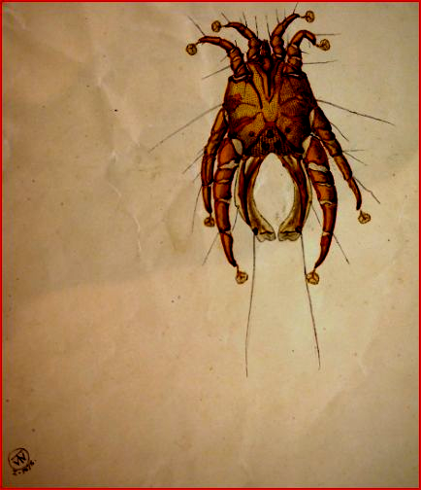
Images courtesy of Richard Baker
I have said that there would be “first editions”: the images above are hitherto unpublished, and that below is from a small collection of a descendant of the West family, Elizabeth Taylor.
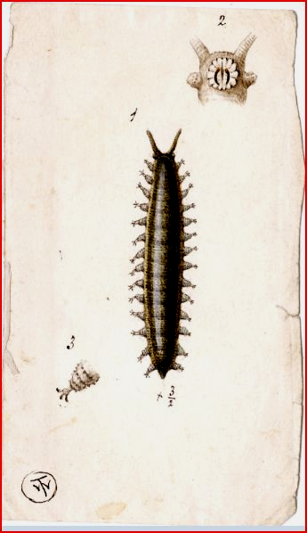
Image courtesy of Elizabeth Taylor
Discovery of original unpublished watercolours by Tuffen West is exciting, and I’ll be showing some more in forthcoming Micscape articles. For now though, the present study would be incomplete without further reference to the New Sydenham Society. The publication which gave Jonathan Hutchinson most pride was his Atlas of Skin Diseases. Tuffen West was not the principal artist for this, which was issued in series of plates over several years: however when it came to issuing a catalogue of what had been published, fresh material was included in the catalogue itself, namely illustrations of mites causing human skin conditions, and these were once again supplied by the West brothers, with original drawings by Tuffen (as opposed to transcriptions from other authors like van der Kolk).
The New Sydenham Society, volume 66 part 2 (1875)
While this, and a preceding similar small volume, are titled merely as “catalogues”, part two contains four composite plates by the Wests on various mites. It’s been a very long time since I’ve seen these little books offered by antiquarian booksellers, and even the cheap reproductions have only recently started to appear, in small numbers. Tuffen’s original drawings have languished in the Leeds University library for over a century. I was long aware that these, and many others, were there, but could never afford what the library charged for scans. Baker, Evenett and Gill (Quekett Journal of Microscopy, winter2014), have therefore performed a valuable service in making Acari illustrations by Tuffen available to a wide public. Below, I show illustrations as they actually appeared in the New Sydenham Society catalogue, part 2. These are monochrome black – the originals on which they were based were probably somewhat more colourful, as can be seen in the Quekett Journal article.
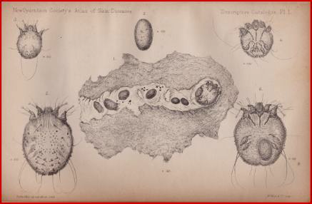
The plate above shows male and female human itch-mites in various stages of development, and eggs including one in the process of hatching. The central histological section shows a mite which has burrowed into the skin, which is characteristic and produces the intense itchy irritation of scabies.
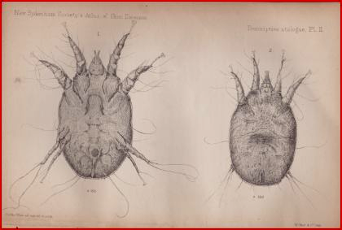
Scab-insect of the sheep
Occasionally, as with the scab-insect above, Acari normally found on other animals may cause skin irritation in humans. More examples are shown below.
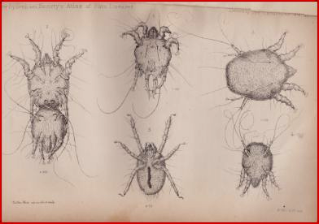
Itch-mites from ox mange
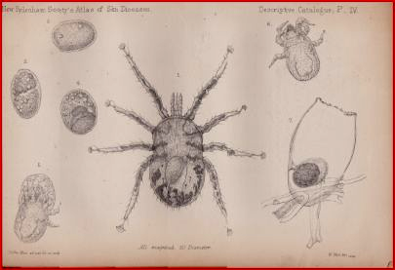
Itch-mites from domestic fowl
From what the Quekett paper’s authors say, the original lithographs for all four plates are probably in the Leeds University library. There are well over a hundred Tuffen West drawings languishing there: hopefully, one day someone (with very long pockets) will pay for scans to bring them to the light of day for historians and microscopy enthusiasts.
In forthcoming Micscape articles, I hope to present more lesser known examples of Tuffen West’s work, relevant biographical details, and more “first editions”.
Acknowledgements
I am grateful to Richard Baker for the examples of Tuffen’s monogram
A great debt is owed to Elizabeth Taylor for making available images of original Tuffen watercolour sketches. More will be shown in further Micscape articles.
Sources
Schroeder van der Kolk: On the minute structure and functions of the spinal cord and medulla, and on the proximate cause and rational treatment of epilepsy: trans. W.D. Moore, New Sydenham Society, London, 1859
Selected Monographs (Czermak et al): The New Sydenham Society, London, 1861 (includes a chapter by van der Kolk)
A descriptive catalogue (part 2) of the New Sydenham Society’s atlas of portraits of diseases of the skin, London, 1875
R.A. Baker, P.J. Evennett & S. Gill: The Acari or mites, by the microscopical investigator, artist and book illustrator Tuffen West (1823-1891), with particular reference to his collection at Leeds: The Quekett Journal of Microscopy, vol.42 part 4, winter 2014
www.ancestry.com

Email author: lois737@bigpond.com
Published in the September 2015 issue of Micscape Magazine.
www.micscape.org

